UNITED STATES
SECURITIES AND EXCHANGE COMMISSION
Washington, DC 20549

FORM 8-K

CURRENT REPORT
PURSUANT TO SECTION 13 OR 15(d) OF THE
SECURITIES EXCHANGE ACT OF 1934

DATE OF REPORT (Date of earliest event reported): October 21, 2026

FIRST MERCHANTS CORPORATION
(Exact name of registrant as specified in its charter)
Indiana
(State or other jurisdiction of incorporation)
001-41342 |  |  | 35-1544218
(Commission File Number) |  |  | (IRS Employer Identification No.)

200 East Jackson Street
P.O. Box 792
Muncie, IN 47305-2814
(Address of principal executive offices, including zip code)

(765) 747-1500
(Registrant's telephone number, including area code)

Not Applicable
(Former name or former address, if changed since last report)
Title of Each Class |  |  | Trading Symbol(s) |  |  | Name of each exchange on which registered
Common Stock, $0.125 stated value per share |  |  | FRME |  |  | The Nasdaq Stock Market LLC
Depositary Shares, each representing a 1/100th interest in a share of Non-Cumulative Perpetual Preferred Stock, Series A |  |  | FRMEP |  |  | The Nasdaq Stock Market LLC

Check the appropriate box below if the Form 8-K filing is intended to simultaneously satisfy the filing obligation of the registrant under any of the following provisions:

☐ Written communications pursuant to Rule 425 under the Securities Act (17 CFR 230.425)
☐ Soliciting material pursuant to Rule 14a-12 under the Exchange Act (17 CFR 240.14a-12)
☐ Pre-commencement communications pursuant to Rule 14d-2(b) under the Exchange Act (17 CFR 240.14d-2(b))
☐ Pre-commencement communications pursuant to Rule 13e-4(c) under the Exchange Act (17 CFR 240.13e-4(c))

Indicate by check mark whether the registrant is an emerging growth company as defined in Rule 405 of the Securities Act of 1933 (§230.405 of this chapter) or Rule 12b-2 of the Securities Exchange Act of 1934 (§240.12b-2 of this chapter).

Emerging growth company ☐

If an emerging growth company, indicate by check mark if the registrant has elected not to use the extended transition period for complying with any new or revised financial accounting standards provided pursuant to Section 13(a) of the Exchange Act. ☐

ITEM 2.02 RESULTS OF OPERATIONS AND FINANCIAL CONDITION.

On October 21, 2026, First Merchants Corporation issued a press release to report its financial results for the third quarter ended September 30, 2026. A copy of the press release is furnished as Exhibit 99.1 to this Current Report on Form 8-K.

On October 22, 2026, First Merchants Corporation will conduct a third quarter 2026 earnings conference call and webcast at 9:00 a.m. (ET). A copy of the slide presentation utilized on the conference call is furnished as Exhibit 99.2 to this Current Report on Form 8-K.

The information in this Current Report on Form 8-K, including Exhibit 99.1 and Exhibit 99.2 hereto, shall not be deemed "filed" for purposes of Section 18 of the Securities Exchange Act of 1934, as amended, or otherwise subject to liability of that section. The information in this Current Report shall not be incorporated by reference into any filing or other document pursuant to the Securities Act of 1933, as amended, except as shall be expressly set forth by specific reference in such filing or document.

ITEM 9.01 FINANCIAL STATEMENTS AND EXHIBITS.

(a) Not applicable.

(b) Not applicable.

(c) Not applicable.

(d) Exhibits.

Exhibit 99.1 |  |  | Press Release, dated October 21, 2026, issued by First Merchants Corporation
Exhibit 99.2 |  |  | Slide Presentation, utilized on October 22, 2026 during conference call and webcast by First Merchants Corporation
Exhibit 104 |  |  | Cover Page Interactive Data File (embedded within the Inline XBRL document)

SIGNATURES

Pursuant to the requirements of the Securities Exchange Act of 1934, the Registrant has duly caused this report to be signed on its behalf by the undersigned hereunto duly authorized.

First Merchants Corporation
(Registrant)
By: /s/ Michele M. Kawiecki

Michele M. Kawiecki

Executive Vice President, Chief Financial Officer
(Principal Financial and Accounting Officer)
Dated: October 21, 2026

N / E / W / S R / E / L / E / A / S / E

October 21, 2026

FOR IMMEDIATE RELEASE
For more information, contact:
Nicole M. Weaver, First Vice President and Director of Corporate Administration
765-521-7619
http://www.firstmerchants.com

SOURCE: First Merchants Corporation, Muncie, Indiana

FIRST MERCHANTS CORPORATION ANNOUNCES THIRD QUARTER 2026 RESULTS

First Merchants Corporation (NASDAQ - FRME) (the "Corporation" or "First Merchants")

Third Quarter 2026 Highlights:

•Net income available to common stockholders was $67.8 million, or $1.09 per diluted common share, compared with $43.5 million, or $0.70 per diluted common share, in the second quarter of 2026 and $56.3 million, or $0.98 per diluted common share in the third quarter of 2025.
•Adjusted pre-tax, pre-provision income1 of $83.7 million, compared to $84.6 million in the prior quarter and $70.5 million in the third quarter of 2025.
•Net interest margin on a fully taxable equivalent basis1 of 3.44%, up 6 basis points from the prior quarter and up 20 basis points from the third quarter of 2025.
•Loan growth of $70.2 million, or 1.8% annualized, on a linked quarter basis.
•Deposit growth of $175.6 million, or 4.2% annualized, on a linked quarter basis.
•Robust capital position with Common Equity Tier 1 Capital Ratio of 11.22%.
•Completed $100 million subordinated debt issuance in late September.
•Repurchased 1,264,062 shares of common stock totaling $50.3 million year-to-date, including 287,431 shares totaling $12.0 million in the third quarter.
•Nonperforming assets to total assets were 57 basis points compared to 56 basis points on a linked quarter basis.
•Efficiency ratio1 totaled 54.55% for the quarter.
•Announced the planned CEO transition: President Mike Stewart will succeed Mark Hardwick as Chief Executive Officer upon Mr. Hardwick’s retirement at year-end 2026.

"First Merchants delivered strong third quarter results. Earnings per diluted share were $1.09, up 11 percent from the third quarter of last year, fully taxable equivalent net interest margin1 rose 6 basis points to 3.44 percent, and deposit growth was solid," said Mark Hardwick, Chief Executive Officer. "We made meaningful progress resolving the two commercial credits identified last quarter, and nonperforming assets remained stable. Our capital position remains very strong and we continue to return capital to shareholders through dividends and share repurchases."

"As I approach my retirement at year-end, I am grateful to our 2,200 teammates for their dedication and to our clients and shareholders for the trust they have placed in us during my 29 years with First Merchants. I have great confidence in Mike Stewart and our leadership team, and I believe First Merchants is well positioned for continued success as they build on our Midwestern strength, deepen our client relationships and continue helping the communities we serve prosper."

Third Quarter Financial Results:

The Corporation reported net income available to common stockholders of $67.8 million for the third quarter of 2026, compared with $56.3 million in the third quarter of 2025. Diluted earnings per common share were $1.09, compared with $0.98 a year earlier. Current quarter results included acquisition-related costs of $0.9 million that consisted primarily of equipment and professional fees. Excluding these non-core charges, adjusted earnings per diluted common share1 for the third quarter of 2026 totaled $1.10 compared to $0.99 in the prior-year period.

For the nine months ended September 30, 2026, net income available to common stockholders totaled $139.0 million, or $2.24 per diluted common share, compared with $167.5 million, or $2.90 per diluted common share in the prior-year period. Adjusted net income available to common stockholders1 was $178.0 million, or $2.87 per diluted common share, compared with $168.2 million, or $2.91 per diluted common share, a year earlier. Nine-month adjusted earnings exclude $21.7 million of acquisition-related expenses and the $29.8 million negative valuation adjustment recorded in the first quarter on $271.1 million of mortgage loans sold, resulting in total adjustments of $51.4 million before tax and $39.0 million after tax.

Total assets of the Corporation equaled $21.1 billion as of quarter-end and loans totaled $15.6 billion. Loans increased $2.0 billion during the last twelve months and $70.2 million on a linked quarter basis. Excluding loans acquired through First Savings Financial Group, Inc. (“First Savings”) and the impact of mortgage loan sale activity in the first quarter of 2026, the Corporation generated organic loan growth of $473.7 million, or 3.5% during the past twelve months.

Investment securities, totaling $3.1 billion, decreased $257.9 million, or 7.6% during the last twelve months and decreased $167.6 million on a linked quarter basis. Investment securities declined during the quarter due to principal paydowns and maturities, and a decline in the securities portfolio valuation due to increases in interest rates.

Total deposits equaled $16.9 billion as of quarter-end and increased by $2.1 billion over the past twelve months. The acquisition of First Savings contributed $1.7 billion in deposits. Total deposits increased $175.6 million, or 4.2% annualized, on a linked quarter basis. The loan-to-deposit ratio remained relatively stable at 92.2% at period end, compared to 92.7% in the prior quarter.

The Corporation’s Allowance for Credit Losses – Loans (ACL) totaled $215.5 million as of quarter-end, or 1.38% of loans, a decrease of $26.1 million from the prior quarter. Net charge-offs totaled $29.4 million driven by two non-performing credits for which specific reserves were established in the prior quarter. Provision for credit losses of $3.3 million was recorded during the quarter. Nonperforming assets to total assets remained relatively stable at 0.57%, compared to 0.56% in the prior quarter. Related credit costs for new nonaccrual loans were recognized in prior quarters. Reserves for unfunded commitments totaling $18.5 million remained unchanged from the previous quarter.

Net interest income, totaling $161.1 million for the quarter, increased $2.1 million, or 1.3%, compared to prior quarter and increased $27.4 million, or 20.5%, compared to the third quarter of 2025. Fully taxable equivalent net interest margin1 was 3.44%, an increase of 6 basis points from the linked quarter and an increase of 20 basis points compared to the third quarter of 2025.

Noninterest income totaled $38.0 million for the quarter, an increase of $0.8 million, compared to the prior quarter and an increase of $5.5 million compared to the third quarter of 2025. The linked-quarter increase primarily reflects higher deposit service charges and an increase in income from CRA investments recorded through Other Income.

Noninterest expense totaled $116.3 million for the quarter, an increase of $0.9 million from the prior quarter and an increase of $19.7 million from the third quarter of 2025. Acquisition-related costs totaling $0.9 million were incurred during the quarter and $3.8 million were recorded in the prior quarter. Excluding acquisition costs, noninterest expense increased $3.9 million linked quarter, primarily driven by a $1.4 million increase in marketing expense, a $0.7 million increase in employee health insurance costs, and a $0.6 million increase in premises expense that included a $0.5 million building lease impairment charge.

The Corporation’s total risk-based capital ratio equaled 13.58%, the common equity tier 1 capital ratio equaled 11.22%, and the tangible common equity ratio totaled 8.83%. These ratios continue to reflect the Corporation’s strong capital position.

1 See “Non-GAAP Financial Information” for reconciliation

CONFERENCE CALL

First Merchants Corporation will conduct an earnings conference call and webcast at 9:00 a.m. (ET) on Thursday, October 22, 2026.

To access via phone, participants will need to register using the following link where they will be provided a phone number and access code: (https://register-conf.media-server.com/register/BIb6ca7718e42d48c3b903034aad19eef4)

To view the webcast and presentation slides, please go to (https://edge.media-server.com/mmc/p/izzbnu6m) during the time of the call. A replay of the webcast will be available until October 22, 2027.

Detailed financial results are reported on the attached pages.

About First Merchants Corporation

First Merchants Corporation is a financial holding company headquartered in Muncie, Indiana. The Corporation has one full-service bank charter, First Merchants Bank. The Bank also operates as First Merchants Private Wealth Advisors (as a division of First Merchants Bank).

First Merchants Corporation’s common stock is traded on the NASDAQ Global Select Market System under the symbol FRME. Quotations are carried in daily newspapers and can be found on the company’s Internet web page (http://www.firstmerchants.com).

FIRST MERCHANTS and the Shield Logo are federally registered trademarks of First Merchants Corporation.

Forward-Looking Statements

This news release contains forward-looking statements made pursuant to the safe-harbor provisions of the Private Securities Litigation Reform Act of 1995. Such forward-looking statements can often, but not always, be identified by the use of words like “believe”, “continue”, “pattern”, “estimate”, “project”, “intend”, “anticipate”, “expect” and similar expressions or future or conditional verbs such as “will”, “would”, “should”, “could”, “might”, “can”, “may”, or similar expressions. These forward-looking statements include, but are not limited to, statements relating to the expected benefits of the merger between First Merchants and First Savings, including future financial and operating results, cost savings, enhanced revenues, and accretion/dilution to reported earnings that may be realized from the merger, as well as other statements of expectations regarding the merger, and other statements of First Merchants’ goals, intentions and expectations; statements regarding First Merchants’ business plan and growth strategies; statements regarding the asset quality of First Merchants’ loan and investment portfolios; and estimates of First Merchants’ risks and future costs and benefits, whether with respect to the merger or otherwise. These forward-looking statements are subject to significant risks, assumptions and uncertainties that may cause results to differ materially from those set forth in forward-looking statements, including, among other things: the risk that the businesses of First Merchants and First Savings will not be integrated successfully or such integration may be more difficult, time-consuming or costly than expected; expected revenue synergies and cost savings from the merger may not be fully realized or realized within the expected time frame; revenues following the merger may be lower than expected; customer and employee relationships and business operations may be disrupted by the merger; possible changes in monetary and fiscal policies, and laws and regulations; the effects of easing restrictions on participants in the financial services industry; the cost and other effects of legal and administrative cases; possible changes in the credit-worthiness of customers and the possible impairment of collectability of loans; fluctuations in market rates of interest; competitive factors in the banking industry; changes in the banking legislation or regulatory requirements of federal and state agencies applicable to bank holding companies and banks like First Merchants’ affiliate bank; continued availability of earnings and excess capital sufficient for the lawful and prudent declaration of dividends; changes in market, economic, operational, liquidity (including the ability to grow and maintain core deposits and retain large uninsured deposits), credit and interest rate risks associated with First Merchants’ business; the impacts of epidemics, pandemics or other infectious disease outbreaks; and other risks and factors identified in each of First Merchants’ filings with the SEC. First Merchants undertakes no obligation to update any forward-looking statement, whether written or oral, relating to the matters discussed in this news release. In addition, First Merchants’ past results of operations do not necessarily indicate their anticipated future results.

Non-GAAP Financial Measures

This news release contains non-GAAP financial measures. For purposes of Regulation G, a non-GAAP financial measure is a numerical measure of the registrant’s historical or future financial performance, financial position or cash flows that excludes amounts, or is subject to adjustments that have the effect of excluding amounts, that are included in the most directly comparable measure calculated and presented in accordance with GAAP in the statement of income, balance sheet or statement of cash flows (or equivalent statements) of the issuer; or includes amounts, or is subject to adjustments that have the effect of including amounts, that are excluded from the most directly comparable measure so calculated and presented. In this regard, GAAP refers to generally accepted accounting principles in the United States. Pursuant to the requirements of Regulation G, First Merchants Corporation has provided reconciliations within this news release, as necessary, of the non-GAAP financial measure to the most directly comparable GAAP financial measure.

* * * *

CONSOLIDATED BALANCE SHEETS (Unaudited)
(Dollars In Thousands, Except Per Share Amounts) |  |  | September 30,
 |  |  | 2026 |  |  |  |  |  | 2025
ASSETS
Cash and due from banks |  |  | $ | 86,594 |  |  |  |  | $ | 88,079
Interest-bearing deposits |  |  | 262,503 |  |  |  |  |  | 168,706
Investment securities available for sale |  |  | 1,251,540 |  |  |  |  |  | 1,386,903
Investment securities held to maturity, net of allowance for credit losses of $245 in 2026 and 2025 |  |  | 1,872,951 |  |  |  |  |  | 1,995,488
Loans held for sale |  |  | 87,300 |  |  |  |  |  | 23,190
Loans |  |  | 15,600,974 |  |  |  |  |  | 13,591,174
Less: Allowance for credit losses - loans |  |  | (215,526) |  |  |  |  |  | (194,468)
Net loans |  |  | 15,385,448 |  |  |  |  |  | 13,396,706
Premises and equipment |  |  | 145,030 |  |  |  |  |  | 121,771
Federal Home Loan Bank stock |  |  | 70,794 |  |  |  |  |  | 47,264
Interest receivable |  |  | 99,280 |  |  |  |  |  | 89,102
Goodwill |  |  | 788,186 |  |  |  |  |  | 712,002
Other intangibles |  |  | 36,320 |  |  |  |  |  | 15,298
Cash surrender value of life insurance |  |  | 374,974 |  |  |  |  |  | 306,583
Other real estate owned |  |  | 1,605 |  |  |  |  |  | 1,270
Tax asset, deferred and receivable |  |  | 136,258 |  |  |  |  |  | 89,758
Other assets |  |  | 457,939 |  |  |  |  |  | 369,509
TOTAL ASSETS |  |  | $ | 21,056,722 |  |  |  |  | $ | 18,811,629
LIABILITIES
Deposits:
Noninterest-bearing |  |  | $ | 3,752,990 |  |  |  |  | $ | 2,100,570
Interest-bearing |  |  | 13,175,942 |  |  |  |  |  | 12,769,409
Total Deposits |  |  | 16,928,932 |  |  |  |  |  | 14,869,979
Borrowings:
Federal funds purchased |  |  | — |  |  |  |  |  | 199,370
Securities sold under repurchase agreements |  |  | 99,638 |  |  |  |  |  | 122,226
Federal Home Loan Bank advances |  |  | 903,941 |  |  |  |  |  | 798,626
Subordinated debentures and other borrowings |  |  | 184,505 |  |  |  |  |  | 57,632
Total Borrowings |  |  | 1,188,084 |  |  |  |  |  | 1,177,854
Interest payable |  |  | 17,095 |  |  |  |  |  | 18,240
Other liabilities |  |  | 286,230 |  |  |  |  |  | 333,154
Total Liabilities |  |  | 18,420,341 |  |  |  |  |  | 16,399,227
STOCKHOLDERS' EQUITY
Preferred Stock, $1,000 par value, $1,000 liquidation value:
Authorized -- 600 cumulative shares
Issued and outstanding - 125 cumulative shares |  |  | 125 |  |  |  |  |  | 125
Preferred Stock, Series A, no par value, $2,500 liquidation preference:
Authorized -- 10,000 non-cumulative perpetual shares
Issued and outstanding - 10,000 non-cumulative perpetual shares |  |  | 25,000 |  |  |  |  |  | 25,000
Common Stock, $0.125 stated value:
Authorized -- 100,000,000 shares
Issued and outstanding - 62,210,134 and 57,192,497 shares |  |  | 7,754 |  |  |  |  |  | 7,149
Additional paid-in capital |  |  | 1,347,943 |  |  |  |  |  | 1,158,026
Retained earnings |  |  | 1,483,496 |  |  |  |  |  | 1,377,966
Accumulated other comprehensive loss |  |  | (227,937) |  |  |  |  |  | (155,864)
Total Stockholders' Equity |  |  | 2,636,381 |  |  |  |  |  | 2,412,402
TOTAL LIABILITIES AND STOCKHOLDERS' EQUITY |  |  | $ | 21,056,722 |  |  |  |  | $ | 18,811,629

CONSOLIDATED STATEMENTS OF INCOME (Unaudited) |  |  | Three Months Ended |  |  |  |  |  |  |  |  |  |  |  | Nine Months Ended
(Dollars In Thousands, Except Per Share Amounts) |  |  | September 30, |  |  |  |  |  |  |  |  |  |  |  | September 30,
 |  |  | 2026 |  |  |  |  |  | 2025 |  |  |  |  |  | 2026 |  |  |  |  |  | 2025
INTEREST INCOME
Loans:
Taxable |  |  | $ | 230,072 |  |  |  |  | $ | 200,406 |  |  |  |  | $ | 670,230 |  |  |  |  | $ | 583,307
Tax-exempt |  |  | 11,379 |  |  |  |  |  | 11,173 |  |  |  |  |  | 34,791 |  |  |  |  |  | 32,510
Investment securities:
Taxable |  |  | 7,331 |  |  |  |  |  | 8,288 |  |  |  |  |  | 22,233 |  |  |  |  |  | 24,926
Tax-exempt |  |  | 12,279 |  |  |  |  |  | 12,460 |  |  |  |  |  | 37,334 |  |  |  |  |  | 37,493
Deposits with financial institutions |  |  | 1,308 |  |  |  |  |  | 1,676 |  |  |  |  |  | 3,699 |  |  |  |  |  | 5,940
Federal Home Loan Bank stock |  |  | 1,578 |  |  |  |  |  | 1,092 |  |  |  |  |  | 5,068 |  |  |  |  |  | 3,172
Total Interest Income |  |  | 263,947 |  |  |  |  |  | 235,095 |  |  |  |  |  | 773,355 |  |  |  |  |  | 687,348
INTEREST EXPENSE
Deposits |  |  | 91,313 |  |  |  |  |  | 90,821 |  |  |  |  |  | 261,660 |  |  |  |  |  | 255,609
Federal funds purchased |  |  | 225 |  |  |  |  |  | 224 |  |  |  |  |  | 1,532 |  |  |  |  |  | 2,001
Securities sold under repurchase agreements |  |  | 378 |  |  |  |  |  | 654 |  |  |  |  |  | 1,129 |  |  |  |  |  | 2,059
Federal Home Loan Bank advances |  |  | 9,537 |  |  |  |  |  | 8,638 |  |  |  |  |  | 33,775 |  |  |  |  |  | 27,716
Subordinated debentures and other borrowings |  |  | 1,426 |  |  |  |  |  | 1,093 |  |  |  |  |  | 3,947 |  |  |  |  |  | 3,014
Total Interest Expense |  |  | 102,879 |  |  |  |  |  | 101,430 |  |  |  |  |  | 302,043 |  |  |  |  |  | 290,399
NET INTEREST INCOME |  |  | 161,068 |  |  |  |  |  | 133,665 |  |  |  |  |  | 471,312 |  |  |  |  |  | 396,949
Provision for credit losses |  |  | 3,300 |  |  |  |  |  | 4,300 |  |  |  |  |  | 41,200 |  |  |  |  |  | 14,100
NET INTEREST INCOME AFTER PROVISION FOR CREDIT LOSSES |  |  | 157,768 |  |  |  |  |  | 129,365 |  |  |  |  |  | 430,112 |  |  |  |  |  | 382,849
NONINTEREST INCOME
Service charges on deposit accounts |  |  | 9,775 |  |  |  |  |  | 8,921 |  |  |  |  |  | 28,184 |  |  |  |  |  | 25,559
Fiduciary and wealth management fees |  |  | 9,786 |  |  |  |  |  | 8,842 |  |  |  |  |  | 29,192 |  |  |  |  |  | 26,317
Card payment fees |  |  | 5,606 |  |  |  |  |  | 5,007 |  |  |  |  |  | 16,386 |  |  |  |  |  | 14,465
Net gains and fees on sales of loans |  |  | 7,428 |  |  |  |  |  | 4,983 |  |  |  |  |  | 21,681 |  |  |  |  |  | 15,854
Derivative hedge fees |  |  | 1,082 |  |  |  |  |  | 1,097 |  |  |  |  |  | 2,763 |  |  |  |  |  | 2,332
Other customer fees |  |  | 584 |  |  |  |  |  | 414 |  |  |  |  |  | 2,057 |  |  |  |  |  | 1,230
Earnings on bank-owned life insurance |  |  | 2,353 |  |  |  |  |  | 1,667 |  |  |  |  |  | 8,124 |  |  |  |  |  | 5,759
Net realized losses on sales of available for sale securities |  |  | — |  |  |  |  |  | — |  |  |  |  |  | — |  |  |  |  |  | (8)
Net loss on mortgage loans reclassified to held for sale |  |  | — |  |  |  |  |  | — |  |  |  |  |  | (29,755) |  |  |  |  |  | —
Other income |  |  | 1,391 |  |  |  |  |  | 1,546 |  |  |  |  |  | 2,358 |  |  |  |  |  | 2,320
Total Noninterest Income |  |  | 38,005 |  |  |  |  |  | 32,477 |  |  |  |  |  | 80,990 |  |  |  |  |  | 93,828
NONINTEREST EXPENSE
Salaries and employee benefits |  |  | 66,339 |  |  |  |  |  | 57,317 |  |  |  |  |  | 201,556 |  |  |  |  |  | 166,826
Net occupancy |  |  | 8,807 |  |  |  |  |  | 7,057 |  |  |  |  |  | 25,335 |  |  |  |  |  | 21,118
Equipment |  |  | 8,061 |  |  |  |  |  | 6,998 |  |  |  |  |  | 24,482 |  |  |  |  |  | 20,933
Marketing |  |  | 3,630 |  |  |  |  |  | 2,120 |  |  |  |  |  | 7,601 |  |  |  |  |  | 5,470
Outside data processing fees |  |  | 7,883 |  |  |  |  |  | 6,943 |  |  |  |  |  | 23,118 |  |  |  |  |  | 19,979
Printing and office supplies |  |  | 481 |  |  |  |  |  | 311 |  |  |  |  |  | 1,349 |  |  |  |  |  | 930
Intangible asset amortization |  |  | 2,652 |  |  |  |  |  | 1,499 |  |  |  |  |  | 7,660 |  |  |  |  |  | 4,530
FDIC assessments |  |  | 4,381 |  |  |  |  |  | 3,526 |  |  |  |  |  | 12,664 |  |  |  |  |  | 10,726
Other real estate owned and foreclosure expenses |  |  | 1,594 |  |  |  |  |  | 121 |  |  |  |  |  | 3,746 |  |  |  |  |  | 750
Professional and other outside services |  |  | 4,665 |  |  |  |  |  | 3,718 |  |  |  |  |  | 24,237 |  |  |  |  |  | 10,720
Other expenses |  |  | 7,761 |  |  |  |  |  | 6,951 |  |  |  |  |  | 24,998 |  |  |  |  |  | 21,079
Total Noninterest Expense |  |  | 116,254 |  |  |  |  |  | 96,561 |  |  |  |  |  | 356,746 |  |  |  |  |  | 283,061
Income Before Income Taxes |  |  | 79,519 |  |  |  |  |  | 65,281 |  |  |  |  |  | 154,356 |  |  |  |  |  | 193,616
Income tax expense |  |  | 11,204 |  |  |  |  |  | 8,516 |  |  |  |  |  | 13,905 |  |  |  |  |  | 24,680
NET INCOME |  |  | 68,315 |  |  |  |  |  | 56,765 |  |  |  |  |  | 140,451 |  |  |  |  |  | 168,936
Preferred stock dividends |  |  | 468 |  |  |  |  |  | 468 |  |  |  |  |  | 1,406 |  |  |  |  |  | 1,406
NET INCOME AVAILABLE TO COMMON STOCKHOLDERS |  |  | $ | 67,847 |  |  |  |  | $ | 56,297 |  |  |  |  | $ | 139,045 |  |  |  |  | $ | 167,530
PER SHARE DATA:
Basic Net Income Available to Common Stockholders |  |  | $ | 1.09 |  |  |  |  | $ | 0.98 |  |  |  |  | $ | 2.25 |  |  |  |  | $ | 2.91
Diluted Net Income Available to Common Stockholders |  |  | $ | 1.09 |  |  |  |  | $ | 0.98 |  |  |  |  | $ | 2.24 |  |  |  |  | $ | 2.90
Cash Dividends Paid to Common Stockholders |  |  | $ | 0.37 |  |  |  |  | $ | 0.36 |  |  |  |  | $ | 1.10 |  |  |  |  | $ | 1.07
Tangible Common Book Value Per Share(1) |  |  | $ | 28.86 |  |  |  |  | $ | 29.08 |  |  |  |  | $ | 28.86 |  |  |  |  | $ | 29.08
Average Diluted Common Shares Outstanding (in thousands) |  |  | 62,411 |  |  |  |  |  | 57,448 |  |  |  |  |  | 62,003 |  |  |  |  |  | 57,817
(1) See "Non-GAAP Financial Information" for reconciliation

FINANCIAL HIGHLIGHTS
(Dollars In Thousands) |  |  | Three Months Ended |  |  |  |  |  |  |  |  |  |  |  | Nine Months Ended
 |  |  | September 30, |  |  |  |  |  |  |  |  |  |  |  | September 30,
 |  |  | 2026 |  |  |  |  |  | 2025 |  |  |  |  |  | 2026 |  |  |  |  |  | 2025
NET CHARGE-OFFS |  |  | $ | 29,389 |  |  |  |  | $ | 5,148 |  |  |  |  | $ | 43,550 |  |  |  |  | $ | 12,389
AVERAGE BALANCES:
Assets |  |  | $ | 21,065,760 |  |  |  |  | $ | 18,637,581 |  |  |  |  | $ | 20,911,229 |  |  |  |  | $ | 18,497,118
Loans |  |  | 15,608,069 |  |  |  |  |  | 13,376,214 |  |  |  |  |  | 15,321,286 |  |  |  |  |  | 13,162,668
Earning Assets |  |  | 19,432,368 |  |  |  |  |  | 17,282,901 |  |  |  |  |  | 19,288,344 |  |  |  |  |  | 17,135,301
Deposits |  |  | 16,885,365 |  |  |  |  |  | 14,907,861 |  |  |  |  |  | 16,537,651 |  |  |  |  |  | 14,654,894
Stockholders' Equity |  |  | 2,695,943 |  |  |  |  |  | 2,367,971 |  |  |  |  |  | 2,684,796 |  |  |  |  |  | 2,349,718
FINANCIAL RATIOS:
Return on Average Assets |  |  | 1.30 |  | % |  |  |  | 1.22 |  | % |  |  |  | 0.90 |  | % |  |  |  | 1.22 |  | %
Return on Average Stockholders' Equity |  |  | 10.07 |  |  |  |  |  | 9.51 |  |  |  |  |  | 6.91 |  |  |  |  |  | 9.51
Return on Tangible Common Stockholders' Equity(1) |  |  | 15.09 |  |  |  |  |  | 14.21 |  |  |  |  |  | 10.43 |  |  |  |  |  | 14.27
Average Earning Assets to Average Assets |  |  | 92.25 |  |  |  |  |  | 92.73 |  |  |  |  |  | 92.24 |  |  |  |  |  | 92.64
Allowance for Credit Losses - Loans as % of Loans |  |  | 1.38 |  |  |  |  |  | 1.43 |  |  |  |  |  | 1.38 |  |  |  |  |  | 1.43
Net Charge-offs as % of Average Loans (Annualized) |  |  | 0.75 |  |  |  |  |  | 0.15 |  |  |  |  |  | 0.38 |  |  |  |  |  | 0.13
Average Stockholders' Equity to Average Assets |  |  | 12.80 |  |  |  |  |  | 12.71 |  |  |  |  |  | 12.84 |  |  |  |  |  | 12.70
Fully Taxable Equivalent ("FTE") Yield on Average Earning Assets |  |  | 5.56 |  |  |  |  |  | 5.58 |  |  |  |  |  | 5.48 |  |  |  |  |  | 5.49
Interest Expense/Average Earning Assets |  |  | 2.12 |  |  |  |  |  | 2.34 |  |  |  |  |  | 2.09 |  |  |  |  |  | 2.26
Net Interest Margin FTE(1) |  |  | 3.44 |  |  |  |  |  | 3.24 |  |  |  |  |  | 3.39 |  |  |  |  |  | 3.23
Efficiency Ratio(1) |  |  | 54.55 |  |  |  |  |  | 55.09 |  |  |  |  |  | 60.44 |  |  |  |  |  | 54.54
(1) See "Non-GAAP Financial Information" for reconciliation

ASSET QUALITY
(Dollars In Thousands) |  |  | September 30, |  |  |  |  |  | June 30, |  |  |  |  |  | March 31, |  |  |  |  |  | December 31, |  |  |  |  |  | September 30,
 |  |  | 2026 |  |  |  |  |  | 2026 |  |  |  |  |  | 2026 |  |  |  |  |  | 2025 |  |  |  |  |  | 2025
Nonaccrual Loans |  |  | $ | 117,415 |  |  |  |  | $ | 118,203 |  |  |  |  | $ | 89,592 |  |  |  |  | $ | 71,773 |  |  |  |  | $ | 65,740
Other Real Estate Owned and Repossessions |  |  | 1,605 |  |  |  |  |  | 1,562 |  |  |  |  |  | 1,264 |  |  |  |  |  | 658 |  |  |  |  |  | 1,270
Nonperforming Assets (NPA) |  |  | 119,020 |  |  |  |  |  | 119,765 |  |  |  |  |  | 90,856 |  |  |  |  |  | 72,431 |  |  |  |  |  | 67,010
Accruing Loans 90+ Days Delinquent |  |  | 12,672 |  |  |  |  |  | 9,738 |  |  |  |  |  | 4,078 |  |  |  |  |  | 2,042 |  |  |  |  |  | 1,925
NPAs & 90+ Days Delinquent |  |  | $ | 131,692 |  |  |  |  | $ | 129,503 |  |  |  |  | $ | 94,934 |  |  |  |  | $ | 74,473 |  |  |  |  | $ | 68,935
Allowance for Credit Losses - Loans |  |  | $ | 215,526 |  |  |  |  | $ | 241,615 |  |  |  |  | $ | 212,520 |  |  |  |  | $ | 195,597 |  |  |  |  | $ | 194,468
Quarterly Net Charge-offs |  |  | 29,389 |  |  |  |  |  | 3,905 |  |  |  |  |  | 10,256 |  |  |  |  |  | 6,021 |  |  |  |  |  | 5,148
NPAs / Assets % |  |  | 0.57 |  | % |  |  |  | 0.56 |  | % |  |  |  | 0.43 |  | % |  |  |  | 0.38 |  | % |  |  |  | 0.36 |  | %
NPAs & 90+ Days / Assets % |  |  | 0.63 |  | % |  |  |  | 0.61 |  | % |  |  |  | 0.45 |  | % |  |  |  | 0.39 |  | % |  |  |  | 0.37 |  | %
NPAs / Loans and OREO % |  |  | 0.76 |  | % |  |  |  | 0.77 |  | % |  |  |  | 0.60 |  | % |  |  |  | 0.52 |  | % |  |  |  | 0.49 |  | %
Allowance for Credit Losses - Loans as % of Loans |  |  | 1.38 |  | % |  |  |  | 1.56 |  | % |  |  |  | 1.39 |  | % |  |  |  | 1.42 |  | % |  |  |  | 1.43 |  | %
Quarterly Net Charge-offs as % of Average Loans (Annualized) |  |  | 0.75 |  | % |  |  |  | 0.10 |  | % |  |  |  | 0.27 |  | % |  |  |  | 0.18 |  | % |  |  |  | 0.15 |  | %

CONSOLIDATED BALANCE SHEETS (Unaudited)
(Dollars In Thousands, Except Per Share Amounts) |  |  | September 30, |  |  |  |  |  | June 30, |  |  |  |  |  | March 31, |  |  |  |  |  | December 31, |  |  |  |  |  | September 30,
 |  |  | 2026 |  |  |  |  |  | 2026 |  |  |  |  |  | 2026 |  |  |  |  |  | 2025 |  |  |  |  |  | 2025
ASSETS
Cash and due from banks |  |  | $ | 86,594 |  |  |  |  | $ | 86,665 |  |  |  |  | $ | 98,083 |  |  |  |  | $ | 84,158 |  |  |  |  | $ | 88,079
Interest-bearing deposits |  |  | 262,503 |  |  |  |  |  | 529,432 |  |  |  |  |  | 175,354 |  |  |  |  |  | 196,300 |  |  |  |  |  | 168,706
Investment securities available for sale |  |  | 1,251,540 |  |  |  |  |  | 1,384,392 |  |  |  |  |  | 1,372,417 |  |  |  |  |  | 1,407,102 |  |  |  |  |  | 1,386,903
Investment securities held to maturity, net of allowance for credit losses |  |  | 1,872,951 |  |  |  |  |  | 1,907,684 |  |  |  |  |  | 1,937,485 |  |  |  |  |  | 1,971,539 |  |  |  |  |  | 1,995,488
Loans held for sale |  |  | 87,300 |  |  |  |  |  | 77,880 |  |  |  |  |  | 401,839 |  |  |  |  |  | 20,079 |  |  |  |  |  | 23,190
Loans |  |  | 15,600,974 |  |  |  |  |  | 15,530,737 |  |  |  |  |  | 15,261,889 |  |  |  |  |  | 13,791,707 |  |  |  |  |  | 13,591,174
Less: Allowance for credit losses - loans |  |  | (215,526) |  |  |  |  |  | (241,615) |  |  |  |  |  | (212,520) |  |  |  |  |  | (195,597) |  |  |  |  |  | (194,468)
Net loans |  |  | 15,385,448 |  |  |  |  |  | 15,289,122 |  |  |  |  |  | 15,049,369 |  |  |  |  |  | 13,596,110 |  |  |  |  |  | 13,396,706
Premises and equipment |  |  | 145,030 |  |  |  |  |  | 148,164 |  |  |  |  |  | 146,013 |  |  |  |  |  | 121,058 |  |  |  |  |  | 121,771
Federal Home Loan Bank stock |  |  | 70,794 |  |  |  |  |  | 70,818 |  |  |  |  |  | 70,835 |  |  |  |  |  | 47,245 |  |  |  |  |  | 47,264
Interest receivable |  |  | 99,280 |  |  |  |  |  | 101,927 |  |  |  |  |  | 97,026 |  |  |  |  |  | 93,374 |  |  |  |  |  | 89,102
Goodwill |  |  | 788,186 |  |  |  |  |  | 788,186 |  |  |  |  |  | 782,789 |  |  |  |  |  | 712,002 |  |  |  |  |  | 712,002
Other intangibles |  |  | 36,320 |  |  |  |  |  | 38,972 |  |  |  |  |  | 41,678 |  |  |  |  |  | 13,800 |  |  |  |  |  | 15,298
Cash surrender value of life insurance |  |  | 374,974 |  |  |  |  |  | 373,242 |  |  |  |  |  | 371,238 |  |  |  |  |  | 308,438 |  |  |  |  |  | 306,583
Other real estate owned |  |  | 1,605 |  |  |  |  |  | 1,562 |  |  |  |  |  | 1,264 |  |  |  |  |  | 658 |  |  |  |  |  | 1,270
Tax asset, deferred and receivable |  |  | 136,258 |  |  |  |  |  | 113,975 |  |  |  |  |  | 116,814 |  |  |  |  |  | 78,664 |  |  |  |  |  | 89,758
Other assets |  |  | 457,939 |  |  |  |  |  | 436,744 |  |  |  |  |  | 410,317 |  |  |  |  |  | 374,574 |  |  |  |  |  | 369,509
TOTAL ASSETS |  |  | $ | 21,056,722 |  |  |  |  | $ | 21,348,765 |  |  |  |  | $ | 21,072,521 |  |  |  |  | $ | 19,025,101 |  |  |  |  | $ | 18,811,629
LIABILITIES
Deposits:
Noninterest-bearing |  |  | $ | 3,752,990 |  |  |  |  | $ | 3,831,836 |  |  |  |  | $ | 3,748,279 |  |  |  |  | $ | 2,137,262 |  |  |  |  | $ | 2,100,570
Interest-bearing |  |  | 13,175,942 |  |  |  |  |  | 12,921,545 |  |  |  |  |  | 12,737,338 |  |  |  |  |  | 13,157,593 |  |  |  |  |  | 12,769,409
Total Deposits |  |  | 16,928,932 |  |  |  |  |  | 16,753,381 |  |  |  |  |  | 16,485,617 |  |  |  |  |  | 15,294,855 |  |  |  |  |  | 14,869,979
Borrowings:
Federal funds purchased |  |  | — |  |  |  |  |  | — |  |  |  |  |  | 170,000 |  |  |  |  |  | 40,000 |  |  |  |  |  | 199,370
Securities sold under repurchase agreements |  |  | 99,638 |  |  |  |  |  | 103,340 |  |  |  |  |  | 89,458 |  |  |  |  |  | 103,755 |  |  |  |  |  | 122,226
Federal Home Loan Bank advances |  |  | 903,941 |  |  |  |  |  | 1,414,059 |  |  |  |  |  | 1,299,192 |  |  |  |  |  | 798,549 |  |  |  |  |  | 798,626
Subordinated debentures and other borrowings |  |  | 184,505 |  |  |  |  |  | 86,350 |  |  |  |  |  | 86,345 |  |  |  |  |  | 57,630 |  |  |  |  |  | 57,632
Total Borrowings |  |  | 1,188,084 |  |  |  |  |  | 1,603,749 |  |  |  |  |  | 1,644,995 |  |  |  |  |  | 999,934 |  |  |  |  |  | 1,177,854
Interest payable |  |  | 17,095 |  |  |  |  |  | 17,491 |  |  |  |  |  | 18,890 |  |  |  |  |  | 18,235 |  |  |  |  |  | 18,240
Other liabilities |  |  | 286,230 |  |  |  |  |  | 276,967 |  |  |  |  |  | 250,454 |  |  |  |  |  | 245,410 |  |  |  |  |  | 333,154
Total Liabilities |  |  | 18,420,341 |  |  |  |  |  | 18,651,588 |  |  |  |  |  | 18,399,956 |  |  |  |  |  | 16,558,434 |  |  |  |  |  | 16,399,227
STOCKHOLDERS' EQUITY
Preferred Stock, $1,000 par value, $1,000 liquidation value:
Authorized -- 600 cumulative shares
Issued and outstanding - 125 cumulative shares |  |  | 125 |  |  |  |  |  | 125 |  |  |  |  |  | 125 |  |  |  |  |  | 125 |  |  |  |  |  | 125
Preferred Stock, Series A, no par value, $2,500 liquidation preference:
Authorized -- 10,000 non-cumulative perpetual shares
Issued and outstanding - 10,000 non-cumulative perpetual shares |  |  | 25,000 |  |  |  |  |  | 25,000 |  |  |  |  |  | 25,000 |  |  |  |  |  | 25,000 |  |  |  |  |  | 25,000
Common Stock, $0.125 stated value:
Authorized -- 100,000,000 shares
Issued and outstanding |  |  | 7,754 |  |  |  |  |  | 7,776 |  |  |  |  |  | 7,813 |  |  |  |  |  | 7,119 |  |  |  |  |  | 7,149
Additional paid-in capital |  |  | 1,347,943 |  |  |  |  |  | 1,358,975 |  |  |  |  |  | 1,369,879 |  |  |  |  |  | 1,150,816 |  |  |  |  |  | 1,158,026
Retained earnings |  |  | 1,483,496 |  |  |  |  |  | 1,438,894 |  |  |  |  |  | 1,418,609 |  |  |  |  |  | 1,413,742 |  |  |  |  |  | 1,377,966
Accumulated other comprehensive loss |  |  | (227,937) |  |  |  |  |  | (133,593) |  |  |  |  |  | (148,861) |  |  |  |  |  | (130,135) |  |  |  |  |  | (155,864)
Total Stockholders' Equity |  |  | 2,636,381 |  |  |  |  |  | 2,697,177 |  |  |  |  |  | 2,672,565 |  |  |  |  |  | 2,466,667 |  |  |  |  |  | 2,412,402
TOTAL LIABILITIES AND STOCKHOLDERS' EQUITY |  |  | $ | 21,056,722 |  |  |  |  | $ | 21,348,765 |  |  |  |  | $ | 21,072,521 |  |  |  |  | $ | 19,025,101 |  |  |  |  | $ | 18,811,629

CONSOLIDATED STATEMENTS OF INCOME (Unaudited)
(Dollars In Thousands, Except Per Share Amounts) |  |  | September 30, |  |  |  |  |  | June 30, |  |  |  |  |  | March 31, |  |  |  |  |  | December 31, |  |  |  |  |  | September 30,
 |  |  | 2026 |  |  |  |  |  | 2026 |  |  |  |  |  | 2026 |  |  |  |  |  | 2025 |  |  |  |  |  | 2025
INTEREST INCOME
Loans:
Taxable |  |  | $ | 230,072 |  |  |  |  | $ | 226,531 |  |  |  |  | $ | 213,627 |  |  |  |  | $ | 203,120 |  |  |  |  | $ | 200,406
Tax-exempt |  |  | 11,379 |  |  |  |  |  | 11,823 |  |  |  |  |  | 11,589 |  |  |  |  |  | 10,905 |  |  |  |  |  | 11,173
Investment securities:
Taxable |  |  | 7,331 |  |  |  |  |  | 7,355 |  |  |  |  |  | 7,547 |  |  |  |  |  | 7,736 |  |  |  |  |  | 8,288
Tax-exempt |  |  | 12,279 |  |  |  |  |  | 12,458 |  |  |  |  |  | 12,597 |  |  |  |  |  | 12,459 |  |  |  |  |  | 12,460
Deposits with financial institutions |  |  | 1,308 |  |  |  |  |  | 1,147 |  |  |  |  |  | 1,244 |  |  |  |  |  | 2,187 |  |  |  |  |  | 1,676
Federal Home Loan Bank stock |  |  | 1,578 |  |  |  |  |  | 1,525 |  |  |  |  |  | 1,965 |  |  |  |  |  | 1,037 |  |  |  |  |  | 1,092
Total Interest Income |  |  | 263,947 |  |  |  |  |  | 260,839 |  |  |  |  |  | 248,569 |  |  |  |  |  | 237,444 |  |  |  |  |  | 235,095
INTEREST EXPENSE
Deposits |  |  | 91,313 |  |  |  |  |  | 86,254 |  |  |  |  |  | 84,093 |  |  |  |  |  | 88,670 |  |  |  |  |  | 90,821
Federal funds purchased |  |  | 225 |  |  |  |  |  | 717 |  |  |  |  |  | 590 |  |  |  |  |  | 218 |  |  |  |  |  | 224
Securities sold under repurchase agreements |  |  | 378 |  |  |  |  |  | 419 |  |  |  |  |  | 332 |  |  |  |  |  | 405 |  |  |  |  |  | 654
Federal Home Loan Bank advances |  |  | 9,537 |  |  |  |  |  | 13,190 |  |  |  |  |  | 11,048 |  |  |  |  |  | 8,047 |  |  |  |  |  | 8,638
Subordinated debentures and other borrowings |  |  | 1,426 |  |  |  |  |  | 1,318 |  |  |  |  |  | 1,203 |  |  |  |  |  | 1,040 |  |  |  |  |  | 1,093
Total Interest Expense |  |  | 102,879 |  |  |  |  |  | 101,898 |  |  |  |  |  | 97,266 |  |  |  |  |  | 98,380 |  |  |  |  |  | 101,430
NET INTEREST INCOME |  |  | 161,068 |  |  |  |  |  | 158,941 |  |  |  |  |  | 151,303 |  |  |  |  |  | 139,064 |  |  |  |  |  | 133,665
Provision for credit losses |  |  | 3,300 |  |  |  |  |  | 33,000 |  |  |  |  |  | 4,900 |  |  |  |  |  | 7,150 |  |  |  |  |  | 4,300
NET INTEREST INCOME AFTER PROVISION FOR CREDIT LOSSES |  |  | 157,768 |  |  |  |  |  | 125,941 |  |  |  |  |  | 146,403 |  |  |  |  |  | 131,914 |  |  |  |  |  | 129,365
NONINTEREST INCOME
Service charges on deposit accounts |  |  | 9,775 |  |  |  |  |  | 9,372 |  |  |  |  |  | 9,037 |  |  |  |  |  | 8,704 |  |  |  |  |  | 8,921
Fiduciary and wealth management fees |  |  | 9,786 |  |  |  |  |  | 9,638 |  |  |  |  |  | 9,768 |  |  |  |  |  | 9,175 |  |  |  |  |  | 8,842
Card payment fees |  |  | 5,606 |  |  |  |  |  | 5,505 |  |  |  |  |  | 5,275 |  |  |  |  |  | 5,325 |  |  |  |  |  | 5,007
Net gains and fees on sales of loans |  |  | 7,428 |  |  |  |  |  | 7,742 |  |  |  |  |  | 6,511 |  |  |  |  |  | 5,421 |  |  |  |  |  | 4,983
Derivative hedge fees |  |  | 1,082 |  |  |  |  |  | 1,117 |  |  |  |  |  | 564 |  |  |  |  |  | 1,053 |  |  |  |  |  | 1,097
Other customer fees |  |  | 584 |  |  |  |  |  | 880 |  |  |  |  |  | 593 |  |  |  |  |  | 315 |  |  |  |  |  | 414
Earnings on bank-owned life insurance |  |  | 2,353 |  |  |  |  |  | 2,325 |  |  |  |  |  | 3,446 |  |  |  |  |  | 1,854 |  |  |  |  |  | 1,667
Net loss on mortgage loans reclassified to held for sale |  |  | — |  |  |  |  |  | — |  |  |  |  |  | (29,755) |  |  |  |  |  | — |  |  |  |  |  | —
Other income |  |  | 1,391 |  |  |  |  |  | 577 |  |  |  |  |  | 390 |  |  |  |  |  | 1,259 |  |  |  |  |  | 1,546
Total Noninterest Income |  |  | 38,005 |  |  |  |  |  | 37,156 |  |  |  |  |  | 5,829 |  |  |  |  |  | 33,106 |  |  |  |  |  | 32,477
NONINTEREST EXPENSE
Salaries and employee benefits |  |  | 66,339 |  |  |  |  |  | 65,774 |  |  |  |  |  | 69,443 |  |  |  |  |  | 58,254 |  |  |  |  |  | 57,317
Net occupancy |  |  | 8,807 |  |  |  |  |  | 8,227 |  |  |  |  |  | 8,301 |  |  |  |  |  | 7,283 |  |  |  |  |  | 7,057
Equipment |  |  | 8,061 |  |  |  |  |  | 8,603 |  |  |  |  |  | 7,818 |  |  |  |  |  | 7,681 |  |  |  |  |  | 6,998
Marketing |  |  | 3,630 |  |  |  |  |  | 2,370 |  |  |  |  |  | 1,601 |  |  |  |  |  | 2,324 |  |  |  |  |  | 2,120
Outside data processing fees |  |  | 7,883 |  |  |  |  |  | 8,045 |  |  |  |  |  | 7,190 |  |  |  |  |  | 7,509 |  |  |  |  |  | 6,943
Printing and office supplies |  |  | 481 |  |  |  |  |  | 491 |  |  |  |  |  | 377 |  |  |  |  |  | 450 |  |  |  |  |  | 311
Intangible asset amortization |  |  | 2,652 |  |  |  |  |  | 2,706 |  |  |  |  |  | 2,302 |  |  |  |  |  | 1,498 |  |  |  |  |  | 1,499
FDIC assessments |  |  | 4,381 |  |  |  |  |  | 4,390 |  |  |  |  |  | 3,893 |  |  |  |  |  | 2,684 |  |  |  |  |  | 3,526
Other real estate owned and foreclosure expenses |  |  | 1,594 |  |  |  |  |  | 1,052 |  |  |  |  |  | 1,100 |  |  |  |  |  | 775 |  |  |  |  |  | 121
Professional and other outside services |  |  | 4,665 |  |  |  |  |  | 4,979 |  |  |  |  |  | 14,593 |  |  |  |  |  | 3,774 |  |  |  |  |  | 3,718
Other expenses |  |  | 7,761 |  |  |  |  |  | 8,710 |  |  |  |  |  | 8,527 |  |  |  |  |  | 7,290 |  |  |  |  |  | 6,951
Total Noninterest Expense |  |  | 116,254 |  |  |  |  |  | 115,347 |  |  |  |  |  | 125,145 |  |  |  |  |  | 99,522 |  |  |  |  |  | 96,561
Income Before Income Taxes |  |  | 79,519 |  |  |  |  |  | 47,750 |  |  |  |  |  | 27,087 |  |  |  |  |  | 65,498 |  |  |  |  |  | 65,281
Income tax expense (benefit) |  |  | 11,204 |  |  |  |  |  | 3,770 |  |  |  |  |  | (1,069) |  |  |  |  |  | 8,433 |  |  |  |  |  | 8,516
NET INCOME |  |  | 68,315 |  |  |  |  |  | 43,980 |  |  |  |  |  | 28,156 |  |  |  |  |  | 57,065 |  |  |  |  |  | 56,765
Preferred stock dividends |  |  | 468 |  |  |  |  |  | 469 |  |  |  |  |  | 469 |  |  |  |  |  | 469 |  |  |  |  |  | 468
NET INCOME AVAILABLE TO COMMON STOCKHOLDERS |  |  | $ | 67,847 |  |  |  |  | $ | 43,511 |  |  |  |  | $ | 27,687 |  |  |  |  | $ | 56,596 |  |  |  |  | $ | 56,297
PER SHARE DATA:
Basic Net Income Available to Common Stockholders |  |  | $ | 1.09 |  |  |  |  | $ | 0.70 |  |  |  |  | $ | 0.46 |  |  |  |  | $ | 0.99 |  |  |  |  | $ | 0.98
Diluted Net Income Available to Common Stockholders |  |  | $ | 1.09 |  |  |  |  | $ | 0.70 |  |  |  |  | $ | 0.45 |  |  |  |  | $ | 0.99 |  |  |  |  | $ | 0.98
Cash Dividends Paid to Common Stockholders |  |  | $ | 0.37 |  |  |  |  | $ | 0.37 |  |  |  |  | $ | 0.36 |  |  |  |  | $ | 0.36 |  |  |  |  | $ | 0.36
Tangible Common Book Value Per Share(1) |  |  | $ | 28.86 |  |  |  |  | $ | 29.80 |  |  |  |  | $ | 29.34 |  |  |  |  | $ | 30.18 |  |  |  |  | $ | 29.08
Average Diluted Common Shares Outstanding (in thousands) |  |  | 62,411 |  |  |  |  |  | 62,574 |  |  |  |  |  | 61,008 |  |  |  |  |  | 57,442 |  |  |  |  |  | 57,448
FINANCIAL RATIOS:
Return on Average Assets |  |  | 1.30 |  | % |  |  |  | 0.83 |  | % |  |  |  | 0.55 |  | % |  |  |  | 1.20 |  | % |  |  |  | 1.22 |  | %
Return on Average Stockholders' Equity |  |  | 10.07 |  |  |  |  |  | 6.44 |  |  |  |  |  | 4.17 |  |  |  |  |  | 9.23 |  |  |  |  |  | 9.51
Return on Tangible Common Stockholders' Equity(1) |  |  | 15.09 |  |  |  |  |  | 9.80 |  |  |  |  |  | 6.39 |  |  |  |  |  | 13.57 |  |  |  |  |  | 14.21
Average Earning Assets to Average Assets |  |  | 92.25 |  |  |  |  |  | 92.14 |  |  |  |  |  | 92.33 |  |  |  |  |  | 92.69 |  |  |  |  |  | 92.73
Allowance for Credit Losses - Loans as % of Loans |  |  | 1.38 |  |  |  |  |  | 1.56 |  |  |  |  |  | 1.39 |  |  |  |  |  | 1.42 |  |  |  |  |  | 1.43
Net Charge-offs as % of Average Loans (Annualized) |  |  | 0.75 |  |  |  |  |  | 0.10 |  |  |  |  |  | 0.27 |  |  |  |  |  | 0.18 |  |  |  |  |  | 0.15
Average Stockholders' Equity to Average Assets |  |  | 12.80 |  |  |  |  |  | 12.71 |  |  |  |  |  | 13.01 |  |  |  |  |  | 12.88 |  |  |  |  |  | 12.71
Fully Taxable Equivalent (FTE) Yield on Average Earning Assets |  |  | 5.56 |  |  |  |  |  | 5.46 |  |  |  |  |  | 5.41 |  |  |  |  |  | 5.52 |  |  |  |  |  | 5.58
Interest Expense/Average Earning Assets |  |  | 2.12 |  |  |  |  |  | 2.08 |  |  |  |  |  | 2.06 |  |  |  |  |  | 2.23 |  |  |  |  |  | 2.34
Net Interest Margin FTE(1) |  |  | 3.44 |  |  |  |  |  | 3.38 |  |  |  |  |  | 3.35 |  |  |  |  |  | 3.29 |  |  |  |  |  | 3.24
Efficiency Ratio(1) |  |  | 54.55 |  |  |  |  |  | 55.11 |  |  |  |  |  | 74.45 |  |  |  |  |  | 54.52 |  |  |  |  |  | 55.09
(1) See "Non-GAAP Financial Information" for reconciliation

LOANS
(Dollars In Thousands) |  |  | September 30, |  |  |  |  |  | June 30, |  |  |  |  |  | March 31, |  |  |  |  |  | December 31, |  |  |  |  |  | September 30,
 |  |  | 2026 |  |  |  |  |  | 2026 |  |  |  |  |  | 2026 |  |  |  |  |  | 2025 |  |  |  |  |  | 2025
Commercial and industrial loans |  |  | $ | 4,578,572 |  |  |  |  | $ | 4,720,441 |  |  |  |  | $ | 4,611,596 |  |  |  |  | $ | 4,478,282 |  |  |  |  | $ | 4,604,895
Agricultural land, production and other loans to farmers |  |  | 339,723 |  |  |  |  |  | 323,348 |  |  |  |  |  | 310,788 |  |  |  |  |  | 283,125 |  |  |  |  |  | 275,817
Real estate loans:
Construction |  |  | 959,483 |  |  |  |  |  | 874,419 |  |  |  |  |  | 899,895 |  |  |  |  |  | 804,775 |  |  |  |  |  | 789,021
Commercial real estate, non-owner occupied |  |  | 3,208,902 |  |  |  |  |  | 3,271,620 |  |  |  |  |  | 3,192,337 |  |  |  |  |  | 2,338,666 |  |  |  |  |  | 2,304,889
Commercial real estate, owner occupied |  |  | 1,440,264 |  |  |  |  |  | 1,368,627 |  |  |  |  |  | 1,334,959 |  |  |  |  |  | 1,237,100 |  |  |  |  |  | 1,232,117
Residential |  |  | 2,419,376 |  |  |  |  |  | 2,361,480 |  |  |  |  |  | 2,273,860 |  |  |  |  |  | 2,420,310 |  |  |  |  |  | 2,412,783
Home equity |  |  | 1,139,040 |  |  |  |  |  | 1,118,662 |  |  |  |  |  | 1,104,739 |  |  |  |  |  | 710,980 |  |  |  |  |  | 687,021
Individuals' loans for household and other personal expenditures |  |  | 157,939 |  |  |  |  |  | 149,878 |  |  |  |  |  | 153,283 |  |  |  |  |  | 155,436 |  |  |  |  |  | 138,703
Public finance and other commercial loans |  |  | 1,357,675 |  |  |  |  |  | 1,342,262 |  |  |  |  |  | 1,380,432 |  |  |  |  |  | 1,363,033 |  |  |  |  |  | 1,145,928
Loans |  |  | 15,600,974 |  |  |  |  |  | 15,530,737 |  |  |  |  |  | 15,261,889 |  |  |  |  |  | 13,791,707 |  |  |  |  |  | 13,591,174
Allowance for credit losses - loans |  |  | (215,526) |  |  |  |  |  | (241,615) |  |  |  |  |  | (212,520) |  |  |  |  |  | (195,597) |  |  |  |  |  | (194,468)
NET LOANS |  |  | $ | 15,385,448 |  |  |  |  | $ | 15,289,122 |  |  |  |  | $ | 15,049,369 |  |  |  |  | $ | 13,596,110 |  |  |  |  | $ | 13,396,706

DEPOSITS
(Dollars In Thousands) |  |  | September 30, |  |  |  |  |  | June 30, |  |  |  |  |  | March 31, |  |  |  |  |  | December 31, |  |  |  |  |  | September 30,
 |  |  | 2026 |  |  |  |  |  | 2026 |  |  |  |  |  | 2026 |  |  |  |  |  | 2025 |  |  |  |  |  | 2025
Interest-Bearing Deposits:
Checking deposits |  |  | $ | 4,768,669 |  |  |  |  | $ | 4,738,680 |  |  |  |  | $ | 4,261,269 |  |  |  |  | $ | 5,633,210 |  |  |  |  | $ | 5,545,127
Money market deposits |  |  | 4,780,359 |  |  |  |  |  | 4,632,564 |  |  |  |  |  | 4,761,930 |  |  |  |  |  | 4,219,226 |  |  |  |  |  | 3,908,199
Savings deposits |  |  | 1,380,813 |  |  |  |  |  | 1,410,997 |  |  |  |  |  | 1,442,596 |  |  |  |  |  | 1,262,560 |  |  |  |  |  | 1,256,508
Certificates and other time deposits |  |  | 2,246,101 |  |  |  |  |  | 2,139,304 |  |  |  |  |  | 2,271,543 |  |  |  |  |  | 2,042,597 |  |  |  |  |  | 2,059,575
Total Interest-Bearing Deposits(1) |  |  | 13,175,942 |  |  |  |  |  | 12,921,545 |  |  |  |  |  | 12,737,338 |  |  |  |  |  | 13,157,593 |  |  |  |  |  | 12,769,409
Noninterest-bearing deposits |  |  | 3,752,990 |  |  |  |  |  | 3,831,836 |  |  |  |  |  | 3,748,279 |  |  |  |  |  | 2,137,262 |  |  |  |  |  | 2,100,570
TOTAL DEPOSITS |  |  | $ | 16,928,932 |  |  |  |  | $ | 16,753,381 |  |  |  |  | $ | 16,485,617 |  |  |  |  | $ | 15,294,855 |  |  |  |  | $ | 14,869,979

(1) Total Interest-Bearing Deposits contain brokered deposits of $1.4 billion, which includes brokered CDs of $409.8 million at September 30, 2026.

CONSOLIDATED AVERAGE BALANCE SHEET AND NET INTEREST MARGIN ANALYSIS
(Dollars In Thousands)
 |  |  | Three Months Ended
 |  |  | September 30, 2026 |  |  |  |  |  |  |  |  |  |  |  |  |  |  |  |  |  | September 30, 2025
 |  |  | Average Balance |  |  |  |  |  | Interest  Income /  Expense |  |  |  |  |  | Average  Rate |  |  |  |  |  | Average Balance |  |  |  |  |  | Interest  Income /  Expense |  |  |  |  |  | Average  Rate
ASSETS
Interest-bearing deposits |  |  | $ | 234,715 |  |  |  |  | $ | 1,308 |  |  |  |  | 2.23 |  | % |  |  |  | $ | 229,271 |  |  |  |  | $ | 1,676 |  |  |  |  | 2.92 |  | %
Federal Home Loan Bank stock |  |  | 70,805 |  |  |  |  |  | 1,578 |  |  |  |  |  | 8.91 |  |  |  |  |  | 47,278 |  |  |  |  |  | 1,092 |  |  |  |  |  | 9.24
Investment Securities: (1)
Taxable |  |  | 1,434,474 |  |  |  |  |  | 7,331 |  |  |  |  |  | 2.04 |  |  |  |  |  | 1,567,594 |  |  |  |  |  | 8,288 |  |  |  |  |  | 2.11
Tax-exempt (2) |  |  | 2,005,985 |  |  |  |  |  | 15,543 |  |  |  |  |  | 3.10 |  |  |  |  |  | 2,036,379 |  |  |  |  |  | 15,772 |  |  |  |  |  | 3.10
Total Investment Securities |  |  | 3,440,459 |  |  |  |  |  | 22,874 |  |  |  |  |  | 2.66 |  |  |  |  |  | 3,603,973 |  |  |  |  |  | 24,060 |  |  |  |  |  | 2.67
Loans held for sale |  |  | 78,320 |  |  |  |  |  | 1,600 |  |  |  |  |  | 8.17 |  |  |  |  |  | 26,165 |  |  |  |  |  | 401 |  |  |  |  |  | 6.13
Loans: (3)
Commercial |  |  | 10,915,052 |  |  |  |  |  | 177,309 |  |  |  |  |  | 6.50 |  |  |  |  |  | 9,165,241 |  |  |  |  |  | 158,469 |  |  |  |  |  | 6.92
Real estate mortgage |  |  | 2,215,960 |  |  |  |  |  | 27,989 |  |  |  |  |  | 5.05 |  |  |  |  |  | 2,217,524 |  |  |  |  |  | 25,676 |  |  |  |  |  | 4.63
HELOC and installment |  |  | 1,317,354 |  |  |  |  |  | 23,174 |  |  |  |  |  | 7.04 |  |  |  |  |  | 851,239 |  |  |  |  |  | 15,860 |  |  |  |  |  | 7.45
Tax-exempt (2) |  |  | 1,159,703 |  |  |  |  |  | 14,375 |  |  |  |  |  | 4.96 |  |  |  |  |  | 1,142,210 |  |  |  |  |  | 14,070 |  |  |  |  |  | 4.93
Total Loans, including loans held for sale |  |  | 15,686,389 |  |  |  |  |  | 244,447 |  |  |  |  |  | 6.23 |  |  |  |  |  | 13,402,379 |  |  |  |  |  | 214,476 |  |  |  |  |  | 6.40
Total Earning Assets |  |  | 19,432,368 |  |  |  |  |  | 270,207 |  |  |  |  |  | 5.56 |  | % |  |  |  | 17,282,901 |  |  |  |  |  | 241,304 |  |  |  |  |  | 5.58 |  | %
Total Non-Earning Assets |  |  | 1,633,392 |  |  |  |  |  |  |  |  |  |  |  |  |  |  |  |  |  | 1,354,680
TOTAL ASSETS |  |  | $ | 21,065,760 |  |  |  |  |  |  |  |  |  |  |  |  |  |  |  |  | $ | 18,637,581
LIABILITIES
Interest-Bearing Deposits:
Checking deposits |  |  | $ | 4,774,656 |  |  |  |  | $ | 35,524 |  |  |  |  | 2.98 |  | % |  |  |  | $ | 5,600,373 |  |  |  |  | $ | 37,463 |  |  |  |  | 2.68 |  | %
Money market deposits |  |  | 4,702,730 |  |  |  |  |  | 33,686 |  |  |  |  |  | 2.87 |  |  |  |  |  | 3,843,537 |  |  |  |  |  | 31,709 |  |  |  |  |  | 3.30
Savings deposits |  |  | 1,396,706 |  |  |  |  |  | 2,311 |  |  |  |  |  | 0.66 |  |  |  |  |  | 1,269,539 |  |  |  |  |  | 2,605 |  |  |  |  |  | 0.82
Certificates and other time deposits |  |  | 2,249,894 |  |  |  |  |  | 19,792 |  |  |  |  |  | 3.52 |  |  |  |  |  | 2,036,704 |  |  |  |  |  | 19,044 |  |  |  |  |  | 3.74
Total Interest-Bearing Deposits |  |  | 13,123,986 |  |  |  |  |  | 91,313 |  |  |  |  |  | 2.78 |  |  |  |  |  | 12,750,153 |  |  |  |  |  | 90,821 |  |  |  |  |  | 2.85
Borrowings |  |  | 1,191,522 |  |  |  |  |  | 11,566 |  |  |  |  |  | 3.88 |  |  |  |  |  | 1,072,145 |  |  |  |  |  | 10,609 |  |  |  |  |  | 3.96
Total Interest-Bearing Liabilities |  |  | 14,315,508 |  |  |  |  |  | 102,879 |  |  |  |  |  | 2.87 |  |  |  |  |  | 13,822,298 |  |  |  |  |  | 101,430 |  |  |  |  |  | 2.94
Noninterest-bearing deposits |  |  | 3,761,379 |  |  |  |  |  |  |  |  |  |  |  |  |  |  |  |  |  | 2,157,708
Other liabilities |  |  | 292,930 |  |  |  |  |  |  |  |  |  |  |  |  |  |  |  |  |  | 289,604
Total Liabilities |  |  | 18,369,817 |  |  |  |  |  |  |  |  |  |  |  |  |  |  |  |  |  | 16,269,610
STOCKHOLDERS' EQUITY |  |  | 2,695,943 |  |  |  |  |  |  |  |  |  |  |  |  |  |  |  |  |  | 2,367,971
TOTAL LIABILITIES AND STOCKHOLDERS' EQUITY |  |  | $ | 21,065,760 |  |  |  |  |  |  |  |  |  |  |  |  |  |  |  |  | $ | 18,637,581
Net Interest Income (FTE) |  |  |  |  |  |  |  |  | $ | 167,328 |  |  |  |  |  |  |  |  |  |  |  |  |  |  |  |  | $ | 139,874
Net Interest Spread (FTE) (4) |  |  |  |  |  |  |  |  |  |  |  |  |  |  | 2.69 |  | % |  |  |  |  |  |  |  |  |  |  |  |  |  |  |  | 2.64 |  | %
Net Interest Margin (FTE):
Interest Income (FTE) / Average Earning Assets |  |  |  |  |  |  |  |  |  |  |  |  |  |  | 5.56 |  | % |  |  |  |  |  |  |  |  |  |  |  |  |  |  |  | 5.58 |  | %
Interest Expense / Average Earning Assets |  |  |  |  |  |  |  |  |  |  |  |  |  |  | 2.12 |  | % |  |  |  |  |  |  |  |  |  |  |  |  |  |  |  | 2.34 |  | %
Net Interest Margin (FTE) (5) |  |  |  |  |  |  |  |  |  |  |  |  |  |  | 3.44 |  | % |  |  |  |  |  |  |  |  |  |  |  |  |  |  |  | 3.24 |  | %
(1) Average balance of securities is computed based on the average of the historical amortized cost balances without the effects of the fair value adjustments. Annualized amounts are computed using a 30/360 day basis.
(2) Tax-exempt securities and loans are presented on a fully taxable equivalent basis, using a marginal tax rate of 21 percent for 2026 and 2025. These totals equal $6.3 million and $6.2 million for the three months ended September 30, 2026 and 2025, respectively. See "Non-GAAP Financial Information" for reconciliation.
(3) Nonaccrual loans have been included in the average balances.
(4) Net Interest Spread (FTE) is interest income expressed as a percentage of average earning assets minus interest expense expressed as a percentage of average interest-bearing liabilities. See "Non-GAAP Financial Information" for reconciliation.
(5) Net Interest Margin (FTE) is interest income expressed as a percentage of average earning assets minus interest expense expressed as a percentage of average earning assets. See "Non-GAAP Financial Information" for reconciliation.

CONSOLIDATED AVERAGE BALANCE SHEET AND NET INTEREST MARGIN ANALYSIS
(Dollars In Thousands)
 |  |  | Nine Months Ended
 |  |  | September 30, 2026 |  |  |  |  |  |  |  |  |  |  |  |  |  |  |  |  |  | September 30, 2025
 |  |  | Average Balance |  |  |  |  |  | Interest  Income /  Expense |  |  |  |  |  | Average  Rate |  |  |  |  |  | Average Balance |  |  |  |  |  | Interest  Income /  Expense |  |  |  |  |  | Average  Rate
ASSETS
Interest-bearing deposits |  |  | $ | 225,198 |  |  |  |  | $ | 3,699 |  |  |  |  | 2.19 |  | % |  |  |  | $ | 258,396 |  |  |  |  | $ | 5,940 |  |  |  |  | 3.07 |  | %
Federal Home Loan Bank stock |  |  | 68,147 |  |  |  |  |  | 5,068 |  |  |  |  |  | 9.92 |  |  |  |  |  | 45,964 |  |  |  |  |  | 3,172 |  |  |  |  |  | 9.20
Investment Securities: (1)
Taxable |  |  | 1,467,054 |  |  |  |  |  | 22,233 |  |  |  |  |  | 2.02 |  |  |  |  |  | 1,602,343 |  |  |  |  |  | 24,926 |  |  |  |  |  | 2.07
Tax-exempt (2) |  |  | 2,030,587 |  |  |  |  |  | 47,258 |  |  |  |  |  | 3.10 |  |  |  |  |  | 2,041,755 |  |  |  |  |  | 47,459 |  |  |  |  |  | 3.10
Total Investment Securities |  |  | 3,497,641 |  |  |  |  |  | 69,491 |  |  |  |  |  | 2.65 |  |  |  |  |  | 3,644,098 |  |  |  |  |  | 72,385 |  |  |  |  |  | 2.65
Loans held for sale |  |  | 176,072 |  |  |  |  |  | 7,568 |  |  |  |  |  | 5.73 |  |  |  |  |  | 24,175 |  |  |  |  |  | 1,109 |  |  |  |  |  | 6.12
Loans: (3)
Commercial |  |  | 10,655,628 |  |  |  |  |  | 514,636 |  |  |  |  |  | 6.44 |  |  |  |  |  | 8,982,171 |  |  |  |  |  | 460,349 |  |  |  |  |  | 6.83
Real estate mortgage |  |  | 2,239,083 |  |  |  |  |  | 82,763 |  |  |  |  |  | 4.93 |  |  |  |  |  | 2,203,263 |  |  |  |  |  | 75,184 |  |  |  |  |  | 4.55
HELOC and installment |  |  | 1,241,618 |  |  |  |  |  | 65,263 |  |  |  |  |  | 7.01 |  |  |  |  |  | 838,420 |  |  |  |  |  | 46,665 |  |  |  |  |  | 7.42
Tax-exempt (2) |  |  | 1,184,957 |  |  |  |  |  | 43,912 |  |  |  |  |  | 4.94 |  |  |  |  |  | 1,138,814 |  |  |  |  |  | 41,079 |  |  |  |  |  | 4.81
Total Loans, including loans held for sale |  |  | 15,497,358 |  |  |  |  |  | 714,142 |  |  |  |  |  | 6.14 |  |  |  |  |  | 13,186,843 |  |  |  |  |  | 624,386 |  |  |  |  |  | 6.31
Total Earning Assets |  |  | 19,288,344 |  |  |  |  |  | 792,400 |  |  |  |  |  | 5.48 |  | % |  |  |  | 17,135,301 |  |  |  |  |  | 705,883 |  |  |  |  |  | 5.49 |  | %
Total Non-Earning Assets |  |  | 1,622,885 |  |  |  |  |  |  |  |  |  |  |  |  |  |  |  |  |  | 1,361,817
TOTAL ASSETS |  |  | $ | 20,911,229 |  |  |  |  |  |  |  |  |  |  |  |  |  |  |  |  | $ | 18,497,118
LIABILITIES
Interest-Bearing Deposits:
Checking deposits |  |  | $ | 4,904,249 |  |  |  |  | $ | 96,544 |  |  |  |  | 2.62 |  | % |  |  |  | $ | 5,556,274 |  |  |  |  | $ | 107,372 |  |  |  |  | 2.58 |  | %
Money market deposits |  |  | 4,667,252 |  |  |  |  |  | 99,003 |  |  |  |  |  | 2.83 |  |  |  |  |  | 3,633,314 |  |  |  |  |  | 86,375 |  |  |  |  |  | 3.17
Savings deposits |  |  | 1,397,781 |  |  |  |  |  | 6,823 |  |  |  |  |  | 0.65 |  |  |  |  |  | 1,283,856 |  |  |  |  |  | 7,563 |  |  |  |  |  | 0.79
Certificates and other time deposits |  |  | 2,245,010 |  |  |  |  |  | 59,290 |  |  |  |  |  | 3.52 |  |  |  |  |  | 1,996,406 |  |  |  |  |  | 54,299 |  |  |  |  |  | 3.63
Total Interest-Bearing Deposits |  |  | 13,214,292 |  |  |  |  |  | 261,660 |  |  |  |  |  | 2.64 |  |  |  |  |  | 12,469,850 |  |  |  |  |  | 255,609 |  |  |  |  |  | 2.73
Borrowings |  |  | 1,412,602 |  |  |  |  |  | 40,383 |  |  |  |  |  | 3.81 |  |  |  |  |  | 1,194,498 |  |  |  |  |  | 34,790 |  |  |  |  |  | 3.88
Total Interest-Bearing Liabilities |  |  | 14,626,894 |  |  |  |  |  | 302,043 |  |  |  |  |  | 2.76 |  |  |  |  |  | 13,664,348 |  |  |  |  |  | 290,399 |  |  |  |  |  | 2.83
Noninterest-bearing deposits |  |  | 3,323,359 |  |  |  |  |  |  |  |  |  |  |  |  |  |  |  |  |  | 2,185,044
Other liabilities |  |  | 276,180 |  |  |  |  |  |  |  |  |  |  |  |  |  |  |  |  |  | 298,008
Total Liabilities |  |  | 18,226,433 |  |  |  |  |  |  |  |  |  |  |  |  |  |  |  |  |  | 16,147,400
STOCKHOLDERS' EQUITY |  |  | 2,684,796 |  |  |  |  |  |  |  |  |  |  |  |  |  |  |  |  |  | 2,349,718
TOTAL LIABILITIES AND STOCKHOLDERS' EQUITY |  |  | $ | 20,911,229 |  |  |  |  |  |  |  |  |  |  |  |  |  |  |  |  | $ | 18,497,118
Net Interest Income (FTE) |  |  |  |  |  |  |  |  | $ | 490,357 |  |  |  |  |  |  |  |  |  |  |  |  |  |  |  |  | $ | 415,484
Net Interest Spread (FTE) (4) |  |  |  |  |  |  |  |  |  |  |  |  |  |  | 2.72 |  | % |  |  |  |  |  |  |  |  |  |  |  |  |  |  |  | 2.66 |  | %
Net Interest Margin (FTE):
Interest Income (FTE) / Average Earning Assets |  |  |  |  |  |  |  |  |  |  |  |  |  |  | 5.48 |  | % |  |  |  |  |  |  |  |  |  |  |  |  |  |  |  | 5.49 |  | %
Interest Expense / Average Earning Assets |  |  |  |  |  |  |  |  |  |  |  |  |  |  | 2.09 |  | % |  |  |  |  |  |  |  |  |  |  |  |  |  |  |  | 2.26 |  | %
Net Interest Margin (FTE) (5) |  |  |  |  |  |  |  |  |  |  |  |  |  |  | 3.39 |  | % |  |  |  |  |  |  |  |  |  |  |  |  |  |  |  | 3.23 |  | %
(1) Average balance of securities is computed based on the average of the historical amortized cost balances without the effects of the fair value adjustments. Annualized amounts are computed using a 30/360 day basis.
(2) Tax-exempt securities and loans are presented on a fully taxable equivalent basis, using a marginal tax rate of 21 percent for 2026 and 2025. These totals equal $19.0 million and $18.5 million for the nine months ended September 30, 2026 and 2025, respectively. See "Non-GAAP Financial Information" for reconciliation.
(3) Nonaccrual loans have been included in the average balances.
(4) Net Interest Spread (FTE) is interest income expressed as a percentage of average earning assets minus interest expense expressed as a percentage of average interest-bearing liabilities. See "Non-GAAP Financial Information" for reconciliation.
(5) Net Interest Margin (FTE) is interest income expressed as a percentage of average earning assets minus interest expense expressed as a percentage of average earning assets. See "Non-GAAP Financial Information" for reconciliation.

ADJUSTED NET INCOME AND DILUTED EARNINGS PER COMMON SHARE (NON-GAAP)
(Dollars In Thousands, Except Per Share Amounts) |  |  | Three Months Ended |  |  |  |  |  |  |  |  |  |  |  |  |  |  |  |  |  |  |  |  |  |  |  |  |  |  |  |  |  | Nine Months Ended
 |  |  | September 30, |  |  |  |  |  | June 30, |  |  |  |  |  | March 31, |  |  |  |  |  | December 31, |  |  |  |  |  | September 30, |  |  |  |  |  | September 30, |  |  |  |  |  | September 30,
 |  |  | 2026 |  |  |  |  |  | 2026 |  |  |  |  |  | 2026 |  |  |  |  |  | 2025 |  |  |  |  |  | 2025 |  |  |  |  |  | 2026 |  |  |  |  |  | 2025
Net Income Available to Common Stockholders (GAAP) |  |  | $ | 67,847 |  |  |  |  | $ | 43,511 |  |  |  |  | $ | 27,687 |  |  |  |  | $ | 56,596 |  |  |  |  | $ | 56,297 |  |  |  |  | $ | 139,045 |  |  |  |  | $ | 167,530
Adjustments:
Net realized losses on sales of available for sale securities |  |  | — |  |  |  |  |  | — |  |  |  |  |  | — |  |  |  |  |  | — |  |  |  |  |  | — |  |  |  |  |  | — |  |  |  |  |  | 8
Net loss on mortgage loans reclassified to held for sale |  |  | — |  |  |  |  |  | — |  |  |  |  |  | 29,755 |  |  |  |  |  | — |  |  |  |  |  | — |  |  |  |  |  | 29,755 |  |  |  |  |  | —
Acquisition-related expenses |  |  | 862 |  |  |  |  |  | 3,830 |  |  |  |  |  | 16,968 |  |  |  |  |  | 524 |  |  |  |  |  | 276 |  |  |  |  |  | 21,660 |  |  |  |  |  | 276
Non-core expenses (1)(2) |  |  | — |  |  |  |  |  | — |  |  |  |  |  | — |  |  |  |  |  | (743) |  |  |  |  |  | 633 |  |  |  |  |  | — |  |  |  |  |  | 633
Tax on adjustments |  |  | (208) |  |  |  |  |  | (925) |  |  |  |  |  | (11,279) |  |  |  |  |  | 53 |  |  |  |  |  | (220) |  |  |  |  |  | (12,412) |  |  |  |  |  | (222)
Adjusted Net Income Available to Common Stockholders (non-GAAP) |  |  | $ | 68,501 |  |  |  |  | $ | 46,416 |  |  |  |  | $ | 63,131 |  |  |  |  | $ | 56,430 |  |  |  |  | $ | 56,986 |  |  |  |  | $ | 178,048 |  |  |  |  | $ | 168,225
Average Diluted Common Shares Outstanding (in thousands) |  |  | 62,411 |  |  |  |  |  | 62,574 |  |  |  |  |  | 61,008 |  |  |  |  |  | 57,442 |  |  |  |  |  | 57,448 |  |  |  |  |  | 62,003 |  |  |  |  |  | 57,817
Diluted Earnings Per Common Share (GAAP) |  |  | $ | 1.09 |  |  |  |  | $ | 0.70 |  |  |  |  | $ | 0.45 |  |  |  |  | $ | 0.99 |  |  |  |  | $ | 0.98 |  |  |  |  | $ | 2.24 |  |  |  |  | $ | 2.90
Adjustments:
Net realized losses on sales of available for sale securities |  |  | — |  |  |  |  |  | — |  |  |  |  |  | — |  |  |  |  |  | — |  |  |  |  |  | — |  |  |  |  |  | — |  |  |  |  |  | —
Net loss on mortgage loans reclassified to held for sale |  |  | — |  |  |  |  |  | — |  |  |  |  |  | 0.49 |  |  |  |  |  | — |  |  |  |  |  | — |  |  |  |  |  | 0.48 |  |  |  |  |  | —
Acquisition-related expenses |  |  | 0.01 |  |  |  |  |  | 0.06 |  |  |  |  |  | 0.28 |  |  |  |  |  | — |  |  |  |  |  | — |  |  |  |  |  | 0.35 |  |  |  |  |  | —
Non-core expenses (1)(2) |  |  | — |  |  |  |  |  | — |  |  |  |  |  | — |  |  |  |  |  | (0.01) |  |  |  |  |  | 0.01 |  |  |  |  |  | — |  |  |  |  |  | 0.01
Tax on adjustments |  |  | — |  |  |  |  |  | (0.02) |  |  |  |  |  | (0.19) |  |  |  |  |  | — |  |  |  |  |  | — |  |  |  |  |  | (0.20) |  |  |  |  |  | —
Adjusted Diluted Earnings Per Common Share (non-GAAP) |  |  | $ | 1.10 |  |  |  |  | $ | 0.74 |  |  |  |  | $ | 1.03 |  |  |  |  | $ | 0.98 |  |  |  |  | $ | 0.99 |  |  |  |  | $ | 2.87 |  |  |  |  | $ | 2.91

(1) Non-core expenses in the Three Months Ended December 31, 2025 included a $0.7 million reduction in the FDIC special assessment
(2) Non-core expenses in the Three and Nine Months Ended September 30, 2025 included $0.6 million of severance costs

PRE-TAX, PRE-PROVISION ("PTPP") EARNINGS, AS ADJUSTED (NON-GAAP)
(Dollars In Thousands) |  |  | Three Months Ended |  |  |  |  |  |  |  |  |  |  |  |  |  |  |  |  |  |  |  |  |  |  |  |  |  |  |  |  |  | Nine Months Ended
 |  |  | September 30, |  |  |  |  |  | June 30, |  |  |  |  |  | March 31, |  |  |  |  |  | December 31, |  |  |  |  |  | September 30, |  |  |  |  |  | September 30, |  |  |  |  |  | September 30,
 |  |  | 2026 |  |  |  |  |  | 2026 |  |  |  |  |  | 2026 |  |  |  |  |  | 2025 |  |  |  |  |  | 2025 |  |  |  |  |  | 2026 |  |  |  |  |  | 2025
Net Interest Income (GAAP) |  |  | $ | 161,068 |  |  |  |  | $ | 158,941 |  |  |  |  | $ | 151,303 |  |  |  |  | $ | 139,064 |  |  |  |  | $ | 133,665 |  |  |  |  | $ | 471,312 |  |  |  |  | $ | 396,949
Noninterest Income (GAAP) |  |  | 38,005 |  |  |  |  |  | 37,156 |  |  |  |  |  | 5,829 |  |  |  |  |  | 33,106 |  |  |  |  |  | 32,477 |  |  |  |  |  | 80,990 |  |  |  |  |  | 93,828
Total Revenue |  |  | 199,073 |  |  |  |  |  | 196,097 |  |  |  |  |  | 157,132 |  |  |  |  |  | 172,170 |  |  |  |  |  | 166,142 |  |  |  |  |  | 552,302 |  |  |  |  |  | 490,777
Noninterest Expense (GAAP) |  |  | 116,254 |  |  |  |  |  | 115,347 |  |  |  |  |  | 125,145 |  |  |  |  |  | 99,522 |  |  |  |  |  | 96,561 |  |  |  |  |  | 356,746 |  |  |  |  |  | 283,061
Pre-Tax, Pre-Provision Earnings (non-GAAP) |  |  | 82,819 |  |  |  |  |  | 80,750 |  |  |  |  |  | 31,987 |  |  |  |  |  | 72,648 |  |  |  |  |  | 69,581 |  |  |  |  |  | 195,556 |  |  |  |  |  | 207,716
Provision for Credit Losses (GAAP) |  |  | 3,300 |  |  |  |  |  | 33,000 |  |  |  |  |  | 4,900 |  |  |  |  |  | 7,150 |  |  |  |  |  | 4,300 |  |  |  |  |  | 41,200 |  |  |  |  |  | 14,100
Income Tax Expense (Benefit) (GAAP) |  |  | 11,204 |  |  |  |  |  | 3,770 |  |  |  |  |  | (1,069) |  |  |  |  |  | 8,433 |  |  |  |  |  | 8,516 |  |  |  |  |  | 13,905 |  |  |  |  |  | 24,680
Net Income (GAAP) |  |  | $ | 68,315 |  |  |  |  | $ | 43,980 |  |  |  |  | $ | 28,156 |  |  |  |  | $ | 57,065 |  |  |  |  | $ | 56,765 |  |  |  |  | $ | 140,451 |  |  |  |  | $ | 168,936
Pre-Tax, Pre-Provision Earnings (non-GAAP) |  |  | 82,819 |  |  |  |  |  | 80,750 |  |  |  |  |  | 31,987 |  |  |  |  |  | 72,648 |  |  |  |  |  | 69,581 |  |  |  |  |  | 195,556 |  |  |  |  |  | 207,716
Net realized losses on sales of available for sale securities |  |  | — |  |  |  |  |  | — |  |  |  |  |  | — |  |  |  |  |  | — |  |  |  |  |  | — |  |  |  |  |  | — |  |  |  |  |  | 8
Net loss on mortgage loans reclassified to held for sale |  |  | — |  |  |  |  |  | — |  |  |  |  |  | 29,755 |  |  |  |  |  | — |  |  |  |  |  | — |  |  |  |  |  | 29,755 |  |  |  |  |  | —
Acquisition-related expenses |  |  | 862 |  |  |  |  |  | 3,830 |  |  |  |  |  | 16,968 |  |  |  |  |  | 524 |  |  |  |  |  | 276 |  |  |  |  |  | 21,660 |  |  |  |  |  | 276
Non-core expenses (1)(2) (non-GAAP) |  |  | — |  |  |  |  |  | — |  |  |  |  |  | — |  |  |  |  |  | (743) |  |  |  |  |  | 633 |  |  |  |  |  | — |  |  |  |  |  | 633
Adjusted Pre-Tax, Pre-Provision ("Adjusted PTPP") Earnings (non-GAAP) |  |  | $ | 83,681 |  |  |  |  | $ | 84,580 |  |  |  |  | $ | 78,710 |  |  |  |  | $ | 72,429 |  |  |  |  | $ | 70,490 |  |  |  |  | $ | 246,971 |  |  |  |  | $ | 208,633
Average Assets (GAAP) |  |  | $ | 21,065,760 |  |  |  |  | $ | 21,253,171 |  |  |  |  | $ | 20,407,523 |  |  |  |  | $ | 19,039,989 |  |  |  |  | $ | 18,637,581 |  |  |  |  | $ | 20,911,229 |  |  |  |  | $ | 18,497,118
Average Equity (GAAP) |  |  | $ | 2,695,943 |  |  |  |  | $ | 2,702,249 |  |  |  |  | $ | 2,655,756 |  |  |  |  | $ | 2,452,005 |  |  |  |  | $ | 2,367,971 |  |  |  |  | $ | 2,684,796 |  |  |  |  | $ | 2,349,718
Adjusted PTPP / Average Assets (Adjusted PTPP ROA) |  |  | 1.59 |  | % |  |  |  | 1.59 |  | % |  |  |  | 1.54 |  | % |  |  |  | 1.52 |  | % |  |  |  | 1.51 |  | % |  |  |  | 1.57 |  | % |  |  |  | 1.50 |  | %
Adjusted PTPP / Average Equity (Adjusted PTPP ROE) |  |  | 12.42 |  | % |  |  |  | 12.52 |  | % |  |  |  | 11.86 |  | % |  |  |  | 11.82 |  | % |  |  |  | 11.91 |  | % |  |  |  | 12.27 |  | % |  |  |  | 11.84 |  | %
(1) Non-core expenses in the Three Months Ended December 31, 2025 included a $0.7 million reduction in the FDIC special assessment
(2) Non-core expenses in the Three and Nine Months Ended September 30, 2025 included $0.6 million of severance costs

NET INTEREST SPREAD AND MARGIN (FTE ADJUSTED) (NON-GAAP)
(Dollars in Thousands)
 |  |  | Three Months Ended |  |  |  |  |  |  |  |  |  |  |  |  |  |  |  |  |  |  |  |  |  |  |  |  |  |  |  |  |  | Nine Months Ended
 |  |  | September 30, |  |  |  |  |  | June 30, |  |  |  |  |  | March 31, |  |  |  |  |  | December 31, |  |  |  |  |  | September 30, |  |  |  |  |  | September 30, |  |  |  |  |  | September 30,
 |  |  | 2026 |  |  |  |  |  | 2026 |  |  |  |  |  | 2026 |  |  |  |  |  | 2025 |  |  |  |  |  | 2025 |  |  |  |  |  | 2026 |  |  |  |  |  | 2025
Interest income (GAAP) |  |  | $ | 263,947 |  |  |  |  | $ | 260,839 |  |  |  |  | $ | 248,569 |  |  |  |  | $ | 237,444 |  |  |  |  | $ | 235,095 |  |  |  |  | $ | 773,355 |  |  |  |  | $ | 687,348
FTE adjustment |  |  | 6,260 |  |  |  |  |  | 6,391 |  |  |  |  |  | 6,394 |  |  |  |  |  | 6,185 |  |  |  |  |  | 6,209 |  |  |  |  |  | 19,045 |  |  |  |  |  | 18,535
Interest Income (FTE) (non-GAAP) |  |  | 270,207 |  |  |  |  |  | 267,230 |  |  |  |  |  | 254,963 |  |  |  |  |  | 243,629 |  |  |  |  |  | 241,304 |  |  |  |  |  | 792,400 |  |  |  |  |  | 705,883
Interest Expense (GAAP) |  |  | 102,879 |  |  |  |  |  | 101,898 |  |  |  |  |  | 97,266 |  |  |  |  |  | 98,380 |  |  |  |  |  | 101,430 |  |  |  |  |  | 302,043 |  |  |  |  |  | 290,399
Net Interest Income (FTE) (non-GAAP) |  |  | $ | 167,328 |  |  |  |  | $ | 165,332 |  |  |  |  | $ | 157,697 |  |  |  |  | $ | 145,249 |  |  |  |  | $ | 139,874 |  |  |  |  | $ | 490,357 |  |  |  |  | $ | 415,484
Average Earning Assets (GAAP) |  |  | $ | 19,432,368 |  |  |  |  | $ | 19,583,204 |  |  |  |  | $ | 18,842,984 |  |  |  |  | $ | 17,648,233 |  |  |  |  | $ | 17,282,901 |  |  |  |  | $ | 19,288,344 |  |  |  |  | $ | 17,135,301
Average Interest-Bearing Liabilities (GAAP) |  |  | $ | 14,315,508 |  |  |  |  | $ | 14,553,001 |  |  |  |  | $ | 15,019,911 |  |  |  |  | $ | 14,109,091 |  |  |  |  | $ | 13,822,298 |  |  |  |  | $ | 14,626,894 |  |  |  |  | $ | 13,664,348
Net Interest Spread (GAAP) |  |  | 2.56 |  | % |  |  |  | 2.53 |  | % |  |  |  | 2.69 |  | % |  |  |  | 2.59 |  | % |  |  |  | 2.50 |  | % |  |  |  | 2.59 |  | % |  |  |  | 2.51 |  | %
FTE adjustment |  |  | 0.13 |  | % |  |  |  | 0.13 |  | % |  |  |  | 0.13 |  | % |  |  |  | 0.14 |  | % |  |  |  | 0.14 |  | % |  |  |  | 0.13 |  | % |  |  |  | 0.15 |  | %
Net Interest Spread (FTE) (non-GAAP) |  |  | 2.69 |  | % |  |  |  | 2.66 |  | % |  |  |  | 2.82 |  | % |  |  |  | 2.73 |  | % |  |  |  | 2.64 |  | % |  |  |  | 2.72 |  | % |  |  |  | 2.66 |  | %
Net Interest Margin (GAAP) |  |  | 3.32 |  | % |  |  |  | 3.25 |  | % |  |  |  | 3.21 |  | % |  |  |  | 3.15 |  | % |  |  |  | 3.09 |  | % |  |  |  | 3.26 |  | % |  |  |  | 3.09 |  | %
FTE adjustment |  |  | 0.12 |  | % |  |  |  | 0.13 |  | % |  |  |  | 0.14 |  | % |  |  |  | 0.14 |  | % |  |  |  | 0.15 |  | % |  |  |  | 0.13 |  | % |  |  |  | 0.14 |  | %
Net Interest Margin (FTE) (non-GAAP) |  |  | 3.44 |  | % |  |  |  | 3.38 |  | % |  |  |  | 3.35 |  | % |  |  |  | 3.29 |  | % |  |  |  | 3.24 |  | % |  |  |  | 3.39 |  | % |  |  |  | 3.23 |  | %

EFFICIENCY RATIO (NON-GAAP)
(Dollars In Thousands) |  |  | Three Months Ended |  |  |  |  |  |  |  |  |  |  |  |  |  |  |  |  |  |  |  |  |  |  |  |  |  |  |  |  |  | Nine Months Ended
 |  |  | September 30, |  |  |  |  |  | June 30, |  |  |  |  |  | March 31, |  |  |  |  |  | December 31, |  |  |  |  |  | September 30, |  |  |  |  |  | September 30, |  |  |  |  |  | September 30,
 |  |  | 2026 |  |  |  |  |  | 2026 |  |  |  |  |  | 2026 |  |  |  |  |  | 2025 |  |  |  |  |  | 2025 |  |  |  |  |  | 2026 |  |  |  |  |  | 2025
Noninterest Expense (GAAP) |  |  | $ | 116,254 |  |  |  |  | $ | 115,347 |  |  |  |  | $ | 125,145 |  |  |  |  | $ | 99,522 |  |  |  |  | $ | 96,561 |  |  |  |  | $ | 356,746 |  |  |  |  | $ | 283,061
Less: Intangible asset amortization |  |  | (2,652) |  |  |  |  |  | (2,706) |  |  |  |  |  | (2,302) |  |  |  |  |  | (1,498) |  |  |  |  |  | (1,499) |  |  |  |  |  | (7,660) |  |  |  |  |  | (4,530)
Less: OREO and foreclosure expenses |  |  | (1,594) |  |  |  |  |  | (1,052) |  |  |  |  |  | (1,100) |  |  |  |  |  | (775) |  |  |  |  |  | (121) |  |  |  |  |  | (3,746) |  |  |  |  |  | (750)
Adjusted Noninterest Expense (non-GAAP) |  |  | $ | 112,008 |  |  |  |  | $ | 111,589 |  |  |  |  | $ | 121,743 |  |  |  |  | $ | 97,249 |  |  |  |  | $ | 94,941 |  |  |  |  | $ | 345,340 |  |  |  |  | $ | 277,781
Net Interest Income (GAAP) |  |  | $ | 161,068 |  |  |  |  | $ | 158,941 |  |  |  |  | $ | 151,303 |  |  |  |  | $ | 139,064 |  |  |  |  | $ | 133,665 |  |  |  |  | $ | 471,312 |  |  |  |  | $ | 396,949
Plus: Fully taxable equivalent adjustment |  |  | 6,260 |  |  |  |  |  | 6,391 |  |  |  |  |  | 6,394 |  |  |  |  |  | 6,185 |  |  |  |  |  | 6,209 |  |  |  |  |  | 19,045 |  |  |  |  |  | 18,535
Net Interest Income on a Fully Taxable Equivalent Basis (non-GAAP) |  |  | $ | 167,328 |  |  |  |  | $ | 165,332 |  |  |  |  | $ | 157,697 |  |  |  |  | $ | 145,249 |  |  |  |  | $ | 139,874 |  |  |  |  | $ | 490,357 |  |  |  |  | $ | 415,484
Noninterest Income (GAAP) |  |  | $ | 38,005 |  |  |  |  | $ | 37,156 |  |  |  |  | $ | 5,829 |  |  |  |  | $ | 33,106 |  |  |  |  | $ | 32,477 |  |  |  |  | $ | 80,990 |  |  |  |  | $ | 93,828
Less: Investment securities (gains) losses |  |  | — |  |  |  |  |  | — |  |  |  |  |  | — |  |  |  |  |  | — |  |  |  |  |  | — |  |  |  |  |  | — |  |  |  |  |  | 8
Adjusted Noninterest Income (non-GAAP) |  |  | $ | 38,005 |  |  |  |  | $ | 37,156 |  |  |  |  | $ | 5,829 |  |  |  |  | $ | 33,106 |  |  |  |  | $ | 32,477 |  |  |  |  | $ | 80,990 |  |  |  |  | $ | 93,836
Adjusted Revenue (non-GAAP) |  |  | $ | 205,333 |  |  |  |  | $ | 202,488 |  |  |  |  | $ | 163,526 |  |  |  |  | $ | 178,355 |  |  |  |  | $ | 172,351 |  |  |  |  | $ | 571,347 |  |  |  |  | $ | 509,320
Efficiency Ratio (non-GAAP) |  |  | 54.55 |  | % |  |  |  | 55.11 |  | % |  |  |  | 74.45 |  | % |  |  |  | 54.52 |  | % |  |  |  | 55.09 |  | % |  |  |  | 60.44 |  | % |  |  |  | 54.54 |  | %
Adjusted Noninterest Expense (non-GAAP) |  |  | $ | 112,008 |  |  |  |  | $ | 111,589 |  |  |  |  | $ | 121,743 |  |  |  |  | $ | 97,249 |  |  |  |  | $ | 94,941 |  |  |  |  | $ | 345,340 |  |  |  |  | $ | 277,781
Less: Acquisition-related expenses |  |  | (862) |  |  |  |  |  | (3,830) |  |  |  |  |  | (16,968) |  |  |  |  |  | (524) |  |  |  |  |  | (276) |  |  |  |  |  | (21,660) |  |  |  |  |  | (276)
Less: Non-core expenses (1)(2) |  |  | — |  |  |  |  |  | — |  |  |  |  |  | — |  |  |  |  |  | 743 |  |  |  |  |  | (633) |  |  |  |  |  | — |  |  |  |  |  | (633)
Adjusted Noninterest Expense Excluding Non-core Expenses (non-GAAP) |  |  | $ | 111,146 |  |  |  |  | $ | 107,759 |  |  |  |  | $ | 104,775 |  |  |  |  | $ | 97,468 |  |  |  |  | $ | 94,032 |  |  |  |  | $ | 323,680 |  |  |  |  | $ | 276,872
Adjusted Revenue (non-GAAP) |  |  | $ | 205,333 |  |  |  |  | $ | 202,488 |  |  |  |  | $ | 163,526 |  |  |  |  | $ | 178,355 |  |  |  |  | $ | 172,351 |  |  |  |  | $ | 571,347 |  |  |  |  | $ | 509,320
Add: Net loss on mortgage loans reclassified to held for sale |  |  | — |  |  |  |  |  | — |  |  |  |  |  | 29,755 |  |  |  |  |  | — |  |  |  |  |  | — |  |  |  |  |  | 29,755 |  |  |  |  |  | —
Adjusted Revenue Excluding Net loss on mortgage loans reclassified to held for sale (non-GAAP) |  |  | $ | 205,333 |  |  |  |  | $ | 202,488 |  |  |  |  | $ | 193,281 |  |  |  |  | $ | 178,355 |  |  |  |  | $ | 172,351 |  |  |  |  | $ | 601,102 |  |  |  |  | $ | 509,320
Adjusted Efficiency Ratio (non-GAAP) |  |  | 54.13 |  | % |  |  |  | 53.22 |  | % |  |  |  | 54.21 |  | % |  |  |  | 54.65 |  | % |  |  |  | 54.56 |  | % |  |  |  | 53.85 |  | % |  |  |  | 54.36 |  | %

(1) Non-core expenses in the Three Months Ended December 31, 2025 included a $0.7 million reduction in the FDIC special assessment
(2) Non-core expenses in the Three and Nine Months Ended September 30, 2025 included $0.6 million of severance costs

TANGIBLE COMMON EQUITY (NON-GAAP)
(Dollars In Thousands) |  |  | September 30, |  |  |  |  |  | June 30, |  |  |  |  |  | March 31, |  |  |  |  |  | December 31, |  |  |  |  |  | September 30,
 |  |  | 2026 |  |  |  |  |  | 2026 |  |  |  |  |  | 2026 |  |  |  |  |  | 2025 |  |  |  |  |  | 2025
Total Stockholders' Equity (GAAP) |  |  | $ | 2,636,381 |  |  |  |  | $ | 2,697,177 |  |  |  |  | $ | 2,672,565 |  |  |  |  | $ | 2,466,667 |  |  |  |  | $ | 2,412,402
Less: Preferred stock |  |  | (25,125) |  |  |  |  |  | (25,125) |  |  |  |  |  | (25,125) |  |  |  |  |  | (25,125) |  |  |  |  |  | (25,125)
Less: Intangible assets |  |  | (824,506) |  |  |  |  |  | (827,158) |  |  |  |  |  | (824,467) |  |  |  |  |  | (725,802) |  |  |  |  |  | (727,300)
Tangible Common Equity (non-GAAP) |  |  | $ | 1,786,750 |  |  |  |  | $ | 1,844,894 |  |  |  |  | $ | 1,822,973 |  |  |  |  | $ | 1,715,740 |  |  |  |  | $ | 1,659,977
Total Assets (GAAP) |  |  | $ | 21,056,722 |  |  |  |  | $ | 21,348,765 |  |  |  |  | $ | 21,072,521 |  |  |  |  | $ | 19,025,101 |  |  |  |  | $ | 18,811,629
Less: Intangible assets |  |  | (824,506) |  |  |  |  |  | (827,158) |  |  |  |  |  | (824,467) |  |  |  |  |  | (725,802) |  |  |  |  |  | (727,300)
Tangible Assets (non-GAAP) |  |  | $ | 20,232,216 |  |  |  |  | $ | 20,521,607 |  |  |  |  | $ | 20,248,054 |  |  |  |  | $ | 18,299,299 |  |  |  |  | $ | 18,084,329
Tangible Common Equity Ratio (non-GAAP) |  |  | 8.83 |  | % |  |  |  | 8.99 |  | % |  |  |  | 9.00 |  | % |  |  |  | 9.38 |  | % |  |  |  | 9.18 |  | %

TANGIBLE COMMON EQUITY PER COMMON SHARE (NON-GAAP)
(Dollars In Thousands, Except Per Share Amounts) |  |  | September 30, |  |  |  |  |  | June 30, |  |  |  |  |  | March 31, |  |  |  |  |  | December 31, |  |  |  |  |  | September 30,
 |  |  | 2026 |  |  |  |  |  | 2026 |  |  |  |  |  | 2026 |  |  |  |  |  | 2025 |  |  |  |  |  | 2025
Total Stockholders' Equity (GAAP) |  |  | $ | 2,636,381 |  |  |  |  | $ | 2,697,177 |  |  |  |  | $ | 2,672,565 |  |  |  |  | $ | 2,466,667 |  |  |  |  | $ | 2,412,402
Less: Preferred stock |  |  | (25,125) |  |  |  |  |  | (25,125) |  |  |  |  |  | (25,125) |  |  |  |  |  | (25,125) |  |  |  |  |  | (25,125)
Less: Intangible assets |  |  | (824,506) |  |  |  |  |  | (827,158) |  |  |  |  |  | (824,467) |  |  |  |  |  | (725,802) |  |  |  |  |  | (727,300)
Plus: Tax benefit |  |  | 8,470 |  |  |  |  |  | 9,084 |  |  |  |  |  | 11,069 |  |  |  |  |  | 2,966 |  |  |  |  |  | 3,290
Tangible Common Equity, Net of Tax (non-GAAP) |  |  | $ | 1,795,220 |  |  |  |  | $ | 1,853,978 |  |  |  |  | $ | 1,834,042 |  |  |  |  | $ | 1,718,706 |  |  |  |  | $ | 1,663,267
Common Shares Outstanding |  |  | 62,210,134 |  |  |  |  |  | 62,205,528 |  |  |  |  |  | 62,508,055 |  |  |  |  |  | 56,951,939 |  |  |  |  |  | 57,192,497
Tangible Common Equity per Share, Net of Tax (non-GAAP) |  |  | $ | 28.86 |  |  |  |  | $ | 29.80 |  |  |  |  | $ | 29.34 |  |  |  |  | $ | 30.18 |  |  |  |  | $ | 29.08

RETURN ON TANGIBLE COMMON EQUITY (NON-GAAP)
(Dollars In Thousands) |  |  | Three Months Ended |  |  |  |  |  |  |  |  |  |  |  |  |  |  |  |  |  |  |  |  |  |  |  |  |  |  |  |  |  | Nine Months Ended
 |  |  | September 30, |  |  |  |  |  | June 30, |  |  |  |  |  | March 31, |  |  |  |  |  | December 31, |  |  |  |  |  | September 30, |  |  |  |  |  | September 30, |  |  |  |  |  | September 30,
 |  |  | 2026 |  |  |  |  |  | 2026 |  |  |  |  |  | 2026 |  |  |  |  |  | 2025 |  |  |  |  |  | 2025 |  |  |  |  |  | 2026 |  |  |  |  |  | 2025
Total Average Stockholders' Equity (GAAP) |  |  | $ | 2,695,943 |  |  |  |  | $ | 2,702,249 |  |  |  |  | $ | 2,655,756 |  |  |  |  | $ | 2,452,005 |  |  |  |  | $ | 2,367,971 |  |  |  |  | $ | 2,684,796 |  |  |  |  | $ | 2,349,718
Less: Average preferred stock |  |  | (25,125) |  |  |  |  |  | (25,125) |  |  |  |  |  | (25,125) |  |  |  |  |  | (25,125) |  |  |  |  |  | (25,125) |  |  |  |  |  | (25,125) |  |  |  |  |  | (25,125)
Less: Average intangible assets, net of tax |  |  | (817,139) |  |  |  |  |  | (813,608) |  |  |  |  |  | (784,490) |  |  |  |  |  | (723,466) |  |  |  |  |  | (724,619) |  |  |  |  |  | (805,198) |  |  |  |  |  | (725,775)
Average Tangible Common Equity, Net of Tax (non-GAAP) |  |  | $ | 1,853,679 |  |  |  |  | $ | 1,863,516 |  |  |  |  | $ | 1,846,141 |  |  |  |  | $ | 1,703,414 |  |  |  |  | $ | 1,618,227 |  |  |  |  | $ | 1,854,473 |  |  |  |  | $ | 1,598,818
Net Income Available to Common Stockholders (GAAP) |  |  | $ | 67,847 |  |  |  |  | $ | 43,511 |  |  |  |  | $ | 27,687 |  |  |  |  | $ | 56,596 |  |  |  |  | $ | 56,297 |  |  |  |  | $ | 139,045 |  |  |  |  | $ | 167,530
Plus: Intangible asset amortization, net of tax |  |  | 2,095 |  |  |  |  |  | 2,137 |  |  |  |  |  | 1,819 |  |  |  |  |  | 1,183 |  |  |  |  |  | 1,185 |  |  |  |  |  | 6,051 |  |  |  |  |  | 3,579
Tangible Net Income (non-GAAP) |  |  | $ | 69,942 |  |  |  |  | $ | 45,648 |  |  |  |  | $ | 29,506 |  |  |  |  | $ | 57,779 |  |  |  |  | $ | 57,482 |  |  |  |  | $ | 145,096 |  |  |  |  | $ | 171,109
Return on Tangible Common Equity (non-GAAP) |  |  | 15.09 |  | % |  |  |  | 9.80 |  | % |  |  |  | 6.39 |  | % |  |  |  | 13.57 |  | % |  |  |  | 14.21 |  | % |  |  |  | 10.43 |  | % |  |  |  | 14.27 |  | %



Investor Update Third Quarter 2026

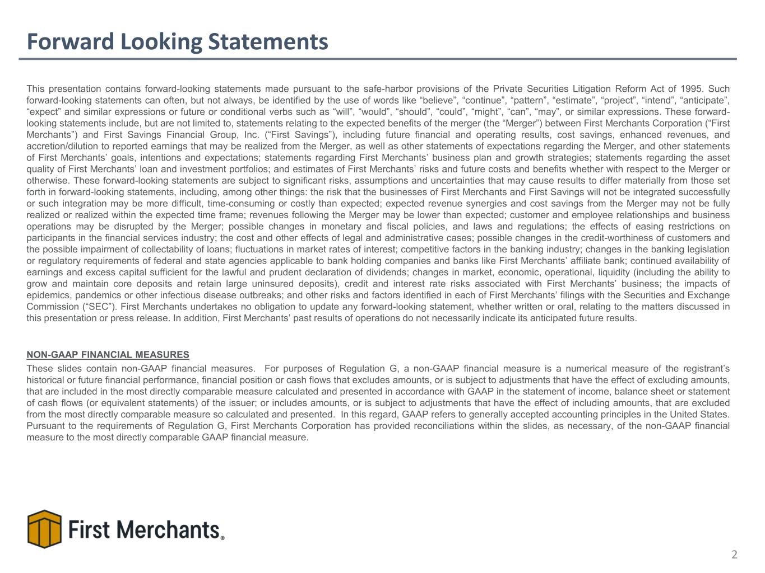
Forward Looking Statements This presentation contains forward-looking statements made pursuant to the safe-harbor provisions of the Private Securities Litigation Reform Act of 1995. Such forward-looking statements can often, but not always, be identified by the use of words like “believe”, “continue”, “pattern”, “estimate”, “project”, “intend”, “anticipate”, “expect” and similar expressions or future or conditional verbs such as “will”, “would”, “should”, “could”, “might”, “can”, “may”, or similar expressions. These forward- looking statements include, but are not limited to, statements relating to the expected benefits of the merger (the “Merger”) between First Merchants Corporation (“First Merchants”) and First Savings Financial Group, Inc. (“First Savings”), including future financial and operating results, cost savings, enhanced revenues, and accretion/dilution to reported earnings that may be realized from the Merger, as well as other statements of expectations regarding the Merger, and other statements of First Merchants’ goals, intentions and expectations; statements regarding First Merchants’ business plan and growth strategies; statements regarding the asset quality of First Merchants’ loan and investment portfolios; and estimates of First Merchants’ risks and future costs and benefits whether with respect to the Merger or otherwise. These forward-looking statements are subject to significant risks, assumptions and uncertainties that may cause results to differ materially from those set forth in forward-looking statements, including, among other things: the risk that the businesses of First Merchants and First Savings will not be integrated successfully or such integration may be more difficult, time-consuming or costly than expected; expected revenue synergies and cost savings from the Merger may not be fully realized or realized within the expected time frame; revenues following the Merger may be lower than expected; customer and employee relationships and business operations may be disrupted by the Merger; possible changes in monetary and fiscal policies, and laws and regulations; the effects of easing restrictions on participants in the financial services industry; the cost and other effects of legal and administrative cases; possible changes in the credit-worthiness of customers and the possible impairment of collectability of loans; fluctuations in market rates of interest; competitive factors in the banking industry; changes in the banking legislation or regulatory requirements of federal and state agencies applicable to bank holding companies and banks like First Merchants’ affiliate bank; continued availability of earnings and excess capital sufficient for the lawful and prudent declaration of dividends; changes in market, economic, operational, liquidity (including the ability to grow and maintain core deposits and retain large uninsured deposits), credit and interest rate risks associated with First Merchants’ business; the impacts of epidemics, pandemics or other infectious disease outbreaks; and other risks and factors identified in each of First Merchants’ filings with the Securities and Exchange Commission (“SEC”). First Merchants undertakes no obligation to update any forward-looking statement, whether written or oral, relating to the matters discussed in this presentation or press release. In addition, First Merchants’ past results of operations do not necessarily indicate its anticipated future results. NON-GAAP FINANCIAL MEASURES These slides contain non-GAAP financial measures. For purposes of Regulation G, a non-GAAP financial measure is a numerical measure of the registrant’s historical or future financial performance, financial position or cash flows that excludes amounts, or is subject to adjustments that have the effect of excluding amounts, that are included in the most directly comparable measure calculated and presented in accordance with GAAP in the statement of income, balance sheet or statement of cash flows (or equivalent statements) of the issuer; or includes amounts, or is subject to adjustments that have the effect of including amounts, that are excluded from the most directly comparable measure so calculated and presented. In this regard, GAAP refers to generally accepted accounting principles in the United States. Pursuant to the requirements of Regulation G, First Merchants Corporation has provided reconciliations within the slides, as necessary, of the non-GAAP financial measure to the most directly comparable GAAP financial measure. 2


Executive Management Team 3 Mark Hardwick Chief Executive Officer Mark K. Hardwick currently serves as the Chief Executive Officer of First Merchants Corporation and First Merchants Bank. Mark joined First Merchants in November of 1997 as Corporate Controller and was promoted to Chief Financial Officer in April of 2002. In 2016, Mark’s title expanded to include Chief Operating Officer, overseeing the leadership responsibilities for finance, operations, technology, risk, legal, and facilities for the corporation. Prior to joining First Merchants Corporation, Mark served as a senior accountant with BKD, LLP in Indianapolis. Mark is a graduate of Ball State University with a Master of Business Administration and Bachelor’s degree in Accounting. He is also a certified public accountant and a graduate of the Stonier School of Banking. FMB: 29 Yrs Banking: 29 Yrs FMB: 11 Yrs Banking: 23 Yrs Michele Kawiecki Chief Financial Officer Michele Kawiecki currently serves as Executive Vice President and Chief Financial Officer for First Merchants Corporation and First Merchants Bank. Michele joined First Merchants in 2015 as Director of Finance. Prior to joining First Merchants, Michele spent 12 years with UMB Financial Corporation in Kansas City, Missouri having served as Senior Vice President of Capital Management and Assistant Treasurer; Director of Corporate Development and the Enterprise Project Management Office; and Chief Risk Officer. Prior to UMB, she worked for PricewaterhouseCoopers LLP as an Audit Manager. Michele earned both a Master of Science in Accounting and an Executive Master of Business Administration from the University of Missouri-Kansas City and a Bachelor’s degree in Accounting from Dakota Wesleyan University. FMB: 18 Yrs Banking: 38 Yrs Mike Stewart President Mike Stewart currently serves as President for First Merchants Corporation and First Merchants Bank overseeing the Commercial, Private Wealth, and Consumer Lines of Business for the Bank. Mike joined the bank in 2008 as Chief Banking Officer. Prior to joining First Merchants, Mike spent 18 years with National City Bank in various commercial sales and credit roles. Mike has a Master of Business Administration from Butler University and a Bachelor’s degree in Finance from Millikin University. FMB: 18 Yrs Banking: 36 Yrs John Martin Chief Credit Officer John Martin currently serves as Executive Vice President and Chief Credit Officer of First Merchants Corporation overseeing the Commercial, Small Business and Consumer Credit functions, as well as Bank Operations and the Mortgage Line of Business. Prior to joining First Merchants, John spent 18 years with National City Bank in various sales and senior credit roles. John is a graduate of Indiana University where he earned a Bachelor of Arts in Economics. He also holds a Master of Business Administration in Finance from Case Western Reserve University. Mark Hardwick – 11/03/1997 Mike Stewart - 02/01/2008 1988 Banking Start John Martin – 12/31/2007 Michele Kawiecki – 03/02/2015

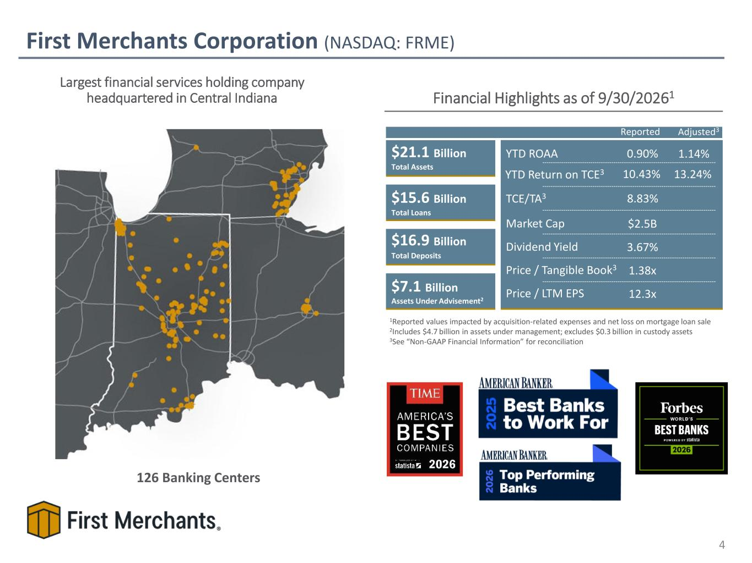
First Merchants Corporation (NASDAQ: FRME) Financial Highlights as of 9/30/20261 $21.1 Billion $15.6 Billion $16.9 Billion $7.1 Billion Assets Under Advisement2 Total Assets Total Loans Total Deposits TCE/TA3 YTD Return on TCE3 YTD ROAA Dividend Yield Price / Tangible Book3 Price / LTM EPS 0.90% 8.83% 10.43% 3.67% 1.38x 12.3x Market Cap $2.5B Largest financial services holding company headquartered in Central Indiana 126 Banking Centers 1Reported values impacted by acquisition-related expenses and net loss on mortgage loan sale 2Includes $4.7 billion in assets under management; excludes $0.3 billion in custody assets 3See “Non-GAAP Financial Information” for reconciliation 4 1.14% 13.24% Reported Adjusted3

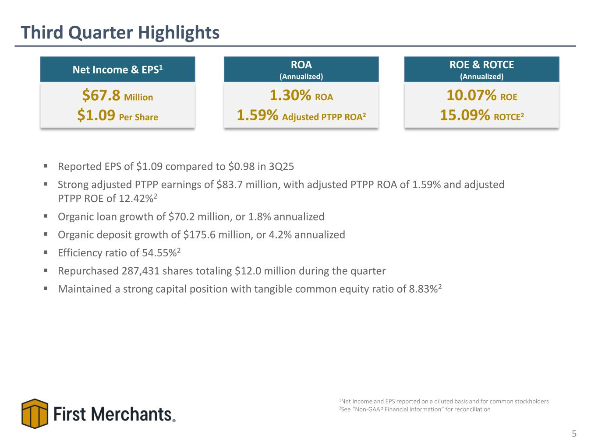
Third Quarter Highlights 5 ▪ Reported EPS of $1.09 compared to $0.98 in 3Q25 ▪ Strong adjusted PTPP earnings of $83.7 million, with adjusted PTPP ROA of 1.59% and adjusted PTPP ROE of 12.42%2 ▪ Organic loan growth of $70.2 million, or 1.8% annualized ▪ Organic deposit growth of $175.6 million, or 4.2% annualized ▪ Efficiency ratio of 54.55%2 ▪ Repurchased 287,431 shares totaling $12.0 million during the quarter ▪ Maintained a strong capital position with tangible common equity ratio of 8.83%2 10.07% ROE 15.09% ROTCE2 ROE & ROTCE (Annualized) $67.8 Million $1.09 Per Share Net Income & EPS1 1Net Income and EPS reported on a diluted basis and for common stockholders 2See “Non-GAAP Financial Information” for reconciliation 1.30% ROA 1.59% Adjusted PTPP ROA2 ROA (Annualized)

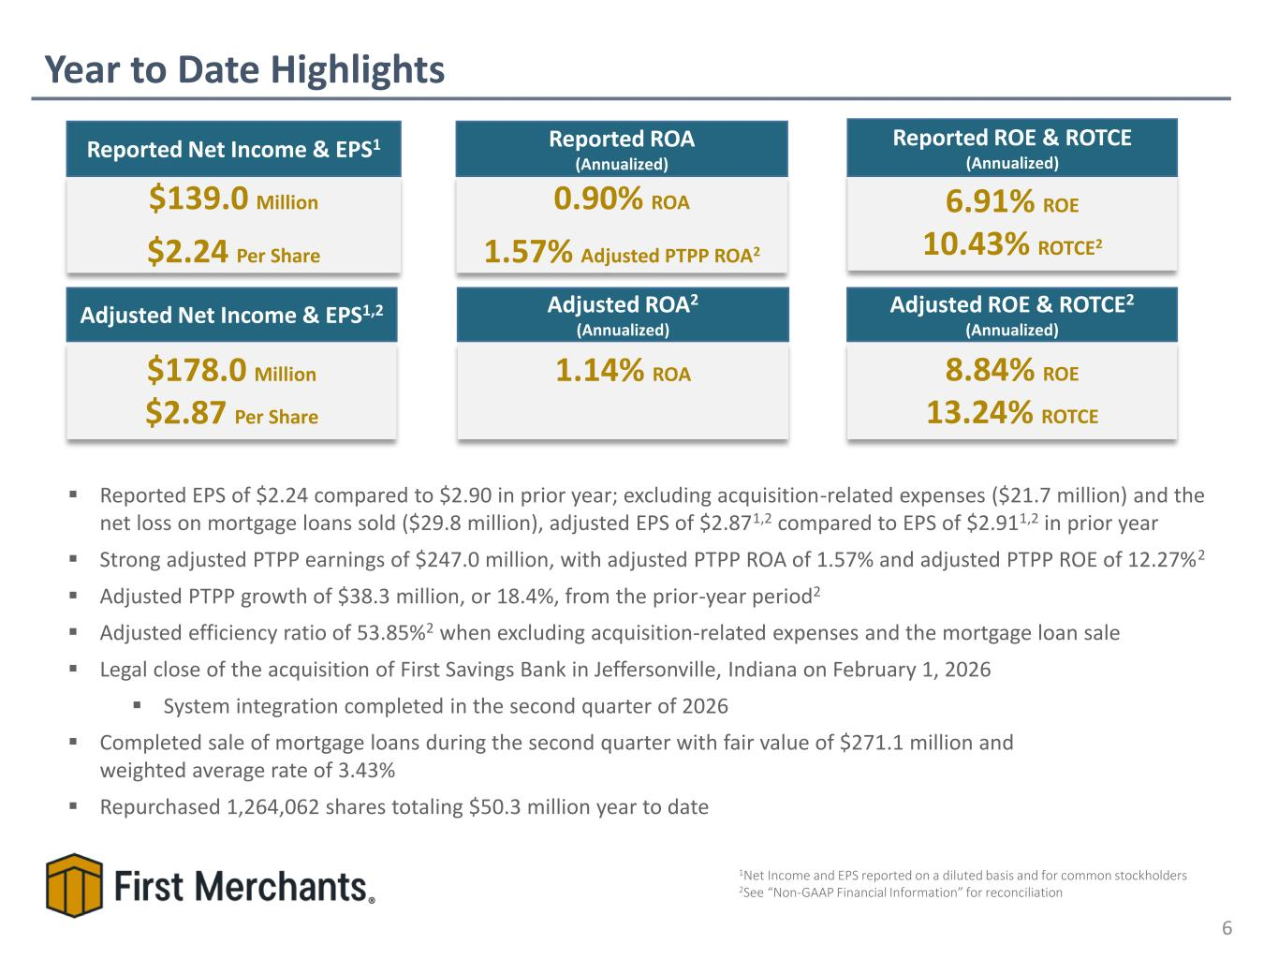
Year to Date Highlights 6 6.91% ROE 10.43% ROTCE2 Reported ROE & ROTCE (Annualized) $139.0 Million $2.24 Per Share Reported Net Income & EPS1 0.90% ROA 1.57% Adjusted PTPP ROA2 Reported ROA (Annualized) ▪ Reported EPS of $2.24 compared to $2.90 in prior year; excluding acquisition-related expenses ($21.7 million) and the net loss on mortgage loans sold ($29.8 million), adjusted EPS of $2.871,2 compared to EPS of $2.911,2 in prior year ▪ Strong adjusted PTPP earnings of $247.0 million, with adjusted PTPP ROA of 1.57% and adjusted PTPP ROE of 12.27%2 ▪ Adjusted PTPP growth of $38.3 million, or 18.4%, from the prior-year period2 ▪ Adjusted efficiency ratio of 53.85%2 when excluding acquisition-related expenses and the mortgage loan sale ▪ Legal close of the acquisition of First Savings Bank in Jeffersonville, Indiana on February 1, 2026 ▪ System integration completed in the second quarter of 2026 ▪ Completed sale of mortgage loans during the second quarter with fair value of $271.1 million and weighted average rate of 3.43% ▪ Repurchased 1,264,062 shares totaling $50.3 million year to date $178.0 Million $2.87 Per Share Adjusted Net Income & EPS1,2 8.84% ROE 13.24% ROTCE Adjusted ROE & ROTCE2 (Annualized) 1.14% ROA Adjusted ROA2 (Annualized) 1Net Income and EPS reported on a diluted basis and for common stockholders 2See “Non-GAAP Financial Information” for reconciliation

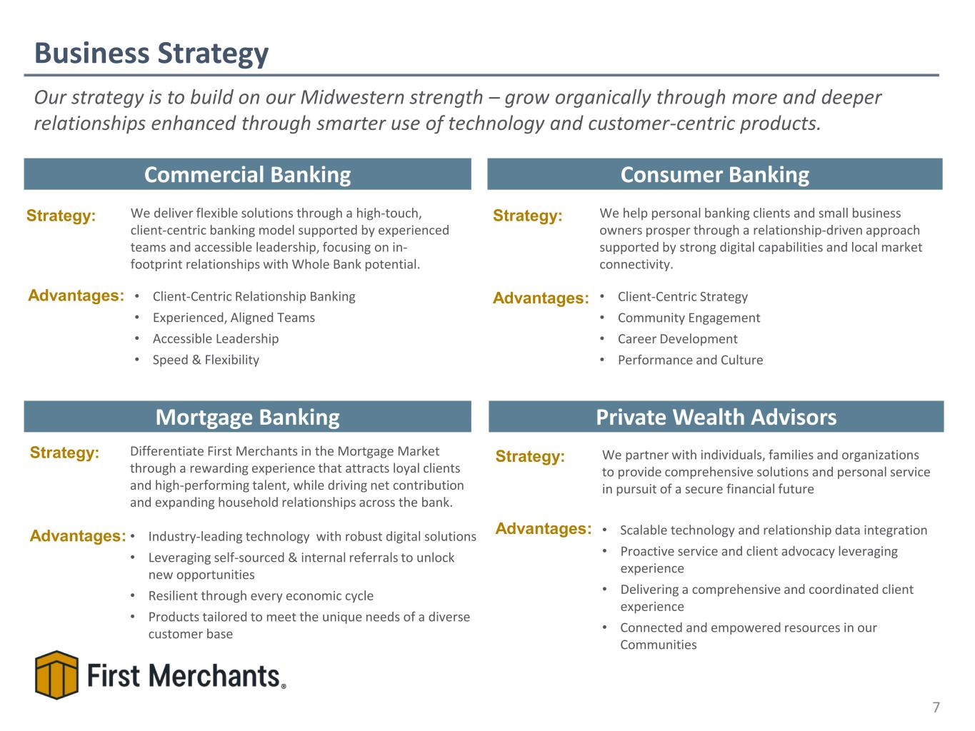
Business Strategy 7 Commercial Banking Private Wealth Advisors Consumer Banking Mortgage Banking Strategy: Advantages: We deliver flexible solutions through a high-touch, client-centric banking model supported by experienced teams and accessible leadership, focusing on in- footprint relationships with Whole Bank potential. • Client-Centric Relationship Banking • Experienced, Aligned Teams • Accessible Leadership • Speed & Flexibility Strategy: We help personal banking clients and small business owners prosper through a relationship-driven approach supported by strong digital capabilities and local market connectivity. • Client-Centric Strategy • Community Engagement • Career Development • Performance and Culture Advantages: Strategy: We partner with individuals, families and organizations to provide comprehensive solutions and personal service in pursuit of a secure financial future • Scalable technology and relationship data integration • Proactive service and client advocacy leveraging experience • Delivering a comprehensive and coordinated client experience • Connected and empowered resources in our Communities Advantages: Strategy: Differentiate First Merchants in the Mortgage Market through a rewarding experience that attracts loyal clients and high-performing talent, while driving net contribution and expanding household relationships across the bank. • Industry-leading technology with robust digital solutions • Leveraging self-sourced & internal referrals to unlock new opportunities • Resilient through every economic cycle • Products tailored to meet the unique needs of a diverse customer base Advantages: Our strategy is to build on our Midwestern strength – grow organically through more and deeper relationships enhanced through smarter use of technology and customer-centric products.

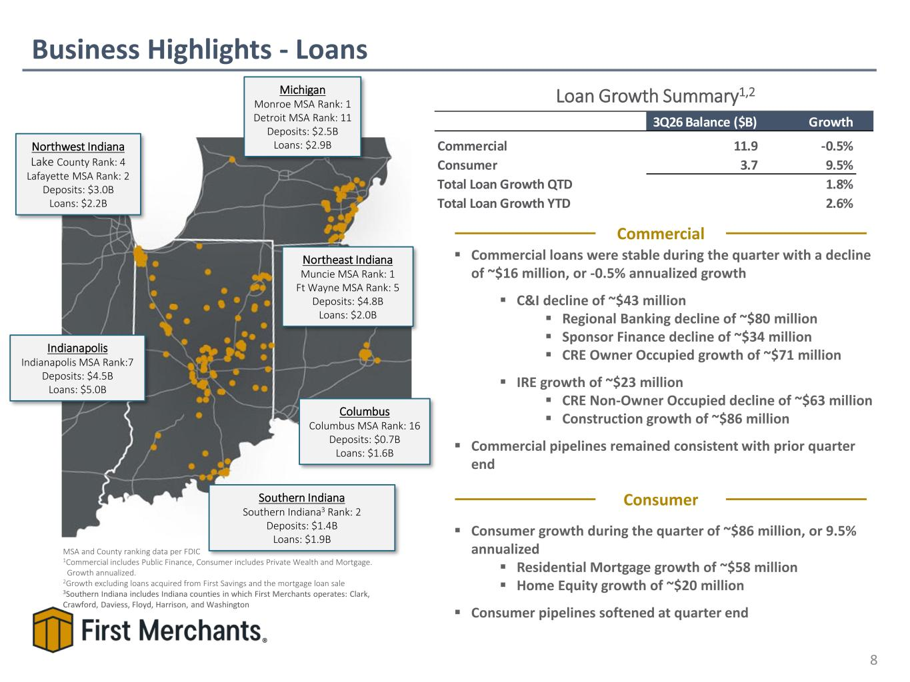
Loan Growth Summary1,2 Business Highlights - Loans 8 MSA and County ranking data per FDIC 1Commercial includes Public Finance, Consumer includes Private Wealth and Mortgage. Growth annualized. 2Growth excluding loans acquired from First Savings and the mortgage loan sale 3Southern Indiana includes Indiana counties in which First Merchants operates: Clark, Crawford, Daviess, Floyd, Harrison, and Washington Indianapolis Indianapolis MSA Rank:7 Deposits: $4.5B Loans: $5.0B Columbus Columbus MSA Rank: 16 Deposits: $0.7B Loans: $1.6B Northwest Indiana Lake County Rank: 4 Lafayette MSA Rank: 2 Deposits: $3.0B Loans: $2.2B Northeast Indiana Muncie MSA Rank: 1 Ft Wayne MSA Rank: 5 Deposits: $4.8B Loans: $2.0B Michigan Monroe MSA Rank: 1 Detroit MSA Rank: 11 Deposits: $2.5B Loans: $2.9B Southern Indiana Southern Indiana3 Rank: 2 Deposits: $1.4B Loans: $1.9B ▪ Commercial loans were stable during the quarter with a decline of ~$16 million, or -0.5% annualized growth ▪ C&I decline of ~$43 million ▪ Regional Banking decline of ~$80 million ▪ Sponsor Finance decline of ~$34 million ▪ CRE Owner Occupied growth of ~$71 million ▪ IRE growth of ~$23 million ▪ CRE Non-Owner Occupied decline of ~$63 million ▪ Construction growth of ~$86 million ▪ Commercial pipelines remained consistent with prior quarter end ▪ Consumer growth during the quarter of ~$86 million, or 9.5% annualized ▪ Residential Mortgage growth of ~$58 million ▪ Home Equity growth of ~$20 million ▪ Consumer pipelines softened at quarter end Commercial Consumer 3Q26 Balance ($B) Growth Commercial 11.9 -0.5% Consumer 3.7 9.5% Total Loan Growth QTD 1.8% Total Loan Growth YTD 2.6%

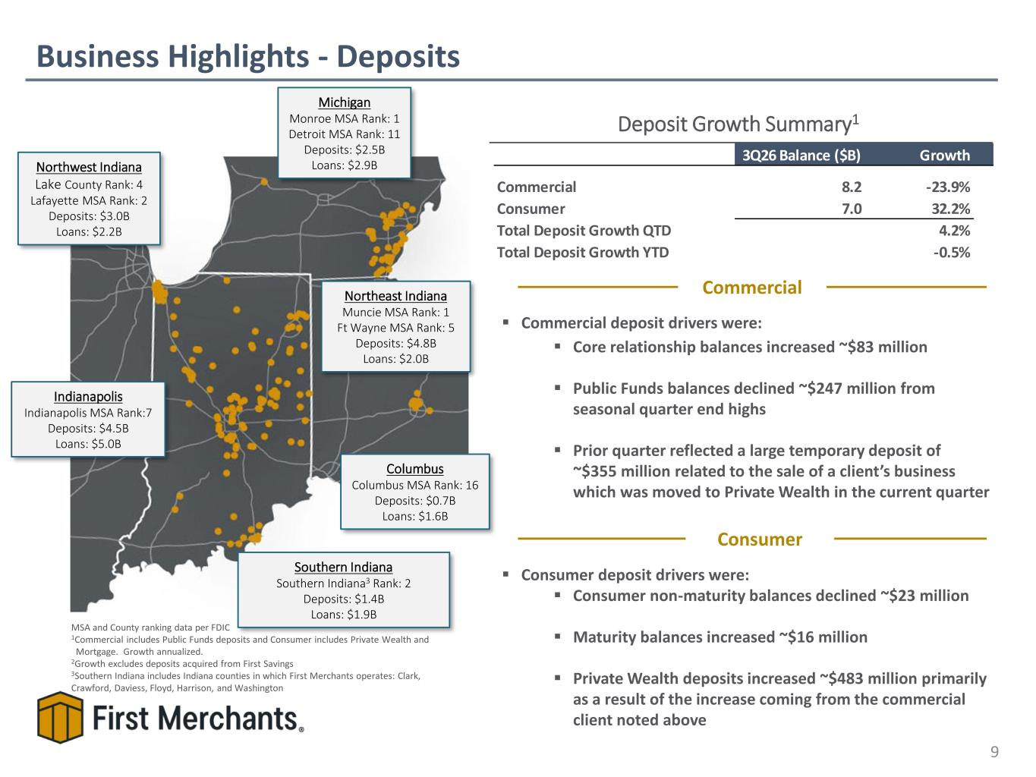
Deposit Growth Summary1 Business Highlights - Deposits 9 MSA and County ranking data per FDIC 1Commercial includes Public Funds deposits and Consumer includes Private Wealth and Mortgage. Growth annualized. 2Growth excludes deposits acquired from First Savings 3Southern Indiana includes Indiana counties in which First Merchants operates: Clark, Crawford, Daviess, Floyd, Harrison, and Washington ▪ Commercial deposit drivers were: ▪ Core relationship balances increased ~$83 million ▪ Public Funds balances declined ~$247 million from seasonal quarter end highs ▪ Prior quarter reflected a large temporary deposit of ~$355 million related to the sale of a client’s business which was moved to Private Wealth in the current quarter ▪ Consumer deposit drivers were: ▪ Consumer non-maturity balances declined ~$23 million ▪ Maturity balances increased ~$16 million ▪ Private Wealth deposits increased ~$483 million primarily as a result of the increase coming from the commercial client noted above Commercial Consumer 3Q26 Balance ($B) Growth Commercial 8.2 -23.9% Consumer 7.0 32.2% Total Deposit Growth QTD 4.2% Total Deposit Growth YTD -0.5% Indianapolis Indianapolis MSA Rank:7 Deposits: $4.5B Loans: $5.0B Columbus Columbus MSA Rank: 16 Deposits: $0.7B Loans: $1.6B Southern Indiana Southern Indiana3 Rank: 2 Deposits: $1.4B Loans: $1.9B Northwest Indiana Lake County Rank: 4 Lafayette MSA Rank: 2 Deposits: $3.0B Loans: $2.2B Northeast Indiana Muncie MSA Rank: 1 Ft Wayne MSA Rank: 5 Deposits: $4.8B Loans: $2.0B Michigan Monroe MSA Rank: 1 Detroit MSA Rank: 11 Deposits: $2.5B Loans: $2.9B

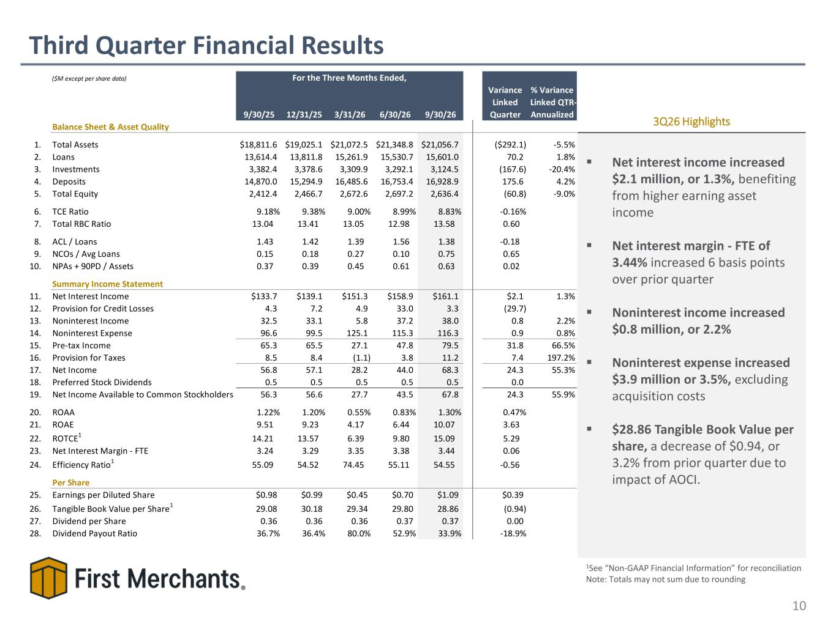
Third Quarter Financial Results 10 ▪ Net interest income increased $2.1 million, or 1.3%, benefiting from higher earning asset income ▪ Net interest margin - FTE of 3.44% increased 6 basis points over prior quarter ▪ Noninterest income increased $0.8 million, or 2.2% ▪ Noninterest expense increased $3.9 million or 3.5%, excluding acquisition costs ▪ $28.86 Tangible Book Value per share, a decrease of $0.94, or 3.2% from prior quarter due to impact of AOCI. 3Q26 Highlights 1See “Non-GAAP Financial Information” for reconciliation Note: Totals may not sum due to rounding ($M except per share data) 9/30/25 12/31/25 3/31/26 6/30/26 9/30/26 Variance Linked Quarter % Variance Linked QTR- Annualized Balance Sheet & Asset Quality 1. Total Assets $18,811.6 $19,025.1 $21,072.5 $21,348.8 $21,056.7 ($292.1) -5.5% 2. Loans 13,614.4 13,811.8 15,261.9 15,530.7 15,601.0 70.2 1.8% 3. Investments 3,382.4 3,378.6 3,309.9 3,292.1 3,124.5 (167.6) -20.4% 4. Deposits 14,870.0 15,294.9 16,485.6 16,753.4 16,928.9 175.6 4.2% 5. Total Equity 2,412.4 2,466.7 2,672.6 2,697.2 2,636.4 (60.8) -9.0% 6. TCE Ratio 9.18% 9.38% 9.00% 8.99% 8.83% -0.16% 7. Total RBC Ratio 13.04 13.41 13.05 12.98 13.58 0.60 8. ACL / Loans 1.43 1.42 1.39 1.56 1.38 -0.18 9. NCOs / Avg Loans 0.15 0.18 0.27 0.10 0.75 0.65 10. NPAs + 90PD / Assets 0.37 0.39 0.45 0.61 0.63 0.02 Summary Income Statement 11. Net Interest Income $133.7 $139.1 $151.3 $158.9 $161.1 $2.1 1.3% 12. Provision for Credit Losses 4.3 7.2 4.9 33.0 3.3 (29.7) 13. Noninterest Income 32.5 33.1 5.8 37.2 38.0 0.8 2.2% 14. Noninterest Expense 96.6 99.5 125.1 115.3 116.3 0.9 0.8% 15. Pre-tax Income 65.3 65.5 27.1 47.8 79.5 31.8 66.5% 16. Provision for Taxes 8.5 8.4 (1.1) 3.8 11.2 7.4 197.2% 17. Net Income 56.8 57.1 28.2 44.0 68.3 24.3 55.3% 18. Preferred Stock Dividends 0.5 0.5 0.5 0.5 0.5 0.0 19. Net Income Available to Common Stockholders 56.3 56.6 27.7 43.5 67.8 24.3 55.9% 20. ROAA 1.22% 1.20% 0.55% 0.83% 1.30% 0.47% 21. ROAE 9.51 9.23 4.17 6.44 10.07 3.63 22. ROTCE1 14.21 13.57 6.39 9.80 15.09 5.29 23. Net Interest Margin - FTE 3.24 3.29 3.35 3.38 3.44 0.06 24. Efficiency Ratio1 55.09 54.52 74.45 55.11 54.55 -0.56 Per Share 25. Earnings per Diluted Share $0.98 $0.99 $0.45 $0.70 $1.09 $0.39 26. Tangible Book Value per Share1 29.08 30.18 29.34 29.80 28.86 (0.94) 27. Dividend per Share 0.36 0.36 0.36 0.37 0.37 0.00 28. Dividend Payout Ratio 36.7% 36.4% 80.0% 52.9% 33.9% -18.9% For the Three Months Ended,

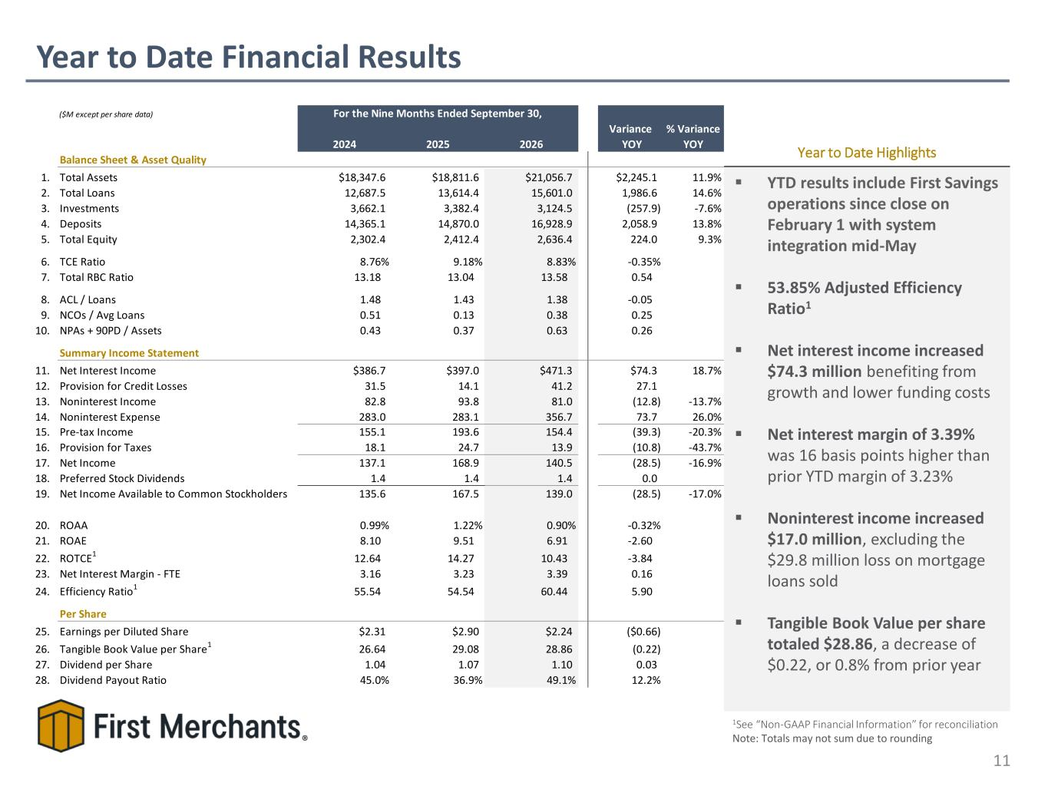
Year to Date Financial Results 11 ▪ YTD results include First Savings operations since close on February 1 with system integration mid-May ▪ 53.85% Adjusted Efficiency Ratio1 ▪ Net interest income increased $74.3 million benefiting from growth and lower funding costs ▪ Net interest margin of 3.39% was 16 basis points higher than prior YTD margin of 3.23% ▪ Noninterest income increased $17.0 million, excluding the $29.8 million loss on mortgage loans sold ▪ Tangible Book Value per share totaled $28.86, a decrease of $0.22, or 0.8% from prior year Year to Date Highlights 1See “Non-GAAP Financial Information” for reconciliation Note: Totals may not sum due to rounding ($M except per share data) 2024 2025 2026 Variance YOY % Variance YOY Balance Sheet & Asset Quality 1. Total Assets $18,347.6 $18,811.6 $21,056.7 $2,245.1 11.9% 2. Total Loans 12,687.5 13,614.4 15,601.0 1,986.6 14.6% 3. Investments 3,662.1 3,382.4 3,124.5 (257.9) -7.6% 4. Deposits 14,365.1 14,870.0 16,928.9 2,058.9 13.8% 5. Total Equity 2,302.4 2,412.4 2,636.4 224.0 9.3% 6. TCE Ratio 8.76% 9.18% 8.83% -0.35% 7. Total RBC Ratio 13.18 13.04 13.58 0.54 8. ACL / Loans 1.48 1.43 1.38 -0.05 9. NCOs / Avg Loans 0.51 0.13 0.38 0.25 10. NPAs + 90PD / Assets 0.43 0.37 0.63 0.26 Summary Income Statement 11. Net Interest Income $386.7 $397.0 $471.3 $74.3 18.7% 12. Provision for Credit Losses 31.5 14.1 41.2 27.1 13. Noninterest Income 82.8 93.8 81.0 (12.8) -13.7% 14. Noninterest Expense 283.0 283.1 356.7 73.7 26.0% 15. Pre-tax Income 155.1 193.6 154.4 (39.3) -20.3% 16. Provision for Taxes 18.1 24.7 13.9 (10.8) -43.7% 17. Net Income 137.1 168.9 140.5 (28.5) -16.9% 18. Preferred Stock Dividends 1.4 1.4 1.4 0.0 19. Net Income Available to Common Stockholders 135.6 167.5 139.0 (28.5) -17.0% 20. ROAA 0.99% 1.22% 0.90% -0.32% 21. ROAE 8.10 9.51 6.91 -2.60 22. ROTCE 1 12.64 14.27 10.43 -3.84 23. Net Interest Margin - FTE 3.16 3.23 3.39 0.16 24. Efficiency Ratio1 55.54 54.54 60.44 5.90 Per Share 25. Earnings per Diluted Share $2.31 $2.90 $2.24 ($0.66) 26. Tangible Book Value per Share1 26.64 29.08 28.86 (0.22) 27. Dividend per Share 1.04 1.07 1.10 0.03 28. Dividend Payout Ratio 45.0% 36.9% 49.1% 12.2% For the Nine Months Ended September 30,

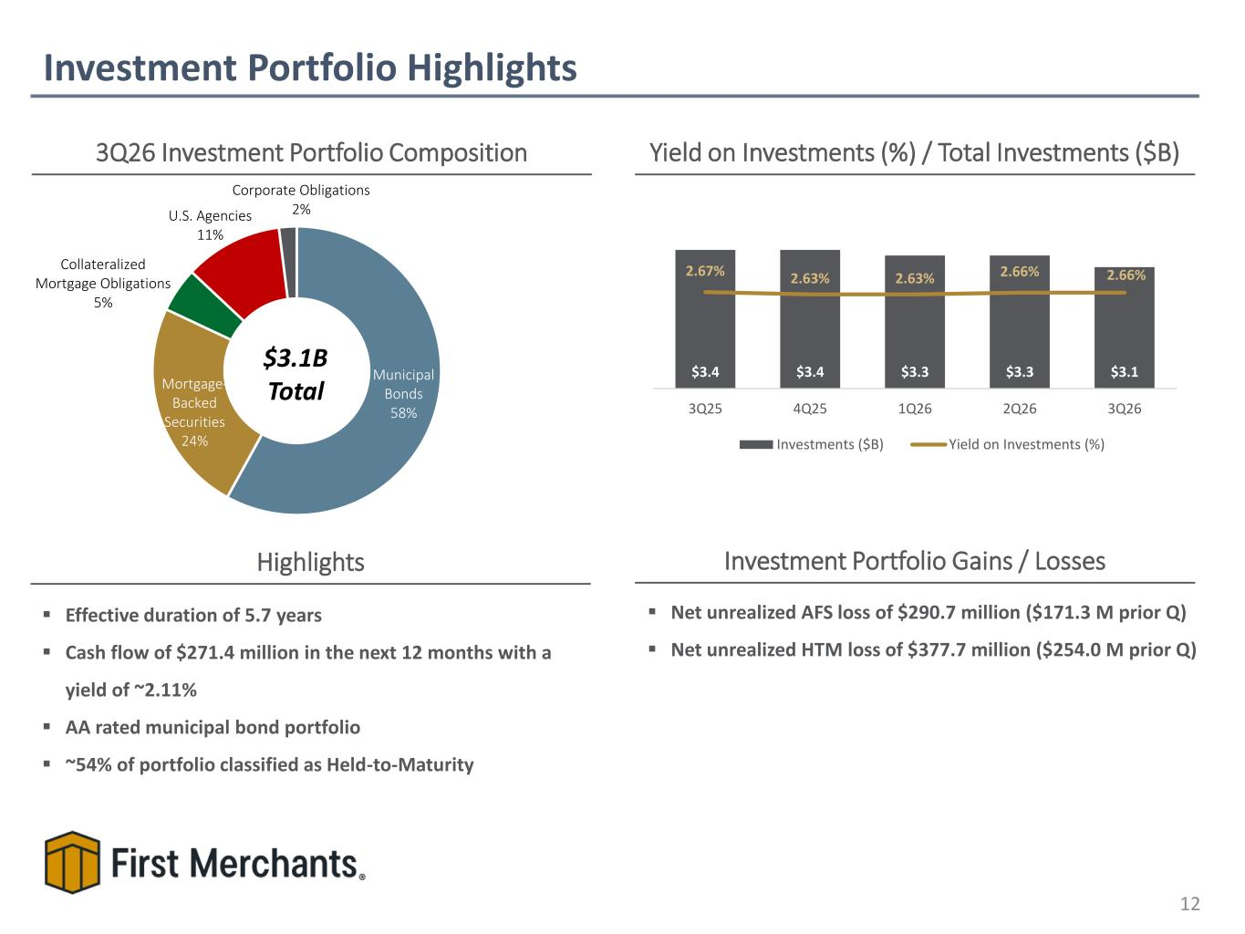
▪ Net unrealized AFS loss of $290.7 million ($171.3 M prior Q) ▪ Net unrealized HTM loss of $377.7 million ($254.0 M prior Q) Investment Portfolio Highlights 12 3Q26 Investment Portfolio Composition Yield on Investments (%) / Total Investments ($B) $3.1B Total Investment Portfolio Gains / LossesHighlights ▪ Effective duration of 5.7 years ▪ Cash flow of $271.4 million in the next 12 months with a yield of ~2.11% ▪ AA rated municipal bond portfolio ▪ ~54% of portfolio classified as Held-to-Maturity Municipal Bonds 58% Mortgage- Backed Securities 24% Collateralized Mortgage Obligations 5% U.S. Agencies 11% Corporate Obligations 2% $3.4 $3.4 $3.3 $3.3 $3.1 2.67% 2.63% 2.63% 2.66% 2.66% 3Q25 4Q25 1Q26 2Q26 3Q26 Investments ($B) Yield on Investments (%)

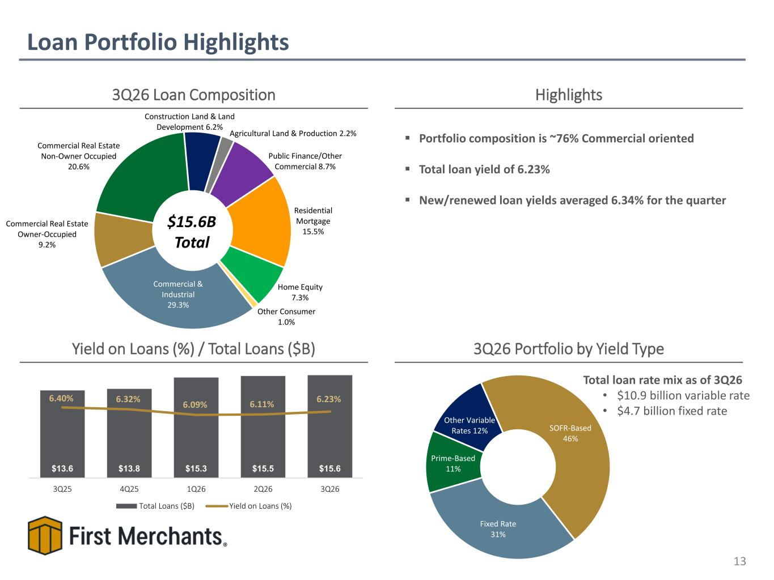
Fixed Rate 31% Prime-Based 11% Other Variable Rates 12% SOFR-Based 46% Loan Portfolio Highlights 13 3Q26 Loan Composition Yield on Loans (%) / Total Loans ($B) $15.6B Total 3Q26 Portfolio by Yield Type Highlights Total loan rate mix as of 3Q26 • $10.9 billion variable rate • $4.7 billion fixed rate ▪ Portfolio composition is ~76% Commercial oriented ▪ Total loan yield of 6.23% ▪ New/renewed loan yields averaged 6.34% for the quarter $0.9 $0.7 $0.7$0.4$0.7$0.7 Commercial & Industrial 29.3% Commercial Real Estate Owner-Occupied 9.2% Commercial Real Estate Non-Owner Occupied 20.6% Construction Land & Land Development 6.2% Agricultural Land & Production 2.2% Public Finance/Other Commercial 8.7% Residential Mortgage 15.5% Home Equity 7.3% Other Consumer 1.0% $13.6 $13.8 $15.3 $15.5 $15.6 6.40% 6.32% 6.09% 6.11% 6.23% 3Q25 4Q25 1Q26 2Q26 3Q26 Total Loans ($B) Yield on Loans (%)

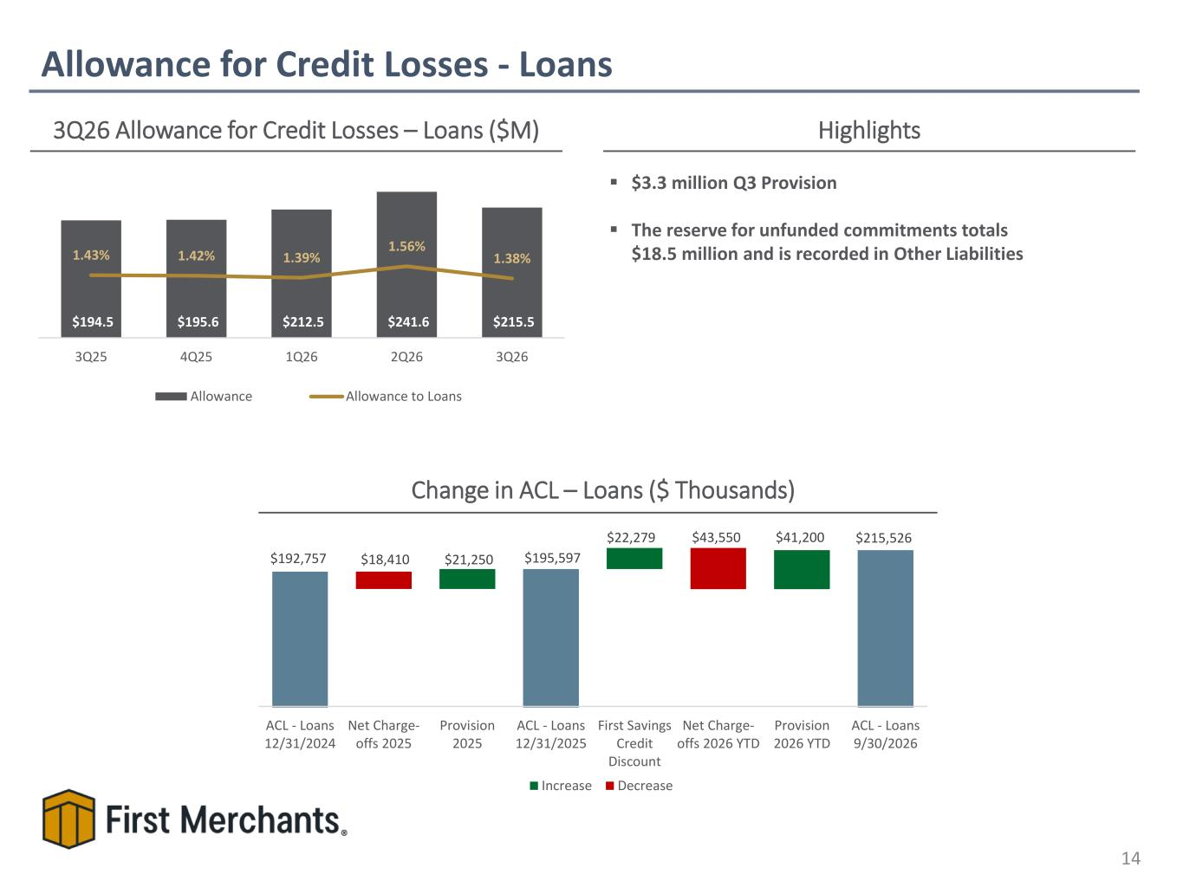
$192,757 $195,597 $215,526 $21,250 $22,279 $41,200 $18,410 $43,550 ACL - Loans 12/31/2024 Net Charge- offs 2025 Provision 2025 ACL - Loans 12/31/2025 First Savings Credit Discount Net Charge- offs 2026 YTD Provision 2026 YTD ACL - Loans 9/30/2026 Increase Decrease Allowance for Credit Losses - Loans 14 3Q26 Allowance for Credit Losses – Loans ($M) Highlights Change in ACL – Loans ($ Thousands) ▪ $3.3 million Q3 Provision ▪ The reserve for unfunded commitments totals $18.5 million and is recorded in Other Liabilities $194.5 $195.6 $212.5 $241.6 $215.5 1.43% 1.42% 1.39% 1.56% 1.38% 3Q25 4Q25 1Q26 2Q26 3Q26 Allowance Allowance to Loans

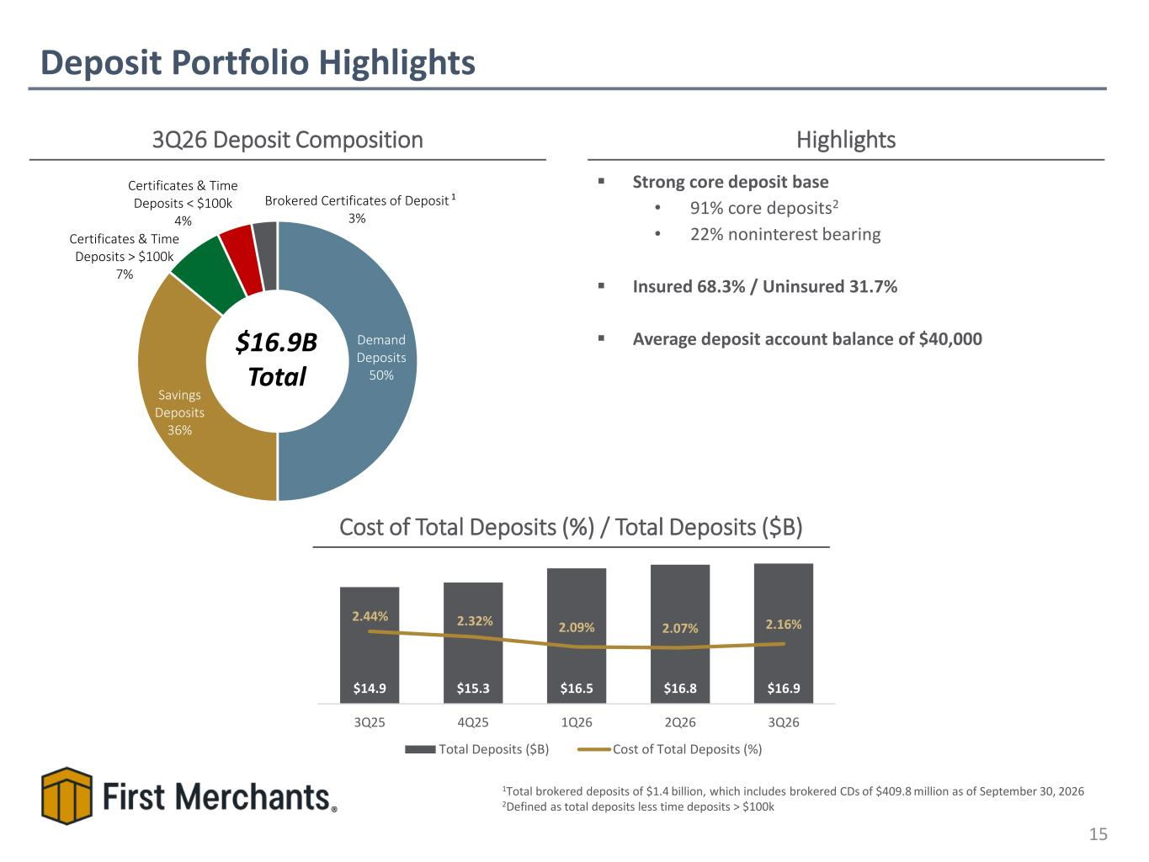
Deposit Portfolio Highlights 15 3Q26 Deposit Composition Highlights $16.9B Total 1Total brokered deposits of $1.4 billion, which includes brokered CDs of $409.8 million as of September 30, 2026 2Defined as total deposits less time deposits > $100k Cost of Total Deposits (%) / Total Deposits ($B) ▪ Strong core deposit base • 91% core deposits2 • 22% noninterest bearing ▪ Insured 68.3% / Uninsured 31.7% ▪ Average deposit account balance of $40,000 1 Demand Deposits 50% Savings Deposits 36% Certificates & Time Deposits > $100k 7% Certificates & Time Deposits < $100k 4% Brokered Certificates of Deposit 3% $14.9 $15.3 $16.5 $16.8 $16.9 2.44% 2.32% 2.09% 2.07% 2.16% 3Q25 4Q25 1Q26 2Q26 3Q26 Total Deposits ($B) Cost of Total Deposits (%)

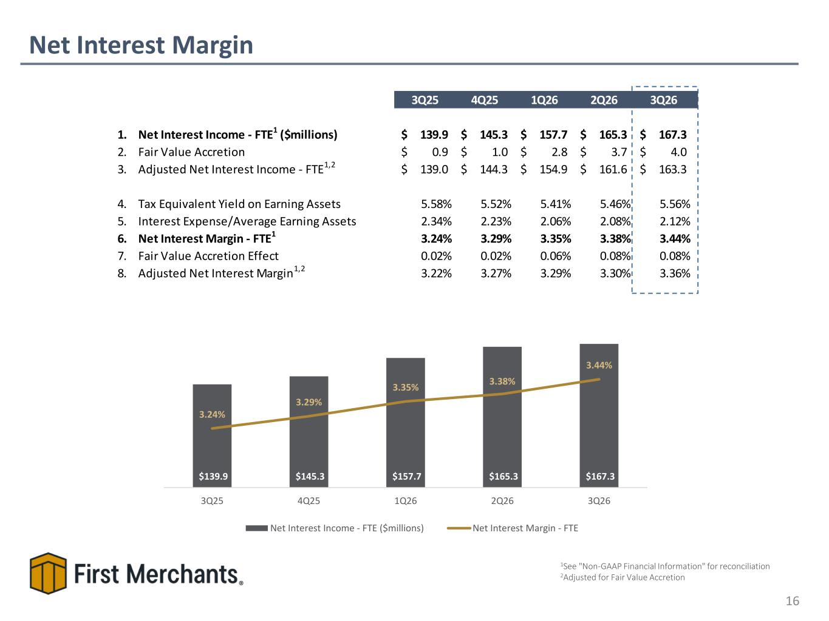
Net Interest Margin 16 $105.1$97.1 $97.3 $105.1 $107.0$97.8 $107.0 $97.3 $105.1 $110.0$109.2 $107.0 $105.1 $109.2 $110.0 $106.9 1See "Non-GAAP Financial Information" for reconciliation 2Adjusted for Fair Value Accretion $139.9 $145.3 $157.7 $165.3 $167.3 3.24% 3.29% 3.35% 3.38% 3.44% 3Q25 4Q25 1Q26 2Q26 3Q26 Net Interest Income - FTE ($millions) Net Interest Margin - FTE 3Q25 4Q25 1Q26 2Q26 3Q26 1. Net Interest Income - FTE1 ($millions) 139.9$ 145.3$ 157.7$ 165.3$ 167.3$ 2. Fair Value Accretion 0.9$ 1.0$ 2.8$ 3.7$ 4.0$ 3. Adjusted Net Interest Income - FTE1,2 139.0$ 144.3$ 154.9$ 161.6$ 163.3$ 4. Tax Equivalent Yield on Earning Assets 5.58% 5.52% 5.41% 5.46% 5.56% 5. Interest Expense/Average Earning Assets 2.34% 2.23% 2.06% 2.08% 2.12% 6. Net Interest Margin - FTE1 3.24% 3.29% 3.35% 3.38% 3.44% 7. Fair Value Accretion Effect 0.02% 0.02% 0.06% 0.08% 0.08% 8. Adjusted Net Interest Margin1,2 3.22% 3.27% 3.29% 3.30% 3.36%

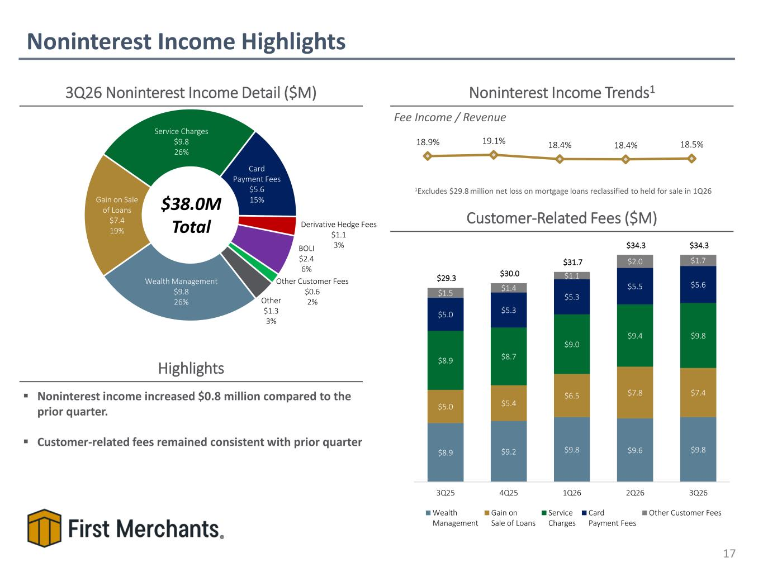
Noninterest Income Highlights 17 3Q26 Noninterest Income Detail ($M) $38.0M Total Noninterest Income Trends1 Fee Income / Revenue Highlights ▪ Noninterest income increased $0.8 million compared to the prior quarter. ▪ Customer-related fees remained consistent with prior quarter Customer-Related Fees ($M) 1Excludes $29.8 million net loss on mortgage loans reclassified to held for sale in 1Q26 18.9% 19.1% 18.4% 18.4% 18.5% $8.9 $9.2 $9.8 $9.6 $9.8 $5.0 $5.4 $6.5 $7.8 $7.4 $8.9 $8.7 $9.0 $9.4 $9.8 $5.0 $5.3 $5.3 $5.5 $5.6 $1.5 $1.4 $1.1 $2.0 $1.7 $29.3 $30.0 $31.7 $34.3 $34.3 3Q25 4Q25 1Q26 2Q26 3Q26 Wealth Management Gain on Sale of Loans Service Charges Card Payment Fees Other Customer Fees Wealth Management $9.8 26% Gain on Sale of Loans $7.4 19% Service Charges $9.8 26% Card Payment Fees $5.6 15% Derivative Hedge Fees $1.1 3%BOLI $2.4 6% Other Customer Fees $0.6 2%Other $1.3 3%

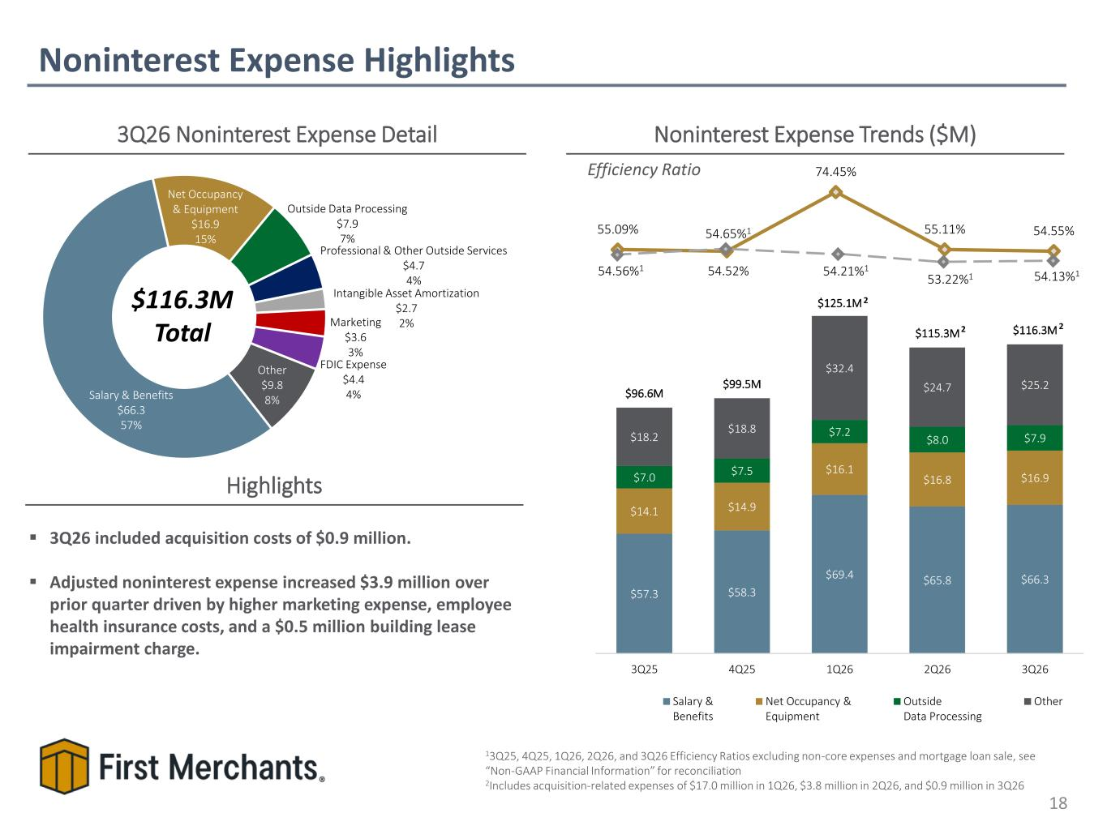
$57.3 $58.3 $69.4 $65.8 $66.3 $14.1 $14.9 $16.1 $16.8 $16.9 $7.0 $7.5 $7.2 $8.0 $7.9 $18.2 $18.8 $32.4 $24.7 $25.2 $96.6M $99.5M $125.1M $115.3M $116.3M 3Q25 4Q25 1Q26 2Q26 3Q26 Salary & Benefits Net Occupancy & Equipment Outside Data Processing Other 55.09% 54.52% 74.45% 55.11% 54.55% Salary & Benefits $66.3 57% Net Occupancy & Equipment $16.9 15% Outside Data Processing $7.9 7% Professional & Other Outside Services $4.7 4% Intangible Asset Amortization $2.7 2%Marketing $3.6 3% FDIC Expense $4.4 4% Other $9.8 8% Noninterest Expense Highlights 18 3Q26 Noninterest Expense Detail $116.3M Total Noninterest Expense Trends ($M) Efficiency Ratio Highlights ▪ 3Q26 included acquisition costs of $0.9 million. ▪ Adjusted noninterest expense increased $3.9 million over prior quarter driven by higher marketing expense, employee health insurance costs, and a $0.5 million building lease impairment charge. 13Q25, 4Q25, 1Q26, 2Q26, and 3Q26 Efficiency Ratios excluding non-core expenses and mortgage loan sale, see “Non-GAAP Financial Information” for reconciliation 2Includes acquisition-related expenses of $17.0 million in 1Q26, $3.8 million in 2Q26, and $0.9 million in 3Q26 54.21%154.56%1 54.65%1 53.22%1 2 2 2 54.13%1

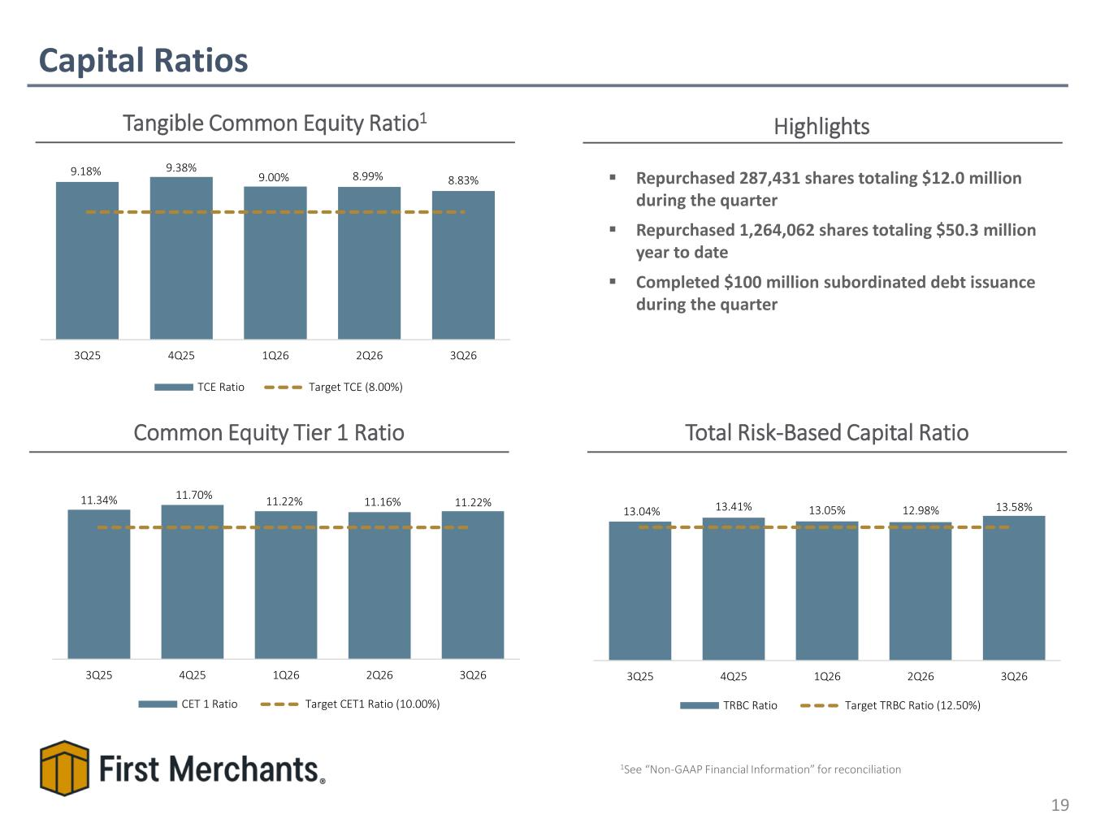
Capital Ratios 19 Tangible Common Equity Ratio1 Common Equity Tier 1 Ratio Total Risk-Based Capital Ratio 9.31% 9.31% 9.57% 9.31% 9.65%9.57%9.31% 9.57% 9.65% ▪ Repurchased 287,431 shares totaling $12.0 million during the quarter ▪ Repurchased 1,264,062 shares totaling $50.3 million year to date ▪ Completed $100 million subordinated debt issuance during the quarter Highlights 9.18% 9.38% 9.00% 8.99% 8.83% 3Q25 4Q25 1Q26 2Q26 3Q26 TCE Ratio Target TCE (8.00%) 1See “Non-GAAP Financial Information” for reconciliation 13.04% 13.41% 13.05% 12.98% 13.58% 3Q25 4Q25 1Q26 2Q26 3Q26 TRBC Ratio Target TRBC Ratio (12.50%) 11.34% 11.70% 11.22% 11.16% 11.22% 3Q25 4Q25 1Q26 2Q26 3Q26 CET 1 Ratio Target CET1 Ratio (10.00%)

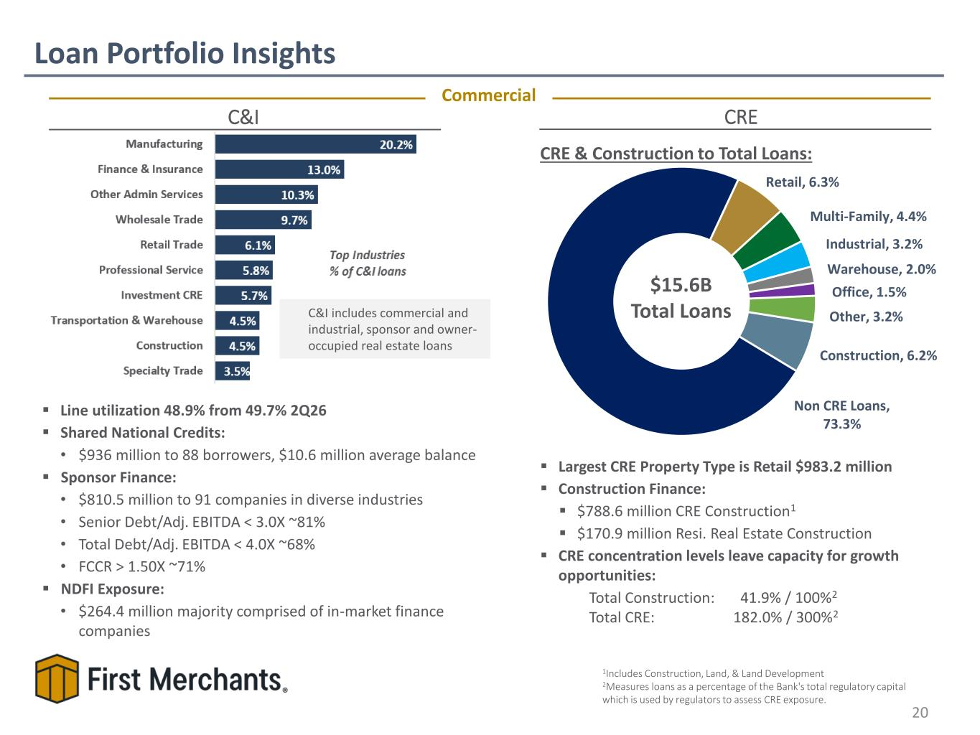
▪ Largest CRE Property Type is Retail $983.2 million ▪ Construction Finance: ▪ $788.6 million CRE Construction1 ▪ $170.9 million Resi. Real Estate Construction ▪ CRE concentration levels leave capacity for growth opportunities: Total Construction: 41.9% / 100%2 Total CRE: 182.0% / 300%2 C&I includes commercial and industrial, sponsor and owner- occupied real estate loans CRE ▪ Line utilization 48.9% from 49.7% 2Q26 ▪ Shared National Credits: • $936 million to 88 borrowers, $10.6 million average balance ▪ Sponsor Finance: • $810.5 million to 91 companies in diverse industries • Senior Debt/Adj. EBITDA < 3.0X ~81% • Total Debt/Adj. EBITDA < 4.0X ~68% • FCCR > 1.50X ~71% ▪ NDFI Exposure:​ • $264.4 million majority comprised of in-market finance companies Loan Portfolio Insights 20 C&I Commercial CRE & Construction to Total Loans: 1Includes Construction, Land, & Land Development 2Measures loans as a percentage of the Bank's total regulatory capital which is used by regulators to assess CRE exposure. $15.6B Total Loans Retail, 6.3% Multi-Family, 4.4% Industrial, 3.2% Warehouse, 2.0% Office, 1.5% Other, 3.2% Construction, 6.2% Non CRE Loans, 73.3%

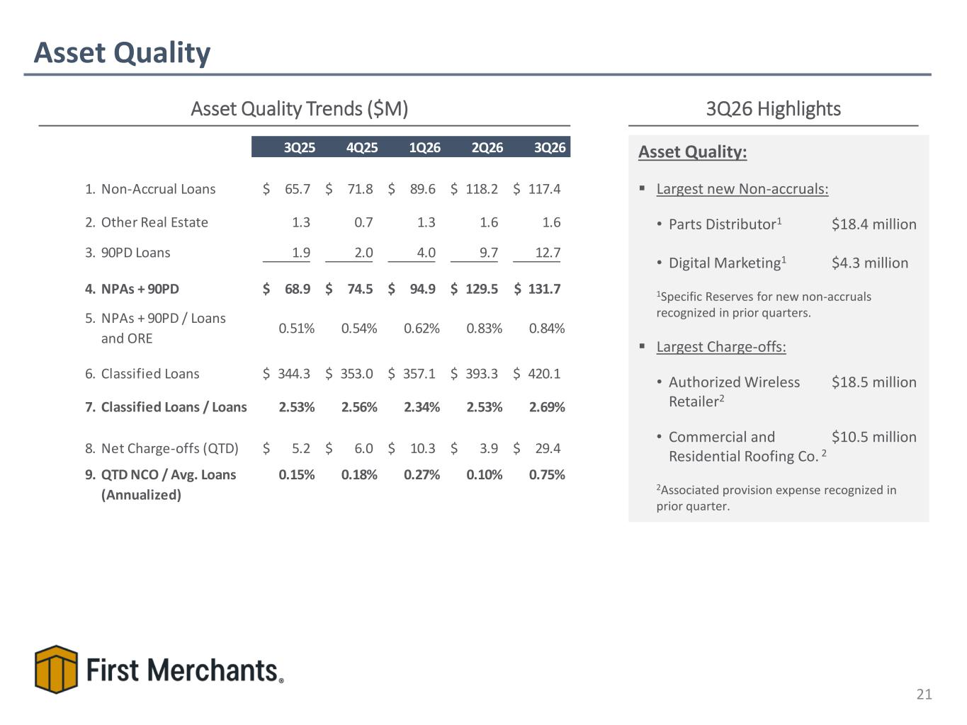
Asset Quality 21 Asset Quality Trends ($M) 3Q26 Highlights Asset Quality: ▪ Largest new Non-accruals: • Parts Distributor1 $18.4 million • Digital Marketing1 $4.3 million 1Specific Reserves for new non-accruals recognized in prior quarters. ▪ Largest Charge-offs: • Authorized Wireless $18.5 million Retailer2 • Commercial and $10.5 million Residential Roofing Co. 2 2Associated provision expense recognized in prior quarter. 3Q25 4Q25 1Q26 2Q26 3Q26 1. Non-Accrual Loans 65.7$ 71.8$ 89.6$ 118.2$ 117.4$ 2. Other Real Estate 1.3 0.7 1.3 1.6 1.6 3. 90PD Loans 1.9 2.0 4.0 9.7 12.7 4. NPAs + 90PD 68.9$ 74.5$ 94.9$ 129.5$ 131.7$ 5. NPAs + 90PD / Loans and ORE 0.51% 0.54% 0.62% 0.83% 0.84% 6. Classified Loans 344.3$ 353.0$ 357.1$ 393.3$ 420.1$ 7. Classified Loans / Loans 2.53% 2.56% 2.34% 2.53% 2.69% 8. Net Charge-offs (QTD) 5.2$ 6.0$ 10.3$ 3.9$ 29.4$ 9. QTD NCO / Avg. Loans (Annualized) 0.15% 0.18% 0.27% 0.10% 0.75%

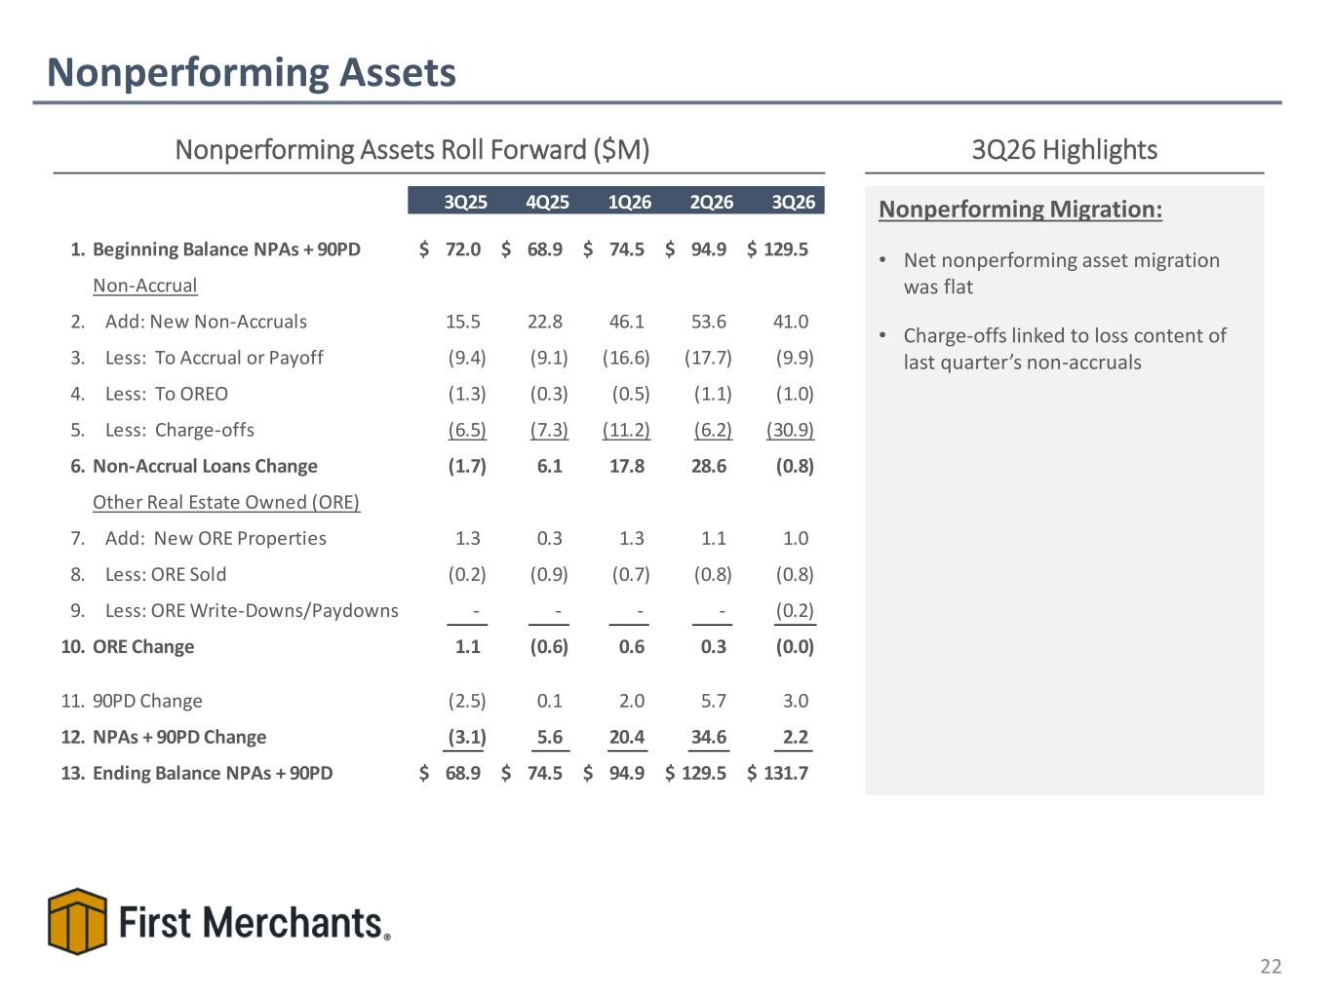
Nonperforming Assets 22 Nonperforming Assets Roll Forward ($M) 3Q26 Highlights Nonperforming Migration: • Net nonperforming asset migration was flat • Charge-offs linked to loss content of last quarter’s non-accruals 3Q25 4Q25 1Q26 2Q26 3Q26 1. Beginning Balance NPAs + 90PD 72.0$ 68.9$ 74.5$ 94.9$ 129.5$ Non-Accrual 2. Add: New Non-Accruals 15.5 22.8 46.1 53.6 41.0 3. Less: To Accrual or Payoff (9.4) (9.1) (16.6) (17.7) (9.9) 4. Less: To OREO (1.3) (0.3) (0.5) (1.1) (1.0) 5. Less: Charge-offs (6.5) (7.3) (11.2) (6.2) (30.9) 6. Non-Accrual Loans Change (1.7) 6.1 17.8 28.6 (0.8) Other Real Estate Owned (ORE) 7. Add: New ORE Properties 1.3 0.3 1.3 1.1 1.0 8. Less: ORE Sold (0.2) (0.9) (0.7) (0.8) (0.8) 9. Less: ORE Write-Downs/Paydowns - - - - (0.2) 10. ORE Change 1.1 (0.6) 0.6 0.3 (0.0) 11. 90PD Change (2.5) 0.1 2.0 5.7 3.0 12. NPAs + 90PD Change (3.1) 5.6 20.4 34.6 2.2 13. Ending Balance NPAs + 90PD 68.9$ 74.5$ 94.9$ 129.5$ 131.7$

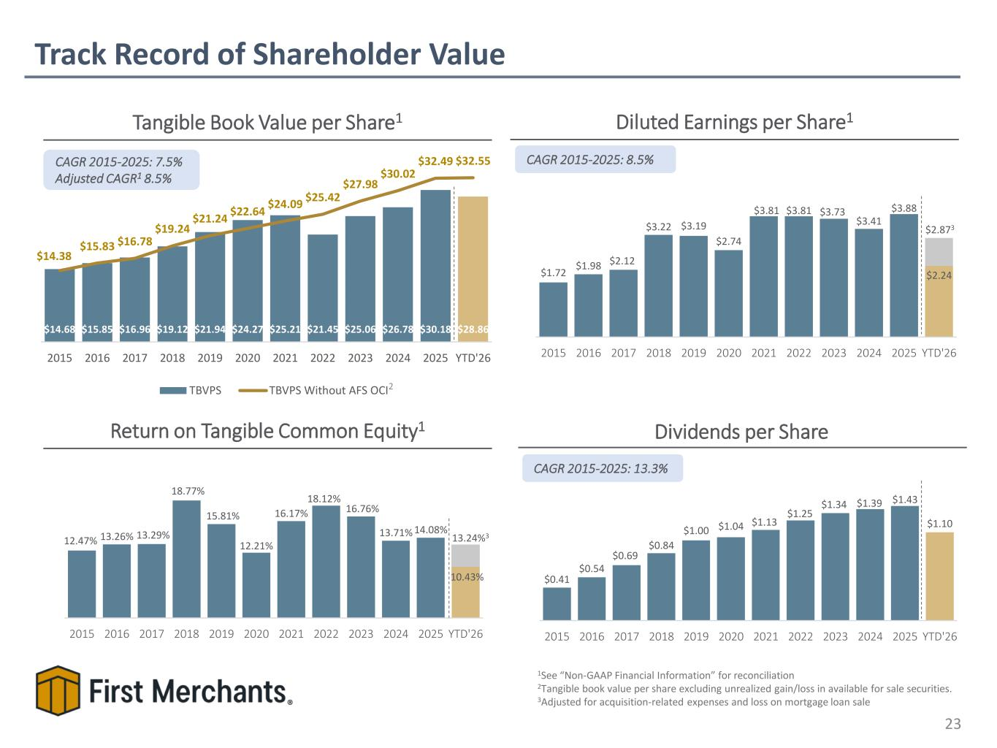
$1.72 $1.98 $2.12 $3.22 $3.19 $2.74 $3.81 $3.81 $3.73 $3.41 $3.88 $2.24 2015 2016 2017 2018 2019 2020 2021 2022 2023 2024 2025 YTD'26 12.47% 13.26% 13.29% 18.77% 15.81% 12.21% 16.17% 18.12% 16.76% 13.71% 14.08% 10.43% 2015 2016 2017 2018 2019 2020 2021 2022 2023 2024 2025 YTD'26 $14.68 $15.85 $16.96 $19.12 $21.94 $24.27 $25.21 $21.45 $25.06 $26.78 $30.18 $28.86 $14.38 $15.83 $16.78 $19.24 $21.24 $22.64 $24.09 $25.42 $27.98 $30.02 $32.49 $32.55 2015 2016 2017 2018 2019 2020 2021 2022 2023 2024 2025 YTD'26 TBVPS TBVPS Without AFS OCI Track Record of Shareholder Value 23 Diluted Earnings per Share1Tangible Book Value per Share1 Dividends per Share CAGR 2015-2025: 8.5% Return on Tangible Common Equity1 1See “Non-GAAP Financial Information” for reconciliation 2Tangible book value per share excluding unrealized gain/loss in available for sale securities. 3Adjusted for acquisition-related expenses and loss on mortgage loan sale CAGR 2015-2025: 13.3% 2 CAGR 2015-2025: 7.5% Adjusted CAGR1 8.5% 13.24%3 $2.873 $0.41 $0.54 $0.69 $0.84 $1.00 $1.04 $1.13 $1.25 $1.34 $1.39 $1.43 $1.10 2015 2016 2017 2018 2019 2020 2021 2022 2023 2024 2025 YTD'26

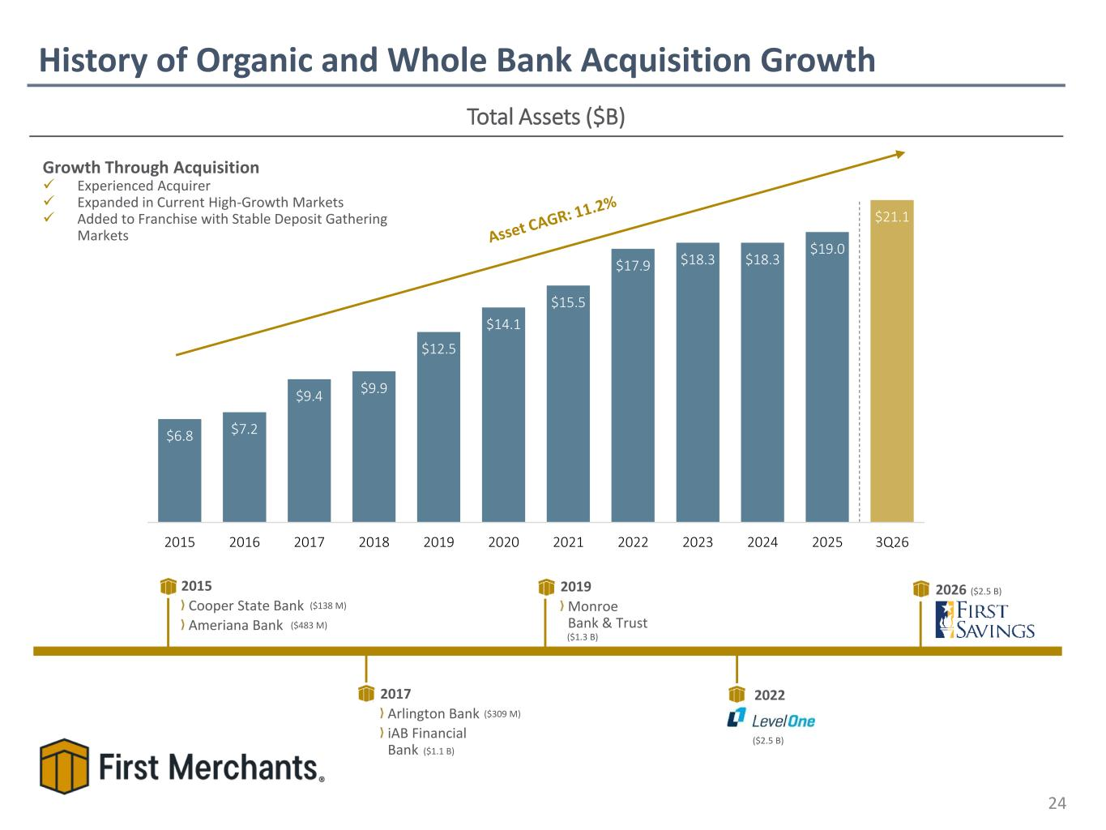
History of Organic and Whole Bank Acquisition Growth 24 Total Assets ($B) Growth Through Acquisition ✓ Experienced Acquirer ✓ Expanded in Current High-Growth Markets ✓ Added to Franchise with Stable Deposit Gathering Markets 2015 Cooper State Bank Ameriana Bank 2017 Arlington Bank iAB Financial Bank 2019 Monroe Bank & Trust 2022 ($309 M) ($138 M) ($2.5 B) ($1.3 B) ($483 M) ($1.1 B) 2026 ($2.5 B) $6.8 $7.2 $9.4 $9.9 $12.5 $14.1 $15.5 $17.9 $18.3 $18.3 $19.0 $21.1 2015 2016 2017 2018 2019 2020 2021 2022 2023 2024 2025 3Q26

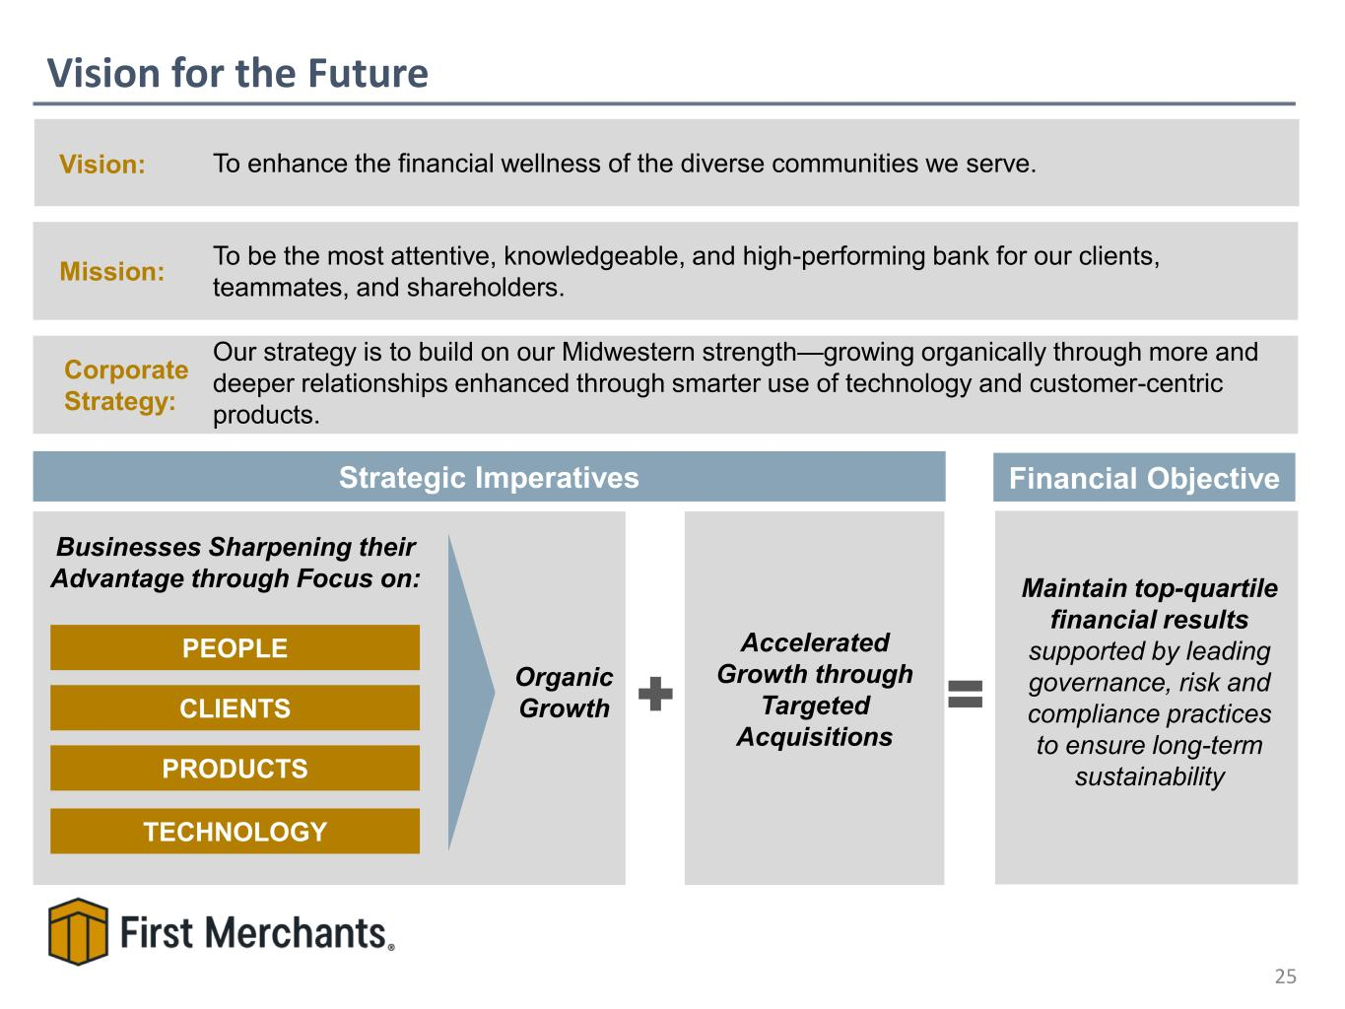
Vision for the Future 25 Mission: To be the most attentive, knowledgeable, and high-performing bank for our clients, teammates, and shareholders. Strategic Imperatives Vision: To enhance the financial wellness of the diverse communities we serve. PEOPLE CLIENTS PRODUCTS TECHNOLOGY Businesses Sharpening their Advantage through Focus on: Accelerated Growth through Targeted Acquisitions Organic Growth Maintain top-quartile financial results supported by leading governance, risk and compliance practices to ensure long-term sustainability Financial Objective Corporate Strategy: Our strategy is to build on our Midwestern strength—growing organically through more and deeper relationships enhanced through smarter use of technology and customer-centric products.

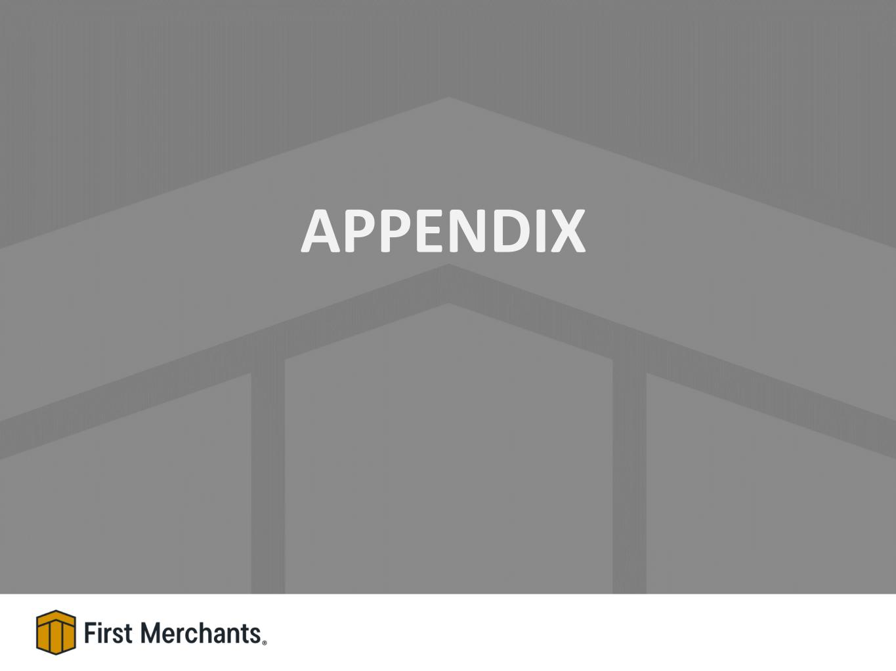
APPENDIX

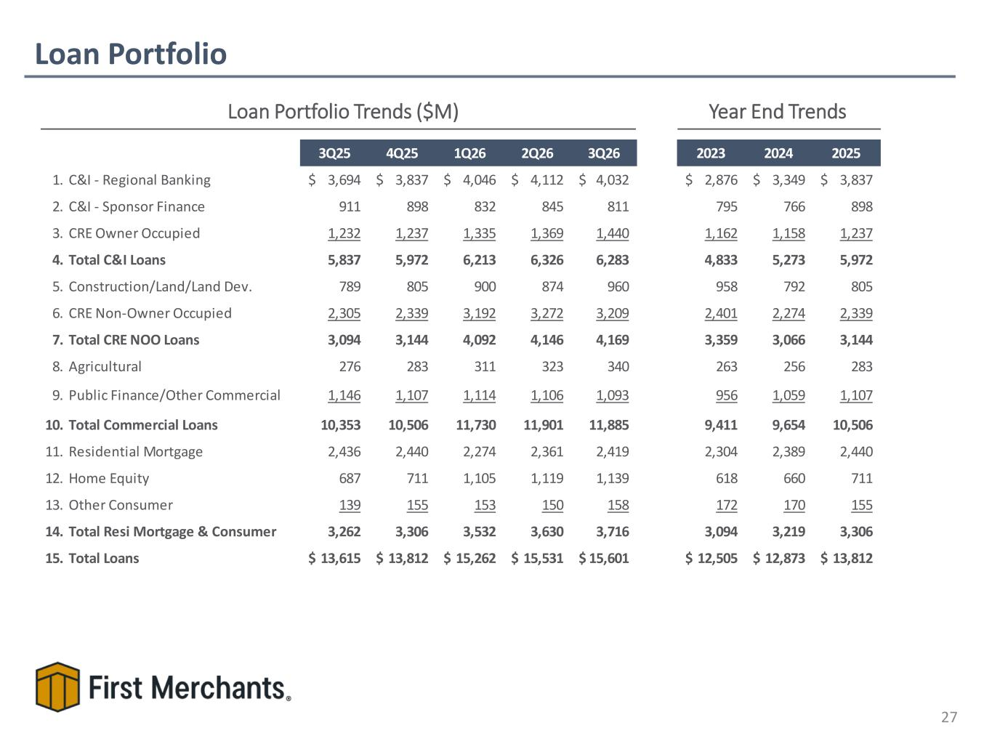
Loan Portfolio 27 Loan Portfolio Trends ($M) Year End Trends 3Q25 4Q25 1Q26 2Q26 3Q26 2023 2024 2025 1. C&I - Regional Banking 3,694$ 3,837$ 4,046$ 4,112$ 4,032$ 2,876$ 3,349$ 3,837$ 2. C&I - Sponsor Finance 911 898 832 845 811 795 766 898 3. CRE Owner Occupied 1,232 1,237 1,335 1,369 1,440 1,162 1,158 1,237 4. Total C&I Loans 5,837 5,972 6,213 6,326 6,283 4,833 5,273 5,972 5. Construction/Land/Land Dev. 789 805 900 874 960 958 792 805 6. CRE Non-Owner Occupied 2,305 2,339 3,192 3,272 3,209 2,401 2,274 2,339 7. Total CRE NOO Loans 3,094 3,144 4,092 4,146 4,169 3,359 3,066 3,144 8. Agricultural 276 283 311 323 340 263 256 283 9. Public Finance/Other Commercial 1,146 1,107 1,114 1,106 1,093 956 1,059 1,107 10. Total Commercial Loans 10,353 10,506 11,730 11,901 11,885 9,411 9,654 10,506 11. Residential Mortgage 2,436 2,440 2,274 2,361 2,419 2,304 2,389 2,440 12. Home Equity 687 711 1,105 1,119 1,139 618 660 711 13. Other Consumer 139 155 153 150 158 172 170 155 14. Total Resi Mortgage & Consumer 3,262 3,306 3,532 3,630 3,716 3,094 3,219 3,306 15. Total Loans 13,615$ 13,812$ 15,262$ 15,531$ 15,601$ 12,505$ 12,873$ 13,812$

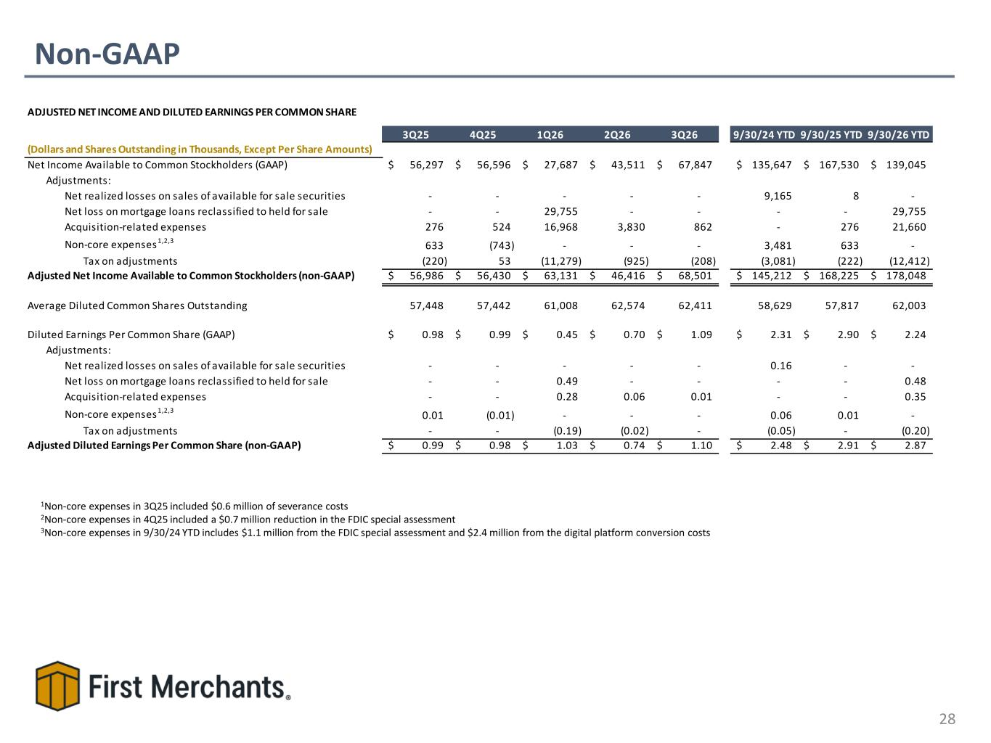
Non-GAAP 28 1Non-core expenses in 3Q25 included $0.6 million of severance costs 2Non-core expenses in 4Q25 included a $0.7 million reduction in the FDIC special assessment 3Non-core expenses in 9/30/24 YTD includes $1.1 million from the FDIC special assessment and $2.4 million from the digital platform conversion costs ADJUSTED NET INCOME AND DILUTED EARNINGS PER COMMON SHARE 3Q25 4Q25 1Q26 2Q26 3Q26 9/30/24 YTD 9/30/25 YTD 9/30/26 YTD (Dollars and Shares Outstanding in Thousands, Except Per Share Amounts) Net Income Available to Common Stockholders (GAAP) 56,297$ 56,596$ 27,687$ 43,511$ 67,847$ 135,647$ 167,530$ 139,045$ Adjustments: Net realized losses on sales of available for sale securities - - - - - 9,165 8 - Net loss on mortgage loans reclassified to held for sale - - 29,755 - - - - 29,755 Acquisition-related expenses 276 524 16,968 3,830 862 - 276 21,660 Non-core expenses1,2,3 633 (743) - - - 3,481 633 - Tax on adjustments (220) 53 (11,279) (925) (208) (3,081) (222) (12,412) Adjusted Net Income Available to Common Stockholders (non-GAAP) 56,986$ 56,430$ 63,131$ 46,416$ 68,501$ 145,212$ 168,225$ 178,048$ Average Diluted Common Shares Outstanding 57,448 57,442 61,008 62,574 62,411 58,629 57,817 62,003 Diluted Earnings Per Common Share (GAAP) 0.98$ 0.99$ 0.45$ 0.70$ 1.09$ 2.31$ 2.90$ 2.24$ Adjustments: Net realized losses on sales of available for sale securities - - - - - 0.16 - - Net loss on mortgage loans reclassified to held for sale - - 0.49 - - - - 0.48 Acquisition-related expenses - - 0.28 0.06 0.01 - - 0.35 Non-core expenses1,2,3 0.01 (0.01) - - - 0.06 0.01 - Tax on adjustments - - (0.19) (0.02) - (0.05) - (0.20) Adjusted Diluted Earnings Per Common Share (non-GAAP) 0.99$ 0.98$ 1.03$ 0.74$ 1.10$ 2.48$ 2.91$ 2.87$

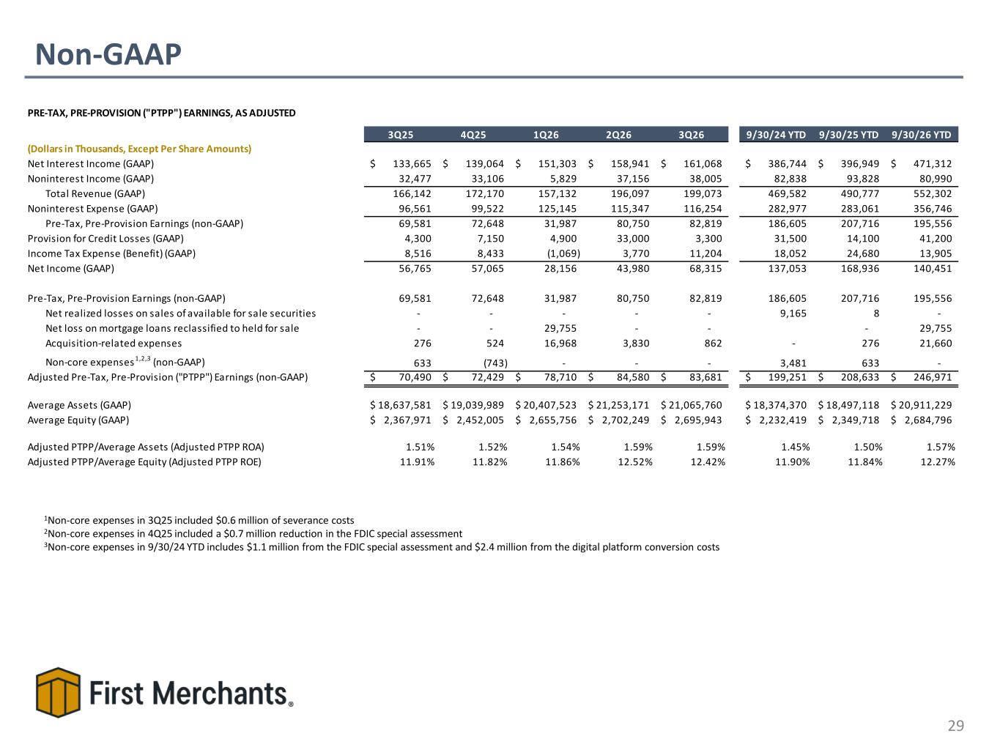
Non-GAAP 29 1Non-core expenses in 3Q25 included $0.6 million of severance costs 2Non-core expenses in 4Q25 included a $0.7 million reduction in the FDIC special assessment 3Non-core expenses in 9/30/24 YTD includes $1.1 million from the FDIC special assessment and $2.4 million from the digital platform conversion costs PRE-TAX, PRE-PROVISION ("PTPP") EARNINGS, AS ADJUSTED 3Q25 4Q25 1Q26 2Q26 3Q26 9/30/24 YTD 9/30/25 YTD 9/30/26 YTD (Dollars in Thousands, Except Per Share Amounts) Net Interest Income (GAAP) 133,665$ 139,064$ 151,303$ 158,941$ 161,068$ 386,744$ 396,949$ 471,312$ Noninterest Income (GAAP) 32,477 33,106 5,829 37,156 38,005 82,838 93,828 80,990 Total Revenue (GAAP) 166,142 172,170 157,132 196,097 199,073 469,582 490,777 552,302 Noninterest Expense (GAAP) 96,561 99,522 125,145 115,347 116,254 282,977 283,061 356,746 Pre-Tax, Pre-Provision Earnings (non-GAAP) 69,581 72,648 31,987 80,750 82,819 186,605 207,716 195,556 Provision for Credit Losses (GAAP) 4,300 7,150 4,900 33,000 3,300 31,500 14,100 41,200 Income Tax Expense (Benefit) (GAAP) 8,516 8,433 (1,069) 3,770 11,204 18,052 24,680 13,905 Net Income (GAAP) 56,765 57,065 28,156 43,980 68,315 137,053 168,936 140,451 Pre-Tax, Pre-Provision Earnings (non-GAAP) 69,581 72,648 31,987 80,750 82,819 186,605 207,716 195,556 Net realized losses on sales of available for sale securities - - - - - 9,165 8 - Net loss on mortgage loans reclassified to held for sale - - 29,755 - - - 29,755 Acquisition-related expenses 276 524 16,968 3,830 862 - 276 21,660 Non-core expenses1,2,3 (non-GAAP) 633 (743) - - - 3,481 633 - Adjusted Pre-Tax, Pre-Provision ("PTPP") Earnings (non-GAAP) 70,490$ 72,429$ 78,710$ 84,580$ 83,681$ 199,251$ 208,633$ 246,971$ Average Assets (GAAP) 18,637,581$ 19,039,989$ 20,407,523$ 21,253,171$ 21,065,760$ 18,374,370$ 18,497,118$ 20,911,229$ Average Equity (GAAP) 2,367,971$ 2,452,005$ 2,655,756$ 2,702,249$ 2,695,943$ 2,232,419$ 2,349,718$ 2,684,796$ Adjusted PTPP/Average Assets (Adjusted PTPP ROA) 1.51% 1.52% 1.54% 1.59% 1.59% 1.45% 1.50% 1.57% Adjusted PTPP/Average Equity (Adjusted PTPP ROE) 11.91% 11.82% 11.86% 12.52% 12.42% 11.90% 11.84% 12.27%

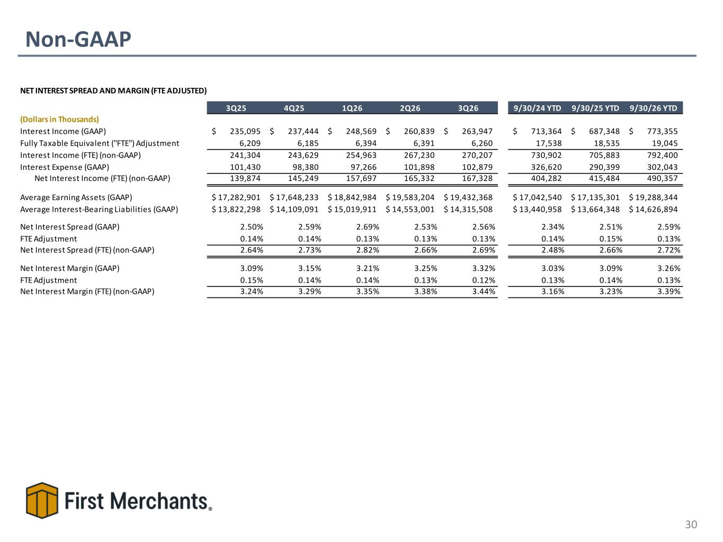
Non-GAAP 30 NET INTEREST SPREAD AND MARGIN (FTE ADJUSTED) 3Q25 4Q25 1Q26 2Q26 3Q26 9/30/24 YTD 9/30/25 YTD 9/30/26 YTD (Dollars in Thousands) Interest Income (GAAP) 235,095$ 237,444$ 248,569$ 260,839$ 263,947$ 713,364$ 687,348$ 773,355$ Fully Taxable Equivalent ("FTE") Adjustment 6,209 6,185 6,394 6,391 6,260 17,538 18,535 19,045 Interest Income (FTE) (non-GAAP) 241,304 243,629 254,963 267,230 270,207 730,902 705,883 792,400 Interest Expense (GAAP) 101,430 98,380 97,266 101,898 102,879 326,620 290,399 302,043 Net Interest Income (FTE) (non-GAAP) 139,874 145,249 157,697 165,332 167,328 404,282 415,484 490,357 Average Earning Assets (GAAP) 17,282,901$ 17,648,233$ 18,842,984$ 19,583,204$ 19,432,368$ 17,042,540$ 17,135,301$ 19,288,344$ Average Interest-Bearing Liabilities (GAAP) 13,822,298$ 14,109,091$ 15,019,911$ 14,553,001$ 14,315,508$ 13,440,958$ 13,664,348$ 14,626,894$ Net Interest Spread (GAAP) 2.50% 2.59% 2.69% 2.53% 2.56% 2.34% 2.51% 2.59% FTE Adjustment 0.14% 0.14% 0.13% 0.13% 0.13% 0.14% 0.15% 0.13% Net Interest Spread (FTE) (non-GAAP) 2.64% 2.73% 2.82% 2.66% 2.69% 2.48% 2.66% 2.72% Net Interest Margin (GAAP) 3.09% 3.15% 3.21% 3.25% 3.32% 3.03% 3.09% 3.26% FTE Adjustment 0.15% 0.14% 0.14% 0.13% 0.12% 0.13% 0.14% 0.13% Net Interest Margin (FTE) (non-GAAP) 3.24% 3.29% 3.35% 3.38% 3.44% 3.16% 3.23% 3.39%

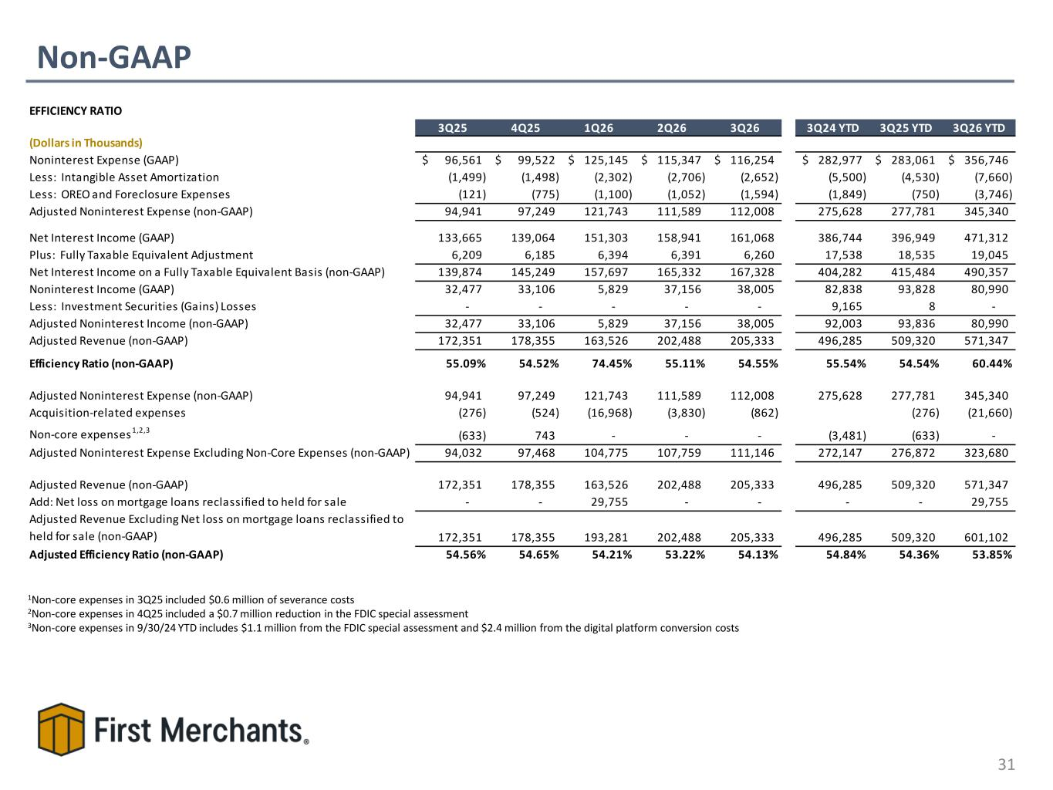
Non-GAAP 31 1Non-core expenses in 3Q25 included $0.6 million of severance costs 2Non-core expenses in 4Q25 included a $0.7 million reduction in the FDIC special assessment 3Non-core expenses in 9/30/24 YTD includes $1.1 million from the FDIC special assessment and $2.4 million from the digital platform conversion costs EFFICIENCY RATIO 3Q25 4Q25 1Q26 2Q26 3Q26 3Q24 YTD 3Q25 YTD 3Q26 YTD (Dollars in Thousands) Noninterest Expense (GAAP) 96,561$ 99,522$ 125,145$ 115,347$ 116,254$ 282,977$ 283,061$ 356,746$ Less: Intangible Asset Amortization (1,499) (1,498) (2,302) (2,706) (2,652) (5,500) (4,530) (7,660) Less: OREO and Foreclosure Expenses (121) (775) (1,100) (1,052) (1,594) (1,849) (750) (3,746) Adjusted Noninterest Expense (non-GAAP) 94,941 97,249 121,743 111,589 112,008 275,628 277,781 345,340 Net Interest Income (GAAP) 133,665 139,064 151,303 158,941 161,068 386,744 396,949 471,312 Plus: Fully Taxable Equivalent Adjustment 6,209 6,185 6,394 6,391 6,260 17,538 18,535 19,045 Net Interest Income on a Fully Taxable Equivalent Basis (non-GAAP) 139,874 145,249 157,697 165,332 167,328 404,282 415,484 490,357 Noninterest Income (GAAP) 32,477 33,106 5,829 37,156 38,005 82,838 93,828 80,990 Less: Investment Securities (Gains) Losses - - - - - 9,165 8 - Adjusted Noninterest Income (non-GAAP) 32,477 33,106 5,829 37,156 38,005 92,003 93,836 80,990 Adjusted Revenue (non-GAAP) 172,351 178,355 163,526 202,488 205,333 496,285 509,320 571,347 Efficiency Ratio (non-GAAP) 55.09% 54.52% 74.45% 55.11% 54.55% 55.54% 54.54% 60.44% Adjusted Noninterest Expense (non-GAAP) 94,941 97,249 121,743 111,589 112,008 275,628 277,781 345,340 Acquisition-related expenses (276) (524) (16,968) (3,830) (862) (276) (21,660) Non-core expenses1,2,3 (633) 743 - - - (3,481) (633) - Adjusted Noninterest Expense Excluding Non-Core Expenses (non-GAAP) 94,032 97,468 104,775 107,759 111,146 272,147 276,872 323,680 Adjusted Revenue (non-GAAP) 172,351 178,355 163,526 202,488 205,333 496,285 509,320 571,347 Add: Net loss on mortgage loans reclassified to held for sale - - 29,755 - - - - 29,755 Adjusted Revenue Excluding Net loss on mortgage loans reclassified to held for sale (non-GAAP) 172,351 178,355 193,281 202,488 205,333 496,285 509,320 601,102 Adjusted Efficiency Ratio (non-GAAP) 54.56% 54.65% 54.21% 53.22% 54.13% 54.84% 54.36% 53.85%

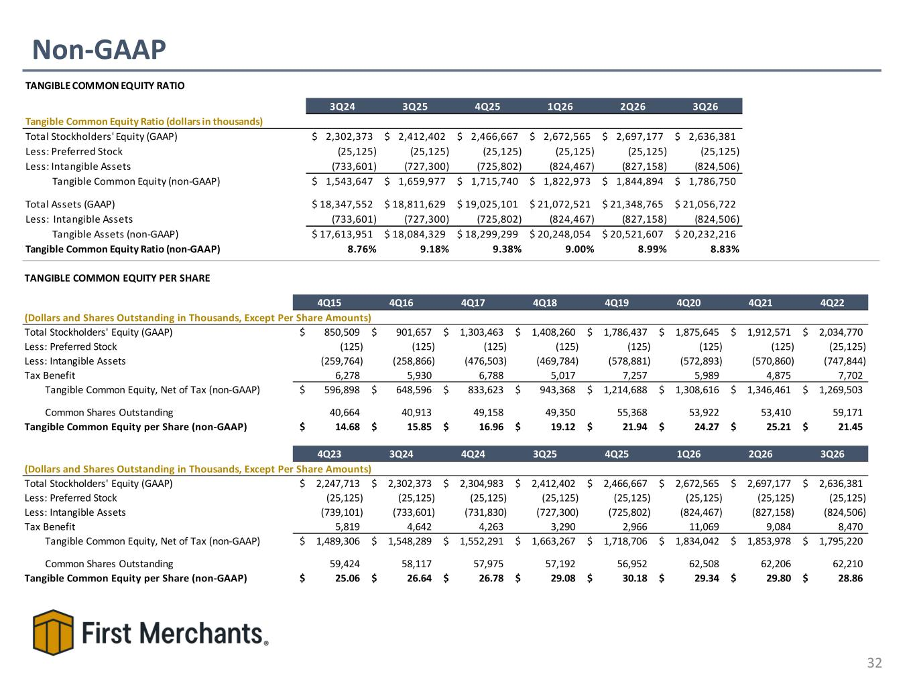
Non-GAAP 32 TANGIBLE COMMON EQUITY RATIO 3Q24 3Q25 4Q25 1Q26 2Q26 3Q26 Tangible Common Equity Ratio (dollars in thousands) Total Stockholders' Equity (GAAP) 2,302,373$ 2,412,402$ 2,466,667$ 2,672,565$ 2,697,177$ 2,636,381$ Less: Preferred Stock (25,125) (25,125) (25,125) (25,125) (25,125) (25,125) Less: Intangible Assets (733,601) (727,300) (725,802) (824,467) (827,158) (824,506) Tangible Common Equity (non-GAAP) 1,543,647$ 1,659,977$ 1,715,740$ 1,822,973$ 1,844,894$ 1,786,750$ Total Assets (GAAP) 18,347,552$ 18,811,629$ 19,025,101$ 21,072,521$ 21,348,765$ 21,056,722$ Less: Intangible Assets (733,601) (727,300) (725,802) (824,467) (827,158) (824,506) Tangible Assets (non-GAAP) 17,613,951$ 18,084,329$ 18,299,299$ 20,248,054$ 20,521,607$ 20,232,216$ Tangible Common Equity Ratio (non-GAAP) 8.76% 9.18% 9.38% 9.00% 8.99% 8.83% TANGIBLE COMMON EQUITY PER SHARE 4Q15 4Q16 4Q17 4Q18 4Q19 4Q20 4Q21 4Q22 (Dollars and Shares Outstanding in Thousands, Except Per Share Amounts) Total Stockholders' Equity (GAAP) 850,509$ 901,657$ 1,303,463$ 1,408,260$ 1,786,437$ 1,875,645$ 1,912,571$ 2,034,770$ Less: Preferred Stock (125) (125) (125) (125) (125) (125) (125) (25,125) Less: Intangible Assets (259,764) (258,866) (476,503) (469,784) (578,881) (572,893) (570,860) (747,844) Tax Benefit 6,278 5,930 6,788 5,017 7,257 5,989 4,875 7,702 Tangible Common Equity, Net of Tax (non-GAAP) 596,898$ 648,596$ 833,623$ 943,368$ 1,214,688$ 1,308,616$ 1,346,461$ 1,269,503$ Common Shares Outstanding 40,664 40,913 49,158 49,350 55,368 53,922 53,410 59,171 Tangible Common Equity per Share (non-GAAP) 14.68$ 15.85$ 16.96$ 19.12$ 21.94$ 24.27$ 25.21$ 21.45$ 4Q23 3Q24 4Q24 3Q25 4Q25 1Q26 2Q26 3Q26 (Dollars and Shares Outstanding in Thousands, Except Per Share Amounts) Total Stockholders' Equity (GAAP) 2,247,713$ 2,302,373$ 2,304,983$ 2,412,402$ 2,466,667$ 2,672,565$ 2,697,177$ 2,636,381$ Less: Preferred Stock (25,125) (25,125) (25,125) (25,125) (25,125) (25,125) (25,125) (25,125) Less: Intangible Assets (739,101) (733,601) (731,830) (727,300) (725,802) (824,467) (827,158) (824,506) Tax Benefit 5,819 4,642 4,263 3,290 2,966 11,069 9,084 8,470 Tangible Common Equity, Net of Tax (non-GAAP) 1,489,306$ 1,548,289$ 1,552,291$ 1,663,267$ 1,718,706$ 1,834,042$ 1,853,978$ 1,795,220$ Common Shares Outstanding 59,424 58,117 57,975 57,192 56,952 62,508 62,206 62,210 Tangible Common Equity per Share (non-GAAP) 25.06$ 26.64$ 26.78$ 29.08$ 30.18$ 29.34$ 29.80$ 28.86$

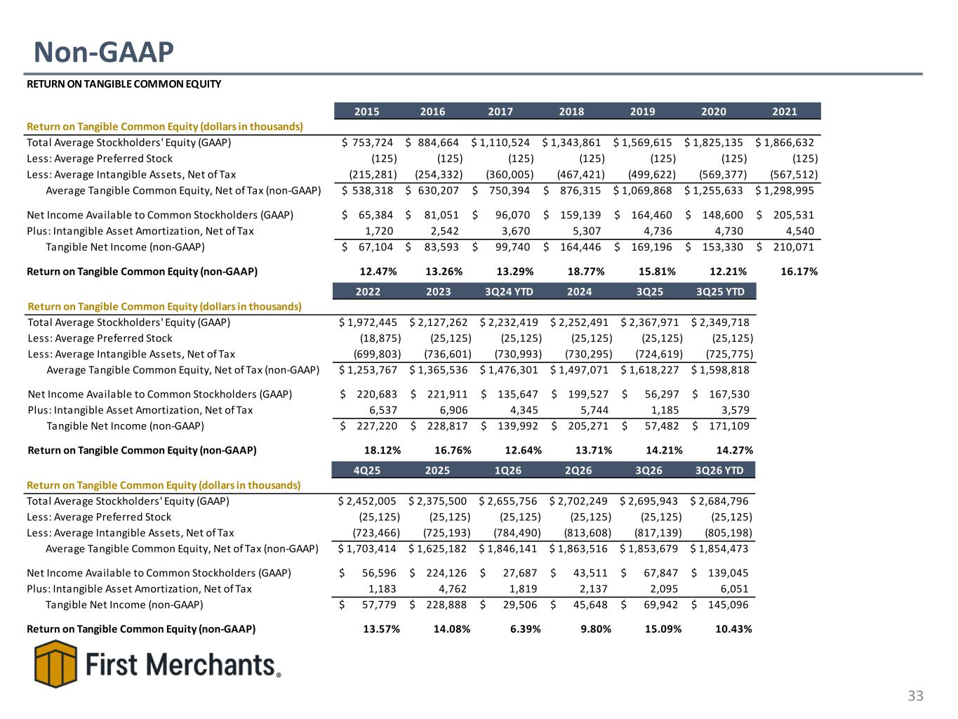
Non-GAAP 33 RETURN ON TANGIBLE COMMON EQUITY 2015 2016 2017 2018 2019 2020 2021 Return on Tangible Common Equity (dollars in thousands) Total Average Stockholders' Equity (GAAP) 753,724$ 884,664$ 1,110,524$ 1,343,861$ 1,569,615$ 1,825,135$ 1,866,632$ Less: Average Preferred Stock (125) (125) (125) (125) (125) (125) (125) Less: Average Intangible Assets, Net of Tax (215,281) (254,332) (360,005) (467,421) (499,622) (569,377) (567,512) Average Tangible Common Equity, Net of Tax (non-GAAP) 538,318$ 630,207$ 750,394$ 876,315$ 1,069,868$ 1,255,633$ 1,298,995$ Net Income Available to Common Stockholders (GAAP) 65,384$ 81,051$ 96,070$ 159,139$ 164,460$ 148,600$ 205,531$ Plus: Intangible Asset Amortization, Net of Tax 1,720 2,542 3,670 5,307 4,736 4,730 4,540 Tangible Net Income (non-GAAP) 67,104$ 83,593$ 99,740$ 164,446$ 169,196$ 153,330$ 210,071$ Return on Tangible Common Equity (non-GAAP) 12.47% 13.26% 13.29% 18.77% 15.81% 12.21% 16.17% 2022 2023 3Q24 YTD 2024 3Q25 3Q25 YTD Return on Tangible Common Equity (dollars in thousands) Total Average Stockholders' Equity (GAAP) 1,972,445$ 2,127,262$ 2,232,419$ 2,252,491$ 2,367,971$ 2,349,718$ Less: Average Preferred Stock (18,875) (25,125) (25,125) (25,125) (25,125) (25,125) Less: Average Intangible Assets, Net of Tax (699,803) (736,601) (730,993) (730,295) (724,619) (725,775) Average Tangible Common Equity, Net of Tax (non-GAAP) 1,253,767$ 1,365,536$ 1,476,301$ 1,497,071$ 1,618,227$ 1,598,818$ Net Income Available to Common Stockholders (GAAP) 220,683$ 221,911$ 135,647$ 199,527$ 56,297$ 167,530$ Plus: Intangible Asset Amortization, Net of Tax 6,537 6,906 4,345 5,744 1,185 3,579 Tangible Net Income (non-GAAP) 227,220$ 228,817$ 139,992$ 205,271$ 57,482$ 171,109$ Return on Tangible Common Equity (non-GAAP) 18.12% 16.76% 12.64% 13.71% 14.21% 14.27% 4Q25 2025 1Q26 2Q26 3Q26 3Q26 YTD Return on Tangible Common Equity (dollars in thousands) Total Average Stockholders' Equity (GAAP) 2,452,005$ 2,375,500$ 2,655,756$ 2,702,249$ 2,695,943$ 2,684,796$ Less: Average Preferred Stock (25,125) (25,125) (25,125) (25,125) (25,125) (25,125) Less: Average Intangible Assets, Net of Tax (723,466) (725,193) (784,490) (813,608) (817,139) (805,198) Average Tangible Common Equity, Net of Tax (non-GAAP) 1,703,414$ 1,625,182$ 1,846,141$ 1,863,516$ 1,853,679$ 1,854,473$ Net Income Available to Common Stockholders (GAAP) 56,596$ 224,126$ 27,687$ 43,511$ 67,847$ 139,045$ Plus: Intangible Asset Amortization, Net of Tax 1,183 4,762 1,819 2,137 2,095 6,051 Tangible Net Income (non-GAAP) 57,779$ 228,888$ 29,506$ 45,648$ 69,942$ 145,096$ Return on Tangible Common Equity (non-GAAP) 13.57% 14.08% 6.39% 9.80% 15.09% 10.43%

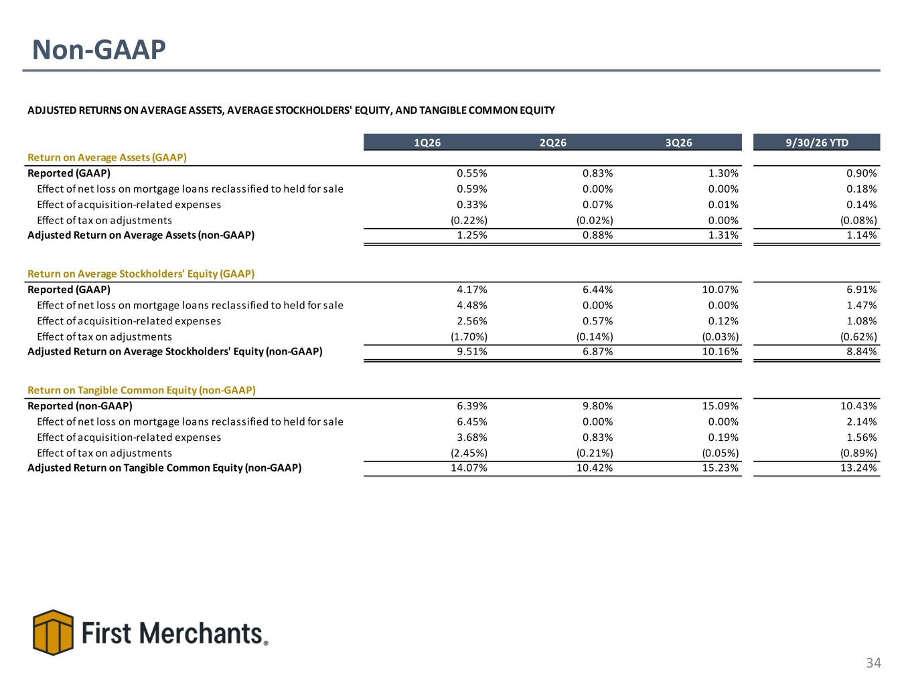
Non-GAAP 34 ADJUSTED RETURNS ON AVERAGE ASSETS, AVERAGE STOCKHOLDERS' EQUITY, AND TANGIBLE COMMON EQUITY 1Q26 2Q26 3Q26 9/30/26 YTD Return on Average Assets (GAAP) Reported (GAAP) 0.55% 0.83% 1.30% 0.90% Effect of net loss on mortgage loans reclassified to held for sale 0.59% 0.00% 0.00% 0.18% Effect of acquisition-related expenses 0.33% 0.07% 0.01% 0.14% Effect of tax on adjustments (0.22%) (0.02%) 0.00% (0.08%) Adjusted Return on Average Assets (non-GAAP) 1.25% 0.88% 1.31% 1.14% Return on Average Stockholders' Equity (GAAP) Reported (GAAP) 4.17% 6.44% 10.07% 6.91% Effect of net loss on mortgage loans reclassified to held for sale 4.48% 0.00% 0.00% 1.47% Effect of acquisition-related expenses 2.56% 0.57% 0.12% 1.08% Effect of tax on adjustments (1.70%) (0.14%) (0.03%) (0.62%) Adjusted Return on Average Stockholders' Equity (non-GAAP) 9.51% 6.87% 10.16% 8.84% Return on Tangible Common Equity (non-GAAP) Reported (non-GAAP) 6.39% 9.80% 15.09% 10.43% Effect of net loss on mortgage loans reclassified to held for sale 6.45% 0.00% 0.00% 2.14% Effect of acquisition-related expenses 3.68% 0.83% 0.19% 1.56% Effect of tax on adjustments (2.45%) (0.21%) (0.05%) (0.89%) Adjusted Return on Tangible Common Equity (non-GAAP) 14.07% 10.42% 15.23% 13.24%

