UNITED STATES
SECURITIES AND EXCHANGE COMMISSION
Washington, DC 20549

FORM 8-K

CURRENT REPORT
PURSUANT TO SECTION 13 OR 15(d) OF THE
SECURITIES EXCHANGE ACT OF 1934

DATE OF REPORT (Date of earliest event reported): April 22, 2026

FIRST MERCHANTS CORPORATION
(Exact name of registrant as specified in its charter)
Indiana
(State or other jurisdiction of incorporation)
001-41342 |  |  | 35-1544218
(Commission File Number) |  |  | (IRS Employer Identification No.)

200 East Jackson Street
P.O. Box 792
Muncie, IN 47305-2814
(Address of principal executive offices, including zip code)

(765) 747-1500
(Registrant's telephone number, including area code)

Not Applicable
(Former name or former address, if changed since last report)
Title of Each Class |  |  | Trading Symbol(s) |  |  | Name of each exchange on which registered
Common Stock, $0.125 stated value per share |  |  | FRME |  |  | The Nasdaq Stock Market LLC
Depositary Shares, each representing a 1/100th interest in a share of Non-Cumulative Perpetual Preferred Stock, Series A |  |  | FRMEP |  |  | The Nasdaq Stock Market LLC

Check the appropriate box below if the Form 8-K filing is intended to simultaneously satisfy the filing obligation of the registrant under any of the following provisions:

☐ Written communications pursuant to Rule 425 under the Securities Act (17 CFR 230.425)
☐ Soliciting material pursuant to Rule 14a-12 under the Exchange Act (17 CFR 240.14a-12)
☐ Pre-commencement communications pursuant to Rule 14d-2(b) under the Exchange Act (17 CFR 240.14d-2(b))
☐ Pre-commencement communications pursuant to Rule 13e-4(c) under the Exchange Act (17 CFR 240.13e-4(c))

Indicate by check mark whether the registrant is an emerging growth company as defined in Rule 405 of the Securities Act of 1933 (§230.405 of this chapter) or Rule 12b-2 of the Securities Exchange Act of 1934 (§240.12b-2 of this chapter).

Emerging growth company ☐

If an emerging growth company, indicate by check mark if the registrant has elected not to use the extended transition period for complying with any new or revised financial accounting standards provided pursuant to Section 13(a) of the Exchange Act. ☐

ITEM 2.02 RESULTS OF OPERATIONS AND FINANCIAL CONDITION.

On April 22, 2026, First Merchants Corporation issued a press release to report its financial results for the first quarter ended March 31, 2026. A copy of the press release is furnished as Exhibit 99.1 to this Current Report on Form 8-K.

On April 23, 2026, First Merchants Corporation will conduct a first quarter 2026 earnings conference call and webcast at 9:00 a.m. (ET). A copy of the slide presentation utilized on the conference call is furnished as Exhibit 99.2 to this Current Report on Form 8-K.

The information in this Current Report on Form 8-K, including Exhibit 99.1 and Exhibit 99.2 hereto, shall not be deemed "filed" for purposes of Section 18 of the Securities Exchange Act of 1934, as amended, or otherwise subject to liability of that section. The information in this Current Report shall not be incorporated by reference into any filing or other document pursuant to the Securities Act of 1933, as amended, except as shall be expressly set forth by specific reference in such filing or document.

ITEM 9.01 FINANCIAL STATEMENTS AND EXHIBITS.

(a) Not applicable.

(b) Not applicable.

(c) Not applicable.

(d) Exhibits.

Exhibit 99.1 |  |  | Press Release, dated April 22, 2026, issued by First Merchants Corporation
Exhibit 99.2 |  |  | Slide Presentation, utilized on April 23, 2026 during conference call and webcast by First Merchants Corporation
Exhibit 104 |  |  | Cover Page Interactive Data File (embedded within the Inline XBRL document)

SIGNATURES

Pursuant to the requirements of the Securities Exchange Act of 1934, the Registrant has duly caused this report to be signed on its behalf by the undersigned hereunto duly authorized.

First Merchants Corporation
(Registrant)
By: /s/ Michele M. Kawiecki

Michele M. Kawiecki

Executive Vice President, Chief Financial Officer
(Principal Financial and Accounting Officer)
Dated: April 22, 2026

EXHIBIT INDEX

Exhibit No. |  |  | Description
99.1 |  |  | Press Release, dated April 22, 2026 issued by First Merchants Corporation
99.2 |  |  | Slide Presentation, utilized on April 23, 2026 during conference call and webcast by First Merchants Corporation
104 |  |  | Cover Page Interactive Data File (embedded within the Inline XBRL document)

N / E / W / S R / E / L / E / A / S / E

April 22, 2026

FOR IMMEDIATE RELEASE
For more information, contact:
Nicole M. Weaver, First Vice President and Director of Corporate Administration
765-521-7619
http://www.firstmerchants.com

SOURCE: First Merchants Corporation, Muncie, Indiana

FIRST MERCHANTS CORPORATION ANNOUNCES FIRST QUARTER 2026 RESULTS

First Merchants Corporation (NASDAQ - FRME) (the "Corporation")

First Quarter 2026 Highlights:

•Net income available to common stockholders was $27.7 million, or $0.45 per diluted share, compared to $56.6 million, or $0.99 per diluted share, in the fourth quarter of 2025. On an adjusted basis1, net income totaled $63.1 million, or $1.03 per diluted share, compared to $56.4 million, or $0.98 per diluted share, in the prior quarter.
•Completed legal closing on the acquisition of First Savings Financial Group, Inc. (“First Savings”) on February 1, 2026.
•Maintained strong capital position with Common Equity Tier 1 Capital Ratio of 11.22%.
•Repurchased 708,856 shares totaling $27.6 million of common stock year-to-date, including 640,486 shares totaling $24.9 million in the first quarter.
•Loans declined $18.8 million, or 0.5% annualized linked quarter, and increased $768.0 million, or 5.9%, during the last twelve months, excluding $1.8 billion of loans added from the First Savings acquisition.
•Deposits declined $499.4 million, or 13.1% annualized linked quarter, and increased $333.5 million, or 2.3%, during the last twelve months, excluding $1.7 billion of deposits added from the First Savings acquisition.
•Nonperforming assets to total assets were 43 basis points compared to 38 basis points in the prior quarter.
•Adjusted efficiency ratio1 totaled 54.21% for the quarter.

"First Merchants delivered a strong start to 2026, highlighted by solid adjusted earnings growth, expanding net interest margin, and continued strength in commercial loan production," said Mark Hardwick, Chief Executive Officer. "We successfully closed the acquisition of First Savings, adding $2.4 billion in assets and further strengthening our statewide Indiana presence while enhancing our ability to serve clients across Indiana, Ohio, and Michigan. Our capital, liquidity, and credit quality remain very strong, positioning us well for continued growth and long-term shareholder value creation."

First Quarter Financial Results:

The Corporation reported first quarter 2026 net income available to common stockholders of $27.7 million compared to $54.9 million during the same period in 2025. Diluted earnings per common share1 for the period totaled $0.45 compared to $0.94 in the first quarter of 2025. Current quarter results included acquisition costs of $17.0 million that primarily consist of employee retention bonuses and severance, contract termination charges and professional fees. Current quarter results also included a mark-to-market loss of $29.8 million on $357 million of mortgage loans moved to held-for-sale with a weighted average coupon of 3.46%. The loan sale is expected to close during the second quarter and will create incremental funding capacity. Excluding these non-core charges, adjusted earnings per common share1 for the first quarter of 2026 totaled $1.03 compared to $0.94 in the prior year period, an increase of 9.6%.

Total assets of the Corporation equaled $21.1 billion as of quarter-end and loans totaled $15.3 billion. Loans increased $2.3 billion during the past twelve months. The acquisition of First Savings contributed $1.8 billion of loans. Excluding acquired loans and the impact of loans moved to held-for-sale, the Corporation experienced organic loan growth of $768.0 million, or 5.9%, during the past twelve months. On a linked quarter basis, loans declined $18.8 million, or 0.5% annualized.

Investment securities, totaling $3.3 billion, decreased $117.2 million, or 3.4%, during the last twelve months and decreased $68.7 million, or 8.1% annualized on a linked quarter basis. Investments declined during the quarter due to principal paydowns and maturities as well as a modest decline in the securities portfolio valuation.

Total deposits equaled $16.5 billion as of quarter-end and increased by $2.0 billion, over the past twelve months. The acquisition of First Savings contributed $1.7 billion in deposits. Excluding acquired deposits, the Corporation experienced an increase in organic deposit growth of $333.5 million, or 2.3%. Deposits decreased $499.4 million, or 13.1% annualized on a linked quarter basis, excluding acquired deposits. The balance sheet growth resulted in an increase in the loan to deposit ratio to 92.6% at period end from 90.3% in the prior quarter.

The Corporation’s Allowance for Credit Losses – Loans (ACL) totaled $212.5 million as of quarter-end, or 1.39% of loans, an increase of $16.9 million from prior quarter. The ACL increased $22.3 million for the purchase accounting adjustment for estimated credit losses recorded for the First Savings loan portfolio. Net charge-offs totaled $10.3 million and provision for credit losses of $4.9 million was recorded during the quarter. Reserves for unfunded commitments totaled $18.5 million, an increase of $0.5 million from prior quarter recorded for estimated credit losses on unfunded commitments of First Savings. Non-performing assets to total assets were 0.43% for the first quarter of 2026, an increase of five basis points compared to 0.38% in the prior quarter reflecting stable credit performance.

Net interest income totaling $151.3 million for the quarter, increased $12.2 million, or 8.8%, compared to prior quarter and increased $21.0 million, or 16.1%, compared to the first quarter of 2025. Positively impacting net interest income was an interest recovery of $1.2 million recorded during the quarter from the successful resolution of a nonaccrual multifamily commercial real estate loan. Fully taxable equivalent net interest margin was 3.35%, an increase of six basis points compared to prior quarter and an increase of 13 basis points compared to the first quarter of 2025. The lower day count in the quarter caused a decline of five basis points in net interest margin from the prior quarter. This was more than offset by an improved funding mix and meaningfully lower deposit costs.

Noninterest income totaled $5.8 million for the quarter, a decrease of $27.3 million, compared to prior quarter and a decrease of $24.2 million compared to the first quarter of 2025. The declines were due to a valuation adjustment on mortgage loans that were reclassified to held-for-sale during the current quarter. Customer-related fees increased by $1.8 million from the previous quarter and $4.7 million over the first quarter of 2025. The linked quarter increase was driven by higher wealth management fees and higher gains on the sales of loans offset by a slight reduction in derivative hedge fees.

Noninterest expense totaled $125.1 million for the quarter, an increase of $25.6 million from the fourth quarter of 2025 and an increase of $32.2 million from the first quarter of 2025. Acquisition-related costs totaling $17.0 million were incurred during the quarter, including $5.2 million attributed to salaries and benefits and $11.3 million in professional and other outside services. Contributing to current quarter expenses was an annual benefit plan expense of $1.1 million and a $0.9 million one-time charge for the write-down of a held-for-sale building.

The Corporation’s total risk-based capital ratio was 13.05%, common equity tier 1 capital ratio was 11.22%, and the tangible common equity ratio was 9.00%. These ratios continue to reflect the Corporation’s strong capital position.

1 See “Non-GAAP Financial Information” for reconciliation

CONFERENCE CALL

First Merchants Corporation will conduct an earnings conference call and webcast at 9:00 a.m. (ET) on Thursday, April 23, 2026.

To access via phone, participants will need to register using the following link where they will be provided a phone number and access code: (https://register-conf.media-server.com/register/BIea2e66c5a6e240dea7770076185c1054)

To view the webcast and presentation slides, please go to (https://edge.media-server.com/mmc/p/i5u3npdn) during the time of the call. A replay of the webcast will be available until April 23, 2027.

Detailed financial results are reported on the attached pages.

About First Merchants Corporation

First Merchants Corporation is a financial holding company headquartered in Muncie, Indiana. The Corporation has one full-service bank charter, First Merchants Bank. The Bank also operates as First Merchants Private Wealth Advisors (as a division of First Merchants Bank).

First Merchants Corporation’s common stock is traded on the NASDAQ Global Select Market System under the symbol FRME. Quotations are carried in daily newspapers and can be found on the company’s Internet web page (http://www.firstmerchants.com).

FIRST MERCHANTS and the Shield Logo are federally registered trademarks of First Merchants Corporation.

Forward-Looking Statements

This news release contains forward-looking statements made pursuant to the safe-harbor provisions of the Private Securities Litigation Reform Act of 1995. Such forward-looking statements can often, but not always, be identified by the use of words like “believe”, “continue”, “pattern”, “estimate”, “project”, “intend”, “anticipate”, “expect” and similar expressions or future or conditional verbs such as “will”, “would”, “should”, “could”, “might”, “can”, “may”, or similar expressions. These forward- looking statements include, but are not limited to, statements relating to the expected benefits of the merger between First Merchants and First Savings, including future financial and operating results, cost savings, enhanced revenues, and accretion/dilution to reported earnings that may be realized from the merger, as well as other statements of expectations regarding the merger, and other statements of First Merchants’ goals, intentions and expectations; statements regarding the First Merchants’ business plan and growth strategies; statements regarding the asset quality of First Merchants’ loan and investment portfolios; and estimates of First Merchants’ risks and future costs and benefits, whether with respect to the merger or otherwise. These forward-looking statements are subject to significant risks, assumptions and uncertainties that may cause results to differ materially from those set forth in forward-looking statements, including, among other things: the risk that the businesses of First Merchants and First Savings will not be integrated successfully or such integration may be more difficult, time-consuming or costly than expected; expected revenue synergies and cost savings from the merger may not be fully realized or realized within the expected time frame; revenues following the merger may be lower than expected; customer and employee relationships and business operations may be disrupted by the merger; the ability to complete the merger on the expected timeframe; possible changes in monetary and fiscal policies, and laws and regulations; the effects of easing restrictions on participants in the financial services industry; the cost and other effects of legal and administrative cases; possible changes in the credit-worthiness of customers and the possible impairment of collectability of loans; fluctuations in market rates of interest; competitive factors in the banking industry; changes in the banking legislation or regulatory requirements of federal and state agencies applicable to bank holding companies and banks like First Merchants’ affiliate bank; continued availability of earnings and excess capital sufficient for the lawful and prudent declaration of dividends; changes in market, economic, operational, liquidity (including the ability to grow and maintain core deposits and retain large uninsured deposits), credit and interest rate risks associated with First Merchants’ business; the impacts of epidemics, pandemics or other infectious disease outbreaks; and other risks and factors identified in each of First Merchants’ filings with the SEC. Neither First Merchants nor First Savings undertakes any obligation to update any forward-looking statement, whether written or oral, relating to the matters discussed in this news release. In addition, the companies’ respective past results of operations do not necessarily indicate their anticipated future results, whether or not the merger is completed.

Non-GAAP Financial Measures

This news release contains non-GAAP financial measures. For purposes of Regulation G, a non-GAAP financial measure is a numerical measure of the registrant’s historical or future financial performance, financial position or cash flows that excludes amounts, or is subject to adjustments that have the effect of excluding amounts, that are included in the most directly comparable measure calculated and presented in accordance with GAAP in the statement of income, balance sheet or statement of cash flows (or equivalent statements) of the issuer; or includes amounts, or is subject to adjustments that have the effect of including amounts, that are excluded from the most directly comparable measure so calculated and presented. In this regard, GAAP refers to generally accepted accounting principles in the United States. Pursuant to the requirements of Regulation G, First Merchants Corporation has provided reconciliations within this news release, as necessary, of the non-GAAP financial measure to the most directly comparable GAAP financial measure.

* * * *

CONSOLIDATED BALANCE SHEETS (Unaudited)
(Dollars In Thousands, Except Per Share Amounts) |  |  | March 31,
 |  |  | 2026 |  |  |  |  |  | 2025
ASSETS
Cash and due from banks |  |  | $ | 98,083 |  |  |  |  | $ | 86,113
Interest-bearing deposits |  |  | 175,354 |  |  |  |  |  | 331,534
Investment securities available for sale |  |  | 1,372,417 |  |  |  |  |  | 1,378,489
Investment securities held to maturity, net of allowance for credit losses of $245 in 2026 and 2025 |  |  | 1,937,485 |  |  |  |  |  | 2,048,632
Loans held for sale |  |  | 401,839 |  |  |  |  |  | 23,004
Loans |  |  | 15,261,889 |  |  |  |  |  | 13,004,905
Less: Allowance for credit losses - loans |  |  | (212,520) |  |  |  |  |  | (192,031)
Net loans |  |  | 15,049,369 |  |  |  |  |  | 12,812,874
Premises and equipment |  |  | 146,013 |  |  |  |  |  | 128,749
Federal Home Loan Bank stock |  |  | 70,835 |  |  |  |  |  | 45,006
Interest receivable |  |  | 97,026 |  |  |  |  |  | 88,352
Goodwill |  |  | 782,789 |  |  |  |  |  | 712,002
Other intangibles |  |  | 41,678 |  |  |  |  |  | 18,302
Cash surrender value of life insurance |  |  | 371,238 |  |  |  |  |  | 304,918
Other real estate owned |  |  | 1,264 |  |  |  |  |  | 4,966
Tax asset, deferred and receivable |  |  | 116,814 |  |  |  |  |  | 87,665
Other assets |  |  | 410,317 |  |  |  |  |  | 369,181
TOTAL ASSETS |  |  | $ | 21,072,521 |  |  |  |  | $ | 18,439,787
LIABILITIES
Deposits:
Noninterest-bearing |  |  | $ | 3,748,279 |  |  |  |  | $ | 2,185,057
Interest-bearing |  |  | 12,737,338 |  |  |  |  |  | 12,276,921
Total Deposits |  |  | 16,485,617 |  |  |  |  |  | 14,461,978
Borrowings:
Federal funds purchased |  |  | 170,000 |  |  |  |  |  | 185,000
Securities sold under repurchase agreements |  |  | 89,458 |  |  |  |  |  | 122,947
Federal Home Loan Bank advances |  |  | 1,299,192 |  |  |  |  |  | 972,478
Subordinated debentures and other borrowings |  |  | 86,345 |  |  |  |  |  | 62,619
Total Borrowings |  |  | 1,644,995 |  |  |  |  |  | 1,343,044
Interest payable |  |  | 18,890 |  |  |  |  |  | 13,304
Other liabilities |  |  | 250,454 |  |  |  |  |  | 289,247
Total Liabilities |  |  | 18,399,956 |  |  |  |  |  | 16,107,573
STOCKHOLDERS' EQUITY
Preferred Stock, $1,000 par value, $1,000 liquidation value:
Authorized -- 600 cumulative shares
Issued and outstanding - 125 cumulative shares |  |  | 125 |  |  |  |  |  | 125
Preferred Stock, Series A, no par value, $2,500 liquidation preference:
Authorized -- 10,000 non-cumulative perpetual shares
Issued and outstanding - 10,000 non-cumulative perpetual shares |  |  | 25,000 |  |  |  |  |  | 25,000
Common Stock, $0.125 stated value:
Authorized -- 100,000,000 shares
Issued and outstanding - 62,508,055 and 57,810,232 shares |  |  | 7,813 |  |  |  |  |  | 7,226
Additional paid-in capital |  |  | 1,369,879 |  |  |  |  |  | 1,183,263
Retained earnings |  |  | 1,418,609 |  |  |  |  |  | 1,306,911
Accumulated other comprehensive loss |  |  | (148,861) |  |  |  |  |  | (190,311)
Total Stockholders' Equity |  |  | 2,672,565 |  |  |  |  |  | 2,332,214
TOTAL LIABILITIES AND STOCKHOLDERS' EQUITY |  |  | $ | 21,072,521 |  |  |  |  | $ | 18,439,787

CONSOLIDATED STATEMENTS OF INCOME (Unaudited) |  |  | Three Months Ended
(Dollars In Thousands, Except Per Share Amounts) |  |  | March 31,
 |  |  | 2026 |  |  |  |  |  | 2025
INTEREST INCOME
Loans:
Taxable |  |  | $ | 213,627 |  |  |  |  | $ | 187,728
Tax-exempt |  |  | 11,589 |  |  |  |  |  | 10,532
Investment securities:
Taxable |  |  | 7,547 |  |  |  |  |  | 8,372
Tax-exempt |  |  | 12,597 |  |  |  |  |  | 12,517
Deposits with financial institutions |  |  | 1,244 |  |  |  |  |  | 2,372
Federal Home Loan Bank stock |  |  | 1,965 |  |  |  |  |  | 997
Total Interest Income |  |  | 248,569 |  |  |  |  |  | 222,518
INTEREST EXPENSE
Deposits |  |  | 84,093 |  |  |  |  |  | 80,547
Federal funds purchased |  |  | 590 |  |  |  |  |  | 812
Securities sold under repurchase agreements |  |  | 332 |  |  |  |  |  | 742
Federal Home Loan Bank advances |  |  | 11,048 |  |  |  |  |  | 9,364
Subordinated debentures and other borrowings |  |  | 1,203 |  |  |  |  |  | 783
Total Interest Expense |  |  | 97,266 |  |  |  |  |  | 92,248
NET INTEREST INCOME |  |  | 151,303 |  |  |  |  |  | 130,270
Provision for credit losses |  |  | 4,900 |  |  |  |  |  | 4,200
NET INTEREST INCOME AFTER PROVISION FOR CREDIT LOSSES |  |  | 146,403 |  |  |  |  |  | 126,070
NONINTEREST INCOME
Service charges on deposit accounts |  |  | 9,037 |  |  |  |  |  | 8,072
Fiduciary and wealth management fees |  |  | 9,768 |  |  |  |  |  | 8,644
Card payment fees |  |  | 5,275 |  |  |  |  |  | 4,526
Net gains and fees on sales of loans |  |  | 6,511 |  |  |  |  |  | 5,022
Derivative hedge fees |  |  | 564 |  |  |  |  |  | 404
Other customer fees |  |  | 593 |  |  |  |  |  | 415
Earnings on bank-owned life insurance |  |  | 3,446 |  |  |  |  |  | 2,179
Net realized losses on sales of available for sale securities |  |  | — |  |  |  |  |  | (7)
Net loss on mortgage loans reclassified to held for sale |  |  | (29,755) |  |  |  |  |  | —
Other income |  |  | 390 |  |  |  |  |  | 793
Total Noninterest Income |  |  | 5,829 |  |  |  |  |  | 30,048
NONINTEREST EXPENSE
Salaries and employee benefits |  |  | 69,443 |  |  |  |  |  | 54,982
Net occupancy |  |  | 8,301 |  |  |  |  |  | 7,216
Equipment |  |  | 7,818 |  |  |  |  |  | 7,008
Marketing |  |  | 1,601 |  |  |  |  |  | 1,353
Outside data processing fees |  |  | 7,190 |  |  |  |  |  | 5,929
Printing and office supplies |  |  | 377 |  |  |  |  |  | 347
Intangible asset amortization |  |  | 2,302 |  |  |  |  |  | 1,526
FDIC assessments |  |  | 3,893 |  |  |  |  |  | 3,648
Other real estate owned and foreclosure expenses |  |  | 1,100 |  |  |  |  |  | 600
Professional and other outside services |  |  | 14,593 |  |  |  |  |  | 3,261
Other expenses |  |  | 8,527 |  |  |  |  |  | 7,032
Total Noninterest Expense |  |  | 125,145 |  |  |  |  |  | 92,902
Income Before Income Taxes |  |  | 27,087 |  |  |  |  |  | 63,216
Income tax expense (benefit) |  |  | (1,069) |  |  |  |  |  | 7,877
NET INCOME |  |  | 28,156 |  |  |  |  |  | 55,339
Preferred stock dividends |  |  | 469 |  |  |  |  |  | 469
NET INCOME AVAILABLE TO COMMON STOCKHOLDERS |  |  | $ | 27,687 |  |  |  |  | $ | 54,870
PER SHARE DATA:
Basic Net Income Available to Common Stockholders |  |  | $ | 0.46 |  |  |  |  | $ | 0.95
Diluted Net Income Available to Common Stockholders |  |  | $ | 0.45 |  |  |  |  | $ | 0.94
Cash Dividends Paid to Common Stockholders |  |  | $ | 0.36 |  |  |  |  | $ | 0.35
Tangible Common Book Value Per Share |  |  | $ | 29.34 |  |  |  |  | $ | 27.34
Average Diluted Common Shares Outstanding (in thousands) |  |  | 61,008 |  |  |  |  |  | 58,242

FINANCIAL HIGHLIGHTS
(Dollars In Thousands) |  |  | Three Months Ended
 |  |  | March 31,
 |  |  | 2026 |  |  |  |  |  | 2025
NET CHARGE-OFFS |  |  | $ | 10,256 |  |  |  |  | $ | 4,926
AVERAGE BALANCES:
Total Assets |  |  | $ | 20,407,523 |  |  |  |  | $ | 18,341,738
Total Loans |  |  | 14,995,685 |  |  |  |  |  | 12,941,353
Total Earning Assets |  |  | 18,842,984 |  |  |  |  |  | 16,960,475
Total Deposits |  |  | 16,080,470 |  |  |  |  |  | 14,419,338
Total Stockholders' Equity |  |  | 2,655,756 |  |  |  |  |  | 2,340,874
FINANCIAL RATIOS:
Return on Average Assets |  |  | 0.55 |  | % |  |  |  | 1.21 |  | %
Return on Average Stockholders' Equity |  |  | 4.17 |  |  |  |  |  | 9.38
Return on Tangible Common Stockholders' Equity |  |  | 6.39 |  |  |  |  |  | 14.12
Average Earning Assets to Average Assets |  |  | 92.33 |  |  |  |  |  | 92.47
Allowance for Credit Losses - Loans as % of Total Loans |  |  | 1.39 |  |  |  |  |  | 1.47
Net Charge-offs as % of Average Loans (Annualized) |  |  | 0.27 |  |  |  |  |  | 0.15
Average Stockholders' Equity to Average Assets |  |  | 13.01 |  |  |  |  |  | 12.76
Fully Taxable Equivalent (FTE) Yield on Average Earning Assets |  |  | 5.41 |  |  |  |  |  | 5.39
Interest Expense/Average Earning Assets |  |  | 2.06 |  |  |  |  |  | 2.17
Net Interest Margin FTE |  |  | 3.35 |  |  |  |  |  | 3.22
Efficiency Ratio |  |  | 74.45 |  |  |  |  |  | 54.54

ASSET QUALITY
(Dollars In Thousands) |  |  | March 31, |  |  |  |  |  | December 31, |  |  |  |  |  | September 30, |  |  |  |  |  | June 30, |  |  |  |  |  | March 31,
 |  |  | 2026 |  |  |  |  |  | 2025 |  |  |  |  |  | 2025 |  |  |  |  |  | 2025 |  |  |  |  |  | 2025
Nonaccrual Loans |  |  | $ | 89,592 |  |  |  |  | $ | 71,773 |  |  |  |  | $ | 65,740 |  |  |  |  | $ | 67,358 |  |  |  |  | $ | 81,922
Other Real Estate Owned and Repossessions |  |  | 1,264 |  |  |  |  |  | 658 |  |  |  |  |  | 1,270 |  |  |  |  |  | 177 |  |  |  |  |  | 4,966
Nonperforming Assets (NPA) |  |  | 90,856 |  |  |  |  |  | 72,431 |  |  |  |  |  | 67,010 |  |  |  |  |  | 67,535 |  |  |  |  |  | 86,888
90+ Days Delinquent |  |  | 4,078 |  |  |  |  |  | 2,042 |  |  |  |  |  | 1,925 |  |  |  |  |  | 4,443 |  |  |  |  |  | 4,280
NPAs & 90+ Days Delinquent |  |  | $ | 94,934 |  |  |  |  | $ | 74,473 |  |  |  |  | $ | 68,935 |  |  |  |  | $ | 71,978 |  |  |  |  | $ | 91,168
Allowance for Credit Losses - Loans |  |  | $ | 212,520 |  |  |  |  | $ | 195,597 |  |  |  |  | $ | 194,468 |  |  |  |  | $ | 195,316 |  |  |  |  | $ | 192,031
Quarterly Net Charge-offs |  |  | 10,256 |  |  |  |  |  | 6,021 |  |  |  |  |  | 5,148 |  |  |  |  |  | 2,315 |  |  |  |  |  | 4,926
NPAs / Assets % |  |  | 0.43 |  | % |  |  |  | 0.38 |  | % |  |  |  | 0.36 |  | % |  |  |  | 0.36 |  | % |  |  |  | 0.47 |  | %
NPAs & 90 Day / Assets % |  |  | 0.45 |  | % |  |  |  | 0.39 |  | % |  |  |  | 0.37 |  | % |  |  |  | 0.39 |  | % |  |  |  | 0.49 |  | %
NPAs / Loans and OREO % |  |  | 0.60 |  | % |  |  |  | 0.52 |  | % |  |  |  | 0.49 |  | % |  |  |  | 0.51 |  | % |  |  |  | 0.67 |  | %
Allowance for Credit Losses - Loans / Loans (%) |  |  | 1.39 |  | % |  |  |  | 1.42 |  | % |  |  |  | 1.43 |  | % |  |  |  | 1.47 |  | % |  |  |  | 1.47 |  | %
Quarterly Net Charge-offs as % of Average Loans (Annualized) |  |  | 0.27 |  | % |  |  |  | 0.18 |  | % |  |  |  | 0.15 |  | % |  |  |  | 0.07 |  | % |  |  |  | 0.15 |  | %

CONSOLIDATED BALANCE SHEETS (Unaudited)
(Dollars In Thousands, Except Per Share Amounts) |  |  | March 31, |  |  |  |  |  | December 31, |  |  |  |  |  | September 30, |  |  |  |  |  | June 30, |  |  |  |  |  | March 31,
 |  |  | 2026 |  |  |  |  |  | 2025 |  |  |  |  |  | 2025 |  |  |  |  |  | 2025 |  |  |  |  |  | 2025
ASSETS
Cash and due from banks |  |  | $ | 98,083 |  |  |  |  | $ | 84,158 |  |  |  |  | $ | 88,079 |  |  |  |  | $ | 81,567 |  |  |  |  | $ | 86,113
Interest-bearing deposits |  |  | 175,354 |  |  |  |  |  | 196,300 |  |  |  |  |  | 168,706 |  |  |  |  |  | 223,343 |  |  |  |  |  | 331,534
Investment securities available for sale |  |  | 1,372,417 |  |  |  |  |  | 1,407,102 |  |  |  |  |  | 1,386,903 |  |  |  |  |  | 1,358,130 |  |  |  |  |  | 1,378,489
Investment securities held to maturity, net of allowance for credit losses |  |  | 1,937,485 |  |  |  |  |  | 1,971,539 |  |  |  |  |  | 1,995,488 |  |  |  |  |  | 2,022,826 |  |  |  |  |  | 2,048,632
Loans held for sale |  |  | 401,839 |  |  |  |  |  | 20,079 |  |  |  |  |  | 23,190 |  |  |  |  |  | 28,783 |  |  |  |  |  | 23,004
Loans |  |  | 15,261,889 |  |  |  |  |  | 13,791,707 |  |  |  |  |  | 13,591,174 |  |  |  |  |  | 13,296,759 |  |  |  |  |  | 13,004,905
Less: Allowance for credit losses - loans |  |  | (212,520) |  |  |  |  |  | (195,597) |  |  |  |  |  | (194,468) |  |  |  |  |  | (195,316) |  |  |  |  |  | (192,031)
Net loans |  |  | 15,049,369 |  |  |  |  |  | 13,596,110 |  |  |  |  |  | 13,396,706 |  |  |  |  |  | 13,101,443 |  |  |  |  |  | 12,812,874
Premises and equipment |  |  | 146,013 |  |  |  |  |  | 121,058 |  |  |  |  |  | 121,771 |  |  |  |  |  | 122,808 |  |  |  |  |  | 128,749
Federal Home Loan Bank stock |  |  | 70,835 |  |  |  |  |  | 47,245 |  |  |  |  |  | 47,264 |  |  |  |  |  | 47,290 |  |  |  |  |  | 45,006
Interest receivable |  |  | 97,026 |  |  |  |  |  | 93,374 |  |  |  |  |  | 89,102 |  |  |  |  |  | 93,258 |  |  |  |  |  | 88,352
Goodwill |  |  | 782,789 |  |  |  |  |  | 712,002 |  |  |  |  |  | 712,002 |  |  |  |  |  | 712,002 |  |  |  |  |  | 712,002
Other intangibles |  |  | 41,678 |  |  |  |  |  | 13,800 |  |  |  |  |  | 15,298 |  |  |  |  |  | 16,797 |  |  |  |  |  | 18,302
Cash surrender value of life insurance |  |  | 371,238 |  |  |  |  |  | 308,438 |  |  |  |  |  | 306,583 |  |  |  |  |  | 305,695 |  |  |  |  |  | 304,918
Other real estate owned |  |  | 1,264 |  |  |  |  |  | 658 |  |  |  |  |  | 1,270 |  |  |  |  |  | 177 |  |  |  |  |  | 4,966
Tax asset, deferred and receivable |  |  | 116,814 |  |  |  |  |  | 78,664 |  |  |  |  |  | 89,758 |  |  |  |  |  | 97,749 |  |  |  |  |  | 87,665
Other assets |  |  | 410,317 |  |  |  |  |  | 374,574 |  |  |  |  |  | 369,509 |  |  |  |  |  | 380,909 |  |  |  |  |  | 369,181
TOTAL ASSETS |  |  | $ | 21,072,521 |  |  |  |  | $ | 19,025,101 |  |  |  |  | $ | 18,811,629 |  |  |  |  | $ | 18,592,777 |  |  |  |  | $ | 18,439,787
LIABILITIES
Deposits:
Noninterest-bearing |  |  | $ | 3,748,279 |  |  |  |  | $ | 2,137,262 |  |  |  |  | $ | 2,100,570 |  |  |  |  | $ | 2,197,416 |  |  |  |  | $ | 2,185,057
Interest-bearing |  |  | 12,737,338 |  |  |  |  |  | 13,157,593 |  |  |  |  |  | 12,769,409 |  |  |  |  |  | 12,600,162 |  |  |  |  |  | 12,276,921
Total Deposits |  |  | 16,485,617 |  |  |  |  |  | 15,294,855 |  |  |  |  |  | 14,869,979 |  |  |  |  |  | 14,797,578 |  |  |  |  |  | 14,461,978
Borrowings:
Federal funds purchased |  |  | 170,000 |  |  |  |  |  | 40,000 |  |  |  |  |  | 199,370 |  |  |  |  |  | 85,000 |  |  |  |  |  | 185,000
Securities sold under repurchase agreements |  |  | 89,458 |  |  |  |  |  | 103,755 |  |  |  |  |  | 122,226 |  |  |  |  |  | 114,758 |  |  |  |  |  | 122,947
Federal Home Loan Bank advances |  |  | 1,299,192 |  |  |  |  |  | 798,549 |  |  |  |  |  | 798,626 |  |  |  |  |  | 898,702 |  |  |  |  |  | 972,478
Subordinated debentures and other borrowings |  |  | 86,345 |  |  |  |  |  | 57,630 |  |  |  |  |  | 57,632 |  |  |  |  |  | 62,617 |  |  |  |  |  | 62,619
Total Borrowings |  |  | 1,644,995 |  |  |  |  |  | 999,934 |  |  |  |  |  | 1,177,854 |  |  |  |  |  | 1,161,077 |  |  |  |  |  | 1,343,044
Interest payable |  |  | 18,890 |  |  |  |  |  | 18,235 |  |  |  |  |  | 18,240 |  |  |  |  |  | 16,174 |  |  |  |  |  | 13,304
Other liabilities |  |  | 250,454 |  |  |  |  |  | 245,410 |  |  |  |  |  | 333,154 |  |  |  |  |  | 269,996 |  |  |  |  |  | 289,247
Total Liabilities |  |  | 18,399,956 |  |  |  |  |  | 16,558,434 |  |  |  |  |  | 16,399,227 |  |  |  |  |  | 16,244,825 |  |  |  |  |  | 16,107,573
STOCKHOLDERS' EQUITY
Preferred Stock, $1,000 par value, $1,000 liquidation value:
Authorized -- 600 cumulative shares
Issued and outstanding - 125 cumulative shares |  |  | 125 |  |  |  |  |  | 125 |  |  |  |  |  | 125 |  |  |  |  |  | 125 |  |  |  |  |  | 125
Preferred Stock, Series A, no par value, $2,500 liquidation preference:
Authorized -- 10,000 non-cumulative perpetual shares
Issued and outstanding - 10,000 non-cumulative perpetual shares |  |  | 25,000 |  |  |  |  |  | 25,000 |  |  |  |  |  | 25,000 |  |  |  |  |  | 25,000 |  |  |  |  |  | 25,000
Common Stock, $0.125 stated value:
Authorized -- 100,000,000 shares
Issued and outstanding |  |  | 7,813 |  |  |  |  |  | 7,119 |  |  |  |  |  | 7,149 |  |  |  |  |  | 7,159 |  |  |  |  |  | 7,226
Additional paid-in capital |  |  | 1,369,879 |  |  |  |  |  | 1,150,816 |  |  |  |  |  | 1,158,026 |  |  |  |  |  | 1,163,170 |  |  |  |  |  | 1,183,263
Retained earnings |  |  | 1,418,609 |  |  |  |  |  | 1,413,742 |  |  |  |  |  | 1,377,966 |  |  |  |  |  | 1,342,473 |  |  |  |  |  | 1,306,911
Accumulated other comprehensive loss |  |  | (148,861) |  |  |  |  |  | (130,135) |  |  |  |  |  | (155,864) |  |  |  |  |  | (189,975) |  |  |  |  |  | (190,311)
Total Stockholders' Equity |  |  | 2,672,565 |  |  |  |  |  | 2,466,667 |  |  |  |  |  | 2,412,402 |  |  |  |  |  | 2,347,952 |  |  |  |  |  | 2,332,214
TOTAL LIABILITIES AND STOCKHOLDERS' EQUITY |  |  | $ | 21,072,521 |  |  |  |  | $ | 19,025,101 |  |  |  |  | $ | 18,811,629 |  |  |  |  | $ | 18,592,777 |  |  |  |  | $ | 18,439,787

CONSOLIDATED STATEMENTS OF INCOME (Unaudited)
(Dollars In Thousands, Except Per Share Amounts) |  |  | March 31, |  |  |  |  |  | December 31, |  |  |  |  |  | September 30, |  |  |  |  |  | June 30, |  |  |  |  |  | March 31,
 |  |  | 2026 |  |  |  |  |  | 2025 |  |  |  |  |  | 2025 |  |  |  |  |  | 2025 |  |  |  |  |  | 2025
INTEREST INCOME
Loans:
Taxable |  |  | $ | 213,627 |  |  |  |  | $ | 203,120 |  |  |  |  | $ | 200,406 |  |  |  |  | $ | 195,173 |  |  |  |  | $ | 187,728
Tax-exempt |  |  | 11,589 |  |  |  |  |  | 10,905 |  |  |  |  |  | 11,173 |  |  |  |  |  | 10,805 |  |  |  |  |  | 10,532
Investment securities:
Taxable |  |  | 7,547 |  |  |  |  |  | 7,736 |  |  |  |  |  | 8,288 |  |  |  |  |  | 8,266 |  |  |  |  |  | 8,372
Tax-exempt |  |  | 12,597 |  |  |  |  |  | 12,459 |  |  |  |  |  | 12,460 |  |  |  |  |  | 12,516 |  |  |  |  |  | 12,517
Deposits with financial institutions |  |  | 1,244 |  |  |  |  |  | 2,187 |  |  |  |  |  | 1,676 |  |  |  |  |  | 1,892 |  |  |  |  |  | 2,372
Federal Home Loan Bank stock |  |  | 1,965 |  |  |  |  |  | 1,037 |  |  |  |  |  | 1,092 |  |  |  |  |  | 1,083 |  |  |  |  |  | 997
Total Interest Income |  |  | 248,569 |  |  |  |  |  | 237,444 |  |  |  |  |  | 235,095 |  |  |  |  |  | 229,735 |  |  |  |  |  | 222,518
INTEREST EXPENSE
Deposits |  |  | 84,093 |  |  |  |  |  | 88,670 |  |  |  |  |  | 90,821 |  |  |  |  |  | 84,241 |  |  |  |  |  | 80,547
Federal funds purchased |  |  | 590 |  |  |  |  |  | 218 |  |  |  |  |  | 224 |  |  |  |  |  | 965 |  |  |  |  |  | 812
Securities sold under repurchase agreements |  |  | 332 |  |  |  |  |  | 405 |  |  |  |  |  | 654 |  |  |  |  |  | 663 |  |  |  |  |  | 742
Federal Home Loan Bank advances |  |  | 11,048 |  |  |  |  |  | 8,047 |  |  |  |  |  | 8,638 |  |  |  |  |  | 9,714 |  |  |  |  |  | 9,364
Subordinated debentures and other borrowings |  |  | 1,203 |  |  |  |  |  | 1,040 |  |  |  |  |  | 1,093 |  |  |  |  |  | 1,138 |  |  |  |  |  | 783
Total Interest Expense |  |  | 97,266 |  |  |  |  |  | 98,380 |  |  |  |  |  | 101,430 |  |  |  |  |  | 96,721 |  |  |  |  |  | 92,248
NET INTEREST INCOME |  |  | 151,303 |  |  |  |  |  | 139,064 |  |  |  |  |  | 133,665 |  |  |  |  |  | 133,014 |  |  |  |  |  | 130,270
Provision for credit losses |  |  | 4,900 |  |  |  |  |  | 7,150 |  |  |  |  |  | 4,300 |  |  |  |  |  | 5,600 |  |  |  |  |  | 4,200
NET INTEREST INCOME AFTER PROVISION FOR CREDIT LOSSES |  |  | 146,403 |  |  |  |  |  | 131,914 |  |  |  |  |  | 129,365 |  |  |  |  |  | 127,414 |  |  |  |  |  | 126,070
NONINTEREST INCOME
Service charges on deposit accounts |  |  | 9,037 |  |  |  |  |  | 8,704 |  |  |  |  |  | 8,921 |  |  |  |  |  | 8,566 |  |  |  |  |  | 8,072
Fiduciary and wealth management fees |  |  | 9,768 |  |  |  |  |  | 9,175 |  |  |  |  |  | 8,842 |  |  |  |  |  | 8,831 |  |  |  |  |  | 8,644
Card payment fees |  |  | 5,275 |  |  |  |  |  | 5,325 |  |  |  |  |  | 5,007 |  |  |  |  |  | 4,932 |  |  |  |  |  | 4,526
Net gains and fees on sales of loans |  |  | 6,511 |  |  |  |  |  | 5,421 |  |  |  |  |  | 4,983 |  |  |  |  |  | 5,849 |  |  |  |  |  | 5,022
Derivative hedge fees |  |  | 564 |  |  |  |  |  | 1,053 |  |  |  |  |  | 1,097 |  |  |  |  |  | 831 |  |  |  |  |  | 404
Other customer fees |  |  | 593 |  |  |  |  |  | 315 |  |  |  |  |  | 414 |  |  |  |  |  | 401 |  |  |  |  |  | 415
Earnings on bank-owned life insurance |  |  | 3,446 |  |  |  |  |  | 1,854 |  |  |  |  |  | 1,667 |  |  |  |  |  | 1,913 |  |  |  |  |  | 2,179
Net realized losses on sales of available for sale securities |  |  | — |  |  |  |  |  | — |  |  |  |  |  | — |  |  |  |  |  | (1) |  |  |  |  |  | (7)
Net loss on mortgage loans reclassified to held for sale |  |  | (29,755) |  |  |  |  |  | — |  |  |  |  |  | — |  |  |  |  |  | — |  |  |  |  |  | —
Other income (loss) |  |  | 390 |  |  |  |  |  | 1,259 |  |  |  |  |  | 1,546 |  |  |  |  |  | (19) |  |  |  |  |  | 793
Total Noninterest Income |  |  | 5,829 |  |  |  |  |  | 33,106 |  |  |  |  |  | 32,477 |  |  |  |  |  | 31,303 |  |  |  |  |  | 30,048
NONINTEREST EXPENSE
Salaries and employee benefits |  |  | 69,443 |  |  |  |  |  | 58,254 |  |  |  |  |  | 57,317 |  |  |  |  |  | 54,527 |  |  |  |  |  | 54,982
Net occupancy |  |  | 8,301 |  |  |  |  |  | 7,283 |  |  |  |  |  | 7,057 |  |  |  |  |  | 6,845 |  |  |  |  |  | 7,216
Equipment |  |  | 7,818 |  |  |  |  |  | 7,681 |  |  |  |  |  | 6,998 |  |  |  |  |  | 6,927 |  |  |  |  |  | 7,008
Marketing |  |  | 1,601 |  |  |  |  |  | 2,324 |  |  |  |  |  | 2,120 |  |  |  |  |  | 1,997 |  |  |  |  |  | 1,353
Outside data processing fees |  |  | 7,190 |  |  |  |  |  | 7,509 |  |  |  |  |  | 6,943 |  |  |  |  |  | 7,107 |  |  |  |  |  | 5,929
Printing and office supplies |  |  | 377 |  |  |  |  |  | 450 |  |  |  |  |  | 311 |  |  |  |  |  | 272 |  |  |  |  |  | 347
Intangible asset amortization |  |  | 2,302 |  |  |  |  |  | 1,498 |  |  |  |  |  | 1,499 |  |  |  |  |  | 1,505 |  |  |  |  |  | 1,526
FDIC assessments |  |  | 3,893 |  |  |  |  |  | 2,684 |  |  |  |  |  | 3,526 |  |  |  |  |  | 3,552 |  |  |  |  |  | 3,648
Other real estate owned and foreclosure expenses |  |  | 1,100 |  |  |  |  |  | 775 |  |  |  |  |  | 121 |  |  |  |  |  | 29 |  |  |  |  |  | 600
Professional and other outside services |  |  | 14,593 |  |  |  |  |  | 3,774 |  |  |  |  |  | 3,718 |  |  |  |  |  | 3,741 |  |  |  |  |  | 3,261
Other expenses |  |  | 8,527 |  |  |  |  |  | 7,290 |  |  |  |  |  | 6,951 |  |  |  |  |  | 7,096 |  |  |  |  |  | 7,032
Total Noninterest Expense |  |  | 125,145 |  |  |  |  |  | 99,522 |  |  |  |  |  | 96,561 |  |  |  |  |  | 93,598 |  |  |  |  |  | 92,902
Income Before Income Taxes |  |  | 27,087 |  |  |  |  |  | 65,498 |  |  |  |  |  | 65,281 |  |  |  |  |  | 65,119 |  |  |  |  |  | 63,216
Income tax expense (benefit) |  |  | (1,069) |  |  |  |  |  | 8,433 |  |  |  |  |  | 8,516 |  |  |  |  |  | 8,287 |  |  |  |  |  | 7,877
NET INCOME |  |  | 28,156 |  |  |  |  |  | 57,065 |  |  |  |  |  | 56,765 |  |  |  |  |  | 56,832 |  |  |  |  |  | 55,339
Preferred stock dividends |  |  | 469 |  |  |  |  |  | 469 |  |  |  |  |  | 468 |  |  |  |  |  | 469 |  |  |  |  |  | 469
NET INCOME AVAILABLE TO COMMON STOCKHOLDERS |  |  | $ | 27,687 |  |  |  |  | $ | 56,596 |  |  |  |  | $ | 56,297 |  |  |  |  | $ | 56,363 |  |  |  |  | $ | 54,870
PER SHARE DATA:
Basic Net Income Available to Common Stockholders |  |  | $ | 0.46 |  |  |  |  | $ | 0.99 |  |  |  |  | $ | 0.98 |  |  |  |  | $ | 0.98 |  |  |  |  | $ | 0.95
Diluted Net Income Available to Common Stockholders |  |  | $ | 0.45 |  |  |  |  | $ | 0.99 |  |  |  |  | $ | 0.98 |  |  |  |  | $ | 0.98 |  |  |  |  | $ | 0.94
Cash Dividends Paid to Common Stockholders |  |  | $ | 0.36 |  |  |  |  | $ | 0.36 |  |  |  |  | $ | 0.36 |  |  |  |  | $ | 0.36 |  |  |  |  | $ | 0.35
Tangible Common Book Value Per Share |  |  | $ | 29.34 |  |  |  |  | $ | 30.18 |  |  |  |  | $ | 29.08 |  |  |  |  | $ | 27.90 |  |  |  |  | $ | 27.34
Average Diluted Common Shares Outstanding (in thousands) |  |  | 61,008 |  |  |  |  |  | 57,442 |  |  |  |  |  | 57,448 |  |  |  |  |  | 57,773 |  |  |  |  |  | 58,242
FINANCIAL RATIOS:
Return on Average Assets |  |  | 0.55 |  | % |  |  |  | 1.20 |  | % |  |  |  | 1.22 |  | % |  |  |  | 1.23 |  | % |  |  |  | 1.21 |  | %
Return on Average Stockholders' Equity |  |  | 4.17 |  |  |  |  |  | 9.23 |  |  |  |  |  | 9.51 |  |  |  |  |  | 9.63 |  |  |  |  |  | 9.38
Return on Tangible Common Stockholders' Equity |  |  | 6.39 |  |  |  |  |  | 13.57 |  |  |  |  |  | 14.21 |  |  |  |  |  | 14.49 |  |  |  |  |  | 14.12
Average Earning Assets to Average Assets |  |  | 92.33 |  |  |  |  |  | 92.69 |  |  |  |  |  | 92.73 |  |  |  |  |  | 92.71 |  |  |  |  |  | 92.47
Allowance for Credit Losses - Loans as % of Total Loans |  |  | 1.39 |  |  |  |  |  | 1.42 |  |  |  |  |  | 1.43 |  |  |  |  |  | 1.47 |  |  |  |  |  | 1.47
Net Charge-offs as % of Average Loans (Annualized) |  |  | 0.27 |  |  |  |  |  | 0.18 |  |  |  |  |  | 0.15 |  |  |  |  |  | 0.07 |  |  |  |  |  | 0.15
Average Stockholders' Equity to Average Assets |  |  | 13.01 |  |  |  |  |  | 12.88 |  |  |  |  |  | 12.71 |  |  |  |  |  | 12.64 |  |  |  |  |  | 12.76
Fully Taxable Equivalent (FTE) Yield on Average Earning Assets |  |  | 5.41 |  |  |  |  |  | 5.52 |  |  |  |  |  | 5.58 |  |  |  |  |  | 5.50 |  |  |  |  |  | 5.39
Interest Expense/Average Earning Assets |  |  | 2.06 |  |  |  |  |  | 2.23 |  |  |  |  |  | 2.34 |  |  |  |  |  | 2.25 |  |  |  |  |  | 2.17
Net Interest Margin FTE |  |  | 3.35 |  |  |  |  |  | 3.29 |  |  |  |  |  | 3.24 |  |  |  |  |  | 3.25 |  |  |  |  |  | 3.22
Efficiency Ratio |  |  | 74.45 |  |  |  |  |  | 54.52 |  |  |  |  |  | 55.09 |  |  |  |  |  | 53.99 |  |  |  |  |  | 54.54

LOANS
(Dollars In Thousands) |  |  | March 31, |  |  |  |  |  | December 31, |  |  |  |  |  | September 30, |  |  |  |  |  | June 30, |  |  |  |  |  | March 31,
 |  |  | 2026 |  |  |  |  |  | 2025 |  |  |  |  |  | 2025 |  |  |  |  |  | 2025 |  |  |  |  |  | 2025
Commercial and industrial loans |  |  | $ | 4,611,596 |  |  |  |  | $ | 4,478,282 |  |  |  |  | $ | 4,604,895 |  |  |  |  | $ | 4,440,924 |  |  |  |  | $ | 4,306,597
Agricultural land, production and other loans to farmers |  |  | 310,788 |  |  |  |  |  | 283,125 |  |  |  |  |  | 275,817 |  |  |  |  |  | 265,172 |  |  |  |  |  | 243,864
Real estate loans:
Construction |  |  | 899,895 |  |  |  |  |  | 804,775 |  |  |  |  |  | 789,021 |  |  |  |  |  | 836,033 |  |  |  |  |  | 793,175
Commercial real estate, non-owner occupied |  |  | 3,192,337 |  |  |  |  |  | 2,338,666 |  |  |  |  |  | 2,304,889 |  |  |  |  |  | 2,171,092 |  |  |  |  |  | 2,177,869
Commercial real estate, owner occupied |  |  | 1,334,959 |  |  |  |  |  | 1,237,100 |  |  |  |  |  | 1,232,117 |  |  |  |  |  | 1,226,797 |  |  |  |  |  | 1,214,739
Residential |  |  | 2,273,860 |  |  |  |  |  | 2,420,310 |  |  |  |  |  | 2,412,783 |  |  |  |  |  | 2,397,094 |  |  |  |  |  | 2,389,852
Home equity |  |  | 1,104,739 |  |  |  |  |  | 710,980 |  |  |  |  |  | 687,021 |  |  |  |  |  | 673,961 |  |  |  |  |  | 650,499
Individuals' loans for household and other personal expenditures |  |  | 153,283 |  |  |  |  |  | 155,436 |  |  |  |  |  | 138,703 |  |  |  |  |  | 141,045 |  |  |  |  |  | 140,954
Public finance and other commercial loans |  |  | 1,380,432 |  |  |  |  |  | 1,363,033 |  |  |  |  |  | 1,145,928 |  |  |  |  |  | 1,144,641 |  |  |  |  |  | 1,087,356
Loans |  |  | 15,261,889 |  |  |  |  |  | 13,791,707 |  |  |  |  |  | 13,591,174 |  |  |  |  |  | 13,296,759 |  |  |  |  |  | 13,004,905
Allowance for credit losses - loans |  |  | (212,520) |  |  |  |  |  | (195,597) |  |  |  |  |  | (194,468) |  |  |  |  |  | (195,316) |  |  |  |  |  | (192,031)
NET LOANS |  |  | $ | 15,049,369 |  |  |  |  | $ | 13,596,110 |  |  |  |  | $ | 13,396,706 |  |  |  |  | $ | 13,101,443 |  |  |  |  | $ | 12,812,874

DEPOSITS
(Dollars In Thousands) |  |  | March 31, |  |  |  |  |  | December 31, |  |  |  |  |  | September 30, |  |  |  |  |  | June 30, |  |  |  |  |  | March 31,
 |  |  | 2026 |  |  |  |  |  | 2025 |  |  |  |  |  | 2025 |  |  |  |  |  | 2025 |  |  |  |  |  | 2025
Demand deposits |  |  | $ | 8,009,548 |  |  |  |  | $ | 7,770,473 |  |  |  |  | $ | 7,645,698 |  |  |  |  | $ | 7,798,695 |  |  |  |  | $ | 7,786,554
Savings deposits |  |  | 6,204,526 |  |  |  |  |  | 5,481,785 |  |  |  |  |  | 5,164,707 |  |  |  |  |  | 4,984,659 |  |  |  |  |  | 4,791,874
Certificates and other time deposits of $100,000 or less |  |  | 665,639 |  |  |  |  |  | 603,690 |  |  |  |  |  | 627,828 |  |  |  |  |  | 617,857 |  |  |  |  |  | 625,203
Certificates and other time deposits of $100,000 or more |  |  | 1,012,922 |  |  |  |  |  | 915,293 |  |  |  |  |  | 910,337 |  |  |  |  |  | 891,139 |  |  |  |  |  | 896,143
Brokered certificates of deposits (1) |  |  | 592,982 |  |  |  |  |  | 523,614 |  |  |  |  |  | 521,409 |  |  |  |  |  | 505,228 |  |  |  |  |  | 362,204
TOTAL DEPOSITS |  |  | $ | 16,485,617 |  |  |  |  | $ | 15,294,855 |  |  |  |  | $ | 14,869,979 |  |  |  |  | $ | 14,797,578 |  |  |  |  | $ | 14,461,978

(1) Total brokered deposits of $1.5 billion, which includes brokered CD's of $593.0 million at March 31, 2026.

CONSOLIDATED AVERAGE BALANCE SHEET AND NET INTEREST MARGIN ANALYSIS
(Dollars In Thousands)
 |  |  | Three Months Ended
 |  |  | March 31, 2026 |  |  |  |  |  |  |  |  |  |  |  |  |  |  |  |  |  | March 31, 2025
 |  |  | Average Balance |  |  |  |  |  | Interest  Income /  Expense |  |  |  |  |  | Average  Rate |  |  |  |  |  | Average Balance |  |  |  |  |  | Interest  Income /  Expense |  |  |  |  |  | Average  Rate
ASSETS
Interest-bearing deposits |  |  | $ | 212,164 |  |  |  |  | $ | 1,244 |  |  |  |  | 2.35 |  | % |  |  |  | $ | 294,016 |  |  |  |  | $ | 2,372 |  |  |  |  | 3.23 |  | %
Federal Home Loan Bank stock |  |  | 62,720 |  |  |  |  |  | 1,965 |  |  |  |  |  | 12.53 |  |  |  |  |  | 43,980 |  |  |  |  |  | 997 |  |  |  |  |  | 9.07
Investment Securities: (1)
Taxable |  |  | 1,510,344 |  |  |  |  |  | 7,547 |  |  |  |  |  | 2.00 |  |  |  |  |  | 1,634,452 |  |  |  |  |  | 8,372 |  |  |  |  |  | 2.05
Tax-exempt (2) |  |  | 2,062,071 |  |  |  |  |  | 15,946 |  |  |  |  |  | 3.09 |  |  |  |  |  | 2,046,674 |  |  |  |  |  | 15,844 |  |  |  |  |  | 3.10
Total Investment Securities |  |  | 3,572,415 |  |  |  |  |  | 23,493 |  |  |  |  |  | 2.63 |  |  |  |  |  | 3,681,126 |  |  |  |  |  | 24,216 |  |  |  |  |  | 2.63
Loans held for sale |  |  | 70,911 |  |  |  |  |  | 1,427 |  |  |  |  |  | 8.05 |  |  |  |  |  | 20,965 |  |  |  |  |  | 319 |  |  |  |  |  | 6.09
Loans: (3)
Commercial |  |  | 10,234,765 |  |  |  |  |  | 164,765 |  |  |  |  |  | 6.44 |  |  |  |  |  | 8,770,282 |  |  |  |  |  | 147,772 |  |  |  |  |  | 6.74
Real estate mortgage |  |  | 2,369,115 |  |  |  |  |  | 27,915 |  |  |  |  |  | 4.71 |  |  |  |  |  | 2,191,384 |  |  |  |  |  | 24,446 |  |  |  |  |  | 4.46
HELOC and installment |  |  | 1,123,844 |  |  |  |  |  | 19,520 |  |  |  |  |  | 6.95 |  |  |  |  |  | 828,874 |  |  |  |  |  | 15,191 |  |  |  |  |  | 7.33
Tax-exempt (2) |  |  | 1,197,050 |  |  |  |  |  | 14,634 |  |  |  |  |  | 4.89 |  |  |  |  |  | 1,129,848 |  |  |  |  |  | 13,332 |  |  |  |  |  | 4.72
Total Loans |  |  | 14,995,685 |  |  |  |  |  | 228,261 |  |  |  |  |  | 6.09 |  |  |  |  |  | 12,941,353 |  |  |  |  |  | 201,060 |  |  |  |  |  | 6.21
Total Earning Assets |  |  | 18,842,984 |  |  |  |  |  | 254,963 |  |  |  |  |  | 5.41 |  | % |  |  |  | 16,960,475 |  |  |  |  |  | 228,645 |  |  |  |  |  | 5.39 |  | %
Total Non-Earning Assets |  |  | 1,564,539 |  |  |  |  |  |  |  |  |  |  |  |  |  |  |  |  |  | 1,381,263
TOTAL ASSETS |  |  | $ | 20,407,523 |  |  |  |  |  |  |  |  |  |  |  |  |  |  |  |  | $ | 18,341,738
LIABILITIES
Interest-Bearing Deposits:
Interest-bearing deposits |  |  | $ | 5,430,190 |  |  |  |  | $ | 29,781 |  |  |  |  | 2.19 |  | % |  |  |  | $ | 5,522,434 |  |  |  |  | $ | 34,606 |  |  |  |  | 2.51 |  | %
Money market deposits |  |  | 4,566,275 |  |  |  |  |  | 32,048 |  |  |  |  |  | 2.81 |  |  |  |  |  | 3,437,998 |  |  |  |  |  | 25,952 |  |  |  |  |  | 3.02
Savings deposits |  |  | 1,371,796 |  |  |  |  |  | 2,233 |  |  |  |  |  | 0.65 |  |  |  |  |  | 1,299,405 |  |  |  |  |  | 2,445 |  |  |  |  |  | 0.75
Certificates and other time deposits |  |  | 2,243,417 |  |  |  |  |  | 20,031 |  |  |  |  |  | 3.57 |  |  |  |  |  | 1,947,854 |  |  |  |  |  | 17,544 |  |  |  |  |  | 3.60
Total Interest-Bearing Deposits |  |  | 13,611,678 |  |  |  |  |  | 84,093 |  |  |  |  |  | 2.47 |  |  |  |  |  | 12,207,691 |  |  |  |  |  | 80,547 |  |  |  |  |  | 2.64
Borrowings |  |  | 1,408,233 |  |  |  |  |  | 13,173 |  |  |  |  |  | 3.74 |  |  |  |  |  | 1,262,926 |  |  |  |  |  | 11,701 |  |  |  |  |  | 3.71
Total Interest-Bearing Liabilities |  |  | 15,019,911 |  |  |  |  |  | 97,266 |  |  |  |  |  | 2.59 |  |  |  |  |  | 13,470,617 |  |  |  |  |  | 92,248 |  |  |  |  |  | 2.74
Noninterest-bearing deposits |  |  | 2,468,792 |  |  |  |  |  |  |  |  |  |  |  |  |  |  |  |  |  | 2,211,647
Other liabilities |  |  | 263,064 |  |  |  |  |  |  |  |  |  |  |  |  |  |  |  |  |  | 318,600
Total Liabilities |  |  | 17,751,767 |  |  |  |  |  |  |  |  |  |  |  |  |  |  |  |  |  | 16,000,864
STOCKHOLDERS' EQUITY |  |  | 2,655,756 |  |  |  |  |  |  |  |  |  |  |  |  |  |  |  |  |  | 2,340,874
TOTAL LIABILITIES AND STOCKHOLDERS' EQUITY |  |  | $ | 20,407,523 |  |  |  |  |  |  |  |  |  |  |  |  |  |  |  |  | $ | 18,341,738
Net Interest Income (FTE) |  |  |  |  |  |  |  |  | $ | 157,697 |  |  |  |  |  |  |  |  |  |  |  |  |  |  |  |  | $ | 136,397
Net Interest Spread (FTE) (4) |  |  |  |  |  |  |  |  |  |  |  |  |  |  | 2.82 |  | % |  |  |  |  |  |  |  |  |  |  |  |  |  |  |  | 2.65 |  | %
Net Interest Margin (FTE):
Interest Income (FTE) / Average Earning Assets |  |  |  |  |  |  |  |  |  |  |  |  |  |  | 5.41 |  | % |  |  |  |  |  |  |  |  |  |  |  |  |  |  |  | 5.39 |  | %
Interest Expense / Average Earning Assets |  |  |  |  |  |  |  |  |  |  |  |  |  |  | 2.06 |  | % |  |  |  |  |  |  |  |  |  |  |  |  |  |  |  | 2.17 |  | %
Net Interest Margin (FTE) (5) |  |  |  |  |  |  |  |  |  |  |  |  |  |  | 3.35 |  | % |  |  |  |  |  |  |  |  |  |  |  |  |  |  |  | 3.22 |  | %
(1) Average balance of securities is computed based on the average of the historical amortized cost balances without the effects of the fair value adjustments. Annualized amounts are computed using a 30/360 day basis.
(2) Tax-exempt securities and loans are presented on a fully taxable equivalent basis, using a marginal tax rate of 21 percent for 2026 and 2025. These totals equal $6.4 million and $6.1 million for the three months ended March 31, 2026 and 2025, respectively.
(3) Non accruing loans have been included in the average balances.
(4) Net Interest Spread (FTE) is interest income expressed as a percentage of average earning assets minus interest expense expressed as a percentage of average interest-bearing liabilities.
(5) Net Interest Margin (FTE) is interest income expressed as a percentage of average earning assets minus interest expense expressed as a percentage of average earning assets.

ADJUSTED NET INCOME AND DILUTED EARNINGS PER COMMON SHARE (NON-GAAP)
(Dollars In Thousands, Except Per Share Amounts) |  |  | Three Months Ended
 |  |  | March 31, |  |  |  |  |  | December 31, |  |  |  |  |  | September 30, |  |  |  |  |  | June 30, |  |  |  |  |  | March 31,
 |  |  | 2026 |  |  |  |  |  | 2025 |  |  |  |  |  | 2025 |  |  |  |  |  | 2025 |  |  |  |  |  | 2025
Net Income Available to Common Stockholders (GAAP) |  |  | $ | 27,687 |  |  |  |  | $ | 56,596 |  |  |  |  | $ | 56,297 |  |  |  |  | $ | 56,363 |  |  |  |  | $ | 54,870
Adjustments:
Net realized losses on sales of available for sale securities |  |  | — |  |  |  |  |  | — |  |  |  |  |  | — |  |  |  |  |  | 1 |  |  |  |  |  | 7
Net loss on mortgage loans reclassified to held for sale |  |  | 29,755 |  |  |  |  |  | — |  |  |  |  |  | — |  |  |  |  |  | — |  |  |  |  |  | —
Acquisition-related expenses |  |  | 16,968 |  |  |  |  |  | 524 |  |  |  |  |  | 276 |  |  |  |  |  | — |  |  |  |  |  | —
Non-core expenses (1)(2) |  |  | — |  |  |  |  |  | (743) |  |  |  |  |  | 633 |  |  |  |  |  | — |  |  |  |  |  | —
Tax on adjustments |  |  | (11,279) |  |  |  |  |  | 53 |  |  |  |  |  | (220) |  |  |  |  |  | — |  |  |  |  |  | (2)
Adjusted Net Income Available to Common Stockholders (non-GAAP) |  |  | $ | 63,131 |  |  |  |  | $ | 56,430 |  |  |  |  | $ | 56,986 |  |  |  |  | $ | 56,364 |  |  |  |  | $ | 54,875
Average Diluted Common Shares Outstanding (in thousands) |  |  | 61,008 |  |  |  |  |  | 57,442 |  |  |  |  |  | 57,448 |  |  |  |  |  | 57,773 |  |  |  |  |  | 58,242
Diluted Earnings Per Common Share (GAAP) |  |  | $ | 0.45 |  |  |  |  | $ | 0.99 |  |  |  |  | $ | 0.98 |  |  |  |  | $ | 0.98 |  |  |  |  | $ | 0.94
Adjustments:
Net realized losses on sales of available for sale securities |  |  | — |  |  |  |  |  | — |  |  |  |  |  | — |  |  |  |  |  | — |  |  |  |  |  | —
Net loss on mortgage loans reclassified to held for sale |  |  | 0.49 |  |  |  |  |  | — |  |  |  |  |  | — |  |  |  |  |  | — |  |  |  |  |  | —
Acquisition-related expenses |  |  | 0.28 |  |  |  |  |  | — |  |  |  |  |  | — |  |  |  |  |  | — |  |  |  |  |  | —
Non-core expenses (1)(2) |  |  | — |  |  |  |  |  | (0.01) |  |  |  |  |  | 0.01 |  |  |  |  |  | — |  |  |  |  |  | —
Tax on adjustments |  |  | (0.19) |  |  |  |  |  | — |  |  |  |  |  | — |  |  |  |  |  | — |  |  |  |  |  | —
Adjusted Diluted Earnings Per Common Share (non-GAAP) |  |  | $ | 1.03 |  |  |  |  | $ | 0.98 |  |  |  |  | $ | 0.99 |  |  |  |  | $ | 0.98 |  |  |  |  | $ | 0.94
(1) Non-core expenses in the Three Months Ended December 31, 2025 included a $0.7 million reduction in the FDIC special assessment
(2) Non-core expenses in the Three Months Ended September 30, 2025 included $0.6 million of severance costs

NET INTEREST MARGIN (FTE) (NON-GAAP)
(Dollars in Thousands)
 |  |  | Three Months Ended
 |  |  | March 31, |  |  |  |  |  | December 31, |  |  |  |  |  | September 30, |  |  |  |  |  | June 30, |  |  |  |  |  | March 31,
 |  |  | 2026 |  |  |  |  |  | 2025 |  |  |  |  |  | 2025 |  |  |  |  |  | 2025 |  |  |  |  |  | 2025
Net Interest Income (GAAP) |  |  | $ | 151,303 |  |  |  |  | $ | 139,064 |  |  |  |  | $ | 133,665 |  |  |  |  | $ | 133,014 |  |  |  |  | $ | 130,270
Fully Taxable Equivalent ("FTE") Adjustment |  |  | 6,394 |  |  |  |  |  | 6,185 |  |  |  |  |  | 6,209 |  |  |  |  |  | 6,199 |  |  |  |  |  | 6,127
Net Interest Income (FTE) (Non-GAAP) |  |  | $ | 157,697 |  |  |  |  | $ | 145,249 |  |  |  |  | $ | 139,874 |  |  |  |  | $ | 139,213 |  |  |  |  | $ | 136,397
Average Earning Assets (GAAP) |  |  | $ | 18,842,984 |  |  |  |  | $ | 17,648,233 |  |  |  |  | $ | 17,282,901 |  |  |  |  | $ | 17,158,984 |  |  |  |  | $ | 16,960,475
Net Interest Margin (GAAP) |  |  | 3.21 |  | % |  |  |  | 3.15 |  | % |  |  |  | 3.09 |  | % |  |  |  | 3.10 |  | % |  |  |  | 3.07 |  | %
FTE Adjustment |  |  | 0.14 |  | % |  |  |  | 0.14 |  | % |  |  |  | 0.15 |  | % |  |  |  | 0.15 |  | % |  |  |  | 0.15 |  | %
Net Interest Margin (FTE) (Non-GAAP) |  |  | 3.35 |  | % |  |  |  | 3.29 |  | % |  |  |  | 3.24 |  | % |  |  |  | 3.25 |  | % |  |  |  | 3.22 |  | %

RETURN ON TANGIBLE COMMON EQUITY (NON-GAAP)
(Dollars In Thousands) |  |  | Three Months Ended
 |  |  | March 31, |  |  |  |  |  | December 31, |  |  |  |  |  | September 30, |  |  |  |  |  | June 30, |  |  |  |  |  | March 31,
 |  |  | 2026 |  |  |  |  |  | 2025 |  |  |  |  |  | 2025 |  |  |  |  |  | 2025 |  |  |  |  |  | 2025
Total Average Stockholders' Equity (GAAP) |  |  | $ | 2,655,756 |  |  |  |  | $ | 2,452,005 |  |  |  |  | $ | 2,367,971 |  |  |  |  | $ | 2,340,010 |  |  |  |  | $ | 2,340,874
Less: Average Preferred Stock |  |  | (25,125) |  |  |  |  |  | (25,125) |  |  |  |  |  | (25,125) |  |  |  |  |  | (25,125) |  |  |  |  |  | (25,125)
Less: Average Intangible Assets, Net of Tax |  |  | (784,490) |  |  |  |  |  | (723,466) |  |  |  |  |  | (724,619) |  |  |  |  |  | (725,813) |  |  |  |  |  | (726,917)
Average Tangible Common Equity, Net of Tax (non-GAAP) |  |  | $ | 1,846,141 |  |  |  |  | $ | 1,703,414 |  |  |  |  | $ | 1,618,227 |  |  |  |  | $ | 1,589,072 |  |  |  |  | $ | 1,588,832
Net Income Available to Common Stockholders (GAAP) |  |  | $ | 27,687 |  |  |  |  | $ | 56,596 |  |  |  |  | $ | 56,297 |  |  |  |  | $ | 56,363 |  |  |  |  | $ | 54,870
Plus: Intangible Asset Amortization, Net of Tax |  |  | 1,819 |  |  |  |  |  | 1,183 |  |  |  |  |  | 1,185 |  |  |  |  |  | 1,188 |  |  |  |  |  | 1,206
Tangible Net Income (Non-GAAP) |  |  | $ | 29,506 |  |  |  |  | $ | 57,779 |  |  |  |  | $ | 57,482 |  |  |  |  | $ | 57,551 |  |  |  |  | $ | 56,076
Return on Tangible Common Equity (non-GAAP) |  |  | 6.39 |  | % |  |  |  | 13.57 |  | % |  |  |  | 14.21 |  | % |  |  |  | 14.49 |  | % |  |  |  | 14.12 |  | %

EFFICIENCY RATIO (NON-GAAP)
(Dollars In Thousands) |  |  | Three Months Ended
 |  |  | March 31, |  |  |  |  |  | December 31, |  |  |  |  |  | September 30, |  |  |  |  |  | June 30, |  |  |  |  |  | March 31,
 |  |  | 2026 |  |  |  |  |  | 2025 |  |  |  |  |  | 2025 |  |  |  |  |  | 2025 |  |  |  |  |  | 2025
Noninterest Expense (GAAP) |  |  | $ | 125,145 |  |  |  |  | $ | 99,522 |  |  |  |  | $ | 96,561 |  |  |  |  | $ | 93,598 |  |  |  |  | $ | 92,902
Less: Intangible Asset Amortization |  |  | (2,302) |  |  |  |  |  | (1,498) |  |  |  |  |  | (1,499) |  |  |  |  |  | (1,505) |  |  |  |  |  | (1,526)
Less: OREO and Foreclosure Expenses |  |  | (1,100) |  |  |  |  |  | (775) |  |  |  |  |  | (121) |  |  |  |  |  | (29) |  |  |  |  |  | (600)
Adjusted Noninterest Expense (non-GAAP) |  |  | $ | 121,743 |  |  |  |  | $ | 97,249 |  |  |  |  | $ | 94,941 |  |  |  |  | $ | 92,064 |  |  |  |  | $ | 90,776
Net Interest Income (GAAP) |  |  | $ | 151,303 |  |  |  |  | $ | 139,064 |  |  |  |  | $ | 133,665 |  |  |  |  | $ | 133,014 |  |  |  |  | $ | 130,270
Plus: Fully Taxable Equivalent Adjustment |  |  | 6,394 |  |  |  |  |  | 6,185 |  |  |  |  |  | 6,209 |  |  |  |  |  | 6,199 |  |  |  |  |  | 6,127
Net Interest Income on a Fully Taxable Equivalent Basis (non-GAAP) |  |  | $ | 157,697 |  |  |  |  | $ | 145,249 |  |  |  |  | $ | 139,874 |  |  |  |  | $ | 139,213 |  |  |  |  | $ | 136,397
Noninterest Income (GAAP) |  |  | $ | 5,829 |  |  |  |  | $ | 33,106 |  |  |  |  | $ | 32,477 |  |  |  |  | $ | 31,303 |  |  |  |  | $ | 30,048
Less: Investment Securities (Gains) Losses |  |  | — |  |  |  |  |  | — |  |  |  |  |  | — |  |  |  |  |  | 1 |  |  |  |  |  | 7
Adjusted Noninterest Income (non-GAAP) |  |  | $ | 5,829 |  |  |  |  | $ | 33,106 |  |  |  |  | $ | 32,477 |  |  |  |  | $ | 31,304 |  |  |  |  | $ | 30,055
Adjusted Revenue (non-GAAP) |  |  | $ | 163,526 |  |  |  |  | $ | 178,355 |  |  |  |  | $ | 172,351 |  |  |  |  | $ | 170,517 |  |  |  |  | $ | 166,452
Efficiency Ratio (non-GAAP) |  |  | 74.45 |  | % |  |  |  | 54.52 |  | % |  |  |  | 55.09 |  | % |  |  |  | 53.99 |  | % |  |  |  | 54.54 |  | %
Adjusted Noninterest Expense (non-GAAP) |  |  | $ | 121,743 |  |  |  |  | $ | 97,249 |  |  |  |  | $ | 94,941 |  |  |  |  | $ | 92,064 |  |  |  |  | $ | 90,776
Less: Acquisition-related Expenses |  |  | (16,968) |  |  |  |  |  | (524) |  |  |  |  |  | (276) |  |  |  |  |  | — |  |  |  |  |  | —
Less: Non-core Expenses (1)(2) |  |  | — |  |  |  |  |  | 743 |  |  |  |  |  | (633) |  |  |  |  |  | — |  |  |  |  |  | —
Adjusted Noninterest Expense Excluding Non-core Expenses (non-GAAP) |  |  | $ | 104,775 |  |  |  |  | $ | 97,468 |  |  |  |  | $ | 94,032 |  |  |  |  | $ | 92,064 |  |  |  |  | $ | 90,776
Adjusted Revenue (non-GAAP) |  |  | $ | 163,526 |  |  |  |  | $ | 178,355 |  |  |  |  | $ | 172,351 |  |  |  |  | $ | 170,517 |  |  |  |  | $ | 166,452
Add: Net loss on mortgage loans reclassified to held for sale |  |  | 29,755 |  |  |  |  |  | — |  |  |  |  |  | — |  |  |  |  |  | — |  |  |  |  |  | —
Adjusted Revenue Excluding Net loss on mortgage loans reclassified to held to sale (non-GAAP) |  |  | $ | 193,281 |  |  |  |  | $ | 178,355 |  |  |  |  | $ | 172,351 |  |  |  |  | $ | 170,517 |  |  |  |  | $ | 166,452
Adjusted Efficiency Ratio (non-GAAP) |  |  | 54.21 |  | % |  |  |  | 54.65 |  | % |  |  |  | 54.56 |  | % |  |  |  | 53.99 |  | % |  |  |  | 54.54 |  | %

(1) Non-core expenses in the Three Months Ended December 31, 2025 included a $0.7 million reduction in the FDIC special assessment
(2) Non-core expenses in the Three Months Ended September 30, 2025 included $0.6 million of severance costs



Investor Update First Quarter 2026

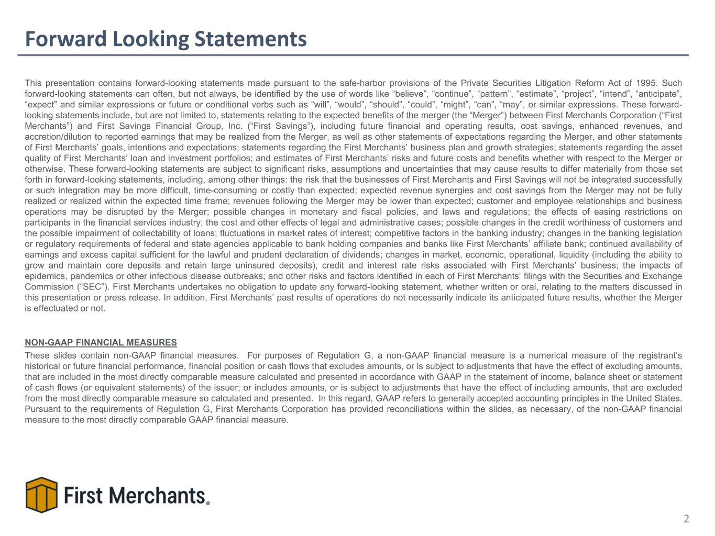
Forward Looking Statements This presentation contains forward-looking statements made pursuant to the safe-harbor provisions of the Private Securities Litigation Reform Act of 1995. Such forward-looking statements can often, but not always, be identified by the use of words like “believe”, “continue”, “pattern”, “estimate”, “project”, “intend”, “anticipate”, “expect” and similar expressions or future or conditional verbs such as “will”, “would”, “should”, “could”, “might”, “can”, “may”, or similar expressions. These forward- looking statements include, but are not limited to, statements relating to the expected benefits of the merger (the “Merger”) between First Merchants Corporation (“First Merchants”) and First Savings Financial Group, Inc. (“First Savings”), including future financial and operating results, cost savings, enhanced revenues, and accretion/dilution to reported earnings that may be realized from the Merger, as well as other statements of expectations regarding the Merger, and other statements of First Merchants’ goals, intentions and expectations; statements regarding the First Merchants’ business plan and growth strategies; statements regarding the asset quality of First Merchants’ loan and investment portfolios; and estimates of First Merchants’ risks and future costs and benefits whether with respect to the Merger or otherwise. These forward-looking statements are subject to significant risks, assumptions and uncertainties that may cause results to differ materially from those set forth in forward-looking statements, including, among other things: the risk that the businesses of First Merchants and First Savings will not be integrated successfully or such integration may be more difficult, time-consuming or costly than expected; expected revenue synergies and cost savings from the Merger may not be fully realized or realized within the expected time frame; revenues following the Merger may be lower than expected; customer and employee relationships and business operations may be disrupted by the Merger; possible changes in monetary and fiscal policies, and laws and regulations; the effects of easing restrictions on participants in the financial services industry; the cost and other effects of legal and administrative cases; possible changes in the credit worthiness of customers and the possible impairment of collectability of loans; fluctuations in market rates of interest; competitive factors in the banking industry; changes in the banking legislation or regulatory requirements of federal and state agencies applicable to bank holding companies and banks like First Merchants’ affiliate bank; continued availability of earnings and excess capital sufficient for the lawful and prudent declaration of dividends; changes in market, economic, operational, liquidity (including the ability to grow and maintain core deposits and retain large uninsured deposits), credit and interest rate risks associated with First Merchants’ business; the impacts of epidemics, pandemics or other infectious disease outbreaks; and other risks and factors identified in each of First Merchants’ filings with the Securities and Exchange Commission (“SEC”). First Merchants undertakes no obligation to update any forward-looking statement, whether written or oral, relating to the matters discussed in this presentation or press release. In addition, First Merchants’ past results of operations do not necessarily indicate its anticipated future results, whether the Merger is effectuated or not. NON-GAAP FINANCIAL MEASURES These slides contain non-GAAP financial measures. For purposes of Regulation G, a non-GAAP financial measure is a numerical measure of the registrant’s historical or future financial performance, financial position or cash flows that excludes amounts, or is subject to adjustments that have the effect of excluding amounts, that are included in the most directly comparable measure calculated and presented in accordance with GAAP in the statement of income, balance sheet or statement of cash flows (or equivalent statements) of the issuer; or includes amounts, or is subject to adjustments that have the effect of including amounts, that are excluded from the most directly comparable measure so calculated and presented. In this regard, GAAP refers to generally accepted accounting principles in the United States. Pursuant to the requirements of Regulation G, First Merchants Corporation has provided reconciliations within the slides, as necessary, of the non-GAAP financial measure to the most directly comparable GAAP financial measure. 2


Executive Management Team 3 Mark Hardwick Chief Executive Officer Mark K. Hardwick currently serves as the Chief Executive Officer of First Merchants Corporation and First Merchants Bank. Mark joined First Merchants in November of 1997 as Corporate Controller and was promoted to Chief Financial Officer in April of 2002. In 2016, Mark’s title expanded to include Chief Operating Officer, overseeing the leadership responsibilities for finance, operations, technology, risk, legal, and facilities for the corporation. Prior to joining First Merchants Corporation, Mark served as a senior accountant with BKD, LLP in Indianapolis. Mark is a graduate of Ball State University with a Master of Business Administration and Bachelor’s degree in Accounting. He is also a certified public accountant and a graduate of the Stonier School of Banking. FMB: 28 Yrs Banking: 28 Yrs FMB: 11 Yrs Banking: 23 Yrs Michele Kawiecki Chief Financial Officer Michele Kawiecki currently serves as Executive Vice President and Chief Financial Officer for First Merchants Corporation and First Merchants Bank. Michele joined First Merchants in 2015 as Director of Finance. Prior to joining First Merchants, Michele spent 12 years with UMB Financial Corporation in Kansas City, Missouri having served as Senior Vice President of Capital Management and Assistant Treasurer; Director of Corporate Development and the Enterprise Project Management Office; and Chief Risk Officer. Prior to UMB, she worked for PriceWaterhouseCoopers LLP as an Audit Manager. Michele earned both a Master of Science in Accounting and an Executive Master of Business Administration from the University of Missouri-Kansas City and a Bachelor’s degree in Accounting from Dakota Wesleyan University. FMB: 18 Yrs Banking: 37 Yrs Mike Stewart President Mike Stewart currently serves as President for First Merchants Corporation and First Merchants Bank overseeing the Commercial, Private Wealth, and Consumer Lines of Business for the Bank. Mike joined the bank in 2008 as Chief Banking Officer. Prior to joining First Merchants, Mike spent 18 years with National City Bank in various commercial sales and credit roles. Mike has a Master of Business Administration from Butler University and a Bachelor’s degree in Finance from Millikin University. FMB: 18 Yrs Banking: 36 Yrs John Martin Chief Credit Officer John Martin currently serves as Executive Vice President and Chief Credit Officer of First Merchants Corporation overseeing the Commercial, Small Business and Consumer Credit functions, as well as Bank Operations and the Mortgage Line of Business. Prior to joining First Merchants, John spent 18 years with National City Bank in various sales and senior credit roles. John is a graduate of Indiana University where he earned a Bachelor of Arts in Economics. He also holds a Master of Business Administration in Finance from Case Western Reserve University. Mark Hardwick – 11/03/1997 Mike Stewart - 02/01/2008 1988 Banking Start John Martin – 12/31/2007 Michele Kawiecki – 03/02/2015

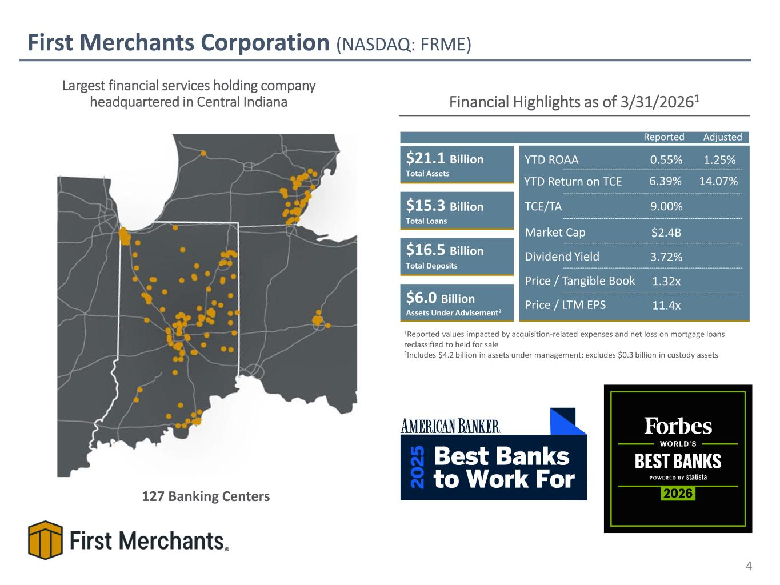
First Merchants Corporation (NASDAQ: FRME) Financial Highlights as of 3/31/20261 $21.1 Billion $15.3 Billion $16.5 Billion $6.0 Billion Assets Under Advisement2 Total Assets Total Loans Total Deposits TCE/TA YTD Return on TCE YTD ROAA Dividend Yield Price / Tangible Book Price / LTM EPS 0.55% 9.00% 6.39% 3.72% 1.32x 11.4x Market Cap $2.4B Largest financial services holding company headquartered in Central Indiana 127 Banking Centers 1Reported values impacted by acquisition-related expenses and net loss on mortgage loans reclassified to held for sale 2Includes $4.2 billion in assets under management; excludes $0.3 billion in custody assets 4 1.25% 14.07% Reported Adjusted

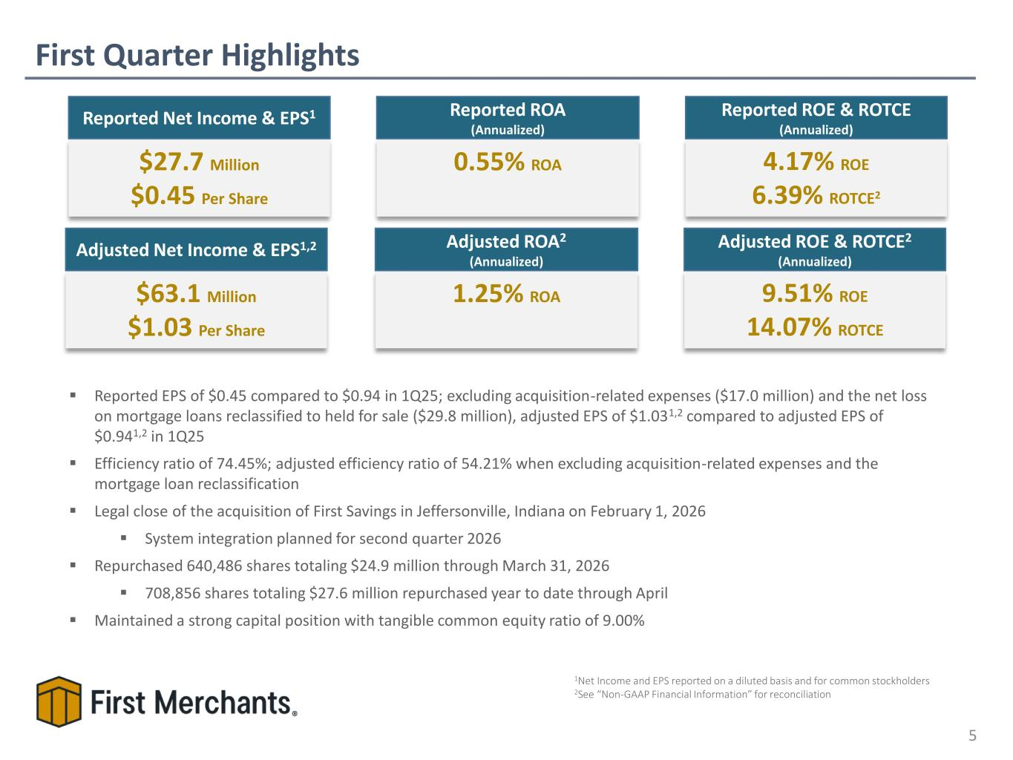
First Quarter Highlights 5 ▪ Reported EPS of $0.45 compared to $0.94 in 1Q25; excluding acquisition-related expenses ($17.0 million) and the net loss on mortgage loans reclassified to held for sale ($29.8 million), adjusted EPS of $1.031,2 compared to adjusted EPS of $0.941,2 in 1Q25 ▪ Efficiency ratio of 74.45%; adjusted efficiency ratio of 54.21% when excluding acquisition-related expenses and the mortgage loan reclassification ▪ Legal close of the acquisition of First Savings in Jeffersonville, Indiana on February 1, 2026 ▪ System integration planned for second quarter 2026 ▪ Repurchased 640,486 shares totaling $24.9 million through March 31, 2026 ▪ 708,856 shares totaling $27.6 million repurchased year to date through April ▪ Maintained a strong capital position with tangible common equity ratio of 9.00% 4.17% ROE 6.39% ROTCE2 Reported ROE & ROTCE (Annualized) $27.7 Million $0.45 Per Share Reported Net Income & EPS1 0.55% ROA Reported ROA (Annualized) 1Net Income and EPS reported on a diluted basis and for common stockholders 2See “Non-GAAP Financial Information” for reconciliation $63.1 Million $1.03 Per Share Adjusted Net Income & EPS1,2 9.51% ROE 14.07% ROTCE Adjusted ROE & ROTCE2 (Annualized) 1.25% ROA Adjusted ROA2 (Annualized)

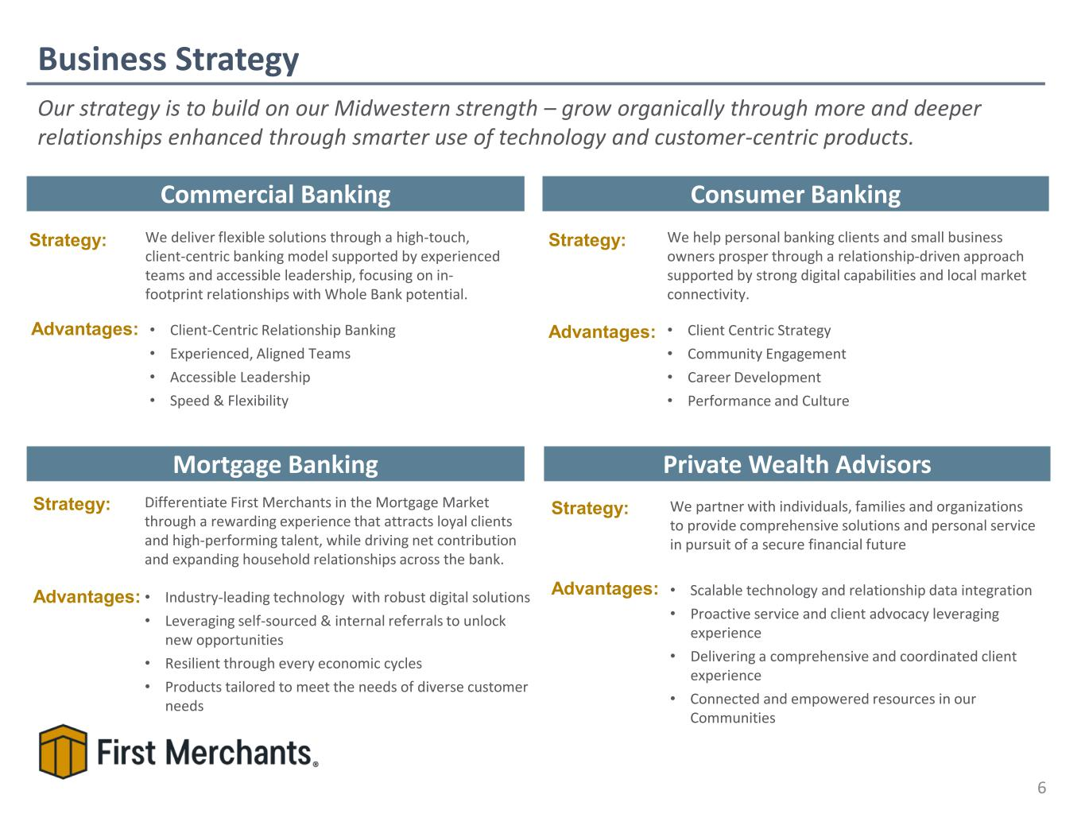
Business Strategy 6 Commercial Banking Private Wealth Advisors Consumer Banking Mortgage Banking Strategy: Advantages: We deliver flexible solutions through a high-touch, client-centric banking model supported by experienced teams and accessible leadership, focusing on in- footprint relationships with Whole Bank potential. • Client-Centric Relationship Banking • Experienced, Aligned Teams • Accessible Leadership • Speed & Flexibility Strategy: We help personal banking clients and small business owners prosper through a relationship-driven approach supported by strong digital capabilities and local market connectivity. • Client Centric Strategy • Community Engagement • Career Development • Performance and Culture Advantages: Strategy: We partner with individuals, families and organizations to provide comprehensive solutions and personal service in pursuit of a secure financial future • Scalable technology and relationship data integration • Proactive service and client advocacy leveraging experience • Delivering a comprehensive and coordinated client experience • Connected and empowered resources in our Communities Advantages: Strategy: Differentiate First Merchants in the Mortgage Market through a rewarding experience that attracts loyal clients and high-performing talent, while driving net contribution and expanding household relationships across the bank. • Industry-leading technology with robust digital solutions • Leveraging self-sourced & internal referrals to unlock new opportunities • Resilient through every economic cycles • Products tailored to meet the needs of diverse customer needs Advantages: Our strategy is to build on our Midwestern strength – grow organically through more and deeper relationships enhanced through smarter use of technology and customer-centric products.

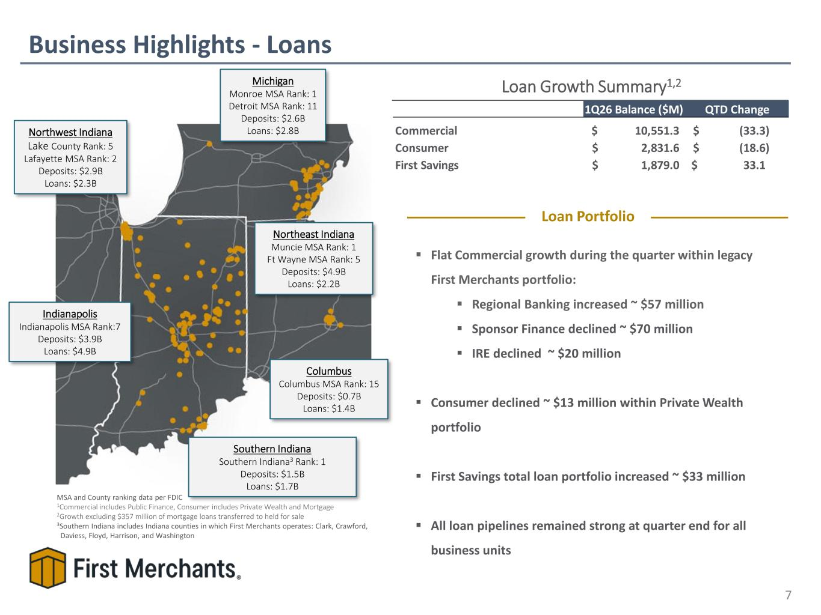
Loan Growth Summary1,2 Business Highlights - Loans 7 MSA and County ranking data per FDIC 1Commercial includes Public Finance, Consumer includes Private Wealth and Mortgage 2Growth excluding $357 million of mortgage loans transferred to held for sale 3Southern Indiana includes Indiana counties in which First Merchants operates: Clark, Crawford, Daviess, Floyd, Harrison, and Washington Indianapolis Indianapolis MSA Rank:7 Deposits: $3.9B Loans: $4.9B Columbus Columbus MSA Rank: 15 Deposits: $0.7B Loans: $1.4B Northwest Indiana Lake County Rank: 5 Lafayette MSA Rank: 2 Deposits: $2.9B Loans: $2.3B Northeast Indiana Muncie MSA Rank: 1 Ft Wayne MSA Rank: 5 Deposits: $4.9B Loans: $2.2B Michigan Monroe MSA Rank: 1 Detroit MSA Rank: 11 Deposits: $2.6B Loans: $2.8B Southern Indiana Southern Indiana3 Rank: 1 Deposits: $1.5B Loans: $1.7B 1Q26 Balance ($M) QTD Change Commercial 10,551.3$ (33.3)$ Consumer 2,831.6$ (18.6)$ First Savings 1,879.0$ 33.1$ ▪ Flat Commercial growth during the quarter within legacy First Merchants portfolio: ▪ Regional Banking increased ~ $57 million ▪ Sponsor Finance declined ~ $70 million ▪ IRE declined ~ $20 million ▪ Consumer declined ~ $13 million within Private Wealth portfolio ▪ First Savings total loan portfolio increased ~ $33 million ▪ All loan pipelines remained strong at quarter end for all business units Loan Portfolio

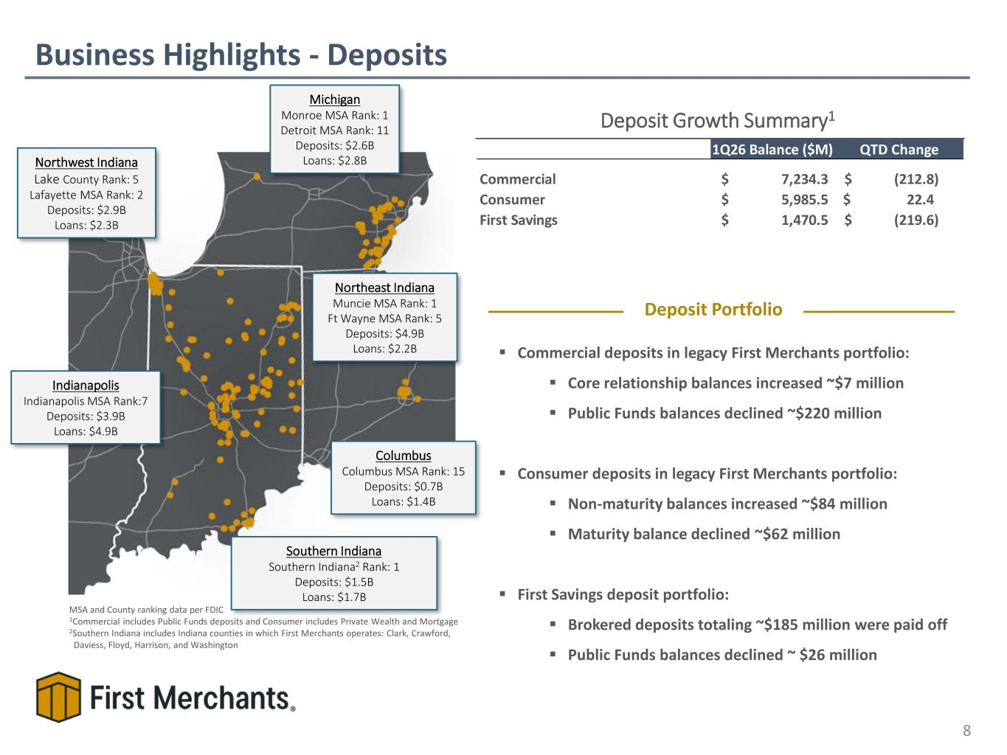
Deposit Growth Summary1 Business Highlights - Deposits 8 MSA and County ranking data per FDIC 1Commercial includes Public Funds deposits and Consumer includes Private Wealth and Mortgage 2Southern Indiana includes Indiana counties in which First Merchants operates: Clark, Crawford, Daviess, Floyd, Harrison, and Washington Indianapolis Indianapolis MSA Rank:7 Deposits: $3.9B Loans: $4.9B Columbus Columbus MSA Rank: 15 Deposits: $0.7B Loans: $1.4B Northwest Indiana Lake County Rank: 5 Lafayette MSA Rank: 2 Deposits: $2.9B Loans: $2.3B Northeast Indiana Muncie MSA Rank: 1 Ft Wayne MSA Rank: 5 Deposits: $4.9B Loans: $2.2B Michigan Monroe MSA Rank: 1 Detroit MSA Rank: 11 Deposits: $2.6B Loans: $2.8B Southern Indiana Southern Indiana2 Rank: 1 Deposits: $1.5B Loans: $1.7B ▪ Commercial deposits in legacy First Merchants portfolio: ▪ Core relationship balances increased ~$7 million ▪ Public Funds balances declined ~$220 million ▪ Consumer deposits in legacy First Merchants portfolio: ▪ Non-maturity balances increased ~$84 million ▪ Maturity balance declined ~$62 million ▪ First Savings deposit portfolio: ▪ Brokered deposits totaling ~$185 million were paid off ▪ Public Funds balances declined ~ $26 million Deposit Portfolio 1Q26 Balance ($M) QTD Change Commercial 7,234.3$ (212.8)$ Consumer 5,985.5$ 22.4$ First Savings 1,470.5$ (219.6)$

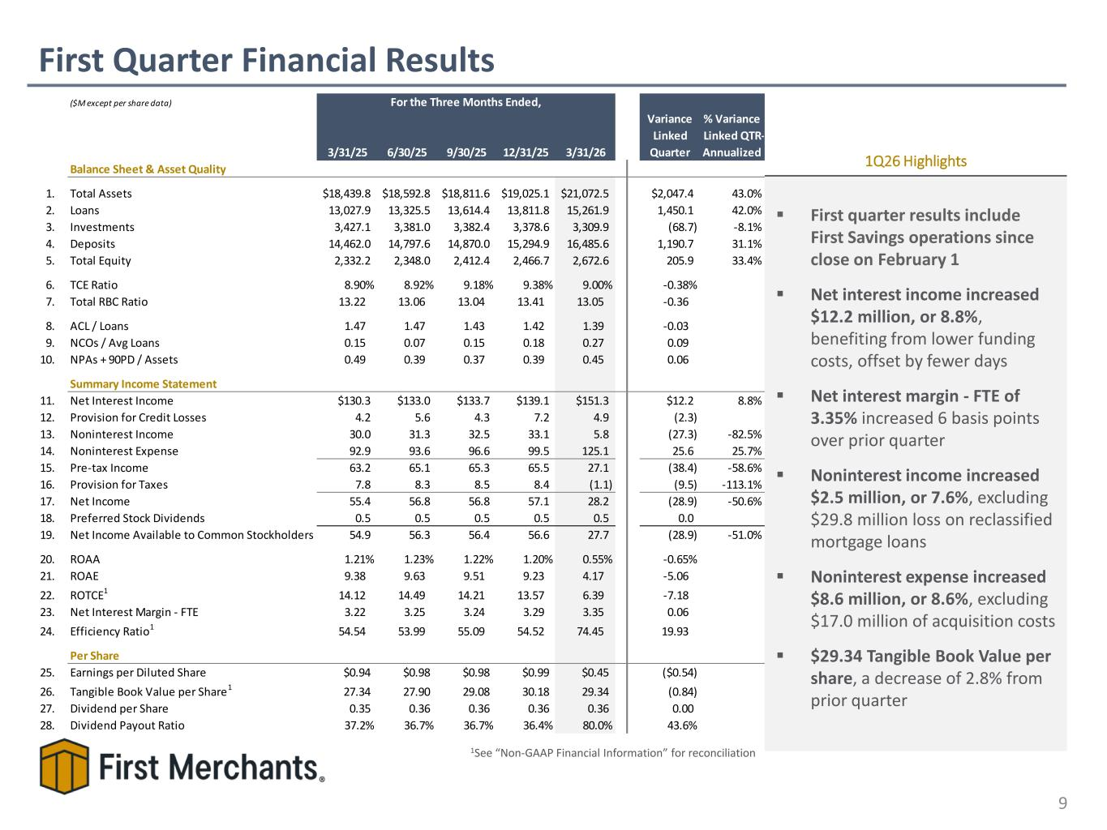
First Quarter Financial Results 9 ▪ First quarter results include First Savings operations since close on February 1 ▪ Net interest income increased $12.2 million, or 8.8%, benefiting from lower funding costs, offset by fewer days ▪ Net interest margin - FTE of 3.35% increased 6 basis points over prior quarter ▪ Noninterest income increased $2.5 million, or 7.6%, excluding $29.8 million loss on reclassified mortgage loans ▪ Noninterest expense increased $8.6 million, or 8.6%, excluding $17.0 million of acquisition costs ▪ $29.34 Tangible Book Value per share, a decrease of 2.8% from prior quarter 1Q26 Highlights 1See “Non-GAAP Financial Information” for reconciliation ($M except per share data) 3/31/25 6/30/25 9/30/25 12/31/25 3/31/26 Variance Linked Quarter % Variance Linked QTR- Annualized Balance Sheet & Asset Quality 1. Total Assets $18,439.8 $18,592.8 $18,811.6 $19,025.1 $21,072.5 $2,047.4 43.0% 2. Loans 13,027.9 13,325.5 13,614.4 13,811.8 15,261.9 1,450.1 42.0% 3. Investments 3,427.1 3,381.0 3,382.4 3,378.6 3,309.9 (68.7) -8.1% 4. Deposits 14,462.0 14,797.6 14,870.0 15,294.9 16,485.6 1,190.7 31.1% 5. Total Equity 2,332.2 2,348.0 2,412.4 2,466.7 2,672.6 205.9 33.4% 6. TCE Ratio 8.90% 8.92% 9.18% 9.38% 9.00% -0.38% 7. Total RBC Ratio 13.22 13.06 13.04 13.41 13.05 -0.36 8. ACL / Loans 1.47 1.47 1.43 1.42 1.39 -0.03 9. NCOs / Avg Loans 0.15 0.07 0.15 0.18 0.27 0.09 10. NPAs + 90PD / Assets 0.49 0.39 0.37 0.39 0.45 0.06 Summary Income Statement 11. Net Interest Income $130.3 $133.0 $133.7 $139.1 $151.3 $12.2 8.8% 12. Provision for Credit Losses 4.2 5.6 4.3 7.2 4.9 (2.3) 13. Noninterest Income 30.0 31.3 32.5 33.1 5.8 (27.3) -82.5% 14. Noninterest Expense 92.9 93.6 96.6 99.5 125.1 25.6 25.7% 15. Pre-tax Income 63.2 65.1 65.3 65.5 27.1 (38.4) -58.6% 16. Provision for Taxes 7.8 8.3 8.5 8.4 (1.1) (9.5) -113.1% 17. Net Income 55.4 56.8 56.8 57.1 28.2 (28.9) -50.6% 18. Preferred Stock Dividends 0.5 0.5 0.5 0.5 0.5 0.0 19. Net Income Available to Common Stockholders 54.9 56.3 56.4 56.6 27.7 (28.9) -51.0% 20. ROAA 1.21% 1.23% 1.22% 1.20% 0.55% -0.65% 21. ROAE 9.38 9.63 9.51 9.23 4.17 -5.06 22. ROTCE1 14.12 14.49 14.21 13.57 6.39 -7.18 23. Net Interest Margin - FTE 3.22 3.25 3.24 3.29 3.35 0.06 24. Efficiency Ratio1 54.54 53.99 55.09 54.52 74.45 19.93 Per Share 25. Earnings per Diluted Share $0.94 $0.98 $0.98 $0.99 $0.45 ($0.54) 26. Tangible Book Value per Share1 27.34 27.90 29.08 30.18 29.34 (0.84) 27. Dividend per Share 0.35 0.36 0.36 0.36 0.36 0.00 28. Dividend Payout Ratio 37.2% 36.7% 36.7% 36.4% 80.0% 43.6% For the Three Months Ended,

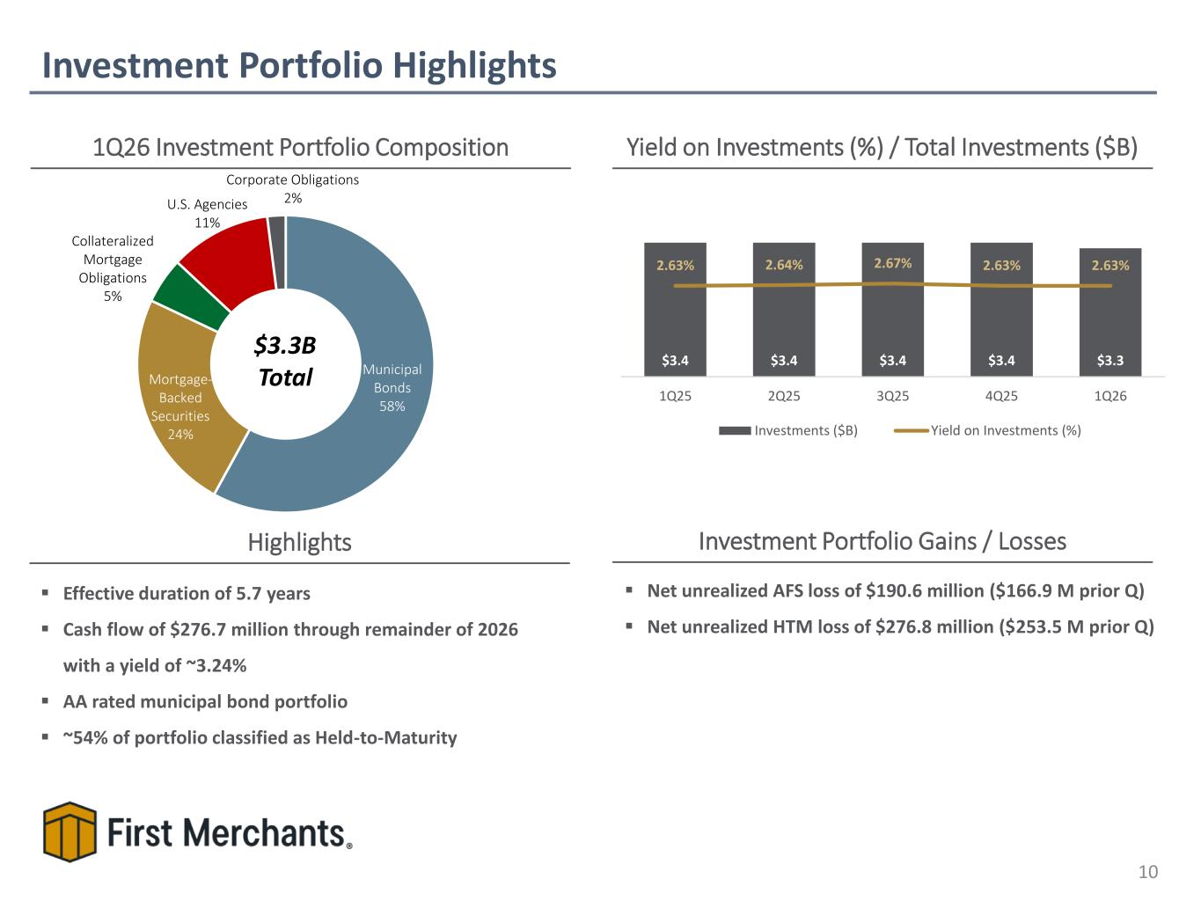
▪ Net unrealized AFS loss of $190.6 million ($166.9 M prior Q) ▪ Net unrealized HTM loss of $276.8 million ($253.5 M prior Q) Investment Portfolio Highlights 10 1Q26 Investment Portfolio Composition Yield on Investments (%) / Total Investments ($B) $3.3B Total Investment Portfolio Gains / LossesHighlights ▪ Effective duration of 5.7 years ▪ Cash flow of $276.7 million through remainder of 2026 with a yield of ~3.24% ▪ AA rated municipal bond portfolio ▪ ~54% of portfolio classified as Held-to-Maturity Municipal Bonds 58% Mortgage- Backed Securities 24% Collateralized Mortgage Obligations 5% U.S. Agencies 11% Corporate Obligations 2% $3.4 $3.4 $3.4 $3.4 $3.3 2.63% 2.64% 2.67% 2.63% 2.63% 1Q25 2Q25 3Q25 4Q25 1Q26 Investments ($B) Yield on Investments (%)

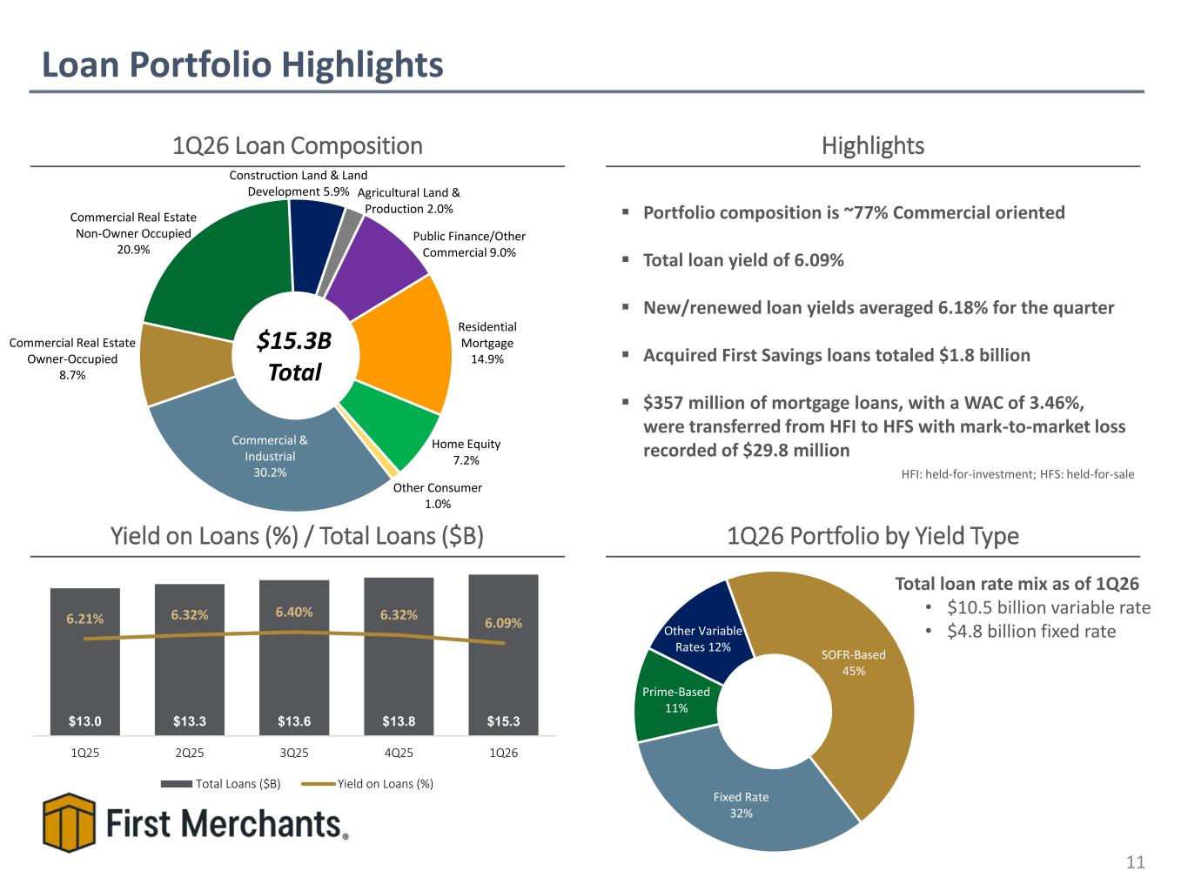
Loan Portfolio Highlights 11 1Q26 Loan Composition Yield on Loans (%) / Total Loans ($B) $15.3B Total 1Q26 Portfolio by Yield Type Highlights Total loan rate mix as of 1Q26 • $10.5 billion variable rate • $4.8 billion fixed rate ▪ Portfolio composition is ~77% Commercial oriented ▪ Total loan yield of 6.09% ▪ New/renewed loan yields averaged 6.18% for the quarter ▪ Acquired First Savings loans totaled $1.8 billion ▪ $357 million of mortgage loans, with a WAC of 3.46%, were transferred from HFI to HFS with mark-to-market loss recorded of $29.8 million $0.9 $0.7 $0.7$0.4$0.7$0.7 $13.0 $13.3 $13.6 $13.8 $15.3 6.21% 6.32% 6.40% 6.32% 6.09% 1Q25 2Q25 3Q25 4Q25 1Q26 Total Loans ($B) Yield on Loans (%) Commercial & Industrial 30.2% Commercial Real Estate Owner-Occupied 8.7% Commercial Real Estate Non-Owner Occupied 20.9% Construction Land & Land Development 5.9% Agricultural Land & Production 2.0% Public Finance/Other Commercial 9.0% Residential Mortgage 14.9% Home Equity 7.2% Other Consumer 1.0% Fixed Rate 32% Prime-Based 11% Other Variable Rates 12% SOFR-Based 45% HFI: held-for-investment; HFS: held-for-sale

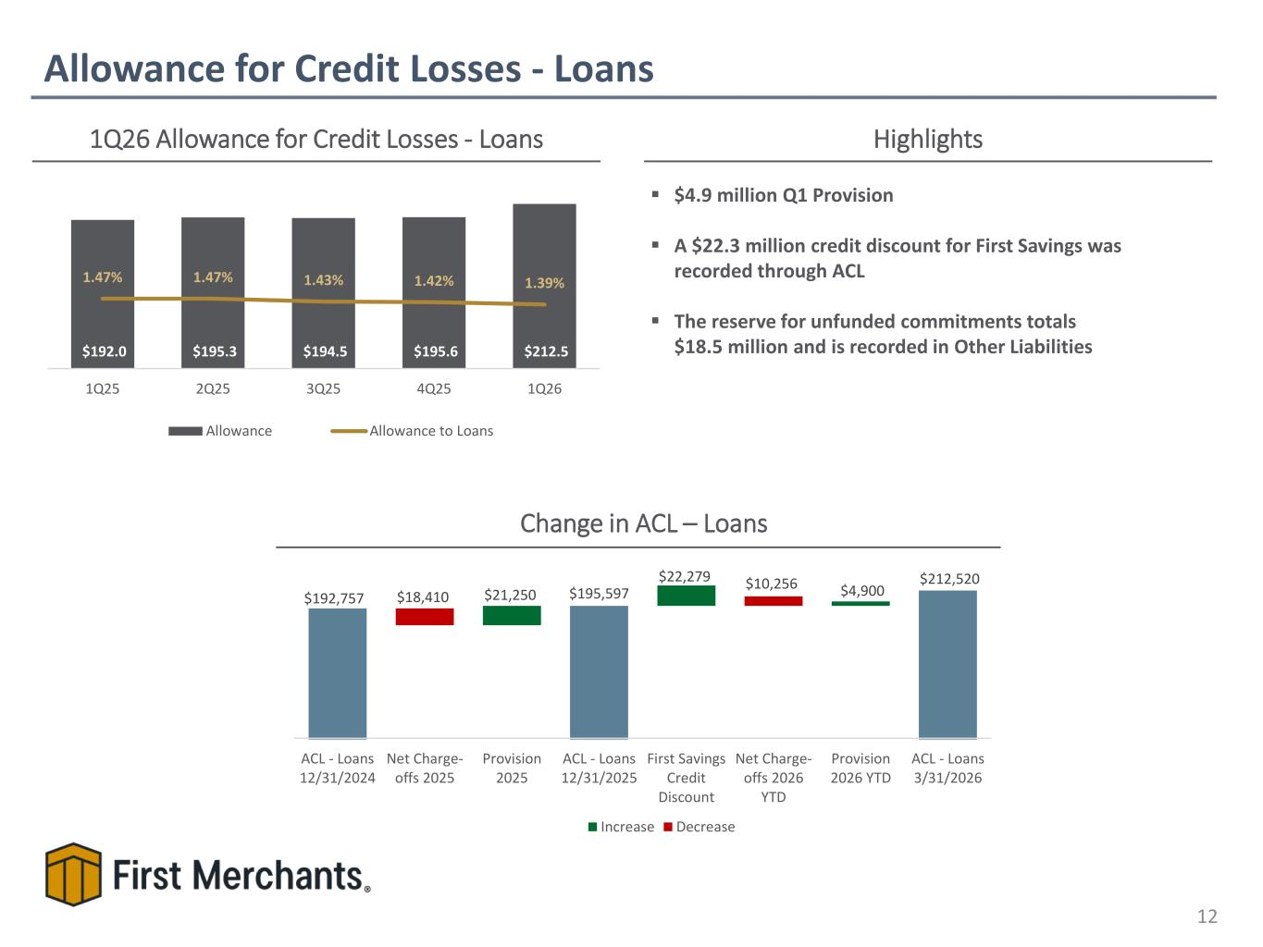
Allowance for Credit Losses - Loans 12 1Q26 Allowance for Credit Losses - Loans Highlights Change in ACL – Loans ▪ $4.9 million Q1 Provision ▪ A $22.3 million credit discount for First Savings was recorded through ACL ▪ The reserve for unfunded commitments totals $18.5 million and is recorded in Other Liabilities$192.0 $195.3 $194.5 $195.6 $212.5 1.47% 1.47% 1.43% 1.42% 1.39% 1Q25 2Q25 3Q25 4Q25 1Q26 Allowance Allowance to Loans $192,757 $195,597 $212,520 $21,250 $22,279 $4,900 $18,410 $10,256 ACL - Loans 12/31/2024 Net Charge- offs 2025 Provision 2025 ACL - Loans 12/31/2025 First Savings Credit Discount Net Charge- offs 2026 YTD Provision 2026 YTD ACL - Loans 3/31/2026 Increase Decrease

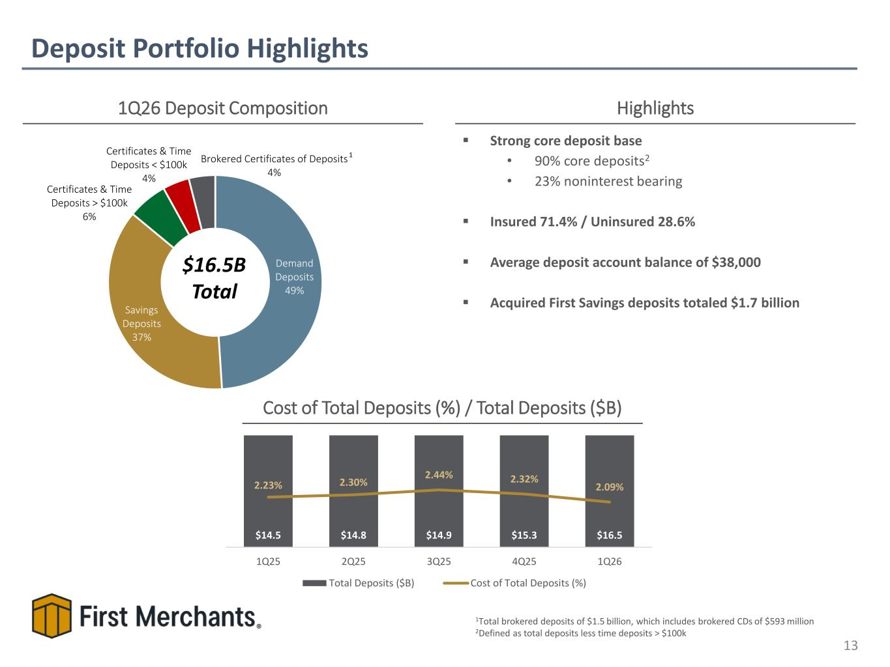
Deposit Portfolio Highlights 13 1Q26 Deposit Composition Highlights $16.5B Total 1Total brokered deposits of $1.5 billion, which includes brokered CDs of $593 million 2Defined as total deposits less time deposits > $100k Cost of Total Deposits (%) / Total Deposits ($B) ▪ Strong core deposit base • 90% core deposits2 • 23% noninterest bearing ▪ Insured 71.4% / Uninsured 28.6% ▪ Average deposit account balance of $38,000 ▪ Acquired First Savings deposits totaled $1.7 billion 1 Demand Deposits 49% Savings Deposits 37% Certificates & Time Deposits > $100k 6% Certificates & Time Deposits < $100k 4% Brokered Certificates of Deposits 4% $14.5 $14.8 $14.9 $15.3 $16.5 2.23% 2.30% 2.44% 2.32% 2.09% 1Q25 2Q25 3Q25 4Q25 1Q26 Total Deposits ($B) Cost of Total Deposits (%)

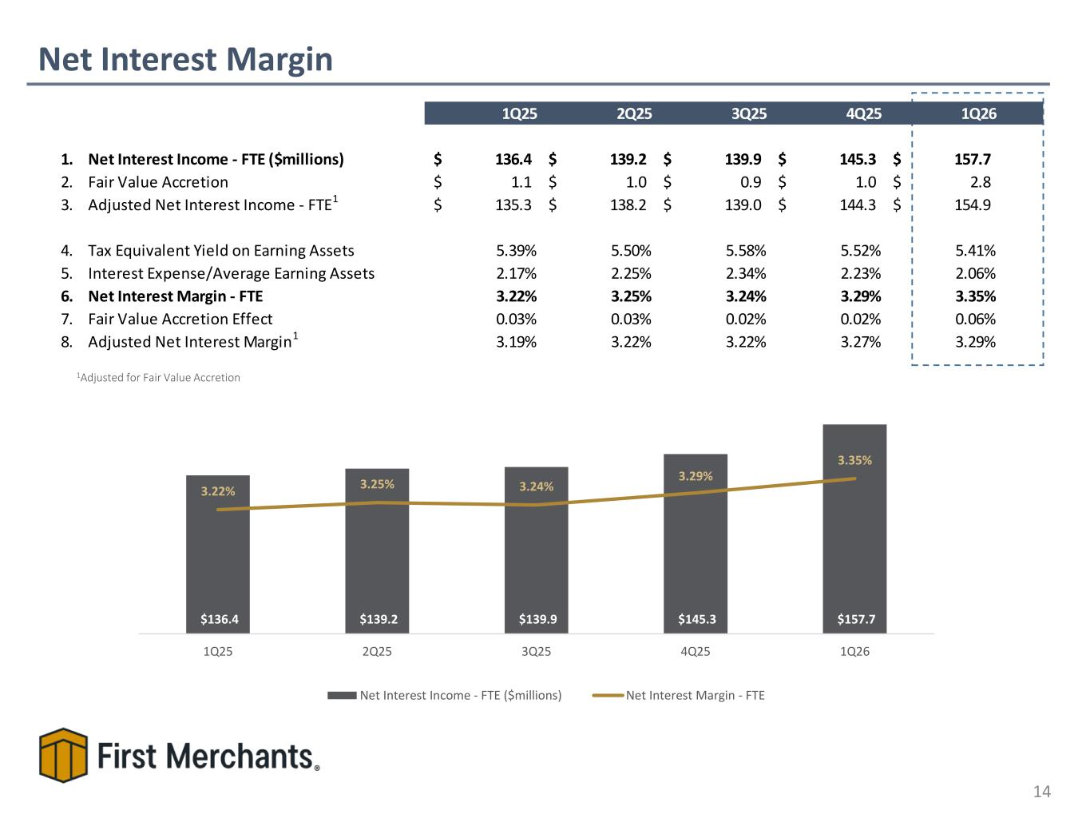
Net Interest Margin 14 $105.1$97.1 $97.3 $105.1 $107.0$97.8 $107.0 $97.3 $105.1 $110.0$109.2 $107.0 $105.1 $109.2 $110.0 $106.9 1Adjusted for Fair Value Accretion 1Q25 2Q25 3Q25 4Q25 1Q26 1. Net Interest Income - FTE ($millions) 136.4$ 139.2$ 139.9$ 145.3$ 157.7$ 2. Fair Value Accretion 1.1$ 1.0$ 0.9$ 1.0$ 2.8$ 3. Adjusted Net Interest Income - FTE1 135.3$ 138.2$ 139.0$ 144.3$ 154.9$ 4. Tax Equivalent Yield on Earning Assets 5.39% 5.50% 5.58% 5.52% 5.41% 5. Interest Expense/Average Earning Assets 2.17% 2.25% 2.34% 2.23% 2.06% 6. Net Interest Margin - FTE 3.22% 3.25% 3.24% 3.29% 3.35% 7. Fair Value Accretion Effect 0.03% 0.03% 0.02% 0.02% 0.06% 8. Adjusted Net Interest Margin1 3.19% 3.22% 3.22% 3.27% 3.29% $136.4 $139.2 $139.9 $145.3 $157.7 3.22% 3.25% 3.24% 3.29% 3.35% 1Q25 2Q25 3Q25 4Q25 1Q26 Net Interest Income - FTE ($millions) Net Interest Margin - FTE

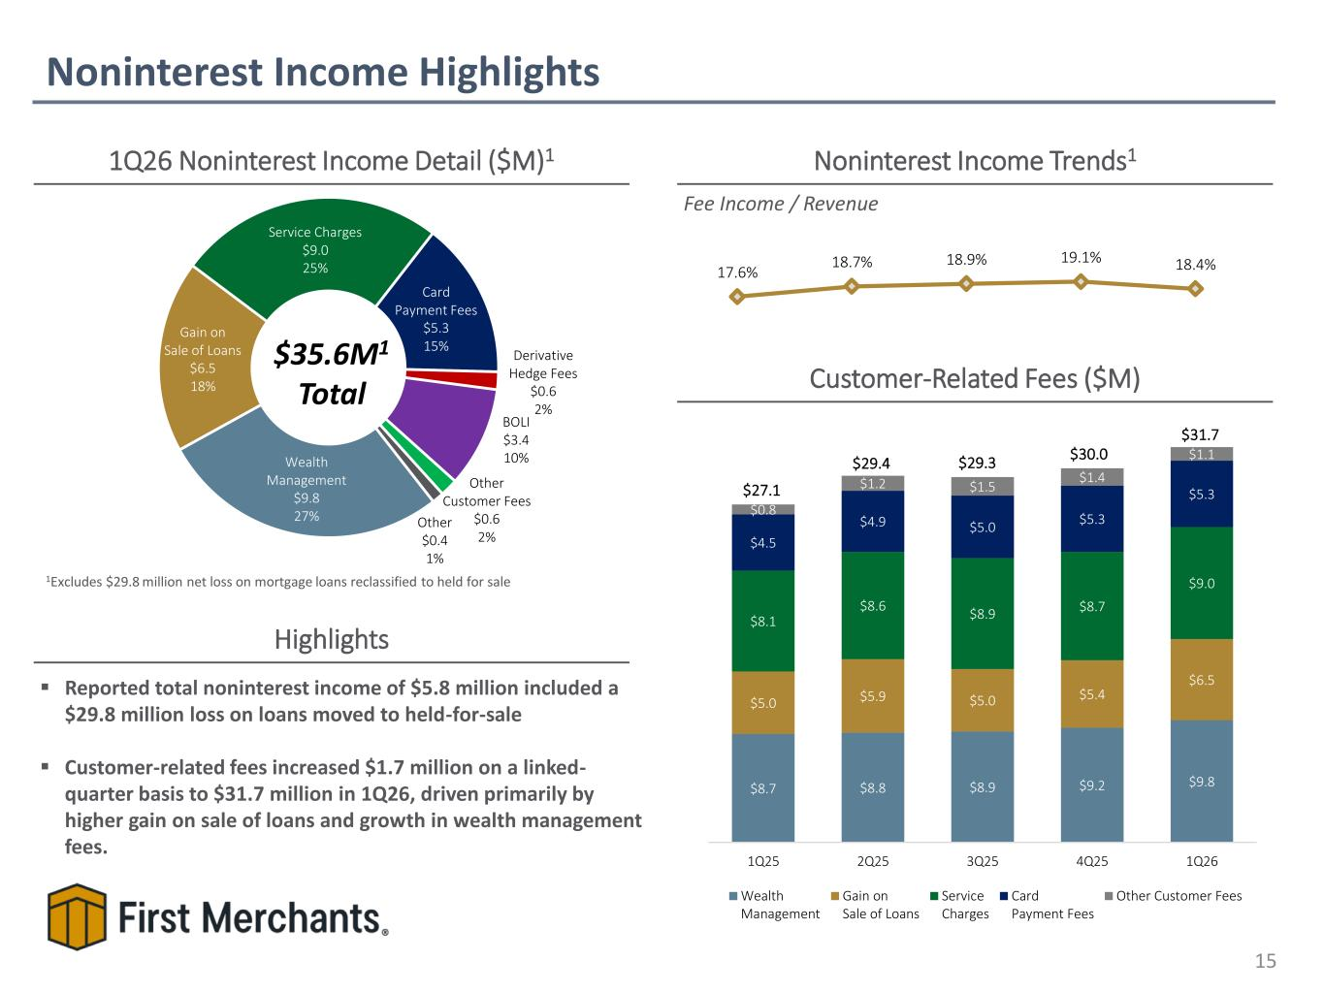
Wealth Management $9.8 27% Gain on Sale of Loans $6.5 18% Service Charges $9.0 25% Card Payment Fees $5.3 15% Derivative Hedge Fees $0.6 2% BOLI $3.4 10% Other Customer Fees $0.6 2% Other $0.4 1% Noninterest Income Highlights 15 1Q26 Noninterest Income Detail ($M)1 $35.6M1 Total Noninterest Income Trends1 Fee Income / Revenue Highlights ▪ Reported total noninterest income of $5.8 million included a $29.8 million loss on loans moved to held-for-sale ▪ Customer-related fees increased $1.7 million on a linked- quarter basis to $31.7 million in 1Q26, driven primarily by higher gain on sale of loans and growth in wealth management fees. Customer-Related Fees ($M) $8.7 $8.8 $8.9 $9.2 $9.8 $5.0 $5.9 $5.0 $5.4 $6.5 $8.1 $8.6 $8.9 $8.7 $9.0 $4.5 $4.9 $5.0 $5.3 $5.3 $0.8 $1.2 $1.5 $1.4 $1.1 $27.1 $29.4 $29.3 $30.0 $31.7 1Q25 2Q25 3Q25 4Q25 1Q26 Wealth Management Gain on Sale of Loans Service Charges Card Payment Fees Other Customer Fees 17.6% 18.7% 18.9% 19.1% 18.4% 1Excludes $29.8 million net loss on mortgage loans reclassified to held for sale

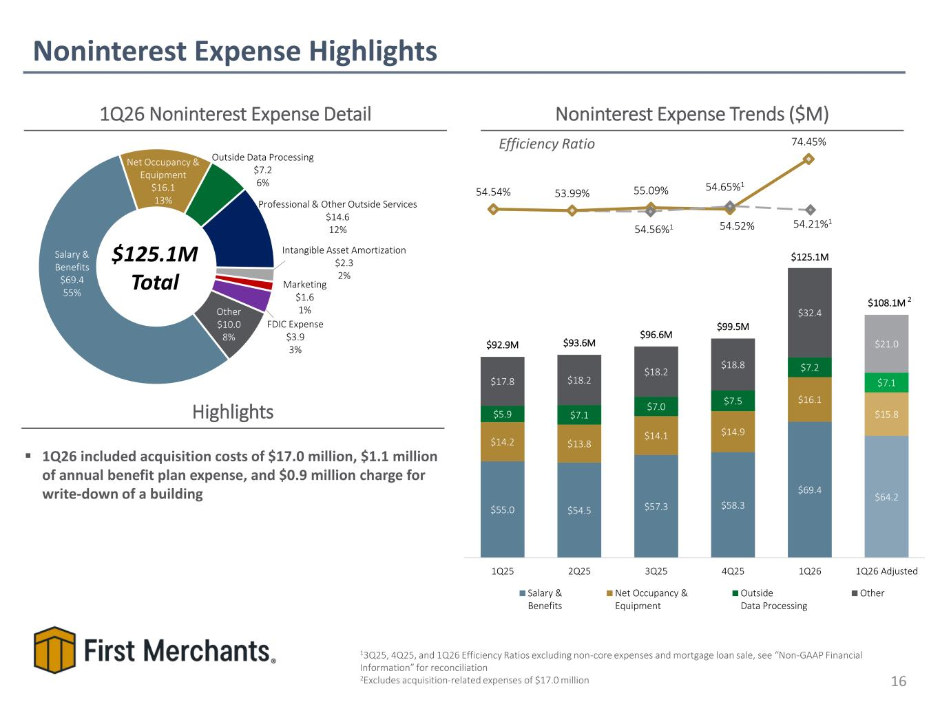
54.54% 53.99% 55.09% 54.52% 74.45% Salary & Benefits $69.4 55% Net Occupancy & Equipment $16.1 13% Outside Data Processing $7.2 6% Professional & Other Outside Services $14.6 12% Intangible Asset Amortization $2.3 2% Marketing $1.6 1% FDIC Expense $3.9 3% Other $10.0 8% Noninterest Expense Highlights 16 1Q26 Noninterest Expense Detail $125.1M Total Noninterest Expense Trends ($M) Efficiency Ratio Highlights ▪ 1Q26 included acquisition costs of $17.0 million, $1.1 million of annual benefit plan expense, and $0.9 million charge for write-down of a building 13Q25, 4Q25, and 1Q26 Efficiency Ratios excluding non-core expenses and mortgage loan sale, see “Non-GAAP Financial Information” for reconciliation 2Excludes acquisition-related expenses of $17.0 million 54.21%1 54.56%1 54.65%1 $55.0 $54.5 $57.3 $58.3 $69.4 $64.2 $14.2 $13.8 $14.1 $14.9 $16.1 $15.8 $5.9 $7.1 $7.0 $7.5 $7.2 $7.1 $17.8 $18.2 $18.2 $18.8 $32.4 $21.0 $92.9M $93.6M $96.6M $99.5M $125.1M $108.1M 1Q25 2Q25 3Q25 4Q25 1Q26 1Q26 Adjusted Salary & Benefits Net Occupancy & Equipment Outside Data Processing Other 2

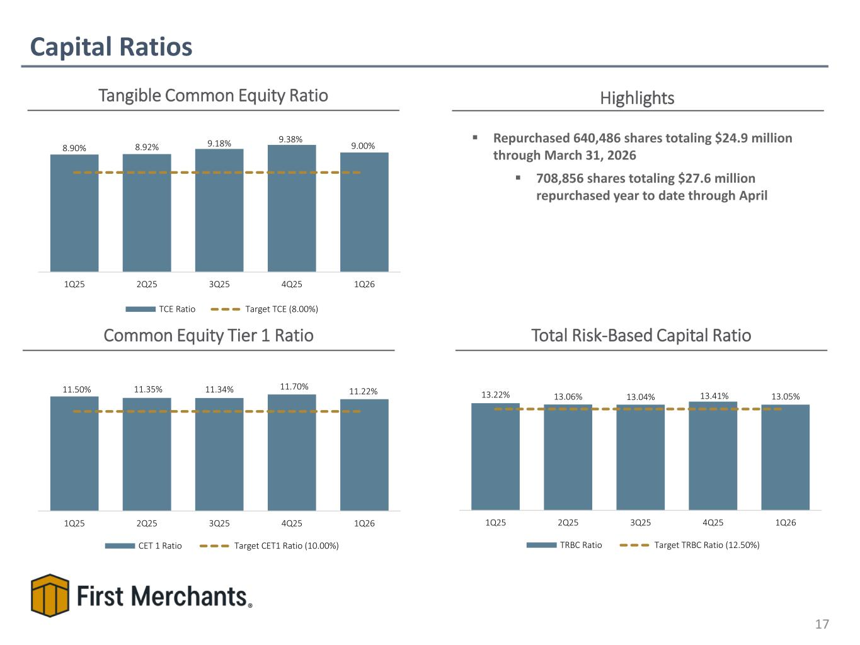
Capital Ratios 17 Tangible Common Equity Ratio Common Equity Tier 1 Ratio Total Risk-Based Capital Ratio 9.31% 9.31% 9.57% 9.31% 9.65%9.57%9.31% 9.57% 9.65% ▪ Repurchased 640,486 shares totaling $24.9 million through March 31, 2026 ▪ 708,856 shares totaling $27.6 million repurchased year to date through April Highlights 8.90% 8.92% 9.18% 9.38% 9.00% 1Q25 2Q25 3Q25 4Q25 1Q26 TCE Ratio Target TCE (8.00%) 11.50% 11.35% 11.34% 11.70% 11.22% 1Q25 2Q25 3Q25 4Q25 1Q26 CET 1 Ratio Target CET1 Ratio (10.00%) 13.22% 13.06% 13.04% 13.41% 13.05% 1Q25 2Q25 3Q25 4Q25 1Q26 TRBC Ratio Target TRBC Ratio (12.50%)

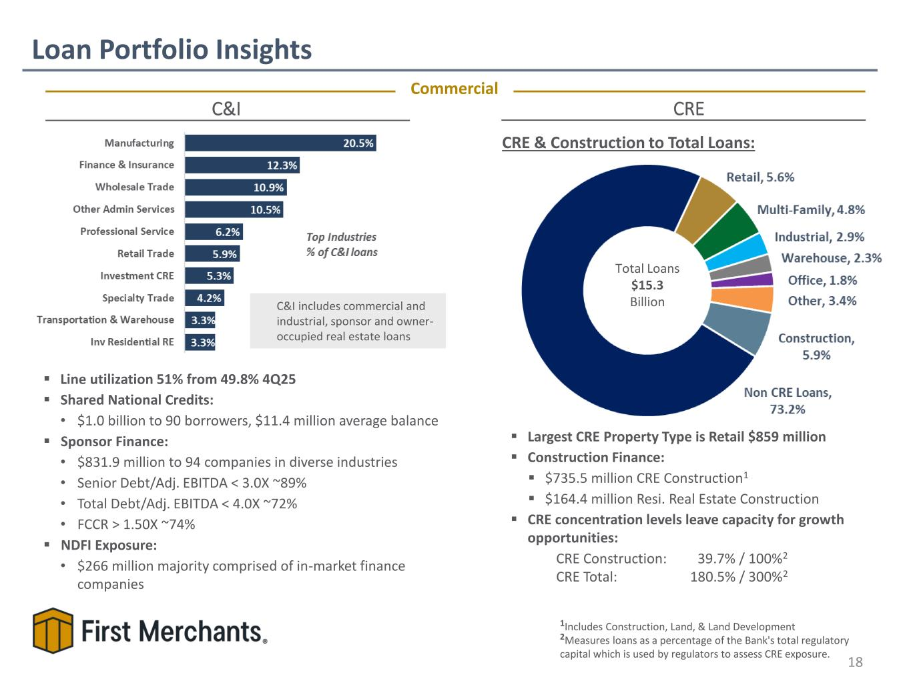
▪ Largest CRE Property Type is Retail $859 million ▪ Construction Finance: ▪ $735.5 million CRE Construction1 ▪ $164.4 million Resi. Real Estate Construction ▪ CRE concentration levels leave capacity for growth opportunities: CRE Construction: 39.7% / 100%2 CRE Total: 180.5% / 300%2 C&I includes commercial and industrial, sponsor and owner- occupied real estate loans CRE ▪ Line utilization 51% from 49.8% 4Q25 ▪ Shared National Credits: • $1.0 billion to 90 borrowers, $11.4 million average balance ▪ Sponsor Finance: • $831.9 million to 94 companies in diverse industries • Senior Debt/Adj. EBITDA < 3.0X ~89% • Total Debt/Adj. EBITDA < 4.0X ~72% • FCCR > 1.50X ~74% ▪ NDFI Exposure:​ • $266 million majority comprised of in-market finance companies Loan Portfolio Insights 18 C&I Commercial CRE & Construction to Total Loans: 1Includes Construction, Land, & Land Development 2Measures loans as a percentage of the Bank's total regulatory capital which is used by regulators to assess CRE exposure. Total Loans $15.3 Billion

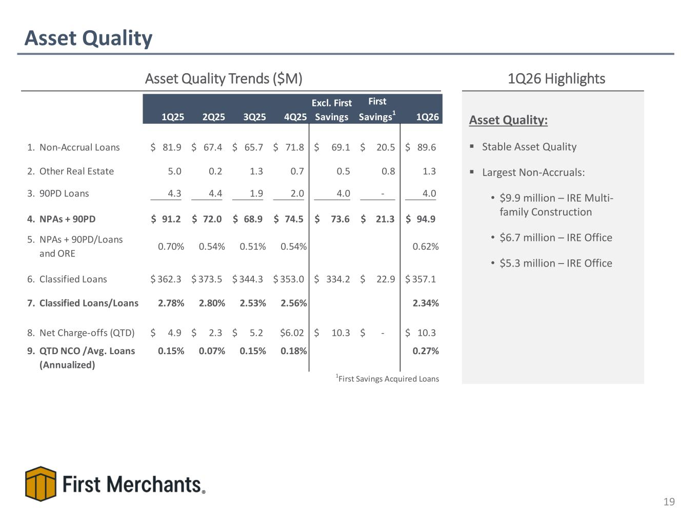
Asset Quality 19 Asset Quality Trends ($M) 1Q26 Highlights 1Q25 2Q25 3Q25 4Q25 Excl. First Savings First Savings1 1Q26 1. Non-Accrual Loans 81.9$ 67.4$ 65.7$ 71.8$ 69.1$ 20.5$ 89.6$ 2. Other Real Estate 5.0 0.2 1.3 0.7 0.5 0.8 1.3 3. 90PD Loans 4.3 4.4 1.9 2.0 4.0 - 4.0 4. NPAs + 90PD 91.2$ 72.0$ 68.9$ 74.5$ 73.6$ 21.3$ 94.9$ 5. NPAs + 90PD/Loans and ORE 0.70% 0.54% 0.51% 0.54% 0.62% 6. Classified Loans 362.3$ 373.5$ 344.3$ 353.0$ 334.2$ 22.9$ 357.1$ 7. Classified Loans/Loans 2.78% 2.80% 2.53% 2.56% 2.34% 8. Net Charge-offs (QTD) 4.9$ 2.3$ 5.2$ $6.02 10.3$ -$ 10.3$ 9. QTD NCO /Avg. Loans (Annualized) 0.15% 0.07% 0.15% 0.18% 0.27% 1First Savings Acquired Loans Asset Quality: ▪ Stable Asset Quality ▪ Largest Non-Accruals: • $9.9 million – IRE Multi- family Construction • $6.7 million – IRE Office • $5.3 million – IRE Office

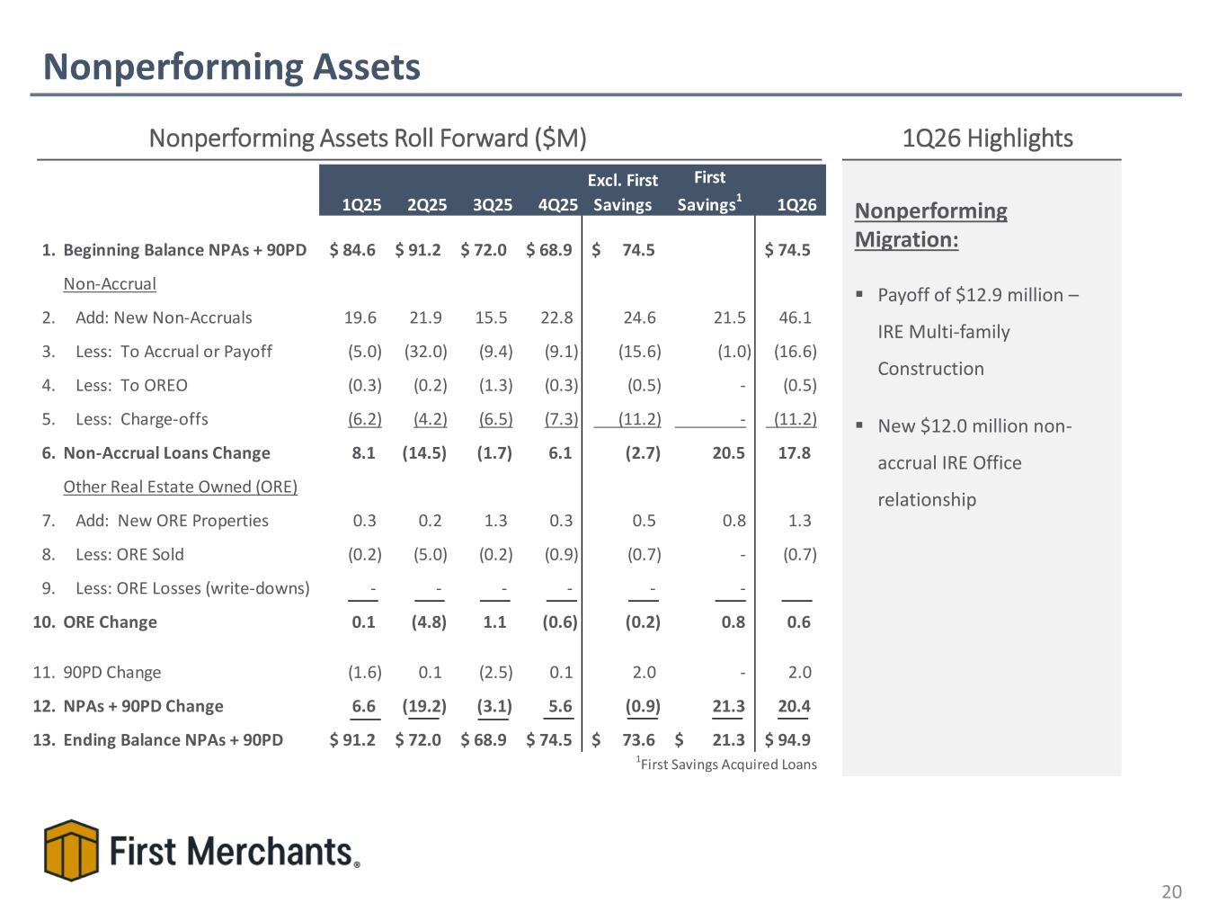
Nonperforming Assets 20 Nonperforming Assets Roll Forward ($M) 1Q26 Highlights 1Q25 2Q25 3Q25 4Q25 Excl. First Savings First Savings1 1Q26 1. Beginning Balance NPAs + 90PD 84.6$ 91.2$ 72.0$ 68.9$ 74.5$ 74.5$ Non-Accrual 2. Add: New Non-Accruals 19.6 21.9 15.5 22.8 24.6 21.5 46.1 3. Less: To Accrual or Payoff (5.0) (32.0) (9.4) (9.1) (15.6) (1.0) (16.6) 4. Less: To OREO (0.3) (0.2) (1.3) (0.3) (0.5) - (0.5) 5. Less: Charge-offs (6.2) (4.2) (6.5) (7.3) (11.2) - (11.2) 6. Non-Accrual Loans Change 8.1 (14.5) (1.7) 6.1 (2.7) 20.5 17.8 Other Real Estate Owned (ORE) 7. Add: New ORE Properties 0.3 0.2 1.3 0.3 0.5 0.8 1.3 8. Less: ORE Sold (0.2) (5.0) (0.2) (0.9) (0.7) - (0.7) 9. Less: ORE Losses (write-downs) - - - - - - 10. ORE Change 0.1 (4.8) 1.1 (0.6) (0.2) 0.8 0.6 11. 90PD Change (1.6) 0.1 (2.5) 0.1 2.0 - 2.0 12. NPAs + 90PD Change 6.6 (19.2) (3.1) 5.6 (0.9) 21.3 20.4 13. Ending Balance NPAs + 90PD 91.2$ 72.0$ 68.9$ 74.5$ 73.6$ 21.3$ 94.9$ 1First Savings Acquired Loans Nonperforming Migration: ▪ Payoff of $12.9 million – IRE Multi-family Construction ▪ New $12.0 million non- accrual IRE Office relationship

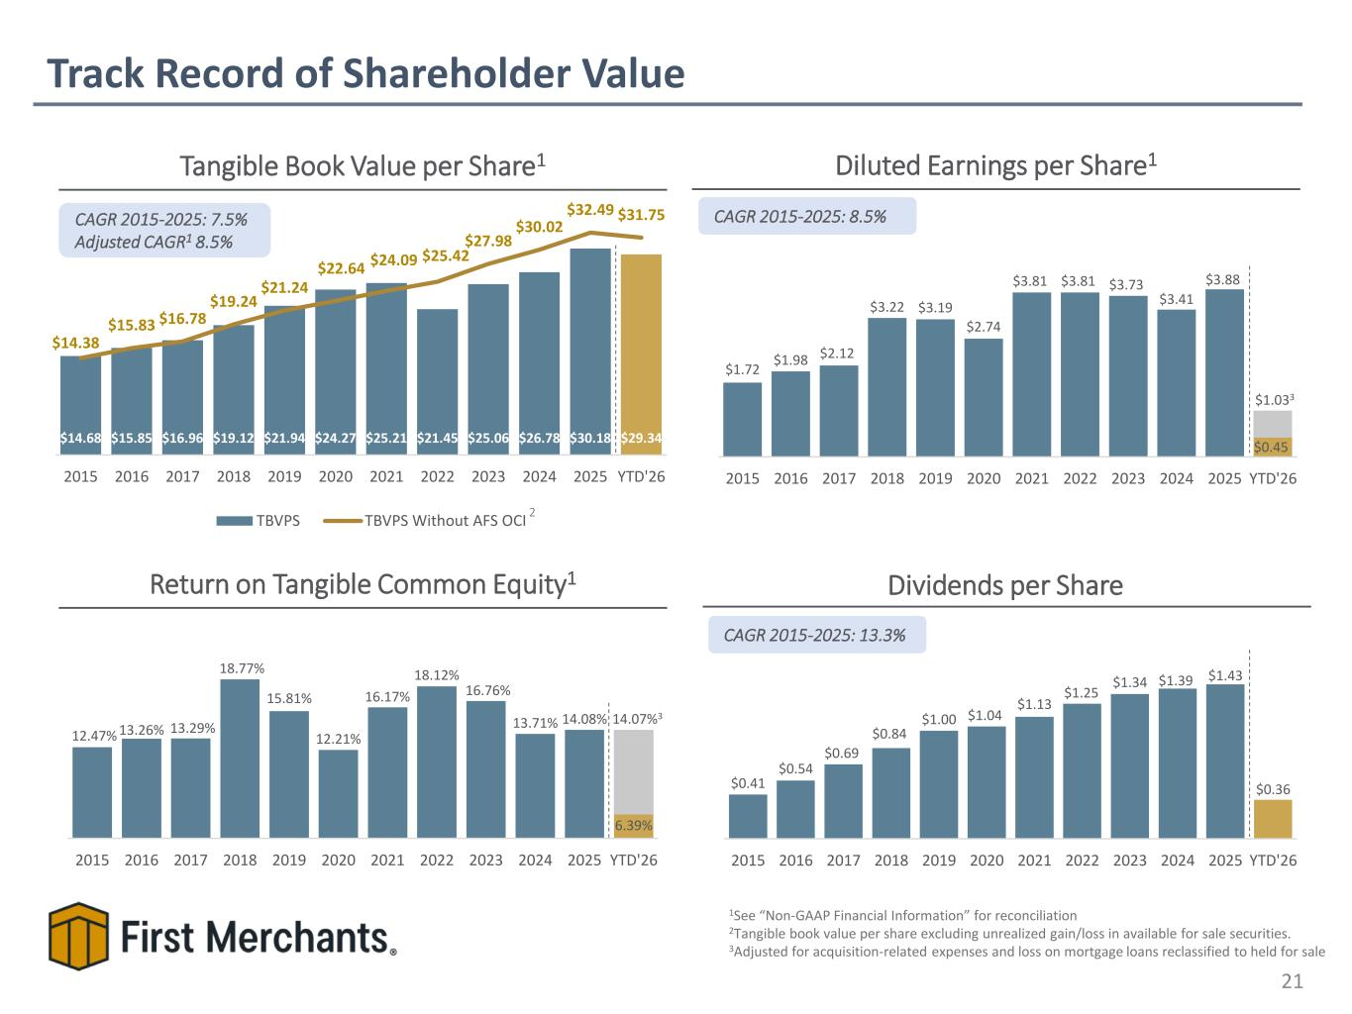
$14.68 $15.85 $16.96 $19.12 $21.94 $24.27 $25.21 $21.45 $25.06 $26.78 $30.18 $29.34 $14.38 $15.83 $16.78 $19.24 $21.24 $22.64 $24.09 $25.42 $27.98 $30.02 $32.49 $31.75 2015 2016 2017 2018 2019 2020 2021 2022 2023 2024 2025 YTD'26 TBVPS TBVPS Without AFS OCI Track Record of Shareholder Value 21 Diluted Earnings per Share1Tangible Book Value per Share1 Dividends per Share CAGR 2015-2025: 8.5% Return on Tangible Common Equity1 1See “Non-GAAP Financial Information” for reconciliation 2Tangible book value per share excluding unrealized gain/loss in available for sale securities. 3Adjusted for acquisition-related expenses and loss on mortgage loans reclassified to held for sale CAGR 2015-2025: 13.3% 2 CAGR 2015-2025: 7.5% Adjusted CAGR1 8.5% $1.72 $1.98 $2.12 $3.22 $3.19 $2.74 $3.81 $3.81 $3.73 $3.41 $3.88 $0.45 2015 2016 2017 2018 2019 2020 2021 2022 2023 2024 2025 YTD'26 $0.41 $0.54 $0.69 $0.84 $1.00 $1.04 $1.13 $1.25 $1.34 $1.39 $1.43 $0.36 2015 2016 2017 2018 2019 2020 2021 2022 2023 2024 2025 YTD'26 12.47% 13.26% 13.29% 18.77% 15.81% 12.21% 16.17% 18.12% 16.76% 13.71% 14.08% 6.39% 2015 2016 2017 2018 2019 2020 2021 2022 2023 2024 2025 YTD'26 14.07%3 $1.033

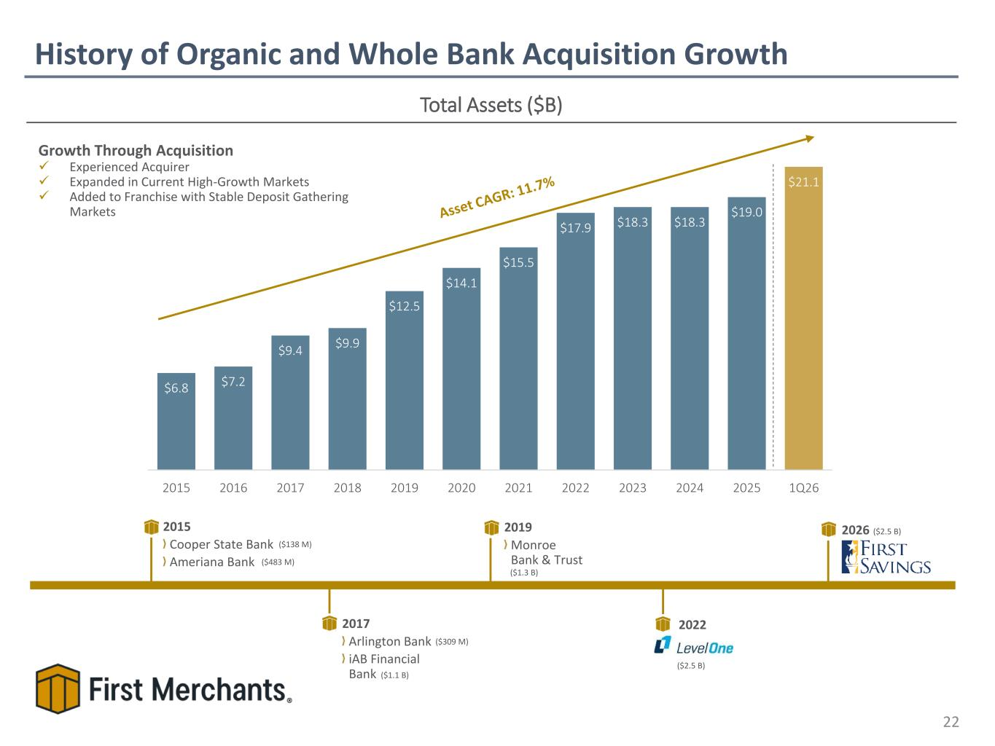
$6.8 $7.2 $9.4 $9.9 $12.5 $14.1 $15.5 $17.9 $18.3 $18.3 $19.0 $21.1 2015 2016 2017 2018 2019 2020 2021 2022 2023 2024 2025 1Q26 History of Organic and Whole Bank Acquisition Growth 22 Total Assets ($B) Growth Through Acquisition ✓ Experienced Acquirer ✓ Expanded in Current High-Growth Markets ✓ Added to Franchise with Stable Deposit Gathering Markets 2015 Cooper State Bank Ameriana Bank 2017 Arlington Bank iAB Financial Bank 2019 Monroe Bank & Trust 2022 ($309 M) ($138 M) ($2.5 B) ($1.3 B) ($483 M) ($1.1 B) 2026 ($2.5 B)

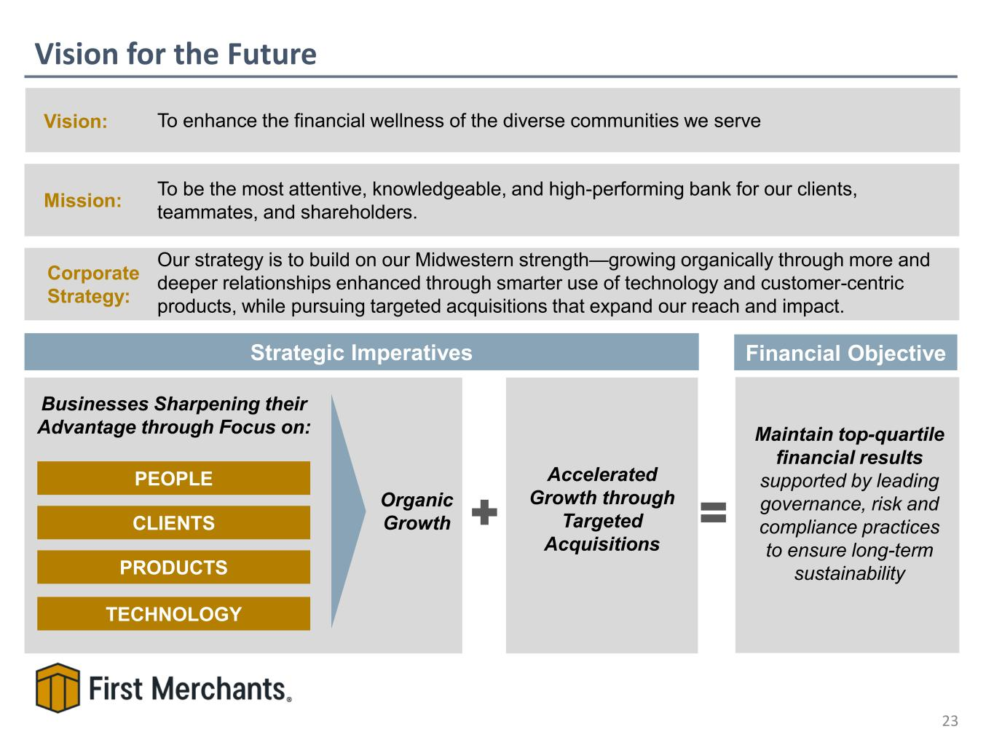
Vision for the Future 23 Mission: To be the most attentive, knowledgeable, and high-performing bank for our clients, teammates, and shareholders. Strategic Imperatives Vision: To enhance the financial wellness of the diverse communities we serve PEOPLE CLIENTS PRODUCTS TECHNOLOGY Businesses Sharpening their Advantage through Focus on: Accelerated Growth through Targeted Acquisitions Organic Growth Maintain top-quartile financial results supported by leading governance, risk and compliance practices to ensure long-term sustainability Financial Objective Corporate Strategy: Our strategy is to build on our Midwestern strength—growing organically through more and deeper relationships enhanced through smarter use of technology and customer-centric products, while pursuing targeted acquisitions that expand our reach and impact.

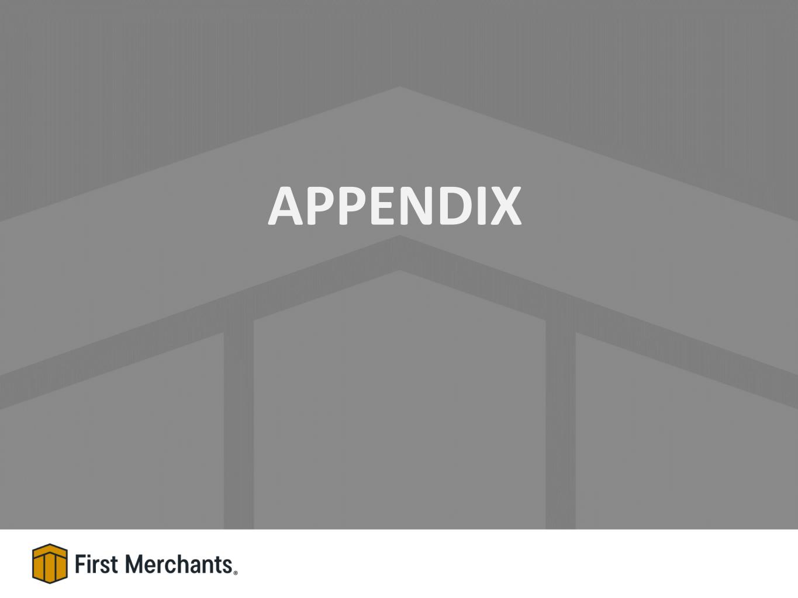
APPENDIX

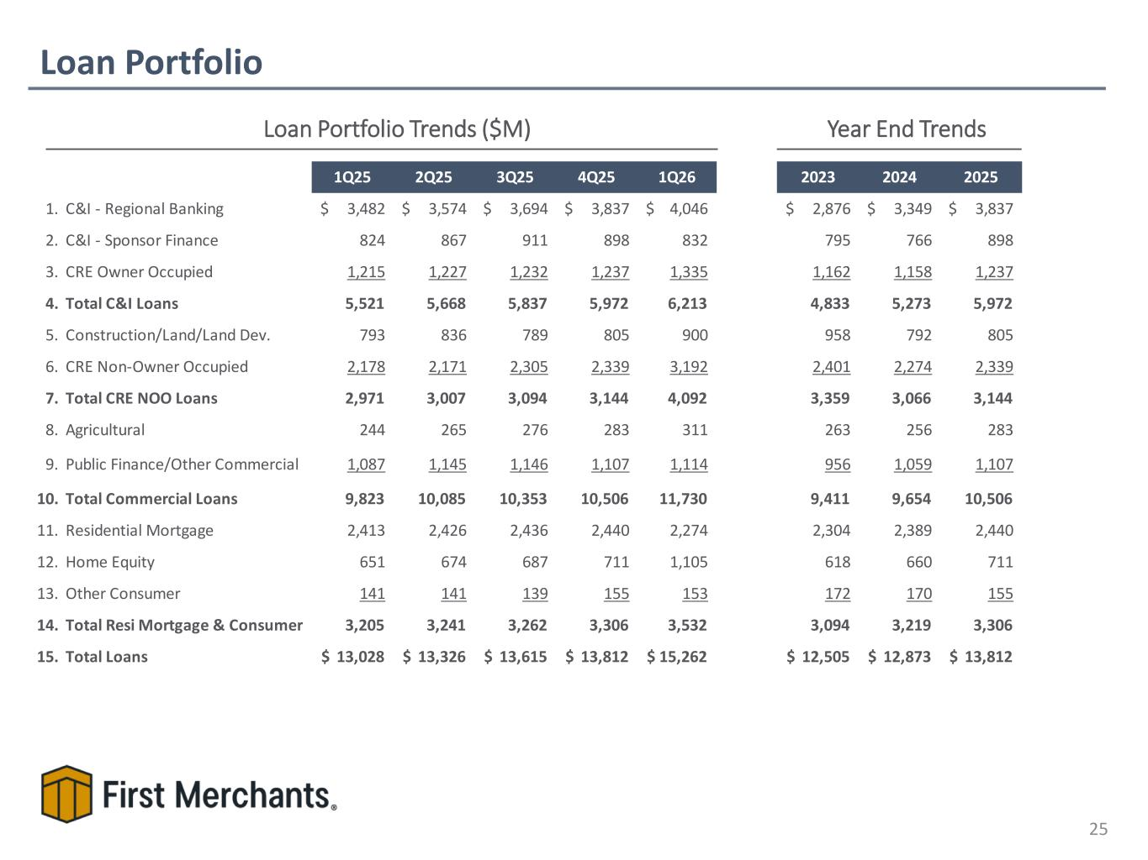
Loan Portfolio 25 Loan Portfolio Trends ($M) Year End Trends 1Q25 2Q25 3Q25 4Q25 1Q26 2023 2024 2025 1. C&I - Regional Banking 3,482$ 3,574$ 3,694$ 3,837$ 4,046$ 2,876$ 3,349$ 3,837$ 2. C&I - Sponsor Finance 824 867 911 898 832 795 766 898 3. CRE Owner Occupied 1,215 1,227 1,232 1,237 1,335 1,162 1,158 1,237 4. Total C&I Loans 5,521 5,668 5,837 5,972 6,213 4,833 5,273 5,972 5. Construction/Land/Land Dev. 793 836 789 805 900 958 792 805 6. CRE Non-Owner Occupied 2,178 2,171 2,305 2,339 3,192 2,401 2,274 2,339 7. Total CRE NOO Loans 2,971 3,007 3,094 3,144 4,092 3,359 3,066 3,144 8. Agricultural 244 265 276 283 311 263 256 283 9. Public Finance/Other Commercial 1,087 1,145 1,146 1,107 1,114 956 1,059 1,107 10. Total Commercial Loans 9,823 10,085 10,353 10,506 11,730 9,411 9,654 10,506 11. Residential Mortgage 2,413 2,426 2,436 2,440 2,274 2,304 2,389 2,440 12. Home Equity 651 674 687 711 1,105 618 660 711 13. Other Consumer 141 141 139 155 153 172 170 155 14. Total Resi Mortgage & Consumer 3,205 3,241 3,262 3,306 3,532 3,094 3,219 3,306 15. Total Loans 13,028$ 13,326$ 13,615$ 13,812$ 15,262$ 12,505$ 12,873$ 13,812$

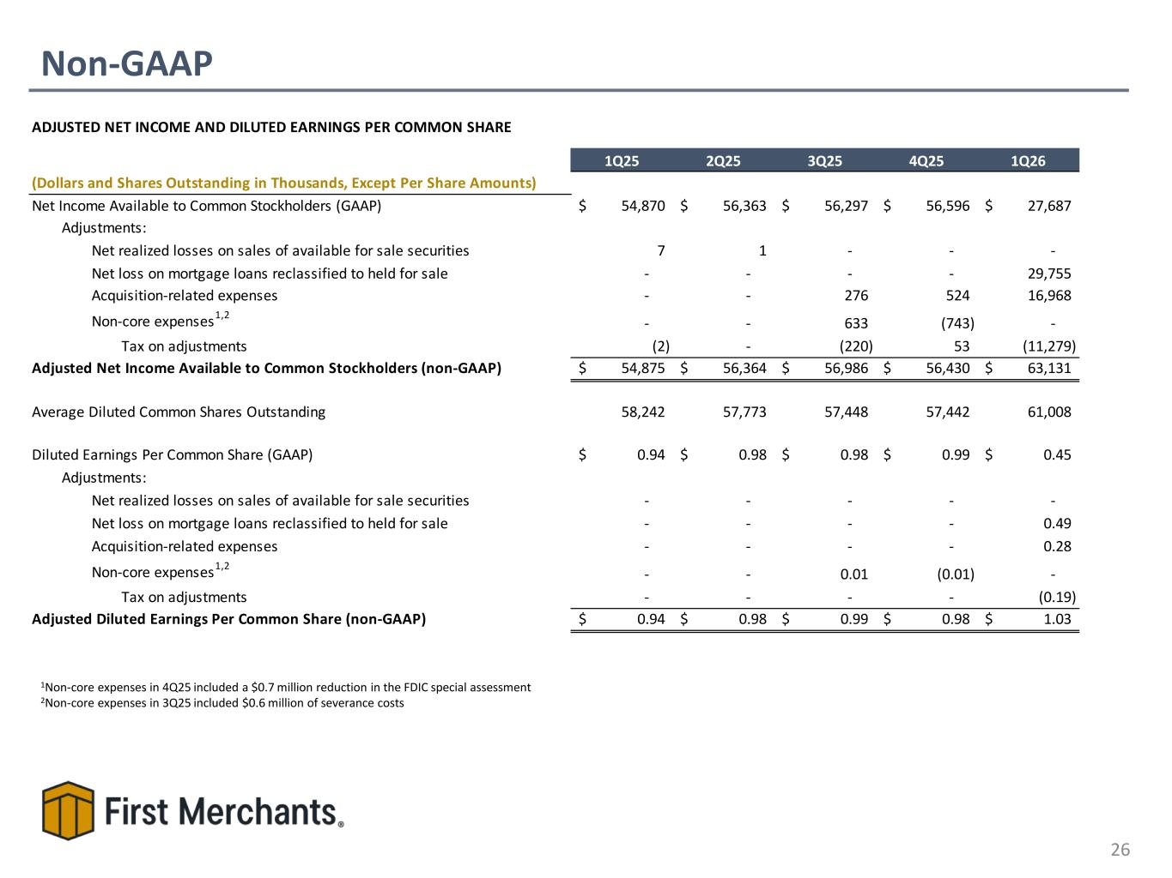
Non-GAAP 26 1Non-core expenses in 4Q25 included a $0.7 million reduction in the FDIC special assessment 2Non-core expenses in 3Q25 included $0.6 million of severance costs ADJUSTED NET INCOME AND DILUTED EARNINGS PER COMMON SHARE 1Q25 2Q25 3Q25 4Q25 1Q26 (Dollars and Shares Outstanding in Thousands, Except Per Share Amounts) Net Income Available to Common Stockholders (GAAP) 54,870$ 56,363$ 56,297$ 56,596$ 27,687$ Adjustments: Net realized losses on sales of available for sale securities 7 1 - - - Net loss on mortgage loans reclassified to held for sale - - - - 29,755 Acquisition-related expenses - - 276 524 16,968 Non-core expenses 1,2 - - 633 (743) - Tax on adjustments (2) - (220) 53 (11,279) Adjusted Net Income Available to Common Stockholders (non-GAAP) 54,875$ 56,364$ 56,986$ 56,430$ 63,131$ Average Diluted Common Shares Outstanding 58,242 57,773 57,448 57,442 61,008 Diluted Earnings Per Common Share (GAAP) 0.94$ 0.98$ 0.98$ 0.99$ 0.45$ Adjustments: Net realized losses on sales of available for sale securities - - - - - Net loss on mortgage loans reclassified to held for sale - - - - 0.49 Acquisition-related expenses - - - - 0.28 Non-core expenses1,2 - - 0.01 (0.01) - Tax on adjustments - - - - (0.19) Adjusted Diluted Earnings Per Common Share (non-GAAP) 0.94$ 0.98$ 0.99$ 0.98$ 1.03$

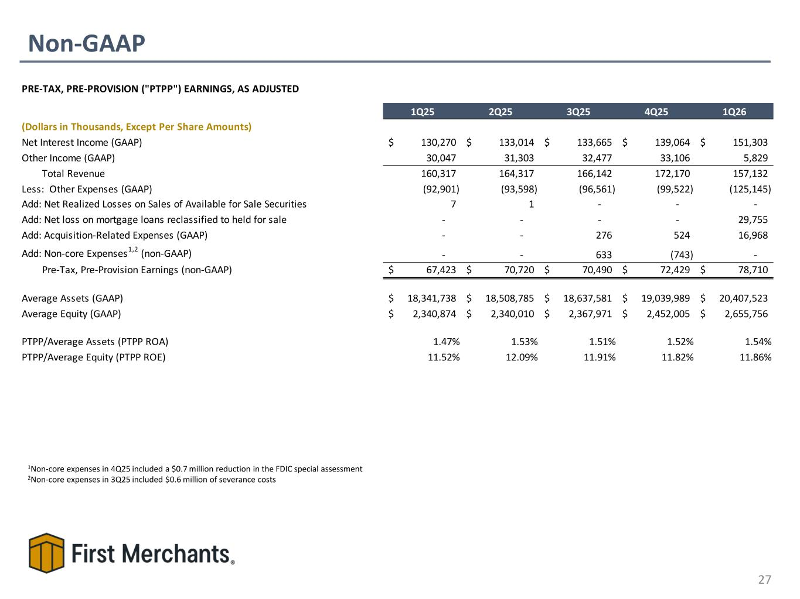
Non-GAAP 27 PRE-TAX, PRE-PROVISION ("PTPP") EARNINGS, AS ADJUSTED 1Q25 2Q25 3Q25 4Q25 1Q26 (Dollars in Thousands, Except Per Share Amounts) Net Interest Income (GAAP) 130,270$ 133,014$ 133,665$ 139,064$ 151,303$ Other Income (GAAP) 30,047 31,303 32,477 33,106 5,829 Total Revenue 160,317 164,317 166,142 172,170 157,132 Less: Other Expenses (GAAP) (92,901) (93,598) (96,561) (99,522) (125,145) Add: Net Realized Losses on Sales of Available for Sale Securities 7 1 - - - Add: Net loss on mortgage loans reclassified to held for sale - - - - 29,755 Add: Acquisition-Related Expenses (GAAP) - - 276 524 16,968 Add: Non-core Expenses1,2 (non-GAAP) - - 633 (743) - Pre-Tax, Pre-Provision Earnings (non-GAAP) 67,423$ 70,720$ 70,490$ 72,429$ 78,710$ Average Assets (GAAP) 18,341,738$ 18,508,785$ 18,637,581$ 19,039,989$ 20,407,523$ Average Equity (GAAP) 2,340,874$ 2,340,010$ 2,367,971$ 2,452,005$ 2,655,756$ PTPP/Average Assets (PTPP ROA) 1.47% 1.53% 1.51% 1.52% 1.54% PTPP/Average Equity (PTPP ROE) 11.52% 12.09% 11.91% 11.82% 11.86% 1Non-core expenses in 4Q25 included a $0.7 million reduction in the FDIC special assessment 2Non-core expenses in 3Q25 included $0.6 million of severance costs

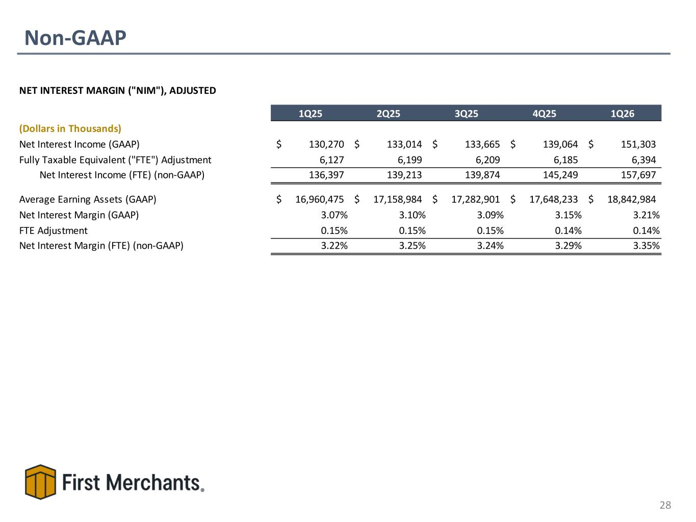
Non-GAAP 28 NET INTEREST MARGIN ("NIM"), ADJUSTED 1Q25 2Q25 3Q25 4Q25 1Q26 (Dollars in Thousands) Net Interest Income (GAAP) 130,270$ 133,014$ 133,665$ 139,064$ 151,303$ Fully Taxable Equivalent ("FTE") Adjustment 6,127 6,199 6,209 6,185 6,394 Net Interest Income (FTE) (non-GAAP) 136,397 139,213 139,874 145,249 157,697 Average Earning Assets (GAAP) 16,960,475$ 17,158,984$ 17,282,901$ 17,648,233$ 18,842,984$ Net Interest Margin (GAAP) 3.07% 3.10% 3.09% 3.15% 3.21% FTE Adjustment 0.15% 0.15% 0.15% 0.14% 0.14% Net Interest Margin (FTE) (non-GAAP) 3.22% 3.25% 3.24% 3.29% 3.35%

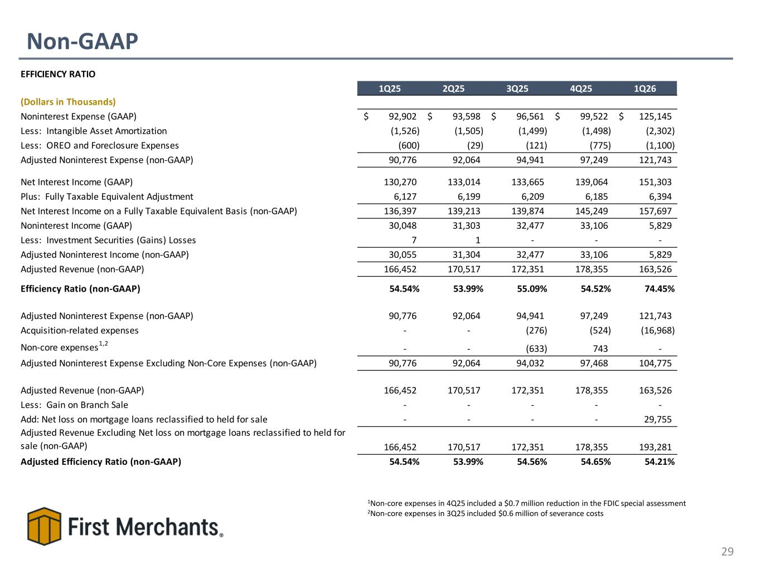
Non-GAAP 29 EFFICIENCY RATIO 1Q25 2Q25 3Q25 4Q25 1Q26 (Dollars in Thousands) Noninterest Expense (GAAP) 92,902$ 93,598$ 96,561$ 99,522$ 125,145$ Less: Intangible Asset Amortization (1,526) (1,505) (1,499) (1,498) (2,302) Less: OREO and Foreclosure Expenses (600) (29) (121) (775) (1,100) Adjusted Noninterest Expense (non-GAAP) 90,776 92,064 94,941 97,249 121,743 Net Interest Income (GAAP) 130,270 133,014 133,665 139,064 151,303 Plus: Fully Taxable Equivalent Adjustment 6,127 6,199 6,209 6,185 6,394 Net Interest Income on a Fully Taxable Equivalent Basis (non-GAAP) 136,397 139,213 139,874 145,249 157,697 Noninterest Income (GAAP) 30,048 31,303 32,477 33,106 5,829 Less: Investment Securities (Gains) Losses 7 1 - - - Adjusted Noninterest Income (non-GAAP) 30,055 31,304 32,477 33,106 5,829 Adjusted Revenue (non-GAAP) 166,452 170,517 172,351 178,355 163,526 Efficiency Ratio (non-GAAP) 54.54% 53.99% 55.09% 54.52% 74.45% Adjusted Noninterest Expense (non-GAAP) 90,776 92,064 94,941 97,249 121,743 Acquisition-related expenses - - (276) (524) (16,968) Non-core expenses1,2 - - (633) 743 - Adjusted Noninterest Expense Excluding Non-Core Expenses (non-GAAP) 90,776 92,064 94,032 97,468 104,775 Adjusted Revenue (non-GAAP) 166,452 170,517 172,351 178,355 163,526 Less: Gain on Branch Sale - - - - - Add: Net loss on mortgage loans reclassified to held for sale - - - - 29,755 Adjusted Revenue Excluding Net loss on mortgage loans reclassified to held for sale (non-GAAP) 166,452 170,517 172,351 178,355 193,281 Adjusted Efficiency Ratio (non-GAAP) 54.54% 53.99% 54.56% 54.65% 54.21% 1Non-core expenses in 4Q25 included a $0.7 million reduction in the FDIC special assessment 2Non-core expenses in 3Q25 included $0.6 million of severance costs

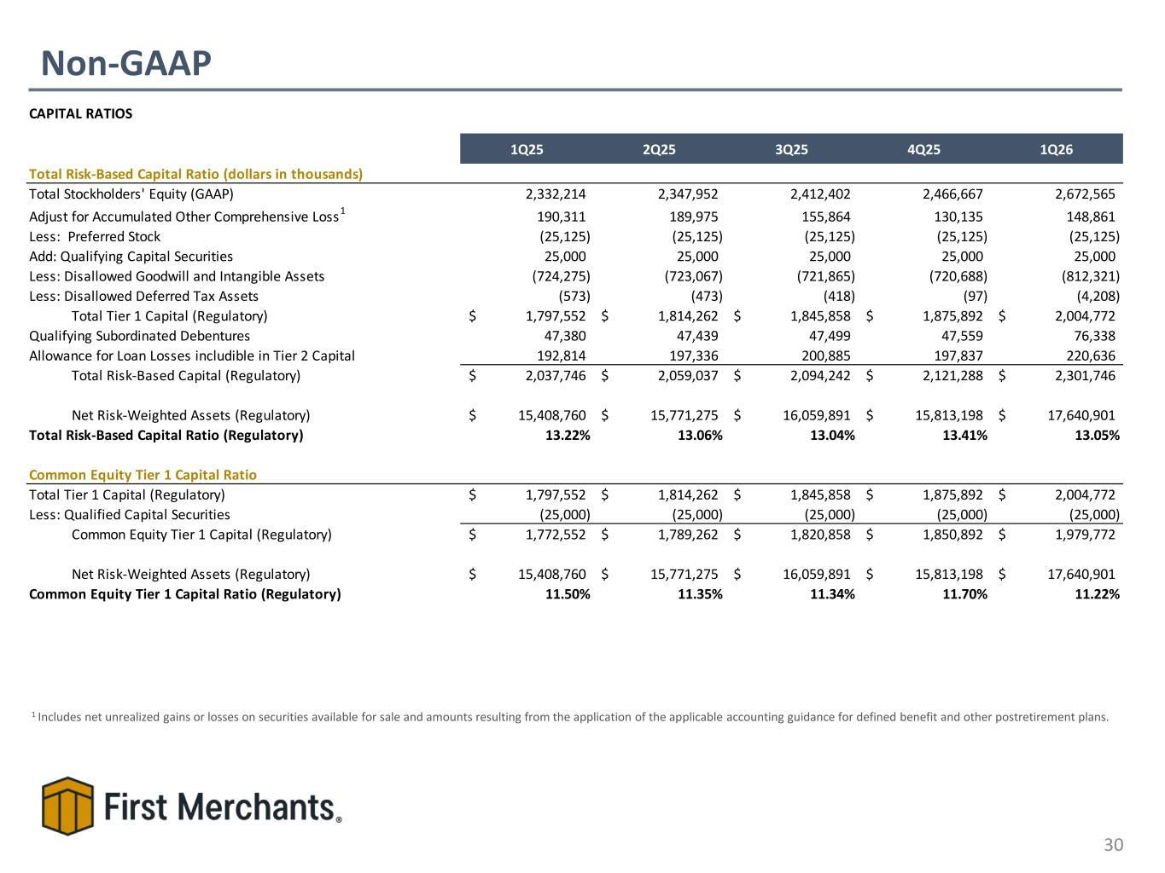
Non-GAAP 30 1 Includes net unrealized gains or losses on securities available for sale and amounts resulting from the application of the applicable accounting guidance for defined benefit and other postretirement plans. CAPITAL RATIOS 1Q25 2Q25 3Q25 4Q25 1Q26 Total Risk-Based Capital Ratio (dollars in thousands) Total Stockholders' Equity (GAAP) 2,332,214 2,347,952 2,412,402 2,466,667 2,672,565 Adjust for Accumulated Other Comprehensive Loss1 190,311 189,975 155,864 130,135 148,861 Less: Preferred Stock (25,125) (25,125) (25,125) (25,125) (25,125) Add: Qualifying Capital Securities 25,000 25,000 25,000 25,000 25,000 Less: Disallowed Goodwill and Intangible Assets (724,275) (723,067) (721,865) (720,688) (812,321) Less: Disallowed Deferred Tax Assets (573) (473) (418) (97) (4,208) Total Tier 1 Capital (Regulatory) 1,797,552$ 1,814,262$ 1,845,858$ 1,875,892$ 2,004,772$ Qualifying Subordinated Debentures 47,380 47,439 47,499 47,559 76,338 Allowance for Loan Losses includible in Tier 2 Capital 192,814 197,336 200,885 197,837 220,636 Total Risk-Based Capital (Regulatory) 2,037,746$ 2,059,037$ 2,094,242$ 2,121,288$ 2,301,746$ Net Risk-Weighted Assets (Regulatory) 15,408,760$ 15,771,275$ 16,059,891$ 15,813,198$ 17,640,901$ Total Risk-Based Capital Ratio (Regulatory) 13.22% 13.06% 13.04% 13.41% 13.05% Common Equity Tier 1 Capital Ratio Total Tier 1 Capital (Regulatory) 1,797,552$ 1,814,262$ 1,845,858$ 1,875,892$ 2,004,772$ Less: Qualified Capital Securities (25,000) (25,000) (25,000) (25,000) (25,000) Common Equity Tier 1 Capital (Regulatory) 1,772,552$ 1,789,262$ 1,820,858$ 1,850,892$ 1,979,772$ Net Risk-Weighted Assets (Regulatory) 15,408,760$ 15,771,275$ 16,059,891$ 15,813,198$ 17,640,901$ Common Equity Tier 1 Capital Ratio (Regulatory) 11.50% 11.35% 11.34% 11.70% 11.22%

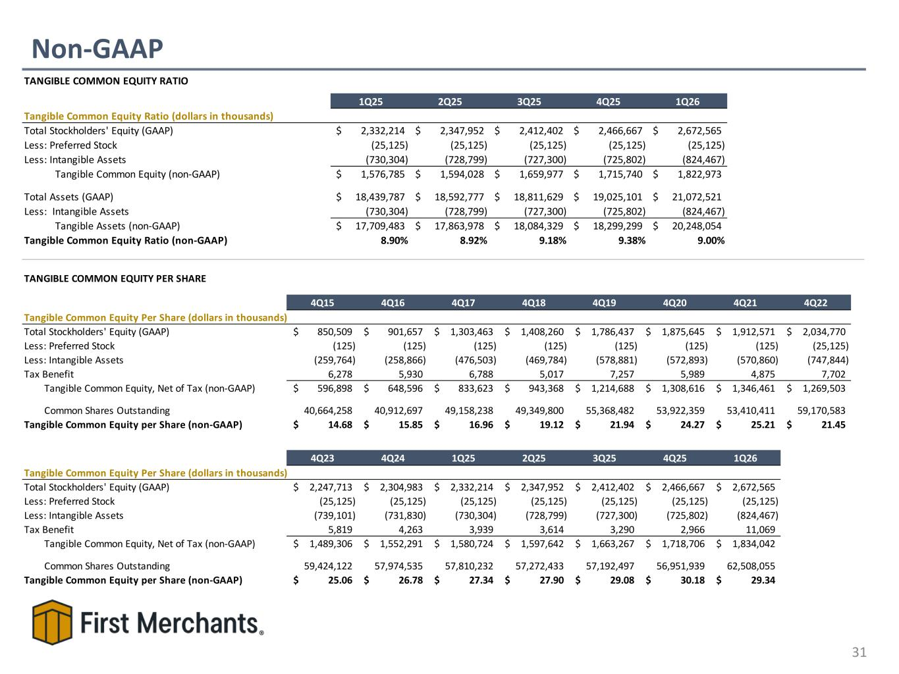
Non-GAAP 31 TANGIBLE COMMON EQUITY RATIO 1Q25 2Q25 3Q25 4Q25 1Q26 Tangible Common Equity Ratio (dollars in thousands) Total Stockholders' Equity (GAAP) 2,332,214$ 2,347,952$ 2,412,402$ 2,466,667$ 2,672,565$ Less: Preferred Stock (25,125) (25,125) (25,125) (25,125) (25,125) Less: Intangible Assets (730,304) (728,799) (727,300) (725,802) (824,467) Tangible Common Equity (non-GAAP) 1,576,785$ 1,594,028$ 1,659,977$ 1,715,740$ 1,822,973$ Total Assets (GAAP) 18,439,787$ 18,592,777$ 18,811,629$ 19,025,101$ 21,072,521$ Less: Intangible Assets (730,304) (728,799) (727,300) (725,802) (824,467) Tangible Assets (non-GAAP) 17,709,483$ 17,863,978$ 18,084,329$ 18,299,299$ 20,248,054$ Tangible Common Equity Ratio (non-GAAP) 8.90% 8.92% 9.18% 9.38% 9.00% TANGIBLE COMMON EQUITY PER SHARE 4Q15 4Q16 4Q17 4Q18 4Q19 4Q20 4Q21 4Q22 Tangible Common Equity Per Share (dollars in thousands) Total Stockholders' Equity (GAAP) 850,509$ 901,657$ 1,303,463$ 1,408,260$ 1,786,437$ 1,875,645$ 1,912,571$ 2,034,770$ Less: Preferred Stock (125) (125) (125) (125) (125) (125) (125) (25,125) Less: Intangible Assets (259,764) (258,866) (476,503) (469,784) (578,881) (572,893) (570,860) (747,844) Tax Benefit 6,278 5,930 6,788 5,017 7,257 5,989 4,875 7,702 Tangible Common Equity, Net of Tax (non-GAAP) 596,898$ 648,596$ 833,623$ 943,368$ 1,214,688$ 1,308,616$ 1,346,461$ 1,269,503$ Common Shares Outstanding 40,664,258 40,912,697 49,158,238 49,349,800 55,368,482 53,922,359 53,410,411 59,170,583 Tangible Common Equity per Share (non-GAAP) 14.68$ 15.85$ 16.96$ 19.12$ 21.94$ 24.27$ 25.21$ 21.45$ 4Q23 4Q24 1Q25 2Q25 3Q25 4Q25 1Q26 Tangible Common Equity Per Share (dollars in thousands) Total Stockholders' Equity (GAAP) 2,247,713$ 2,304,983$ 2,332,214$ 2,347,952$ 2,412,402$ 2,466,667$ 2,672,565$ Less: Preferred Stock (25,125) (25,125) (25,125) (25,125) (25,125) (25,125) (25,125) Less: Intangible Assets (739,101) (731,830) (730,304) (728,799) (727,300) (725,802) (824,467) Tax Benefit 5,819 4,263 3,939 3,614 3,290 2,966 11,069 Tangible Common Equity, Net of Tax (non-GAAP) 1,489,306$ 1,552,291$ 1,580,724$ 1,597,642$ 1,663,267$ 1,718,706$ 1,834,042$ Common Shares Outstanding 59,424,122 57,974,535 57,810,232 57,272,433 57,192,497 56,951,939 62,508,055 Tangible Common Equity per Share (non-GAAP) 25.06$ 26.78$ 27.34$ 27.90$ 29.08$ 30.18$ 29.34$

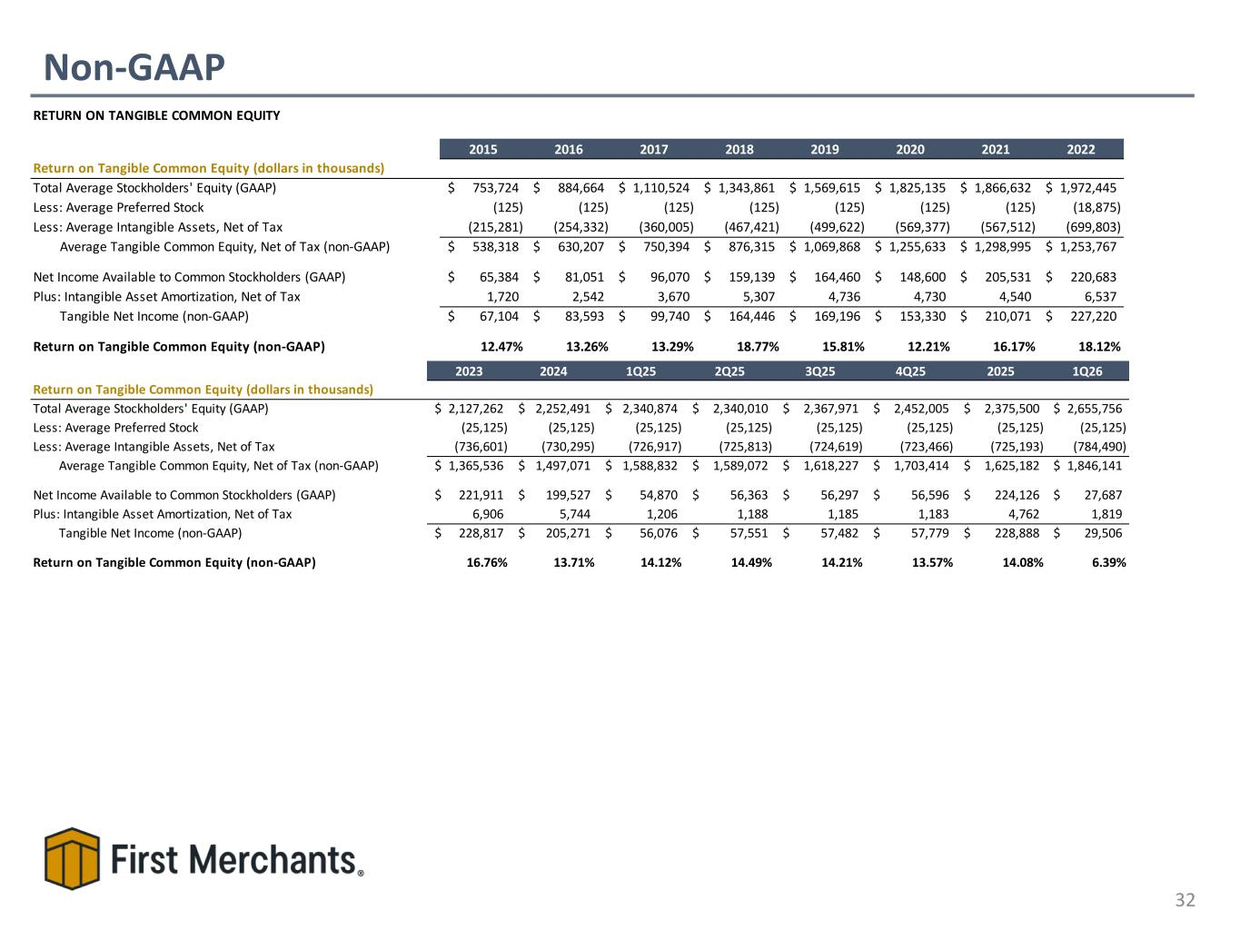
Non-GAAP 32 RETURN ON TANGIBLE COMMON EQUITY 2015 2016 2017 2018 2019 2020 2021 2022 Return on Tangible Common Equity (dollars in thousands) Total Average Stockholders' Equity (GAAP) 753,724$ 884,664$ 1,110,524$ 1,343,861$ 1,569,615$ 1,825,135$ 1,866,632$ 1,972,445$ Less: Average Preferred Stock (125) (125) (125) (125) (125) (125) (125) (18,875) Less: Average Intangible Assets, Net of Tax (215,281) (254,332) (360,005) (467,421) (499,622) (569,377) (567,512) (699,803) Average Tangible Common Equity, Net of Tax (non-GAAP) 538,318$ 630,207$ 750,394$ 876,315$ 1,069,868$ 1,255,633$ 1,298,995$ 1,253,767$ Net Income Available to Common Stockholders (GAAP) 65,384$ 81,051$ 96,070$ 159,139$ 164,460$ 148,600$ 205,531$ 220,683$ Plus: Intangible Asset Amortization, Net of Tax 1,720 2,542 3,670 5,307 4,736 4,730 4,540 6,537 Tangible Net Income (non-GAAP) 67,104$ 83,593$ 99,740$ 164,446$ 169,196$ 153,330$ 210,071$ 227,220$ Return on Tangible Common Equity (non-GAAP) 12.47% 13.26% 13.29% 18.77% 15.81% 12.21% 16.17% 18.12% 2023 2024 1Q25 2Q25 3Q25 4Q25 2025 1Q26 Return on Tangible Common Equity (dollars in thousands) Total Average Stockholders' Equity (GAAP) 2,127,262$ 2,252,491$ 2,340,874$ 2,340,010$ 2,367,971$ 2,452,005$ 2,375,500$ 2,655,756$ Less: Average Preferred Stock (25,125) (25,125) (25,125) (25,125) (25,125) (25,125) (25,125) (25,125) Less: Average Intangible Assets, Net of Tax (736,601) (730,295) (726,917) (725,813) (724,619) (723,466) (725,193) (784,490) Average Tangible Common Equity, Net of Tax (non-GAAP) 1,365,536$ 1,497,071$ 1,588,832$ 1,589,072$ 1,618,227$ 1,703,414$ 1,625,182$ 1,846,141$ Net Income Available to Common Stockholders (GAAP) 221,911$ 199,527$ 54,870$ 56,363$ 56,297$ 56,596$ 224,126$ 27,687$ Plus: Intangible Asset Amortization, Net of Tax 6,906 5,744 1,206 1,188 1,185 1,183 4,762 1,819 Tangible Net Income (non-GAAP) 228,817$ 205,271$ 56,076$ 57,551$ 57,482$ 57,779$ 228,888$ 29,506$ Return on Tangible Common Equity (non-GAAP) 16.76% 13.71% 14.12% 14.49% 14.21% 13.57% 14.08% 6.39%

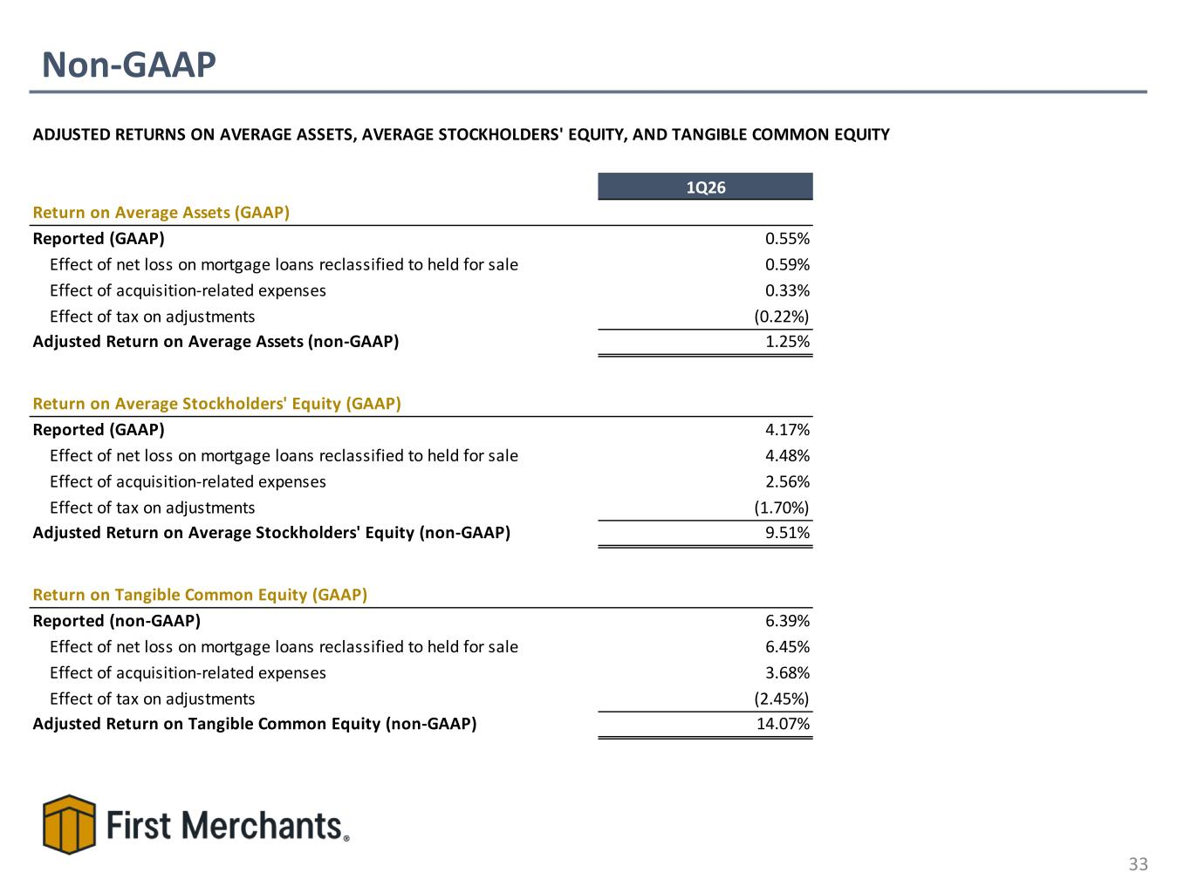
Non-GAAP 33 ADJUSTED RETURNS ON AVERAGE ASSETS, AVERAGE STOCKHOLDERS' EQUITY, AND TANGIBLE COMMON EQUITY 1Q26 Return on Average Assets (GAAP) Reported (GAAP) 0.55% Effect of net loss on mortgage loans reclassified to held for sale 0.59% Effect of acquisition-related expenses 0.33% Effect of tax on adjustments (0.22%) Adjusted Return on Average Assets (non-GAAP) 1.25% Return on Average Stockholders' Equity (GAAP) Reported (GAAP) 4.17% Effect of net loss on mortgage loans reclassified to held for sale 4.48% Effect of acquisition-related expenses 2.56% Effect of tax on adjustments (1.70%) Adjusted Return on Average Stockholders' Equity (non-GAAP) 9.51% Return on Tangible Common Equity (GAAP) Reported (non-GAAP) 6.39% Effect of net loss on mortgage loans reclassified to held for sale 6.45% Effect of acquisition-related expenses 3.68% Effect of tax on adjustments (2.45%) Adjusted Return on Tangible Common Equity (non-GAAP) 14.07%

